Chromis

Kevin Turner Apr 2016

Contents

Pre-requisites 3

PostgreSQL 3

Redis 3

Node 3

Sails 3

Git 3

GitHub 3

JSDoc 3

Windows 4

TortoiseGit 4

Visual Studio Code 4

C++ compiler 4

Summary 4

Setting up a development environment 6

Cloning the repos 6

Chromis 6

Some basics about a Sails.js application 6

Migrating the data 7

Running the Chromis server 7

What runs when I start it up? 8

Main server 8

Server Manager 9

One or many back-end servers for each queue defined 9

Starting and debugging 9

Anatomy – where do my functions live? 12

What does a function look like? 12

How to run in Production Mode 13

How do I apply hotfixes (or cachebust) 13

Online API documentation 13

Notes on creating the readme.md markdown file for github 14

# Pre-requisites

Working on the assumption that we are working with a blank canvas, the following things must be installed on any system (regardless of platform):

## **PostgreSQL**

If not already supplied on the platform, download appropriate version from <http://www.postgresql.org/download/>

Also **pgAdminIII** (from the same site) is pretty much essential.

## Redis

At the time of writing redis is supported on Windows and can be installed by downloading from <https://github.com/MSOpenTech/redis/releases>

I also ran into an error using redis: "MISCONF Redis is configured to save RDB snapshots, but is currently not able to persist on disk."

To fix that I ran **c:\program files\redis\redis-cli**

then

**config set stop-writes-on-bgsave-error no**

Not a solution but a workaround

## Node

Install the latest version of Node from <https://nodejs.org/en/download/>

## Sails

This is the framework upon which the Chromis server is based. You can read about it here: <http://sailsjs.org> but for now install it globally using npm:

**npm install sails –g**

## Git

Used for all source change management: <https://git-scm.com/downloads>

Background reading: <http://readwrite.com/2013/09/30/understanding-github-a-journey-for-beginners-part-1>

## GitHub

If you have not already got an account, register at <https://github.com/>

## **JSDoc**

For better or for worse, we currently use JSDoc to create documentation from our source comments:

**npm install jsdoc –g**

# **Windows**

If you are a developer working on a Windows PC, the following tools are useful additions to your armoury for developing and testing:

## **TortoiseGit**

By no means an essential tool but quite useful for a Windows Explorer GUI interface to Git (which is primarily a command line tool): <https://tortoisegit.org/>

## Visual Studio Code

If you don’t already have a favourite editor, this is a very nice lightweight editor to use with many languages: <https://code.visualstudio.com/>

If you install this, be sure to allow it to add an option to windows explorer to enable you to open resources with vs code from the context menu.

We also need to make a small config change:

Edit the following file – best using VS Code (**Run as Administrator** to get permissions).

C:\Program Files (x86)\Microsoft VS Code\resources\app\extensions\html\package.json

Change the “extensions” JSON property so it looks like this:

**"extensions": [ ".html", ".htm", ".shtml", ".mdoc", ".jsp", ".asp", ".aspx", ".jshtm", ".rml", ".ejs" ],**

Copy

C:\Program Files (x86)\Microsoft VS Code\resources\app\extensions\html   
to  
C:\Users\<user>\.vscode\extensions

## C++ compiler

Some packages from npm need to be compiled. At the time of writing there is a big song and dance about the fact that some things cannot be created on Windows, but there is a workaround if it is still required when you read this:

Install compiler: <https://github.com/nodejs/node-gyp/issues/629#issuecomment-153196245>

### Summary

Install VC++ Build Tools Technical Preview, choose Custom Install, and select both Windows 8.1 and Windows 10 SDKs.

NOTE: [Windows 7 only] requires .NET Framework 4.5.1

Install Python 2.7, and add it to your PATH, "npm config set python <insert path to your python.exe - e.g. C:\Python\python.exe>"

Also add the path to the python.exe to your windows PATH environment variable.

Launch cmd, "npm config set msvs_version 2015 --global"

(this is instead of npm install [package name] --msvs_version=2015 every time.)

A useful resource: <https://github.com/Microsoft/nodejs-guidelines>

# Setting up a development environment

## Cloning the repos

At the time of writing there are four repos on Github of interest.

1. The **Chromis** server repo: <https://github.com/kpturner/chromis.git>
2. The **Chromis Migration** repo: <https://github.com/kpturner/chromis-mig.git>
3. The **Chromis Models** repo: <https://github.com/kpturner/chromis-models.git>

They are private, so you need to be granted access by the owner (me).

Why are these all separate? Well Chromisis an application in its own right, but needs to make use of the **ChromisModels** repo and the **RNS client assets** repo. The **ChromisModels** repo is also used by the **ChromisMigration** application, and the **RNS client assets** is also used by the **RNS for RPG application**. So every multi-homed repo is managed as a separate entity. This has advantages and disadvantages, but that is the way it is for now.

### Chromis

Clone the Chromis repo onto your local machine (I used **c:\users\<user>\repos\chromis** as the home for this).

The assets folder would be populated with your UI assets.

# Some basics about a Sails.js application

All the config for the server (or at least all the config that we don’t store in database tables) is stored in individual .js files in the application /config directory. There is a lot to take in at first as there are lots of config files for various parts of the system. Without wishing to muddy the water, the only thing you really need to be aware of at this stage is:

1. These files are under source control in Git, so anything in these files is valid across all instances
2. One special file called **/config/local.js** is *not* under source control in Git, so in here you can override any of the other config options with things that you want to be uniquely different in your own instance of the server

For your convenience, there is a **/config/local.example** file that you can copy and name as **/config/local.js** and you are good to go.

If you want to delve deeper: <http://sailsjs.org/documentation/anatomy/my-app>

# Migrating the data

**TODO**

# Running the Chromis server

We should load up the Chromis application in VS Code in the same way we did for the migration app, so navigate to the **c:\users\<user>\repos\rns-node** directory in windows explorer you can right-click and take the “Open with code” option. When it is loaded up, you can edit /config/local.js (assuming you have copied the /config/local.example file previously).

Let’s have a look at that and explain some of the options that you need to know about to start with:

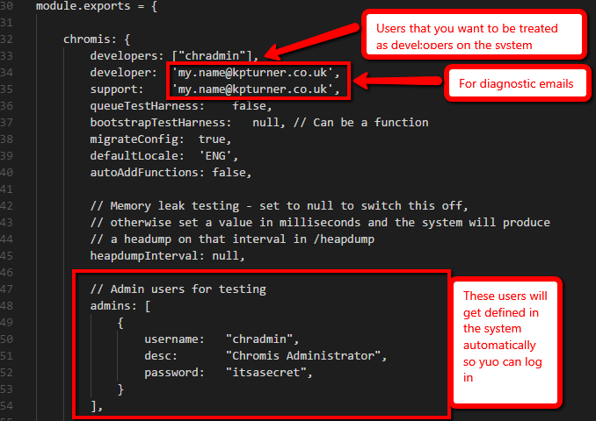

The following table details some additional start up parameters that may be of interest.

|  |  |  |
| --- | --- | --- |
| **Property** | **Value** | **Function** |
| autoAddFunctions | Boolean | If enabled, on startup the database will be populated with any new functions that have been created inside ‘./api/functions/*/*.js’. |

The “migrateConfig” option is interesting because further down the config file you can see a definition for each environment and within that you can specify data for config files that you want populated in the database – so here we are setting up the queues we want (same as back-end server queues on the RPG server):

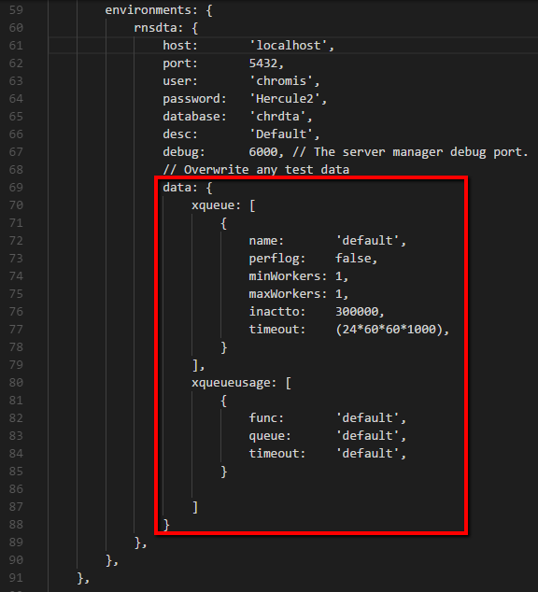

You can do the same with any table if you want your local instance to have specific data (as opposed to the stuff obtained via a migration).

## What runs when I start it up?

It is very similar to what you will be used to with the RPG server. The following things start:

### Main server

The main server. This will listen for traffic on a specific port. The port is determined thus:

1. If specified in **local.js** that will be used at all times
2. If not, then if you are running in development mode the port is defined in **/config/env/development.js**
3. If not, then if you are running in production mode the port is defined in **/config/env/production.js**
4. If not, then the port is derived from an environment variable called PORT
5. If all else fails it will listen on port 1337

If you are in debug mode, the debugger for the main server will listen on port 5858

When the server is started you run it locally – for example: <http://localhost:1337>

### Server Manager

A server manager process will start for each environment that you have defined. Think of this as the equivalent of the back-end server manager for an RPG RNS environment. If you are in debug mode, then debugging will be available by attaching to the debug port you defined for the environment in the config. In our example “rnsdta” uses port 6000 for debugging. For each environment you define, keep the debug port at least 1000 apart (so the next one would be 7000). This is just a convention, but the reason will become clear.

### One or many back-end servers for each queue defined

One or more back-end server processes will start for each queue you have defined. You can define the maximum and minimum number of servers to have, and the manager will increase/decrease these depending on demand – very much like the RPG equivalent. Each server that starts when you first fire things up will, if in debug mode, allow debugging on a port that increments from the server manager for the environment. So if the environment server manager is using port 6000 for debugging, the first back end server will use 6001, the second 6002 and so on. That is why the server managers need to have a decent gap between the ports they use.

As with the RPG server, debugging is easier if you configure your local setup to only have one queue so you can guarantee that requests will go to the back-end server you are debugging.

## Starting and debugging

The normal way to start the server is exactly the same way as was defined previously to start the migration server. This will start up the main server, and you can use the built in debug facilities in Visual Studio Code to set break points etc. If you want to use Visual Studio Code to debug a back-end server instead of the main server, then you can start the main server from a command line. Navigate to **c:\users\<user>\repos\rns-node** and run

**npm install**  *(only needed the first time you go to start it)*

**node --debug app.js**

If you want more logging you can use

**node --debug app.js --verbose**

or even

**node --debug app.js --silly**

When it starts you will see the server managers start (and listen on a debugging port) and the back-server(s) starting and listening on a port. So to debug them we need to tell Visual Studio Code to “Attach” to a port as opposed to the default “Launch”. There is a **launch.example** file in the root which can be copied into a directory called **.vscode** and renamed to **launch.json** – OR we need to configure VS Code to understand what we want to do when we attach. Click here:  
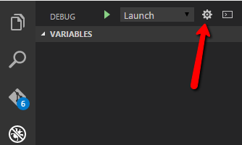

The launch.json will appear in the editor (you may have to select node.js as the execution environment first). We then configure some “Attach” settings for debug ports we want to attach to:  
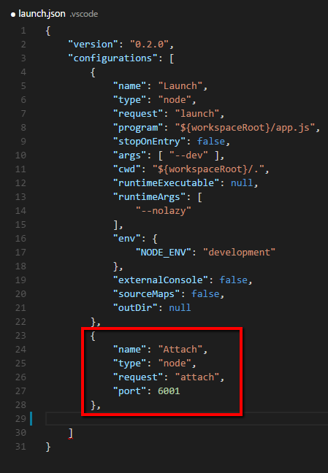

Now, with the server running in your command window, you can attach to, and debug, the other processes from within VS Code. You can use the drop down box to switch from “Launch” to your preferred “Attach” config and start the start button  :

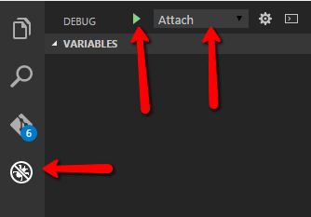

Breakpoints can be added/removed from code simply by clicking in the left margin:

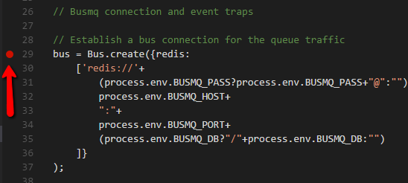

# Anatomy – where do my functions live?

This is all pretty much identical to the RPG server. To develop a framework function called **myapp** (using the Framework as an example), you would create a directory called **/assets/res/framework/functions/myapp**

Within that folder you would create your RML file: **myapp.rml**

Here is the fundamental difference. The model handling program/function that runs on the back-end to serve your RML is no longer an RPG program. It is a node module that lives in **/api/functions/framework/**, so you would also create **myapp.js** in that folder. As with the client side code, applications are in **/api/functions/apps/<app>**

# What does a function look like?

A large assumption here that the reader understands JavaScript and, more importantly, understands node.js. This is not a training document! Anyway, whether or not you know this stuff, there is an example function. Its structure is very similar to the RPG equivalent. This example is correct at the time of writing but of course this may alter as things progress and improve.

Look at **/assets/res/framework/functions/example/example.js**

Basically there are two places to do your stuff – the “initialise” function and the “process” function – pretty much like the RPG equivalent. You have helper services for the model handling (self.MOD) and for session related stuff (self.SES). The code for these (they are Sails hooks) can be found in

# How to run in Production Mode

**node app.js --prod**

# How do I apply hotfixes (or cachebust)

As mentioned previously, if you are running the development mode then your back-end functions get reloaded every time, but what if you are running in production mode or you make changes to other areas of the Framework? In the RPG world we had RNSHOTFIX and/or CACHEBUST but that was confusing for some. Now you can just do one of two things from a command prompt (once you have navigated to the application directory):

**node hotfix.js** (fixed get picked up when the user next logs on)

**node hotfix.js --reload**  (prompts connected users to reload)

# Online API documentation

Visit the **/doc** endpoint on your browser when running Chromis. The docs get generated by a tool called **jsdoc** when you start the server in development mode. For it to work, you obviously need jsdoc installed, so if you have not already done so**: npm install jsdoc –g**

As well as being generated at startup, you may regenerate the docs at any time by running **createdocs.sh**

Your PC may not know how to run shell scripts, but it should prompt you and you can select the Git Bash option available from a previous install of Git for Windows. As a personal preference, I like to associate the .sh extension with **c:\program files\git\bin.sh.exe** as stdout etc seems to then appear in the same window.

If you get fed up with generating the docs every time you start the server, you can switch it off in /config/local.js:

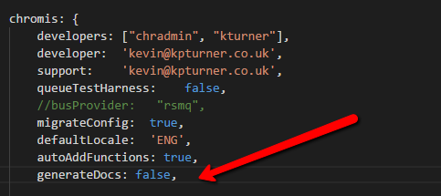

# Notes on creating the readme.md markdown file for github

If you change the documentation (readme.docx) you must also save it as a PDF. Additionally, use must create a markdown file for GitHub called readme.md.  
  
To do this, make sure you have a tool called pandoc installed: <http://pandoc.org/>

Then navigate to the “events” project directory that contains readme.docx and run this command:

***createreadme.sh***