**Alpha Team**

Daniel Graham

Aidan Jacoby

Stephanie Ramos

Case Study: *Bacchus Case Study*

***Milestone 3***

***Report 1: Supplier Delivery Performance Report***

This report describes each supplier along with the supplies they delivered, the expected delivery date, the actual delivery date, and how many days late the delivery was. The data is organized by supplier, and each delivery is listed underneath. This helps identify which suppliers are on time and which ones are delivering late, giving a better view of performance over a couple of months.

***Here’s the report the Python script generates.***

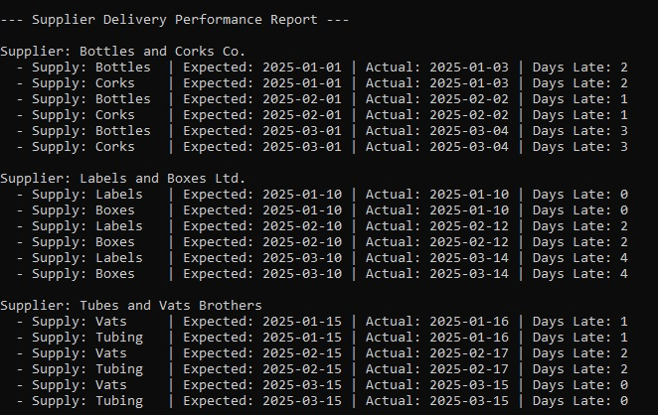

***Report 2: Wine Sales & Distribution Report***

This report describes each individual wine, which distributors are stocking the wine and the total quantity of wine sold per distributor. This helps track the distribution and overall sales of each type of wine, showing which wines are the best performing overall.

***Here’s the report the Python script generates.***

***Report 3: Employee Hours Report***

This report shows each employee, their department, and total hours worked in the last 4 quarters for performance tracking. This allows the company to view at a glance the number of hours each employee is putting in per quarter to evaluate where staffing changes need to be made.

***Here’s the report the Python script generates.***

