CSD310-H307 Database Development and Use

Daniel Graham

Assignment 2.3 – ERD Design Task

6/07/25

Deliverable 1: ERD Design

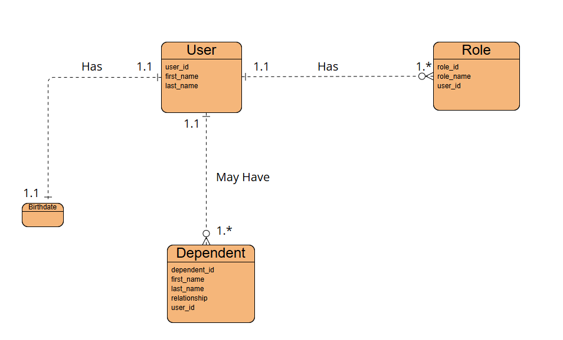

Deliverable 2: NoSQL data structure

{

"user_id": "001",

"first_name": "Bob",

"last_name": "Bilby",

"birthdate": "1999-09-09",

"role": [

{ "role_id": "admin", "role_name": "Administrator", "user_id": "001"},

{ "role_id": "editor", "role_name": "Content Editor", "user_id": "001"}

],

"dependent": [

{ "dependent_id": "1", "first_name": "Andrew", "last_name": "Bilby",

"relationship": "Son", "user_id": "001"},

{ "dependent_id": "2", "first_name": "Ann", "last_name": "Bilby, "relationship": "Spouse", "user_id": "001"}

]

}