CSD310-H307 Database Development and Use

Daniel Graham

Assignment 4.2 – Github Setup

6/21/25

**Github URL**

https://github.com/grahamcoding/csd-310

MySQL Connection (After figuring out ; was needed!)

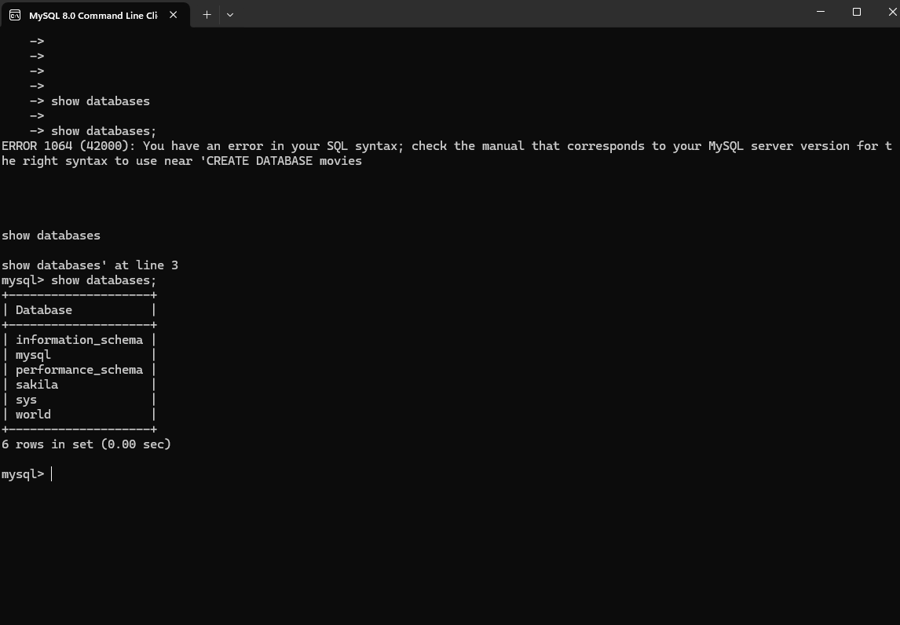

MySQL with movies database created

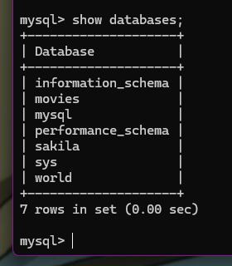

MySQL w/PyCharm Integration (Glad I already picked this IDE for Python Dev class!)

