Daniel Graham

6/8/25

CSD325-H307 Advanced Python 2.2 Assignment

Debugging the tuple assignment from Intro to Python.

Step 1: Create a breakpoint and let program hit that point

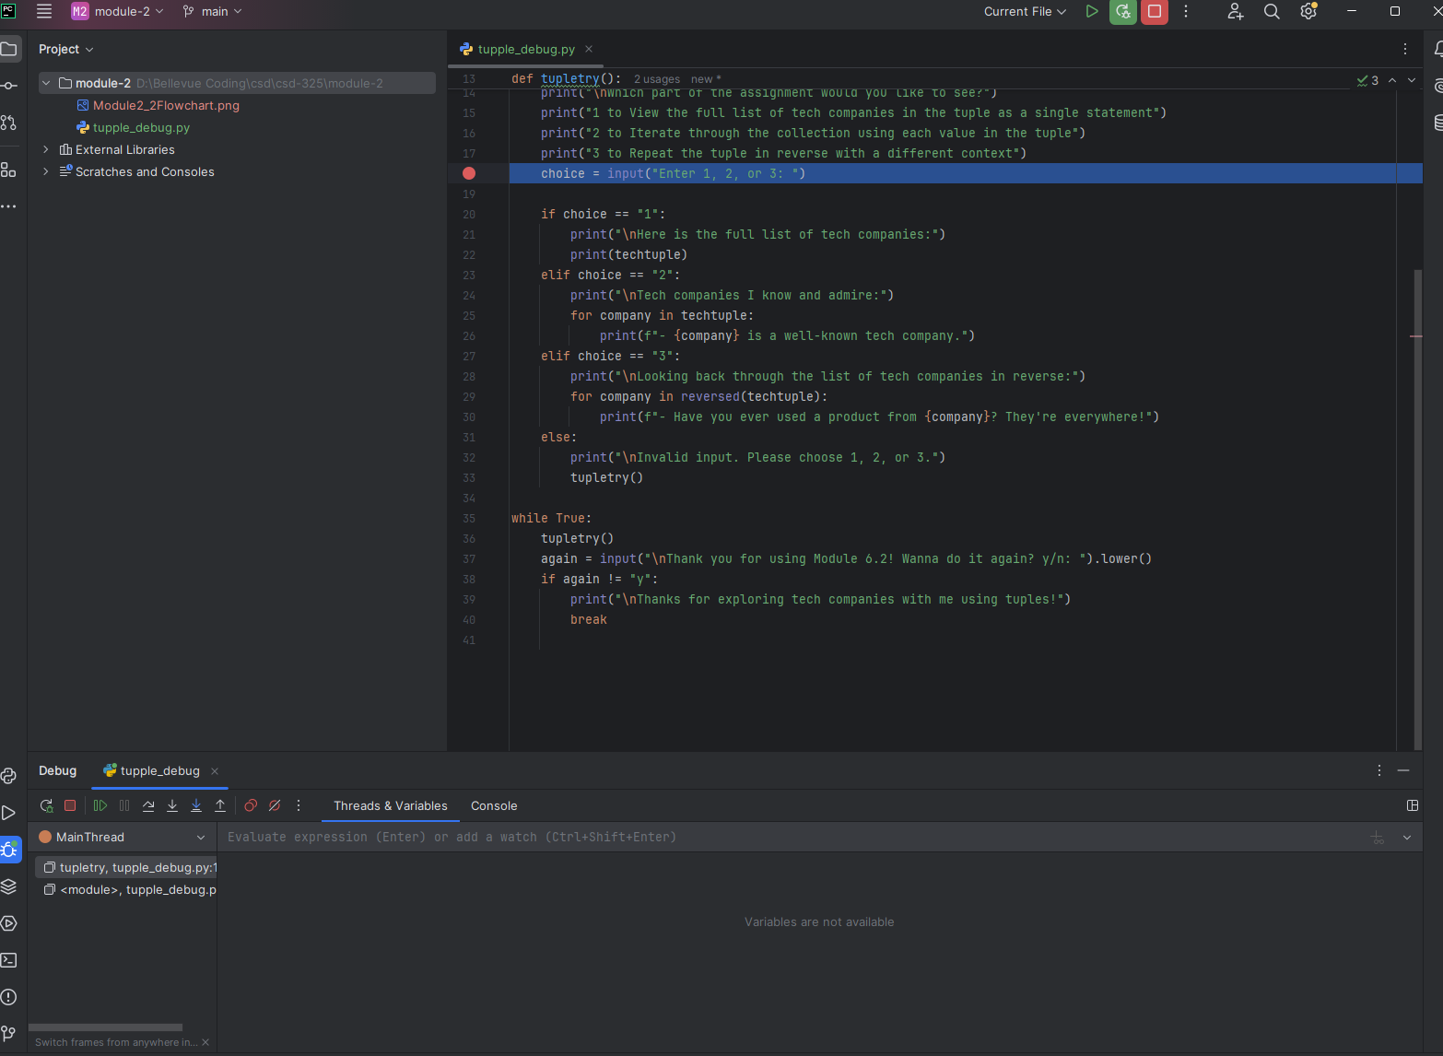

Step 2: Step into the next step of debugging with F8, shows the tuple being called to run the user’s choice of option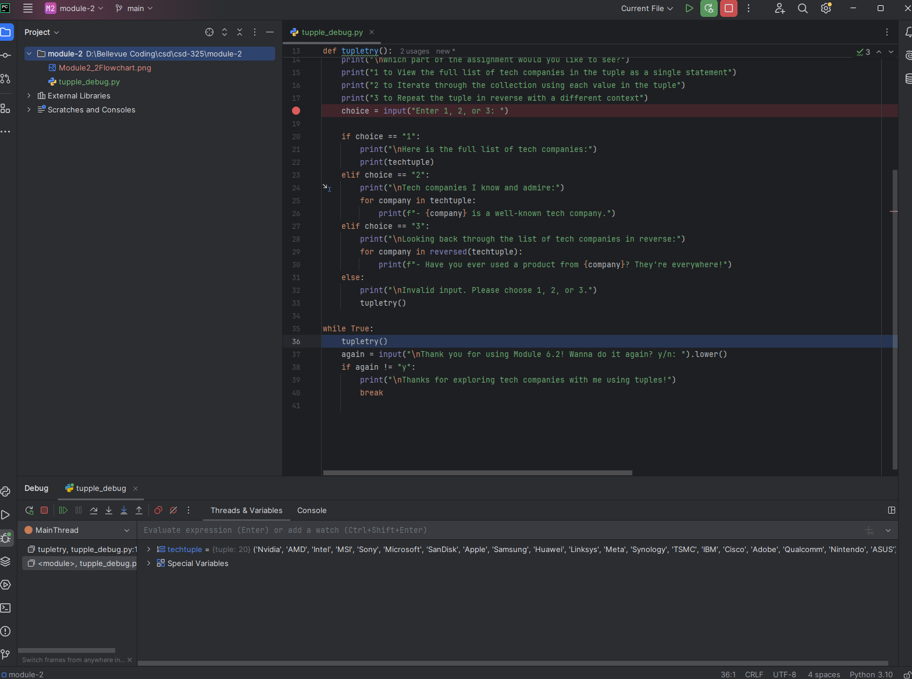

Step 3: Misnamed tuple in the elif statement on line 25 to introduce a bug. Run debugger and use F8 to step through until you hit the NameError referenced in the debugger – now you know what to fix!

