Daniel Graham

6/8/25

CSD325-H307 Advanced Python 2.2 Assignment

Debugging the tuple assignment from Intro to Python.

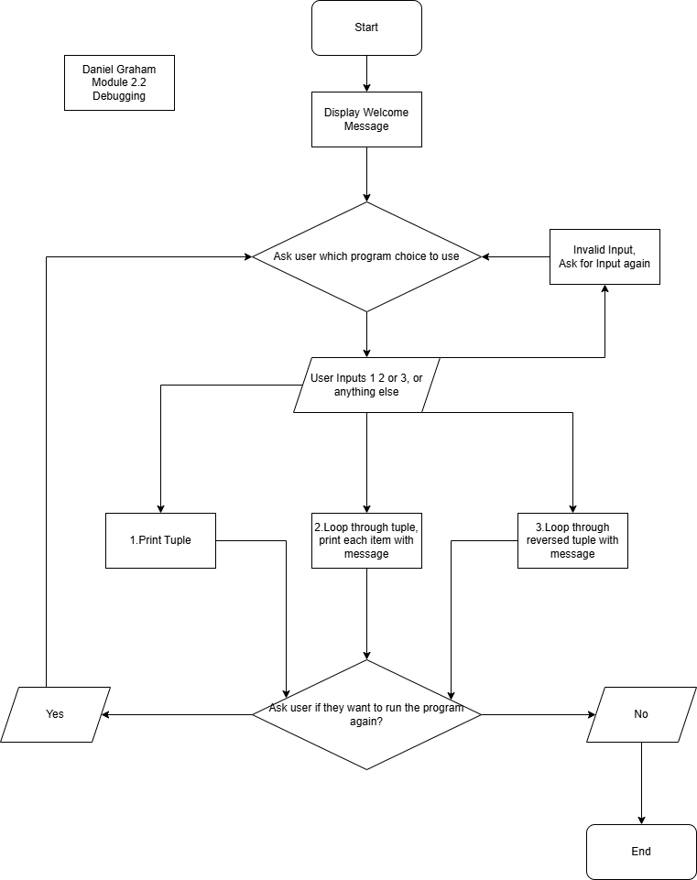Flowchart image: