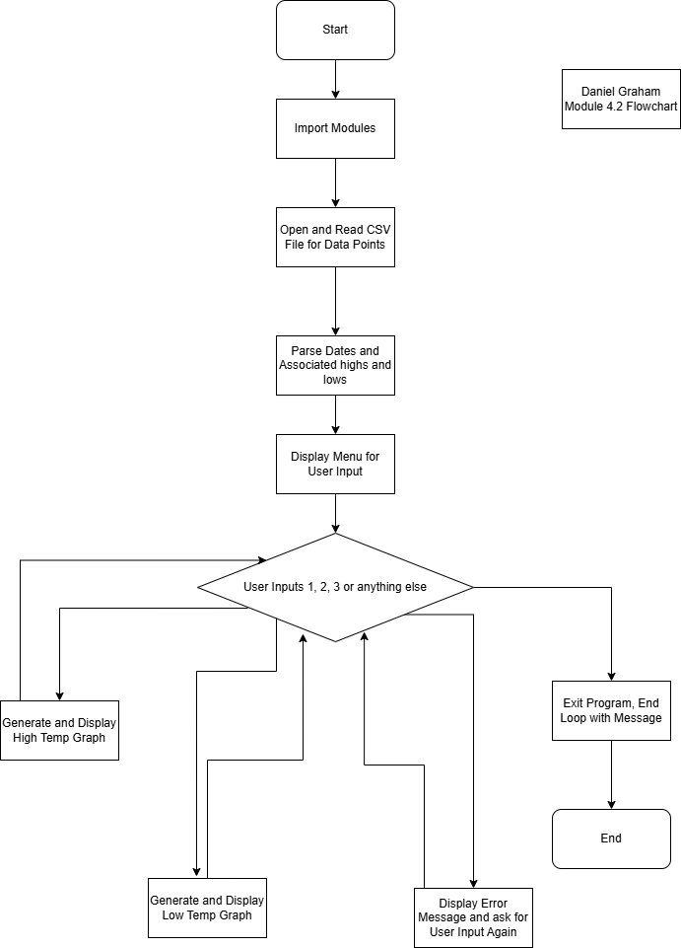Daniel Graham

6/14/25

CSD325-H307 Advanced Python

4.2 Assignment

Sitka Temp Flowchat