**Daniel Graham** 6/14/25 **CSD325-H307 Advanced Python**

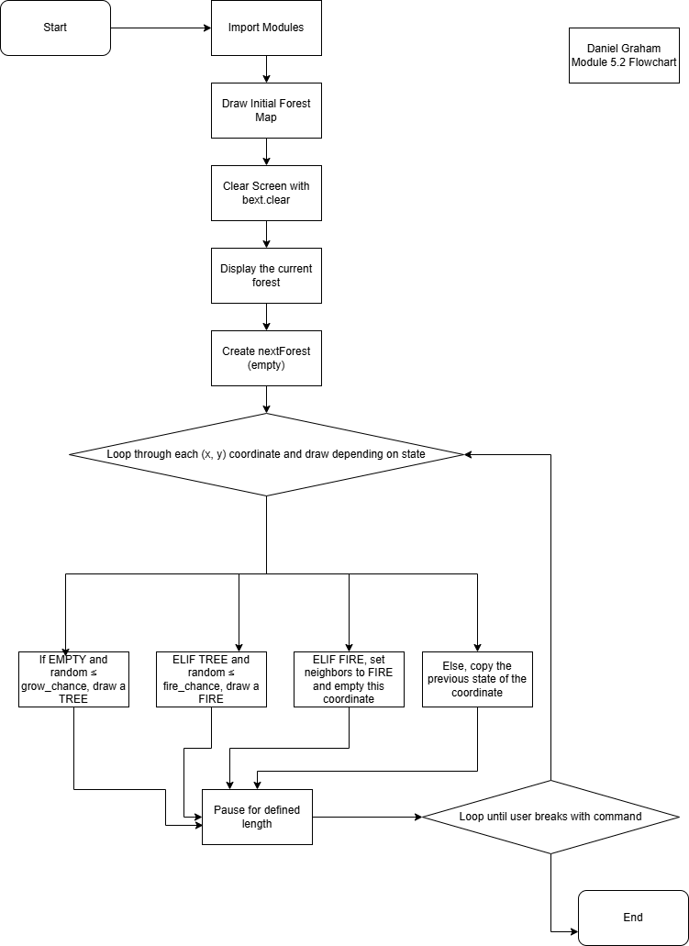5.2 Assignment Forest Fire Simulation Flowchart