**Daniel Graham** 6/28/25 **CSD325-H307 Advanced Python**

8.2 Assignment: JSON Practice

After running program…

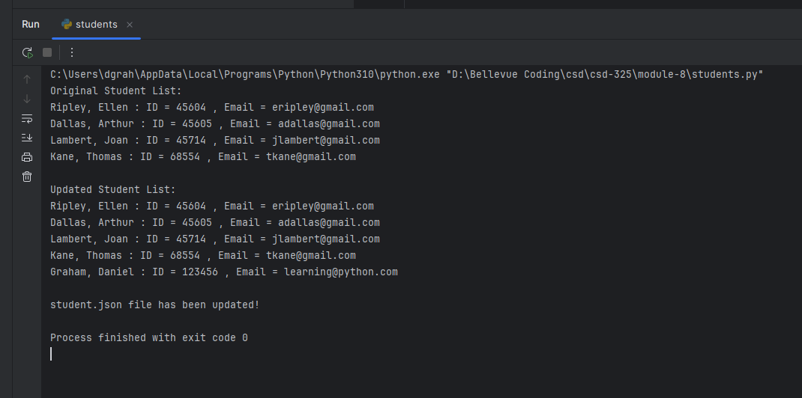

Windows did not prompt to reload the JSON file.

New JSON after running program:

