Project: Assignment 4.2
Course: CSD380-H307 DevOps
Description: Test Plan + Functional Test Assignment
Date: 2/3/26
To complete the test case plan, fill out the information for Project, Course, Description and Date in the header below.
.
TABLE OF CONTENTS
<DESCRIPTION> 2
<DESCRIPTION> 2
<DESCRIPTION> 3

For each test, the developer should: provide a test description, a test objective, the developer name and date tested. For each step, fill out the actions to be taken and describe the expected results, and indicate yes or no for each step depending upon the result. The peer tester should provide their name, date tested, indicate yes or no for each step depending upon the result, and a screenshot (thumbnail) of the result.

Test 1 | Verify Users See the Updated List of Tasks on the Main Page
 | Test Objective: Guarantees users can update this list and it displays to other users. | Developer: Tevyah Hanley  Date tested: 2/3/26 | Peer tester: Daniel Grahjam  Date tested: 2026/02/07
Step | Action | Expected results: | Developer pass/fail | Tester pass/fail  + Screenshot
1 | Go to Landing Page: https://buwebdev.github.io/todo/ | Page Loads Up Displaying the To-Do List | Yes | Yes  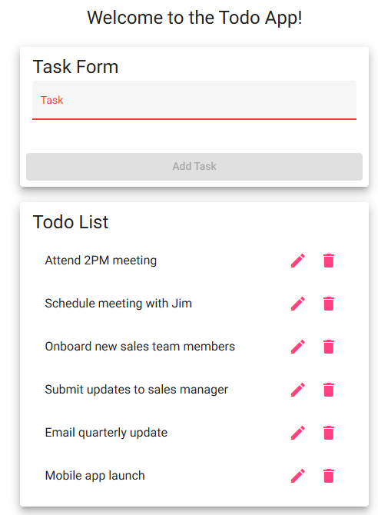
2 | Add Task to the To-Do List by entering data into the task form, then pressing “add task”. | Newly created task appears below in the to-do list. | Yes | Yes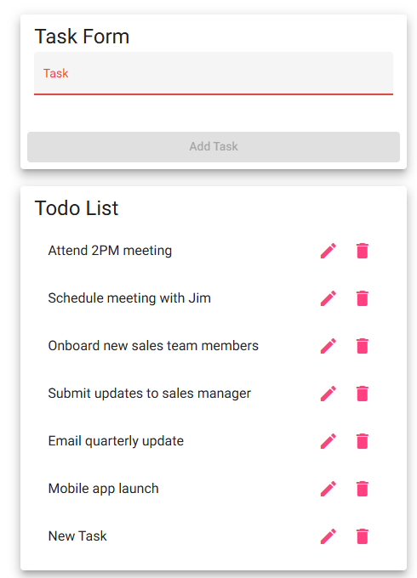
3 | Refresh the page or visit the site url again in the same browser. | Newly created task should stay on the To-Do list, even after refresh. | No | Yes, Visible in above screenshot
4 | Visit a New Browser, Incognito Window, or other device, and go to the landing page again. | Newly created task should still be visible to the user. | No | Yes, Visible in above screenshot
5 | Delete the task in that new browser, go back to the old browser and refresh the page | Task should “disappear” from the user’s view, since it was updated by the other user. | No | Yes
Comments | Works as expected, no changes necessary.

Test 2 | Verify Users can Create Tasks
 | Test Objective: Makes sure that users can add tasks and update the list | Developer: Tevyah Hanley  Date tested: 2/3/26 | Peer tester: Daniel Grahjam  Date tested: 2026/02/07
Step | Action | Expected results: | Developer pass/fail | Tester pass/fail
1 | Go to Landing Page: https://buwebdev.github.io/todo/ | Page Loads Up Displaying the To-Do List | Yes | Yes
2 | Type into the “task” text box. | Text is able to be added to the box, and enables the “add task” button | Yes | Yes
3 | After data is entered into the text box, press the “add task” button | Button is able to be clicked and adds new task to the task list. | Yes | Yes
4 | Verify that the data was the same from what you entered into the task text box | Data matches from users’ input | Yes | Yes, as in above screenshot
5 | Refresh the page or visit the site url again in the same browser. | Newly created task should stay on the To-Do list, even after refresh. | No | Yes, as in above screenshot
Comments | Works as expected, no changes necessary.

Test 3 | Verify Users Can Edit the Current Tasks
 | Test Objective: Shows users can edit tasks and change the current data | Developer: Tevyah Hanley  Date tested: 2/3/26 | Peer tester: Daniel Grahjam  Date tested: 2026/02/07
Step | Action | Expected results: Page Loads Up Displaying the To-Do List | Developer pass/fail | Tester pass/fail
1 | Go to Landing Page: https://buwebdev.github.io/todo/ | Page Loads Up Displaying the To-Do List | Yes | Yes
2 | Verify that tasks are currently displayed on the website after boot up | There are tasks already listed right when the site loads up. | Yes | Yes as in above screenshot
3 | Click the pencil icon next to any of the tasks | The “edit form” pops up, prompting the user to change the data | Yes | Yes
4 | Type new data into the task check box | Data is able to be changed in the text box | Yes | Yes as in above screenshot
5 | After new data has been entered, press the “save” button | The task is now updated to the current data added | Yes
Comments | Works as expected, no changes necessary.

Test 4 | Verify Users Can Delete Tasks
 | Test Objective: Verify Users can delete items from the queue | Developer: Tevyah Hanley  Date tested: 2/3/26 | Peer tester: Daniel Grahjam  Date tested: 2026/02/07
Step | Action | Expected results: | Developer pass/fail | Tester pass/fail
1 | Go to Landing Page: https://buwebdev.github.io/todo/ | Page Loads Up Displaying the To-Do List | Yes | Yes, 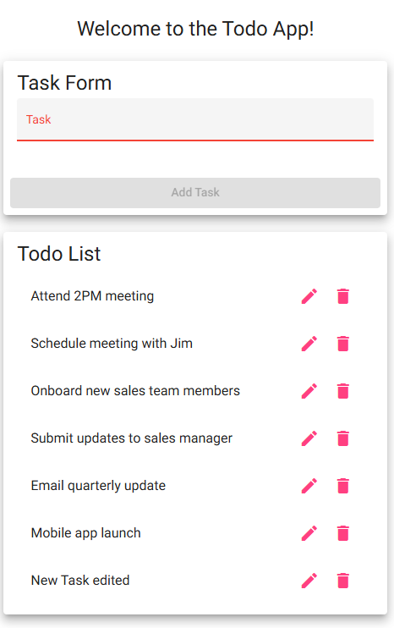
2 | Verify that tasks are currently displayed on the website after booting up | There are tasks already listed right when the site loads up. | Yes | Yes, as above
3 | Click the trash icon next to any of the tasks | Task disappears from the task queue | Yes | Yes
4 | Refresh the webpage | Task should still be deleted from the queue | No | Yes, as above screenshot
5 | Enter a new browser and load up the site again | Item should still be deleted for other users visiting the site | No | Yes, as above screenshot
Comments | Works as expected, no changes necessary.

Test 5 | Verify Users Can’t submit null data into the Form
 | Test Objective: Verify users can’t submit no data into the form, breaking the page. | Developer: Tevyah Hanley  Date tested: 2/3/26 | Peer tester: Daniel Grahjam  Date tested: 2026/02/07
Step | Action | Expected results: | Developer pass/fail | Tester pass/fail
1 | Go to Landing Page: https://buwebdev.github.io/todo/ | Page Loads Up Displaying the To-Do List | Yes | yes
2 | Verify that tasks are currently displayed on the website after booting up | There are tasks already listed right when the site loads up. | Yes | Yes, visible in above screenshot.
3 | Click on the “task” textbox, and then click off of it with no data | Task textbox should turn red, due to having no data | Yes | Yes, visible in above screenshot.
4 | Try to click on the “add task” button with no data in the textbox | Button is greyed out, and non clickable | Yes | Yes, visible in above screenshot.
5 | Fill in data into the textbox | Button is now active, and blue | Yes | Yes, visible in above screenshot. No change once pressed.
Comments | Works as expected, no changes necessary.

