Project: | Stephanie Ramos – M4.2 Assignment Test Plan
Course: | CSD 380 DevOps
Description: | Creating a test plan based on business requirements
Date: | 2026/02/03
To complete the test case plan, fill out the information for Project, Course, Description and Date in the header below.
.
TABLE OF CONTENTS
Create a New Todo Task Item 2
Edit a Todo Task Item 2
Delete a todo task item 3
Prevents a user from submitting a task without entering a todo item 4
Prevent users from submitting the edit form without entering a todo item 4

For each test, the developer should: provide a test description, a test objective, the developer name and date tested. For each step, fill out the actions to be taken and describe the expected results, and indicate yes or no for each step depending upon the result. The peer tester should provide their name, date tested, indicate yes or no for each step depending upon the result, and a screenshot (thumbnail) of the result.

Test 1 | Create a New Todo Task Item
 | Test Objective: Verifies that a user can create a new task and is displayed in todo list | Developer: Stephanie Ramos  Date tested: 2026/02/03 | Peer tester: Daniel Grahjam  Date tested: 2026/02/07
Step | Action | Expected results: | Developer pass/fail | Tester pass/fail  + Screenshot
1 | Visit https://buwebdev.github.io/todo/ | The webpage loads successfully | Yes | Yes 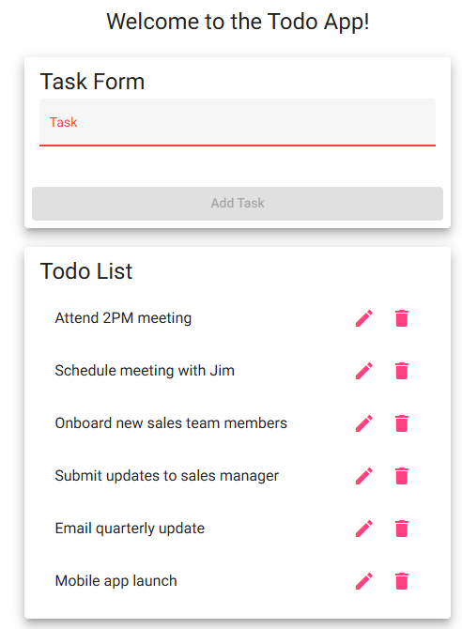
2 | Locate Task Form | The task input form is visible on the page | Yes | Yes, Visible in above screenshot
3 | Click on task input field | Input field is clickable and allows typing | Yes | Yes
4 | Type a task in the input field | The user is able to type a task into the input field | Yes | Yes, visible in above screenshot.
5 | Click “Add Task” | The new task is added and displayed in the list | Yes | Yes,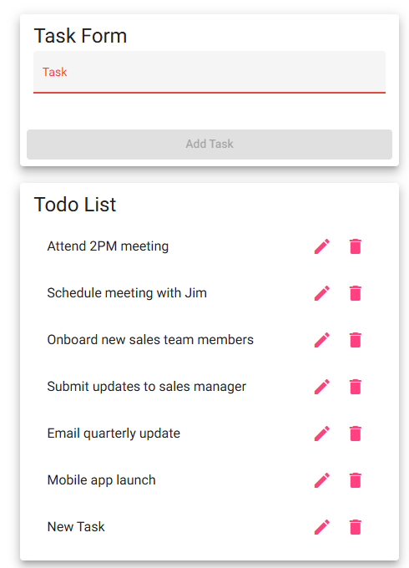
Comments | Works as expected, no changes necessary.

Test 2 | Edit a Todo Task Item
 | Test Objective: Verifies that a user can change/edit a task without creating a new task | Developer: Stephanie Ramos  Date tested: 2026/02/03 | Peer tester: Daniel Grahjam  Date tested: 2026/02/07
Step | Action | Expected results: | Developer pass/fail | Tester pass/fail
1 | Visit https://buwebdev.github.io/todo/ | The webpage loads successfully | Yes | Yes
2 | Locate existing task in the todo list | The task is visible in the todo list | Yes | Yes, visible in above screenshot.
3 | Click on edit icon for the selected task | A pop-up window appears, displaying the existing task text in the input field | Yes | Yes 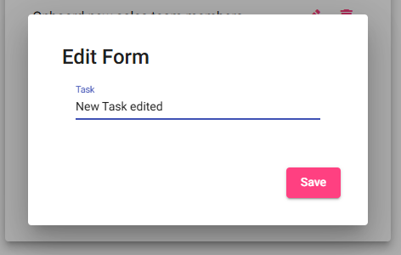
4 | Modify the task text in the input field | The user is able to edit the task text | Yes | Yes, visible in above screenshot.
5 | Click the save button | The updated task replaces the original task and is displayed in the todo list | Yes | Yes  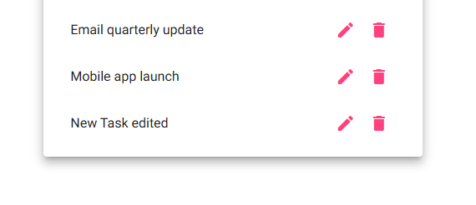
Comments | Works as expected, no changes necessary.

Test 3 | Delete a todo task item
 | Test Objective: Verifies that a user can remove a task from the todo list | Developer: Stephanie Ramos  Date tested: 2026/02/03 | Peer tester: Daniel Grahjam  Date tested: 2026/02/07
Step | Action | Expected results: | Developer pass/fail | Tester pass/fail
1 | Visit webpage | The webpage loads successfully | Yes | Yes 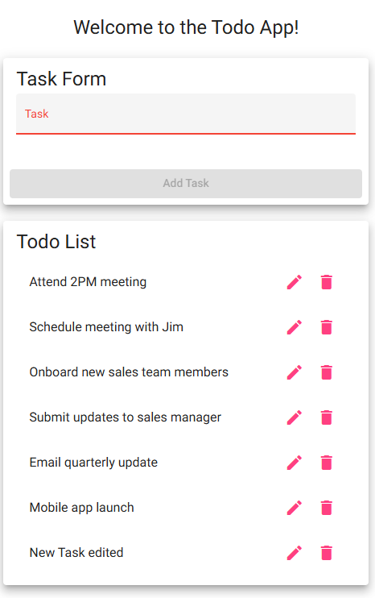
2 | Locate the existing task in the todo list | The task is visible in the todo list | Yes | Yes, visible in above screenshot.
3 | Click on the delete icon for the selected task | The selected task is removed from the todo list | Yes | Yes, removed.
4 | Refresh the browser window | The page reloads successfully | Yes | Yes, visible in above screenshot
5 | Confirm the page reloaded without the deleted task | The deleted task does not appear in the todo list | Yes | Yes, visible in above screenshot
Comments | Works as expected, no changes necessary.

Test 4 | Prevents a user from submitting a task without entering a todo item
 | Test Objective: Verifies that the user cannot submit a todo task when the input field is empty | Developer: Stephanie Ramos  Date tested: 2026/02/03 | Peer tester: Daniel Grahjam  Date tested: 2026/02/07
Step | Action | Expected results: | Developer pass/fail | Tester pass/fail
1 | Visit https://buwebdev.github.io/todo/ | The webpage loads successfully | Yes | Yes
2 | Locate the task input field | The task input form and Add Task button are visible | Yes | Yes, visible in above screenshot.
3 | Leave the task input field empty | Input field has no text | Yes | Yes, visible in above screenshot.
4 | Observe that the Add Task button is grey | The Add Task button is displayed and cannot be clicked | Yes | Yes, visible in above screenshot.
5 | Attempt to click on the Add Task button | The task is not added to the todo list | Yes | Yes, visible in above screenshot. No change once pressed.
Comments | Works as expected, no changes necessary.

Test 5 | Prevent users from submitting the edit form without entering a todo item
 | Test Objective: Verifies that the user cannot save an edited todo task when the input field is empty | Developer: Stephanie Ramos  Date tested: 2026/02/03 | Peer tester: Daniel Grahjam  Date tested: 2026/02/07
Step | Action | Expected results: | Developer pass/fail | Tester pass/fail  + Screenshot
1 | Visit https://buwebdev.github.io/todo/ | The webpage loads successfully | Yes | Yes
2 | Locate an existing task in the todo list | The task is seen in the todo list | Yes | Yes, visible in above screenshot.
3 | Click the edit icon for the selected task | The edit pop-up opens with the existing text in the input field | Yes | Yes, visible in above screenshot.
4 | Delete all text from the input field | The input field becomes blank | Yes | Yes, visible in above screenshot.
5 | Click the Save button | The application prevents saving an empty task. | No | No, allows for a blank entry now.  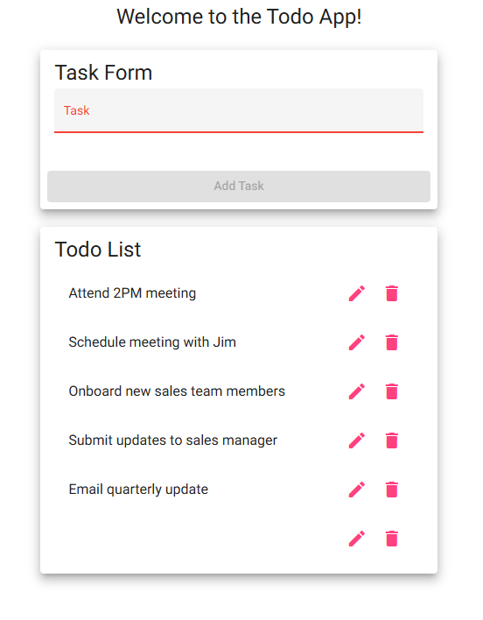
Comments | Does not work properly. Need to implement a blank check on the edit screen to ensure user can’t leave a blank todo.

