1. Write your web app
2. Deploy it to voila locally …

pip install voila

jupyter serverextension enable voila –sys-prefix

Restart your computer

Start Jupyter Notebook

Replace /tree with /voila

Navigate to your web app .ipynb and click on it

You now have a fully locally deployed web app, something like this –

<http://localhost:8888/voila/render/OneDrive%20-%20Lincoln%20College/Python%20Projects/Confidence-Intervals/Confidence%20Interval%20App.ipynb>

1. Create a new GitHub repository

You must create the repository at root level i.e. the .ipynb will be in the root. If it is in a sub-folder mybinder cannot resolve the address

May sure to create a environment.yaml config file that contains the dependencies you will require in the mybinder deployment, for example –

name: voila-gallery-country-indicators

channels:

- conda-forge

dependencies:

- ipywidgets

- scipy

- numpy

- jupyterlab>=3.1

- voila>=0.2.11

This is critical, especially the voila entry as it tells mybinder to bind voila into the build. You also need all libraries you have imported into your Jupyter notebook

1. Deploy your project from Github to mybinder

Navigate to mybinder.org and fill in the fields as follows –

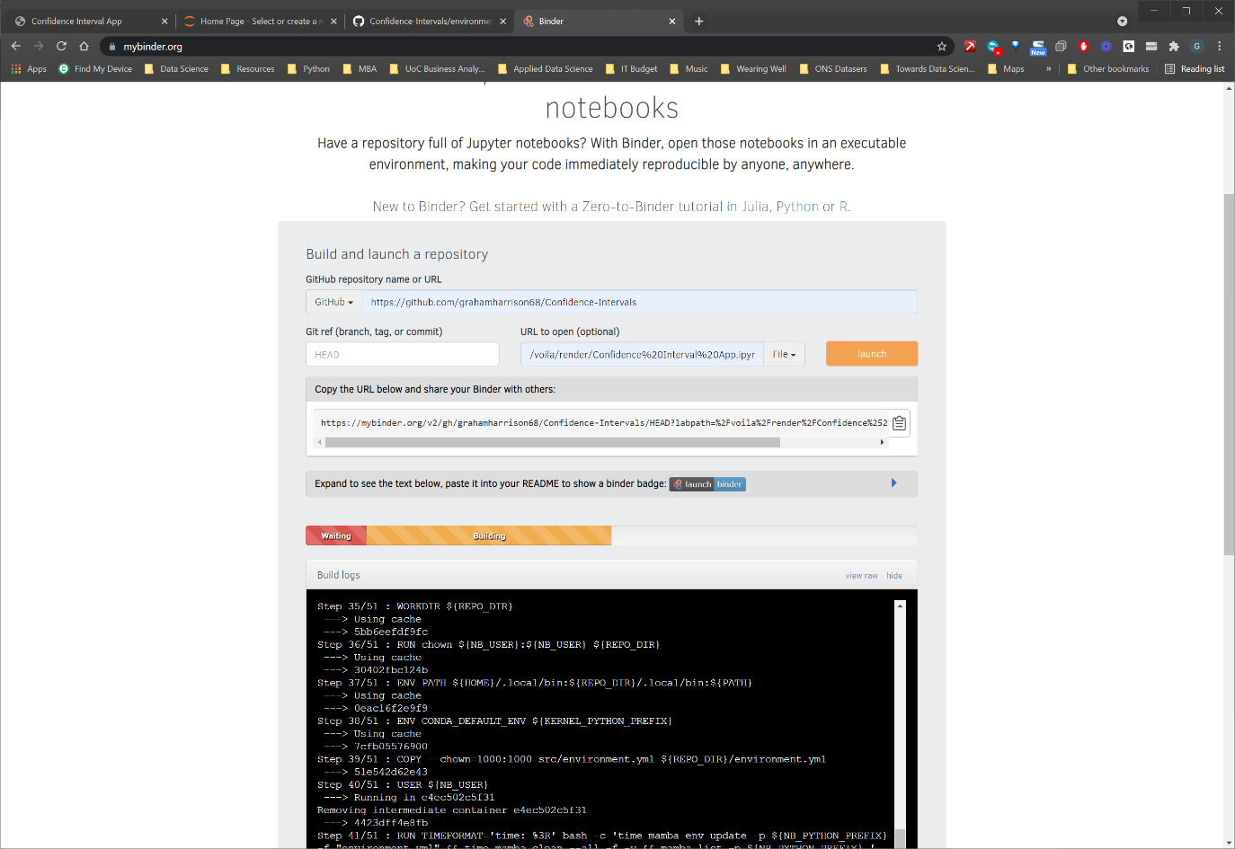

1. Resolve the path to the deployed web app

Copy the URL Provided by mybinder, for example …

<https://mybinder.org/v2/gh/grahamharrison68/Confidence-Intervals/HEAD?labpath=%2Fvoila%2Frender%2FConfidence%2520Interval%2520App.ipynb>

This will launch, but it will give you an error …

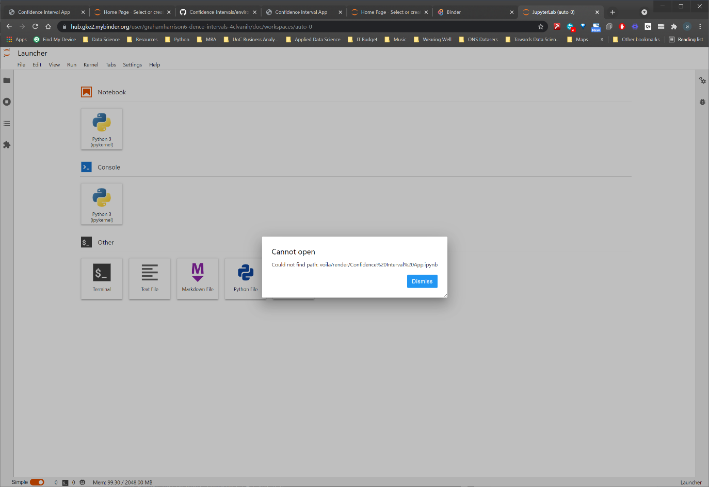

Edit the resolved URL in the URL bar …

<https://hub.gke2.mybinder.org/user/grahamharrison6-dence-intervals-4clvanih/doc/workspaces/auto-0>

… and manually replace /doc/workspaces/auto-0 with /tree to see the Jupyter Notebook or /voila to see the voila directory -

Now click on the notebook to get to the actual voila render URL …

<https://hub.gke2.mybinder.org/user/grahamharrison6-dence-intervals-4clvanih/voila/render/Confidence%20Interval%20App.ipynb>

You now have a URL you can distribute for the deployed web app!