# Review of Fast Profit System

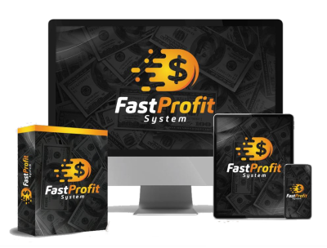

⭐️⭐️⭐️⭐️⭐️

I recently came across The Fast Profit System, and I have to say, it has completely transformed my perspective on making money online! As someone who has dabbled in various online ventures without much success, I was initially skeptical about yet another "done-for-you" system. However, this one truly delivers on its promises.

## **What I Love:**

**1. **User-Friendly Setup**:** The system is incredibly easy to navigate. Within minutes of signing up, I was able to activate my account and plug in my affiliate link. No technical skills are required, which is a huge relief for someone like me who often feels overwhelmed by complicated setups.

**2. **Automated Income**:** The promise of earning $1,000+ per day seemed too good to be true, but I’ve started to see results! The automated traffic system is a game-changer. I love that I can sit back and watch the commissions roll in without having to constantly market or sell.

**3. **Incredible Bonuses**:** The value of the bonuses included is astounding. From a million-dollar funnel to a comprehensive email swipe file, these resources have given me a solid foundation to build my online business. The live orientation masterclass was particularly helpful in getting me started on the right foot.

**4. **Supportive Community**:** Joining the Fast Profit System also means becoming part of a vibrant community. The support from fellow members and the guidance from Glynn Kosky himself have been invaluable. It’s reassuring to know that I’m not alone on this journey.

**5. **Risk-Free Guarantee**:** The 180-day money-back guarantee is a fantastic safety net. It shows that Glynn is confident in his system, and it gives me peace of mind as I navigate this new venture.

## **What Could Be Improved:**

While my experience has been overwhelmingly positive, I would love to see more advanced training options for those who want to dive deeper into affiliate marketing strategies. However, for beginners, the current resources are more than sufficient.

## **Final Thoughts:**

If you’re tired of the endless cycle of low-ticket sales and are looking for a legitimate way to earn substantial commissions online, I highly recommend giving The Fast Profit System a try. It’s refreshing to find a system that actually works and is designed with the user in mind. I’m excited to see where this journey takes me, and I can’t wait to share my success story with others!

Don’t miss out on this opportunity—grab your free license today before it’s too late!

**CHECK THIS OUT TODAY!** [**[Fast Profit System]**](https://www.buildabizonline.com/ar/graham_mcl/?aid=8320)