Module 1 Lab Exercise 1

NB = POWERSHELL HOTKEY = ‘WINDOWS+X’ then ‘I’

• Create a new folder

• Create another folder inside the first one

• Print the contents of the first folder

• Change directory to the second folder, and print the current path

• Change directory back to the original starting place

• Delete the first folder

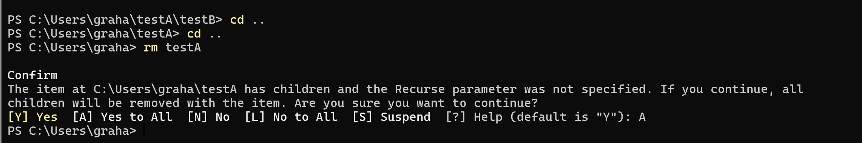

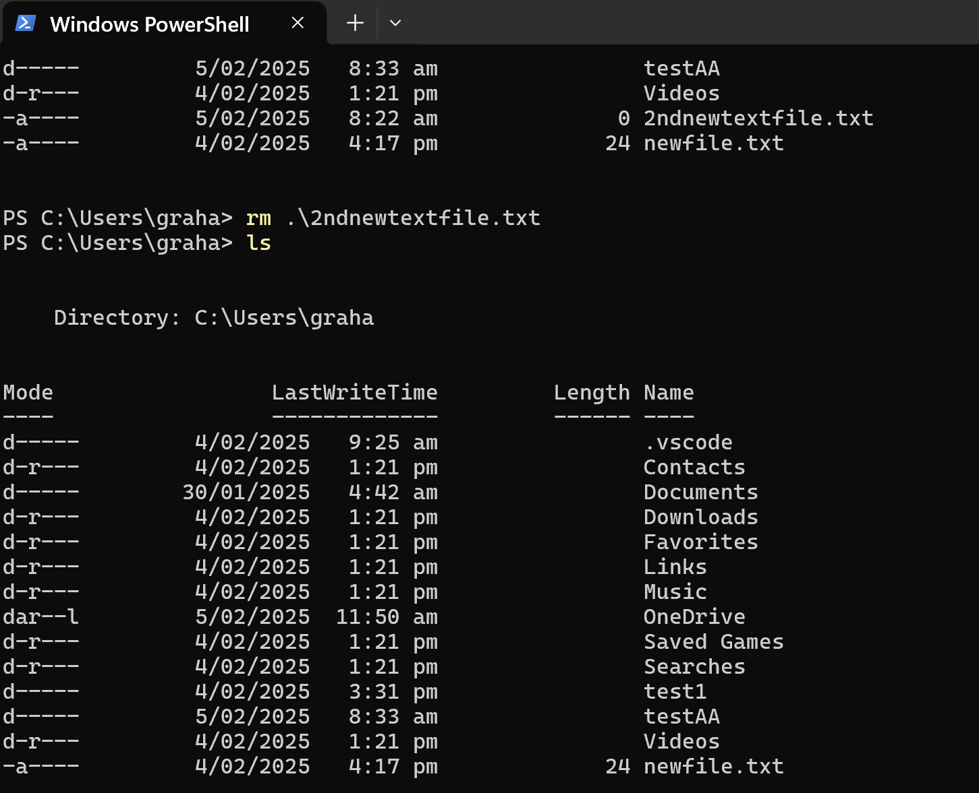

• Extension: Research the cp, mv, cat and find commands

• Create a new file

• Copy a file

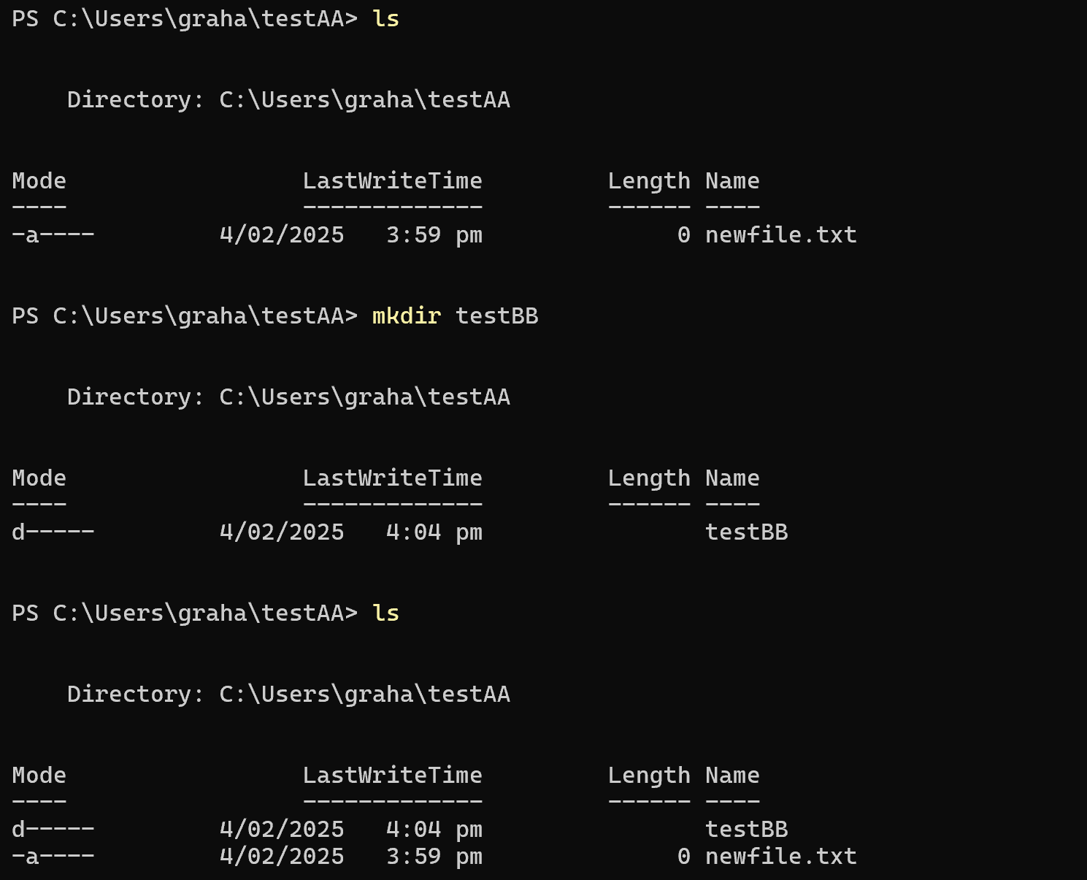

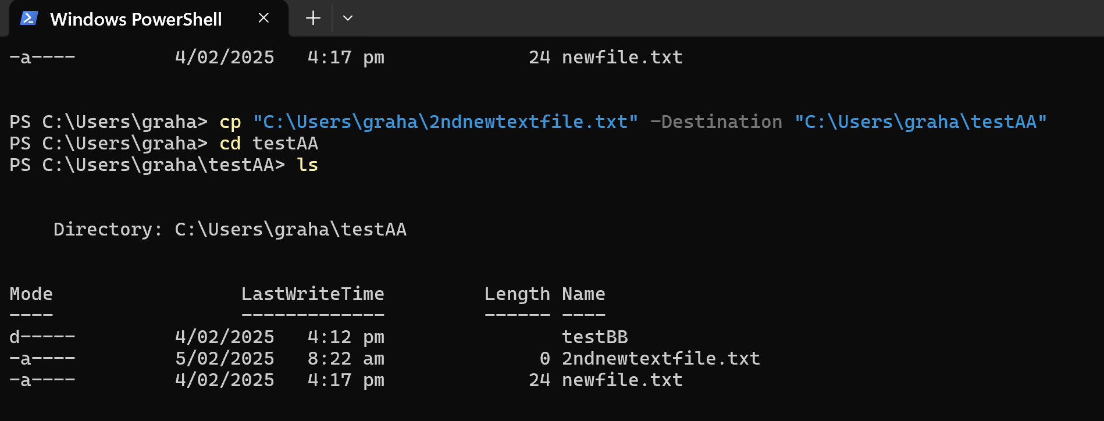

• Move a file

• Use Cat / Get-Content

• research find (Used ‘help find’ used ‘command find’)

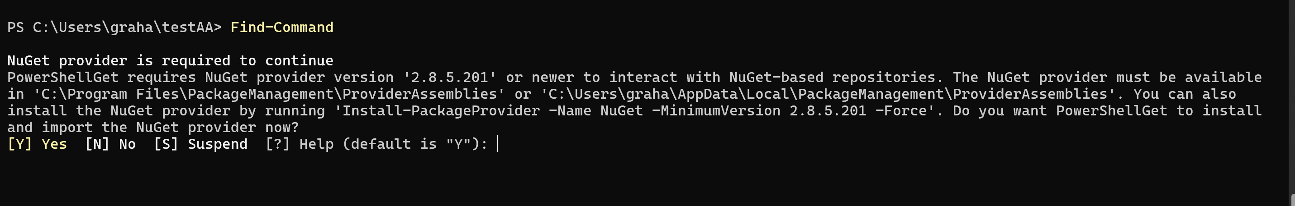

Research Get-Item (as a way to find files / folders etc. as a search command)

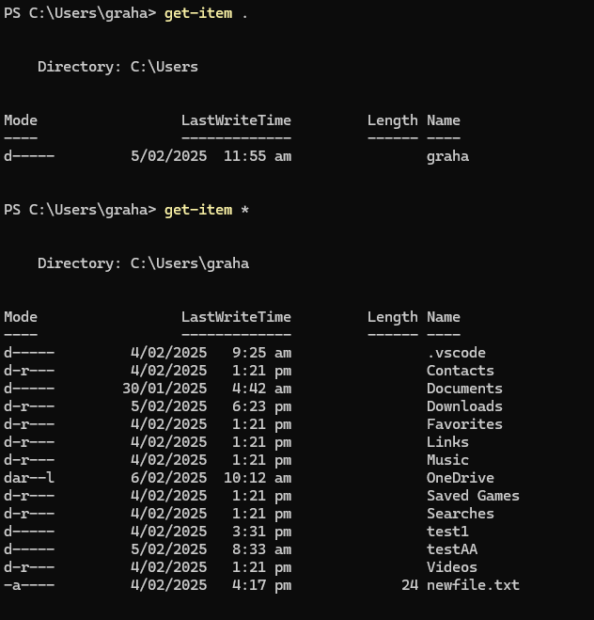

Module 1 Lab Exercise 2

1. Open (or create) your Module1 folder in VS Code.

2. Use the Terminal feature of VS Code to issue commands to create a new folder inside Module1 for LabExercises and change into it.

3. Inside the above folder, create a new file called exercise2.html

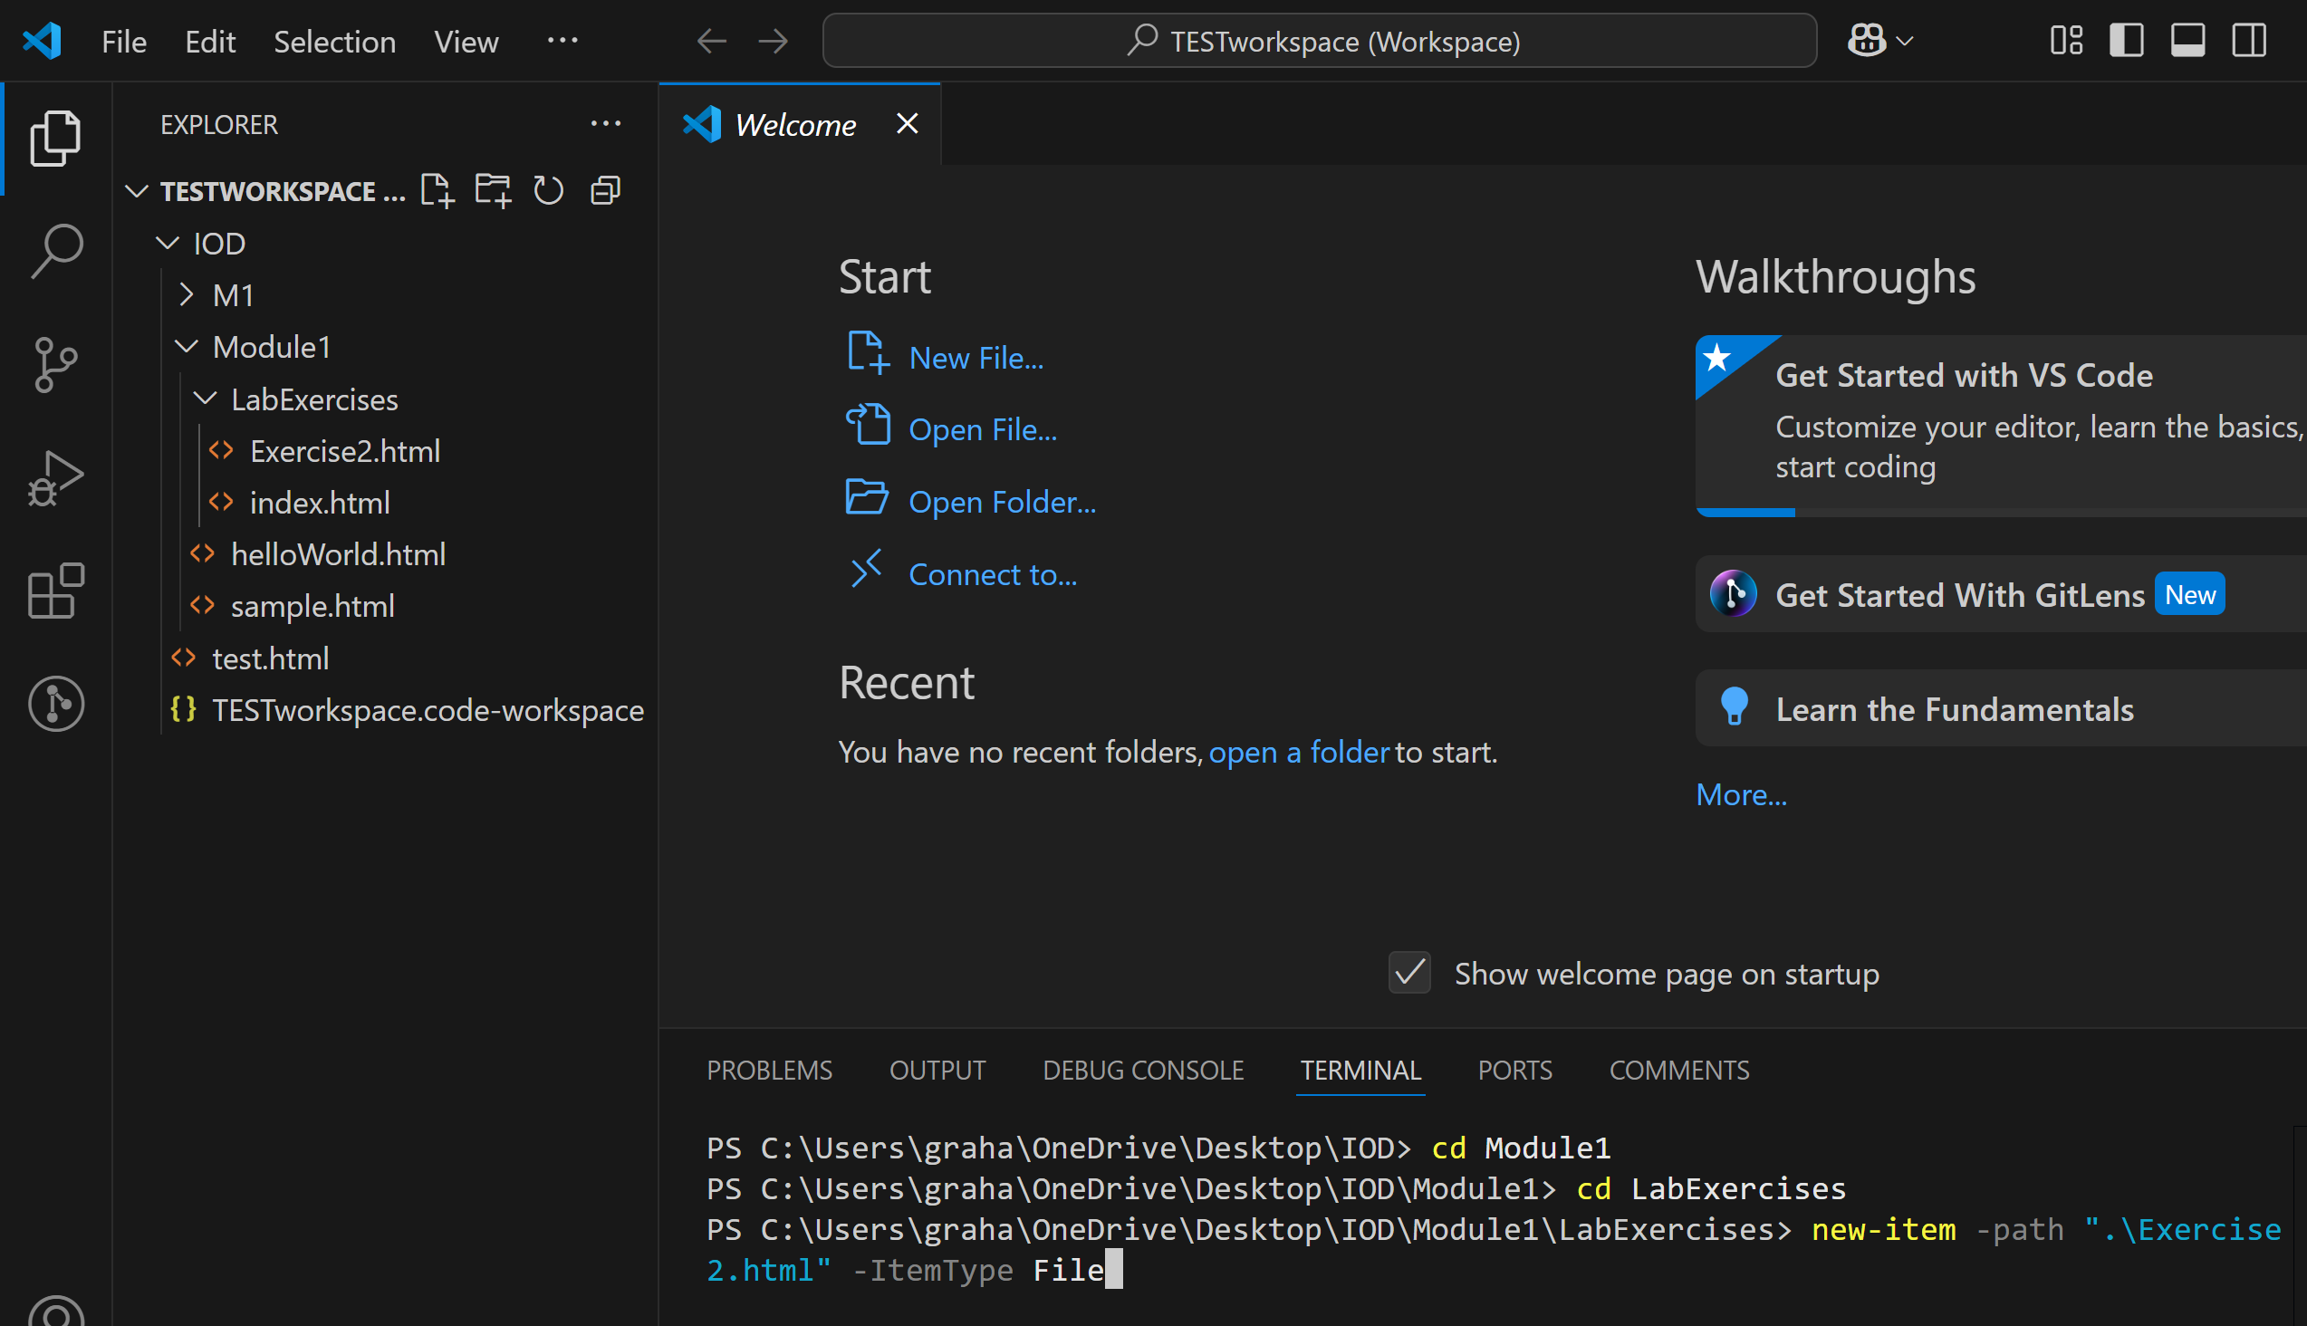

4. As the first character in this file, type an exclamation mark ! and use the Emmet abbreviation to generate a basic HTML skeleton

5. Populate the with basic HTML representing these lab steps

6. Go Live to view and test the HTML

Code copied from Exercise 2 below:

<html>

<!-- Used Emmet ! command to populate empty html file as per below

        commented out section -->

<!-- <!DOCTYPE html>

        <html lang="en">

        <head>

            <meta charset="UTF-8">

            <meta name="viewport" content="width=device-width, initial-scale=1.0">

            <title>Document</title>

        </head>

        <body>

        </body>

        </html>

    -->

<body>

    <h2>Image Example</h2>

    <!-- Used class exercise from slide  30-31 as base code for the below section-->

    <div>

        <!-- example of images from web reset to the same size using the height attribute -->

        <img src="https://www.woolworths.co.nz/images/global-nav/header/woolworths-desktop-logo.svg" alt="Woolies">

        <img src="https://www.paknsave.co.nz/next/images/logos/default.svg" alt="PacknSave">

        <br><br><br>

        <img height="50px" src="https://www.woolworths.co.nz/images/global-nav/header/woolworths-desktop-logo.svg"

            alt="Woolies">

        <img height="50px" src="https://www.paknsave.co.nz/next/images/logos/default.svg" alt="PacknSave">

    </div>

    <div>

        <!-- example of a table -->

        <br><br><br>

        <table style="border: 1px solid black;">

            <tr style="font-size: larger;">

                <th style="padding: 2em;">Name</th>

                <th>Age</th>

                <th>Role</th>

            </tr>

            <tr>

                <td>Tom</td>

                <td>22</td>

                <td>Student</td>

            </tr>

            <tr>

                <td>Alice</td>

                <td>30</td>

                <td>Teacher</td>

            </tr>

        </table>

    </div>

    <div>

        <!-- example of a form -->

        <br><br><br>

        <form action="/action_page">

            <div>

                <label for="firstName">First name:</label><br>

                <input type="text" id="firstName" name="firstName" value="Eve">

            </div>

            <div>

                <label for="lastName">Last name:</label><br>

                <input type="text" id="lastName" name="lastName" value="Doe">

            </div>

            <input type="submit" value="CONFIRM BY CLICKING">

        </form>

    </div>

</body>

</html>