**TECHNICAL REPORT**

(Android app for Stock Market Analysis)

For making this android app we have used latest version of Android Studio 2.3.3. Out of other frameworks we selected android studio due to following features.

* Intelligent code editor
* Fast and feature-rich emulator
* Optimized for all Android devices.
* C++ and NDK support and many more features.

To install Android Studio

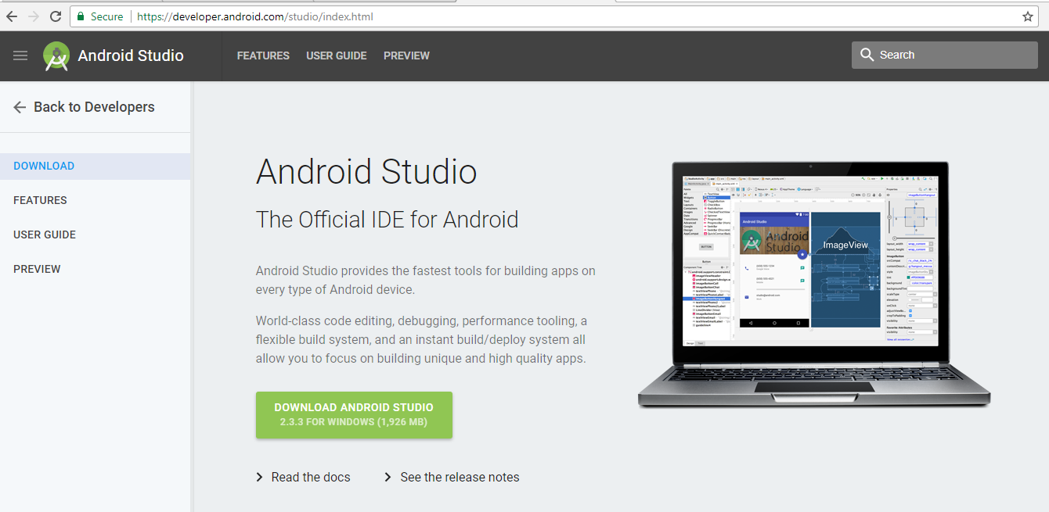

Once you complete this download it will appear like this.

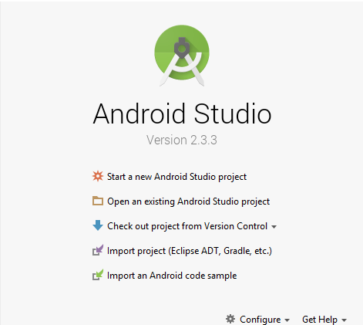

When we start a project we have to give application name.

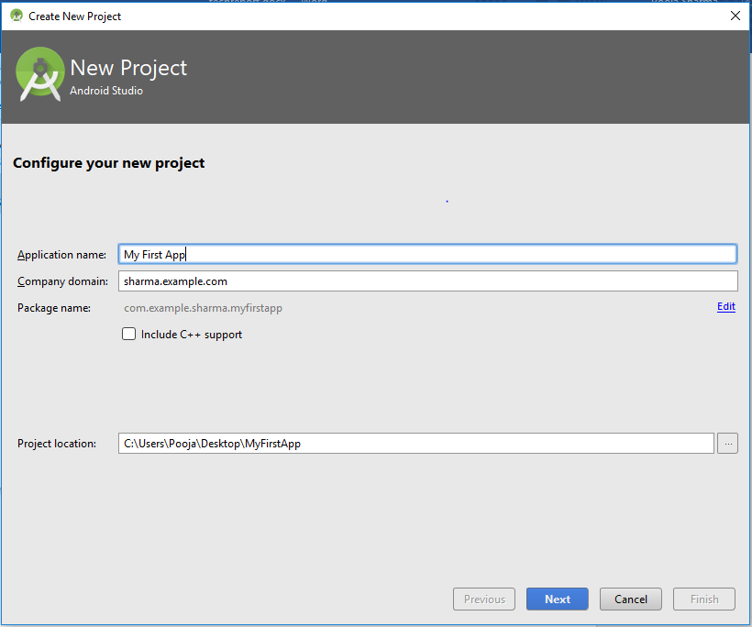

Once we started our project then we can make various Xml layouts and activities. Xml means Extensible Markup Language. Android provides a Xml vocabulary that corresponds to the View classes and subclasses. The main goal of using Xml vocabulary, is to quickly design UI layouts and the screen elements they contain.

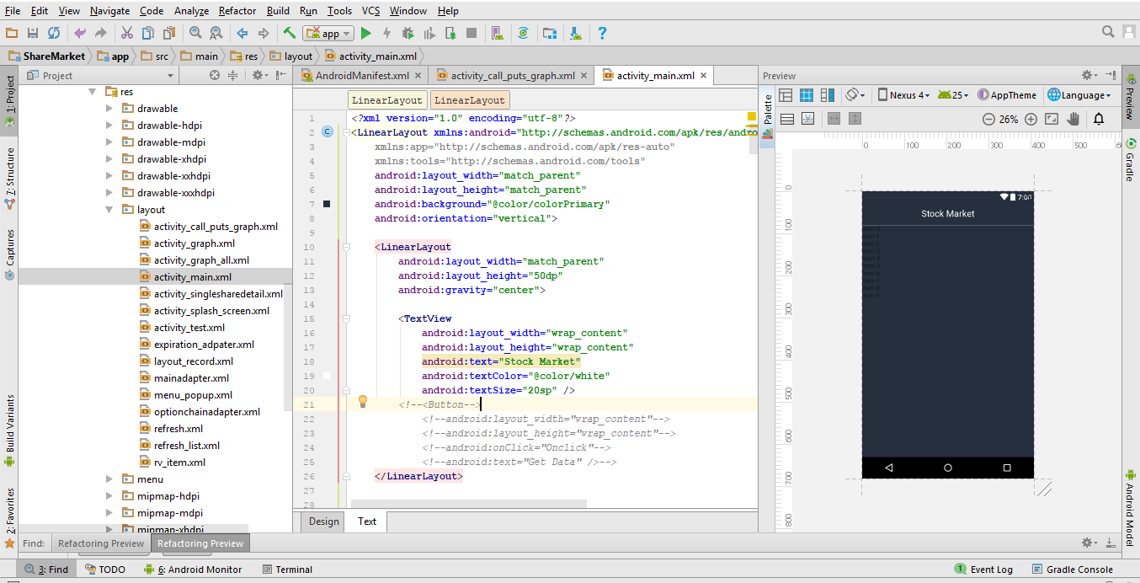

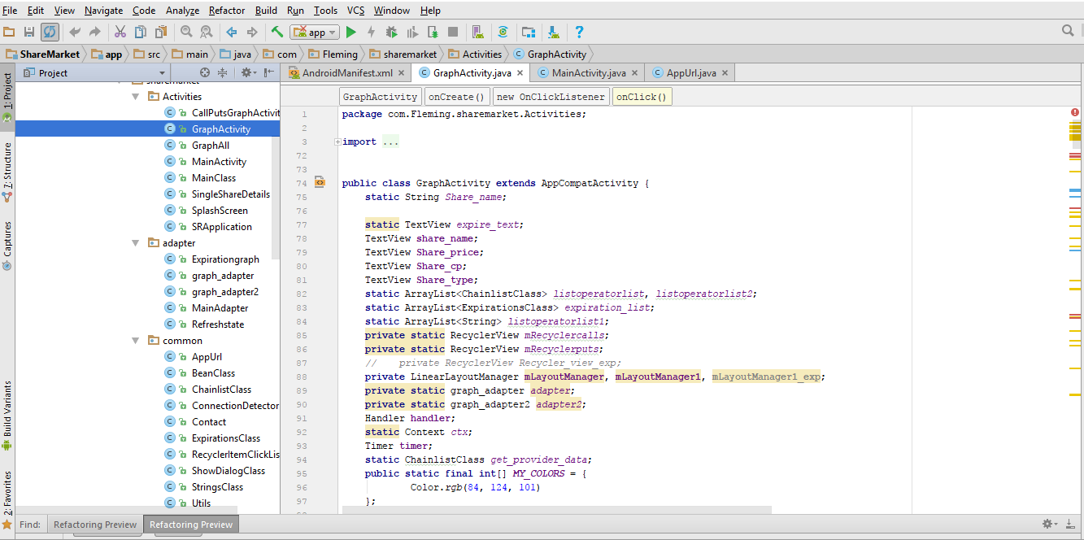

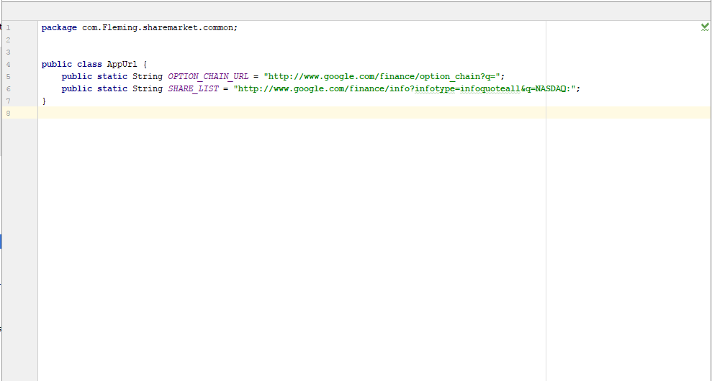

These are our app Url from where we are fetching data dynamically but the problem is we are not able to find any Url with expiration dates for every month.

We need not to connect our device everytime to run our app. We can run it on an emulator.

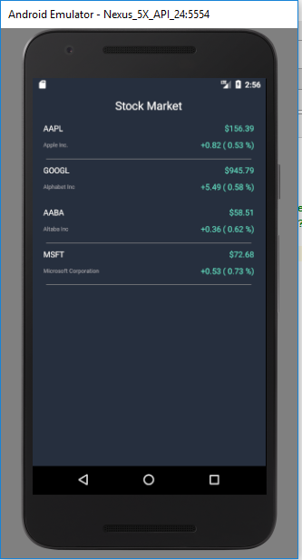

We can check the structure of the response which we are getting from URL by viewing in Json lint.

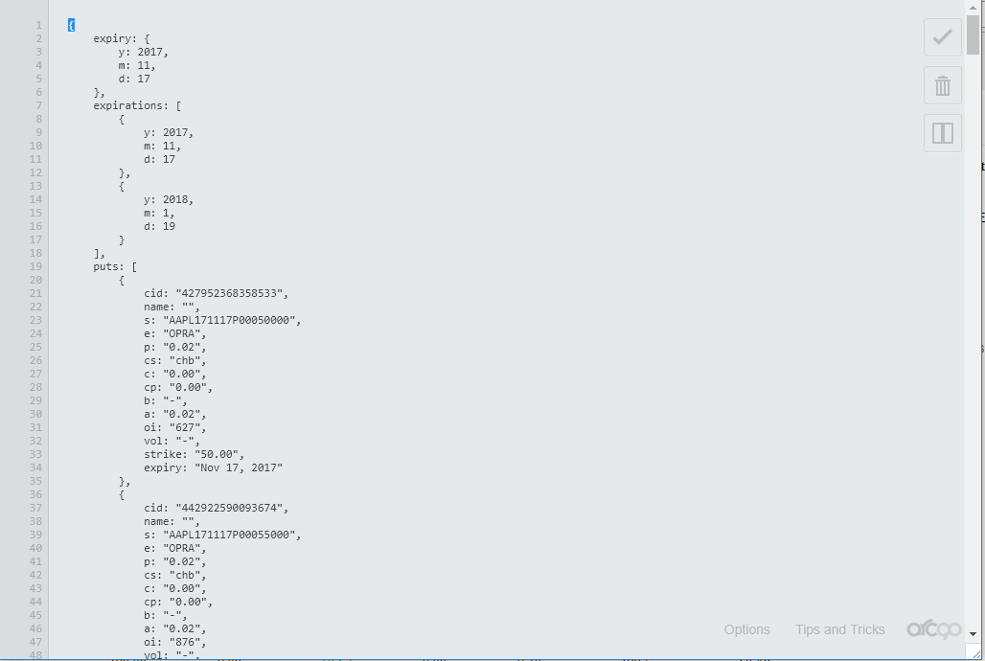

In manifest file we have added various permissions.

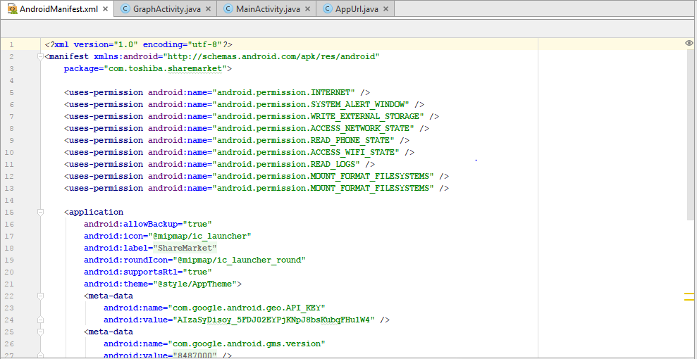

To run our app we have to simply click the run button and select the deployment target.

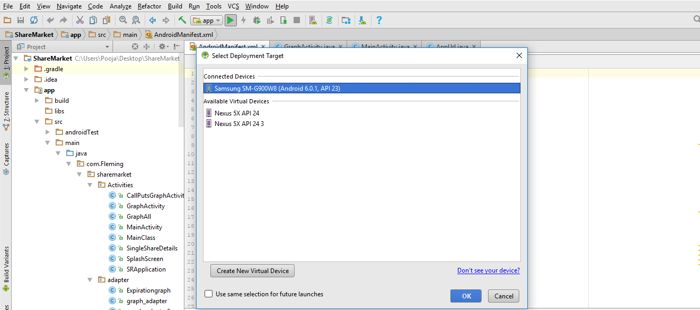

**FUTURE WORK:**

As we are not able to complete all the deliverables of our project. So, in future other group can continue work on playback feature and build overlay expiration feature which we were not able to do and find API that contain number of expiration date for every month.

**RECOMMENDATION:**

It is recommended that you must have a clear vision before starting work on any feature. Do as much research as possible so that concept should be clear. Always discuss with your sponsor if you have any doubts.