**NASA DEVELOP National Program**



NASA Ames Research Center

*Summer 2016*

San Francisco Bay Area Health and Air Quality

Using Aircraft and Ground-Based Observations to Improve

Methane Monitoring for the San Francisco Bay Area

 **Technical Report**

Rough Draft – June 30, 2016

Maya Midzik (Project Lead)

Joseph Abbate

Garima Raheja

Dr. Abhinav Guha, Bay Area Air Quality Management District (Mentor)

Dr. Phil Martien, Bay Area Air Quality Management District (Mentor)

Dr. Laura Iraci, NASA Ames Research Center (Mentor)

Dr. Josette Marrero, NASA Postdoctoral Program (Mentor)

Dr. Warren Gore, NASA Ames Research Center (Mentor)

Dr. Emma Yates, Bay Area Environmental Research Institute (Mentor)

Dr. Juan Torres-Pérez, Bay Area Environmental Research Institute (Science Advisor)

# 1. Abstract

Methane (CH4 ) is a potent greenhouse gas. According to the Environmental Protection Agency (EPA), one ton of methane emissions can absorb almost twenty five times as much energy as one ton of carbon dioxide emissions over a one hundred year timescale. A majority of these emissions can be attributed to livestock farms, landfills, and wastewater treatment plans. The Bay Area Air Quality Management District (BAAQMD) regulates these and other stationary sources of air pollution in the nine counties surrounding San Francisco Bay, an area with a diverse array of landforms and emissions sources. BAAQMD traditionally estimates emissions using a bottom-up approach, combining emissions factor and activity data to estimate source emissions per sector. However, recent literature suggests that these bottom-up approaches are underestimating CH4 emissions by nearly 50% in many regions of California. Therefore, there is interest in characterizing the ground-level distribution of methane within the urban region of the San Francisco Bay Area and comparing the top-down measurements with the bottom-up spatial emissions inventories utilized by the Bay Area Air Quality Management District (BAAQMD). Though Earth-observing satellites can effectively monitor mid-to-upper tropospheric CH4 on a global scale, current instrumentation is limited in its capacity to accurately measure near-surface CH4 on a local scale. This project used sub-Planetary Boundary Layer aircraft measurements from the NASA Alpha Jet Atmospheric eXperiment (AJAX) to create a comprehensive spatially-resolved CH4 map. Backwards trajectory analysis on wind plumes near locations of “hotspots” (found over Mountain View, Petaluma and San Pablo Bay) was conducted using the National Digital Forecast Database (NDFD). The backward trajectory analysis can be used to identify which emissions sources that are already accounted for in the current BAAQMD emissions inventory are points of further concern, and also hypothesize specific sites for further investigation by the upcoming BAAQMD Mobile GHG Measurement, AJAX, targeted satellite missions, or other top-down greenhouse gas measurement methods.

**Keywords**

Emissions inventory, bottom-up estimate, top-down measurement, remote sensing

# 2. Introduction

***2.1. Background Information***

Methane (CH4 ) is a potent greenhouse gas with a radiative forcing second only to CO2  (IPCC, 2013). The concentration of CH4 in the atmosphere has been rising dramatically, with current tropospheric concentrations almost 2.5 times those of pre-1750 levels (Blasing, 2016). Natural processes within ecosystems can emit CH4; however, the rapid increase in atmospheric CH4 has been attributed primarily to anthropogenic sources such as landfills, livestock farms, and natural gas production systems (Miller, 2013).

Regional inventories of CH4 emissions are estimated using a “bottom-up” method, combining local source sector totals and estimated emissions per unit factors (Guha, personal communication, June 28, 2016). Information on source sectors is collected from various databases, including the USDA National Agricultural Statistics Service Cattle Inventory and the US Department of Transportation Office of Highway Policy Information Traffic Volume Trends. The emissions per unit factors rely on a combination of activity data, emission factors, and biogeochemical models.

Recent studies have shown that regional emissions inventories may be largely underestimating true CH4 emissions (Miller et al., 2013). In particular, a study of the Bay Area used the Bay Area Air Quality Management District (BAAQMD) carbon monoxide (CO) emission inventory and the slope of ambient local CH4 to CO to demonstrate that “top-down estimates of CH4 emissions… correspond to reasonably a constant factor of 1.5-2.0 (at 95% confidence) times larger than the BAAQMD CH4 emissions inventory” (Fairley and Fischer 2015). However, this study was conducted using gas chromatography, which is primarily used for measurement of volatile organic compounds (VOCs) and has low sensitivity for CH4  (Guha, personal communication, June 28, 2016). There is significant interest in accurately validating both the top-down and bottom-up emissions estimates using top-down CH4 measurements, which can be provided by airborne and satellite observations. However, greenhouse gas monitoring satellites are prohibitive, since most of these satellites (including TES, AIRS, and SCIAMACHY) are sensitive to measuring CH4 in the upper troposphere, which contains well-mixed CH4, and are not highly sensitive to greenhouse gasses within the planetary boundary layer (PBL), which contains local greenhouse gas enhancements. Targeted greenhouse gas monitoring satellites such as GOSAT (Greenhouse Gases Observing Satellite) provide limited horizontal resolution, and in the case, of the Bay Area, have no coincident measurement times with ground-based sensors. Therefore, airborne measurements are an incredibly valuable source of top-down measurements of greenhouse gas concentrations.

***2.2. Project Partners & Objectives:***

The Bay Area Air Quality Management District (BAAQMD) regulates air pollution within nine counties surrounding the San Francisco Bay in the Northern California region of the United States: Alameda, Contra Costa, Marin, Napa, San Francisco, San Mateo, Santa Clara, Solano, and Sonoma (Fischer, 2015). These counties contain a wide range of land uses, high-density urban metropolises, dairy farms, waste disposal sites, refineries, and homes and businesses. BAAQMD compiles emissions inventories for criteria air pollutants, climate forcing pollutants, and toxic air contaminants. As part of the 2016 Clean Air Plan/Regional Climate Protection Strategy, BAAQMD is creating a Bay Area Greenhouse Gas Monitoring Network. This network includes four stationary monitoring stations (in Bodega Bay, San Martin, Patterson Pass, and Bethel Island), as well as mobile greenhouse gas measurement van that will be deployed starting July 2016 (Guha, personal communication, June 28, 2016).

The Alpha Jet is a demilitarized aircraft shared between the H211 Corporation and the NASA Ames Research Center (ARC) through a Space Act Agreement (Hamil et. al., 2015). It is outfitted with a Meteorological Measurement System (MMS), and a cavity ring-down spectrometer (CRDS, Picarro, Inc., Model G 2301-m), which uses three wavelengths in the infrared to measure atmospheric concentrations of greenhouse gasses including CH4, carbon dioxide, and water vapor (CO2  at 1603 nm, and CH4and H2O at 1651 nm). The Alpha Jet Atmospheric Experiment (AJAX) is located at the NASA Ames Research Center, and conducts flights associated with campaigns to support NASA Orbiting Carbon Observatory (OCO-2), validate the Emission Database for Global Atmospheric Research (EDGAR) emissions inventory over the San Joaquin Valley, and validate GOSAT (Greenhouse Gases Observing Satellite) measurements. Although these campaigns are not primarily focused on Bay Area emissions, takeoff and landing sections of flights out of ARC can provide valuable data over the BAAQMD jurisdiction.

By applying AJAX observations to understanding local CH4  enhancements, this project seeks better understand the distribution of source-specific CH4 emissions, exploring the potential benefits of utilizing NASA airborne instrumentation to aid BAAQMD in understanding and regulating regional air quality.

# 3. Methodology

***3.1 Data Acquisition***

Temporal, geolocated airborne CH4 (ppmv), CO2 (ppmv), and H2O (%v) measurements from 162 AJAX flights between 2011 and 2016 were obtained. All chemical species were measured using a cavity ring-down spectrometer (CRDS, Picarro, Inc., Model G 2301-m). Flights after Flight #99 (on July 17, 2013) also recorded *in situ* meteorological measurements (MMS) of static pressure, static temperature, and wind in three dimensions.

Gridded historical forecasts of wind direction for the Pacific Southwest region (NDFD WMO Heading Reference: YBQZ) from the National Digital Forecast Database (NDFD) maintained by NOAA as part of the NWS Digital Services Program were downloaded through the NOAA National Operational Model Archive & Distribution System (NOMADS).

Hourly *in situ* ground-based CH4 (ppm) data were obtained from BAAQMD monitoring stations: Bethel Island, Bodega Bay, Patterson Pass, and San Martin. The range of the data was October 2015 to June 2016 for the Bodega Bay site, and February 2016 to June 2016 for the other three sites. Hourly *in situ* CH4 measurements were also obtained from the National Oceanic and Atmospheric Administration Earth System Research Laboratory/ Global Monitoring Division (NOAA ESRL/GMD) Tall Tower at Sutro Tower, San Francisco, for the October 2015 to June 2016 timeframe.

Shape and layer data for regional spatial emissions inventory estimates were obtained from the Planning and Climate Protection Division within BAAQMD.

***3.2 Data Processing***

CH4 is a well-mixed gas within Earth’s atmosphere. Consequently, CH4 within the planetary boundary layer (PBL) can largely be attributed to local emissions sources, whereas CH4 in the upper troposphere and the lower stratosphere is largely CH4 that is being transported from global emissions sources.

A Python algorithm was developed to detect the height of the planetary boundary layer, indicated by rapid changes in meteorological factors. For Flight #99 and later, the algorithm used MMS data from the flight. First, the time at which the flight first left the Bay Area jurisdiction (defined as a rectangular box, 37.0 N to 38.5 N and -121 W to -123.2 W) and entered the jurisdiction on its landing were found. The “entry” and “exit” sections of the flights were treated as vertical profiles, since they were continuous and occurred over a short timespan (thus the altitude of the planetary boundary layer would not have changed as much during these vertical profiles). Within the “entry” and “exit” sections, the altitude of the planetary boundary layer was calculated as the mean of the height with the minimum temperature, the minimum pressure, and the minimum wind speed. The lower of the “entry” and “exit” planetary boundary layer altitudes was used as the planetary boundary layer altitude estimate for the entire flight, and all data above this calculated altitude in this flight was removed. This process was repeated for each flight and all data below in-flight-PBL was compiled. The calculated altitudes of the planetary boundary layer ranged from 400 (date) to 133000 (date). For Flight #98 and before, 400 m (the lowest calculated PBL from the flights that had associated MMS data, and therefore the most conservative estimate for PBL height) was uniformly defined as the height of the PBL each flight.

Gridded historical forecasts for wind direction from NDFD were converted into verbose point shapefiles using the tkdegrib program provided by NOAA. The decoded data was input into ArcGIS as wind vector barbs for spatial analysis.

***3.3 Data Analysis***

*3.3.1 Comprehensive Hotspot Mapping*

CH4 concentrations were normalized for each flight, to quantify the enhancement of a methane concentration above its daily background (and remove bias from days with high background methane). All flights had highly right-skewed CH4 distributions and a few points with very high CH4 concentrations. Cumulatively, 86.21% points were within one z-scored of the mean. Areas with CH4 z-scores above 2.0 were considered “hotspots” and plotted as varying degrees of the color red to indicate levels, and all points below z-scores of 2 were plotted as varying degrees of the color red to generate a spatially-resolved visual tool for inspecting and understanding horizontal distribution of CH4.

*3.3.2 Backwards Trajectory Modeling*

Backwards trajectory modeling was conducted from these case study hotspots in the WRF-FDDA model. Mean horizontal winds were simulated using the model and averaged using equal pressure from the surface to the top of the PBL. This model was used to calculate bulk transport trajectories and identify possible downwind sources of enhanced CH4 plumes.

*3.3.3 Time-Series Analysis*

Due to its base at the NASA Ames Research Center (ARC), there is a high deinsity of AJAX flights in the surrounding area. AJAX flights were subset for .05 degrees surrounding ARC. These flights were then processed to below-PBL measurements, and processed in R statistics software. These methane concentrations were then statistically compared to ground-based hourly *in situ* data from BAAQMD’s GHG monitoring network and historical Sutro Tower data.

# 4. Results & Discussion

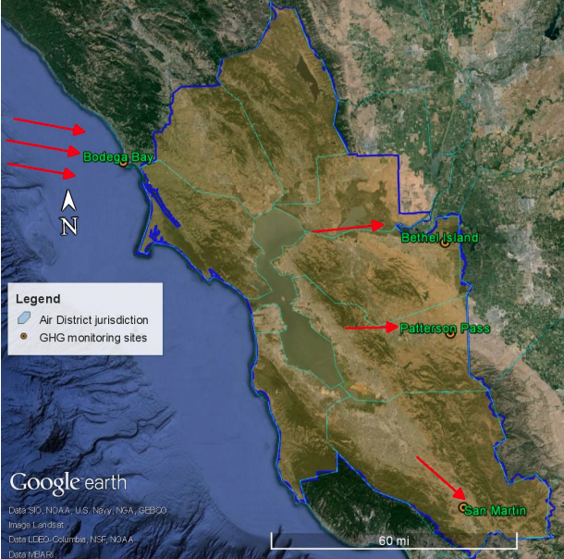

Figure 1: Locations of BAAQMD’s GHG monitoring sites.

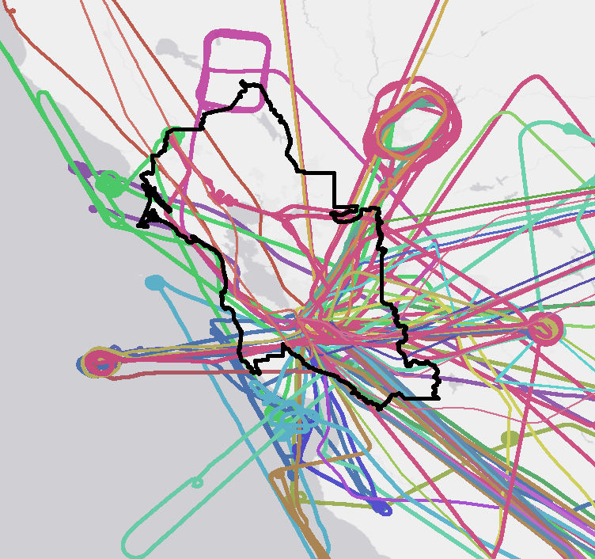

Figure 2: Compiled AJAX flights over BAAQMD regulatory area. AJAX flights are shows in colored lines, BAAQMD jurisdiction in black.

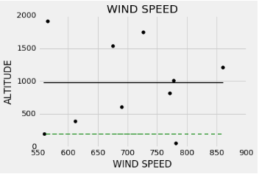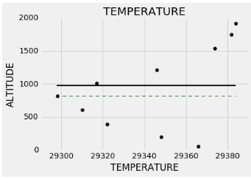

Figure 3: Temperate and wind speed profiles for entry of Flight 132. Lines delineate algorithm-based PBL calculations. Variable-defined lines in green and final, averaged PBL estimate in solid black line.

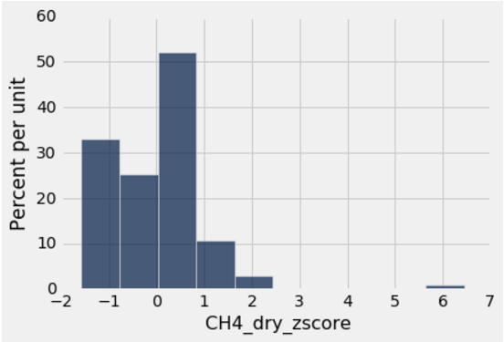

Figure 4: Normalized z-score histogram for Flight 164.

Low: 1.827 (z-score)

High: 2.663 (z-score)

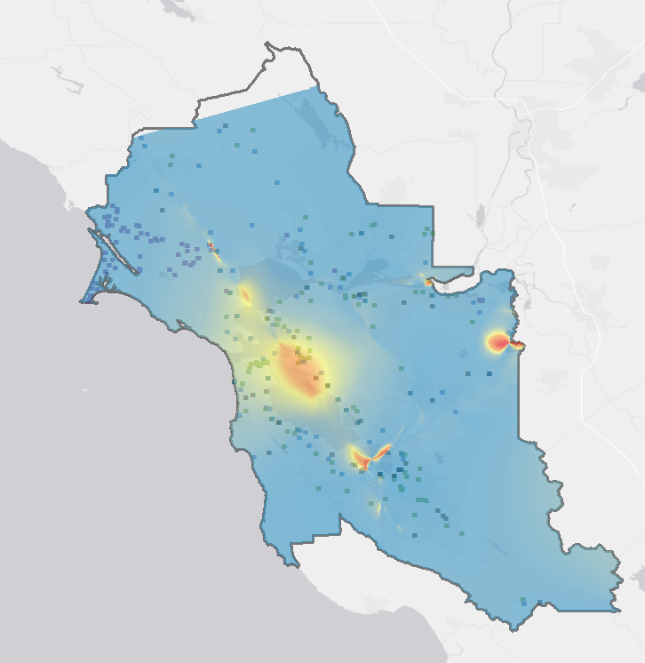

Figure 5: Final normalized CH4 map, interpolated over BAAQMD area. Levels of methane enhancement indicated (as determined by flight-based z-score) in red/blue scale.

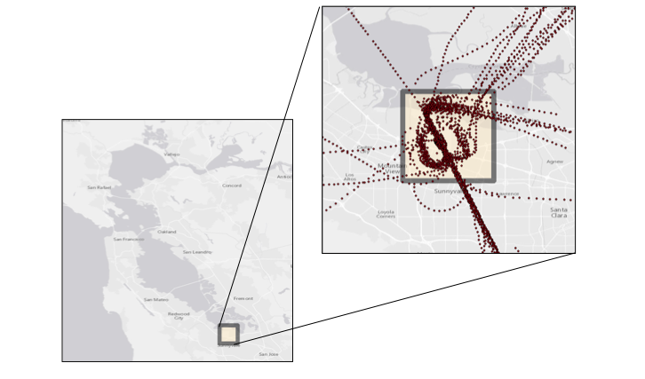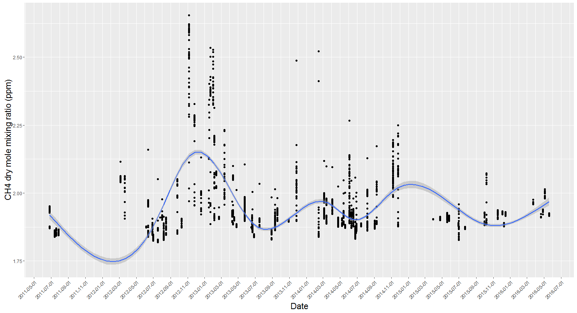

Figure 6: CH4 time series of AJAX measurements for area surrounding the Ames Research Center from May 2011-July 2016. (Working on comparison graphs for San Martin- add here).

Wind vector

Power Plant

Refinery

Water treatment plant

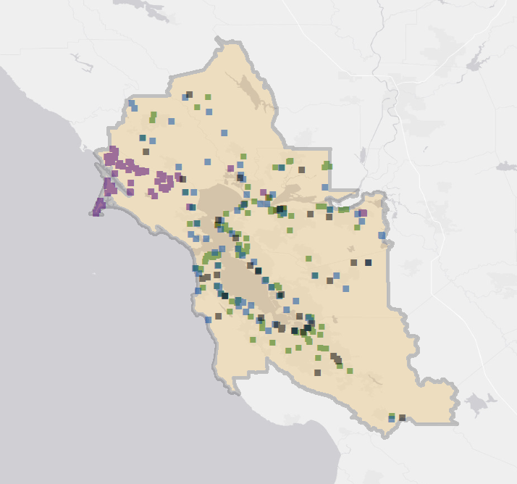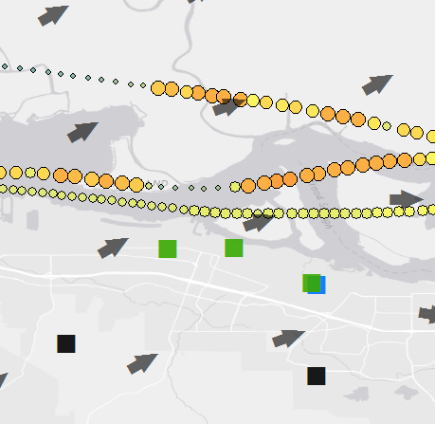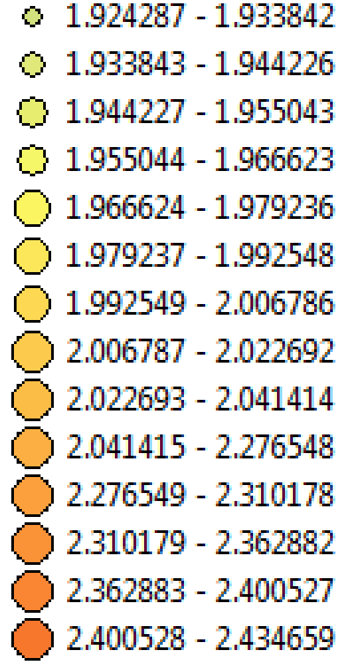

1.9 ppmv CH4

2.5 ppmv CH4

Figure 7: Trajectory analysis over San Pablo Bay area for October 10, 2016. Variation in methane concentrations for flight line shown in both color and icon size. BAAQMD GHG inventory sites (power plants, water treatment plants and refineries) shown in icons. Wind vectors from National Digital Forecast Database (NDFD).

***4.1 Analysis of Results***

Using all AJAX flights from 2011-2016, the final normalized CH4 map (Fig. 5) covered over 95% of BAAQMD’s regulatory jurisdiction. Within this map, three main areas of elevated CH4 are apparent: 1) over the central San Francisco Bay/East of the city of San Francisco, 2) near the Ames Research Center and 3) near the eastern San Pablo Bay area of the BAAQMD jurisdiction. Flight density varies over the San Francisco Bay Area, creating uncertainty in the map. Although this map (Fig. 5) represents significantly enhanced methane measurements, it does not necessarily cover all possible methane hotspots for the area due to limitations in flight density below the PBL.

Time series analysis of methane levels over the Ames Research Center (Fig 6) revealed significant seasonal variation in the gas, with yearly highs of methane occurring between January and March for 2013, 2014 and 2015. BAAQMD measurements over San Martin for 2015-16 monitoring site were shown to be consistent with AJAX observations; however, measurements over Patterson Pass were very different from AJAX measurements over the same region, indicating that further work is needed in utilizing AJAX as a consistent sensor over time.

Trajectory analysis of CH4 hotspots (Fig. 7) indicated potential sources of methane enhancements; however, wind data often pointed to multiple possible point sources. Based on these results, landfills in the South San Francisco and San Pablo Bay areas, as well as refineries near San Pablo Bay, are high likely to be the sources of elevated CH4 concentrations.

***4.2 Future Work***

# This project outlines potential points of interest for future projects to focus on. The BAAQMD Mobile GHG Monitoring Network will begin taking top-down measurements of areas of concern starting in the fall of 2016, with this study providing targets for more specific ground-based studies. In addition, this project represents the beginning of a number of collaborations between AJAX and BAAQMD, including a brief validation campaign planned for the fall of 2016. Future low-altitude AJAX flights will allow for more accurate and detailed characterization of Bay Area CH4 concentrations. Furthermore, future AJAX flights coordinated with BAAQMD Mobile Monitoring data collection will be vital in understanding the spatial and vertical distribution of CH4 concentrations over the diverse landforms of the San Francisco Bay Area.

# 5. Conclusions

Meteorological factors were used to determine the height of the planetary boundary layer at the time and date of each AJAX flight, and the AJAX data within the PBL was used to develop comprehensive maps of estimated CH4 concentrations and local CH4 relative enhancements over the Bay Area. Hotspots were found over Mountain View, Petaluma and San Pablo Bay. These hotspots were investigated by integrating historical wind direction forecasts, and the nearest emissions sources were noted. In the cases of San Pablo Bay and Petaluma, no known sources of emissions were found downwind of the hotspot within the BAAQMD emissions inventory – these hotspots thus indicate points of interest for examination by the BAAQMD Mobile GHG Monitoring Van or by other top-down methods. The high density of data collected over the NASA Ames Research Center was used to create a time series of the CH4 concentrations in Mountain View, and demonstrated regular seasonal fluctuations in CH4 concentrations, with the highest CH4 concentrations occurring in the winter months between November and February, and the lowest CH4 concentrations occurring in the summer months between May and August. These seasonal trends can also be seen in the nascent BAAQMD sensor network, and thus indicate that AJAX is a valuable source of corroboration for the BAAQMD Greenhouse Gas Monitoring Network. Areas of high uncertainty, and areas with high deviations from the bottom-up emissions inventory estimate, were identified for future investigation by top-down methods. Supplementing airborne observations with ground-based measurements will help develop a better understanding of the spatial distribution of CH4 over the San Francisco Bay Area, and will help scientists and policymakers develop more effective strategies for reducing CH4 emissions.

# 6. Acknowledgments

* Partners
  + Dr. Abhinav Guha, Senior Air Quality Engineer, Bay Area Air Quality Management District
  + Dr. Phil Martien, Air Quality Engineering Manager, Bay Area Air Quality Management District
* Alpha Jet Atmospheric Experiment (AJAX)
  + Dr. Laura Iraci, NASA Ames Research Center
  + Dr. Josette Marrero, NASA Postdoctoral Program
  + Dr. Warren Gore, NASA Ames Research Center
  + Dr. Emma Yates, Bay Area Environmental Research Institute
* Mentors / Advisors
  + Ms. Chippie Kislik, DEVELOP Center Lead at NASA Ames Research Center
  + Ms. Vickie Ly, DEVELOP Assistant Center Lead at NASA Ames Research Center
  + Dr. Juan Torres-Pérez, Bay Area Environmental Research Institute

Any opinions, findings, and conclusions or recommendations expressed in this material are those of the author(s) and do not necessarily reflect the views of the National Aeronautics and Space Administration.

This material is based upon work supported by NASA through contract NNL11AA00B and cooperative agreement NNX14AB60A.

# 7. References

Blasing, T. (2016, April). Recent greenhouse gas concentrations. Retrieved June 29, 2016, from <http://cdiac.ornl.gov/pns/current_ghg.html>

Fairley, D., & Fischer, M. L. (2015). Top-down methane emissions estimates for the San Francisco Bay Area from 1990 to 2012. *Atmospheric Environment,* *107*, 1-32. doi:10.1016/j.atmosenv.2015.01.065

Fischer, M. L., & Jeong, S. (2015). *Evaluating the Bay AreaMethane Emission Inventory* [Scholarly project]. Retrieved June 29, 2016.

Guha, A. (n.d.). *GHG Inventory and Measurements Background* [Scholarly project]. Retrieved June 29, 2016.

Hamill, P., Iraci, L. T., Yates, E. L., Gore, W., Bui, T. P., Tanaka, T., & Loewenstein, M. (2016). A new instrumented airborne platform for atmospheric research. *Bulletin of the American Meteorological Society*,*97*(3), 397-404.

Karion, A., Sweeney, C., Pétron, G., Frost, G., Michael Hardesty, R., Kofler, J., ... & Brewer, A. (2013). Methane emissions estimate from airborne measurements over a western United States natural gas field. *Geophysical Research Letters*, *40*(16), 4393-4397.

Miller, S. M., Wofsy, S. C., Michalak, A. M., Kort, E. A., Andrews, A. E., Biraud, S. C., ... & Miller, B. R. (2013). Anthropogenic emissions of methane in the United States. *Proceedings of the National Academy of Sciences*, *110*(50), 20018-20022.

Peischl, J., Ryerson, T. B., Holloway, J. S., Trainer, M., Andrews, A. E., Atlas, E. L., ... & Goldstein, A. H. (2012). Airborne observations of methane emissions from rice cultivation in the Sacramento Valley of California.*Journal of Geophysical Research: Atmospheres*, *117*(D24).

Stocker, T. F., Qin, D., Plattner, G. K., Tignor, M., Allen, S. K., Boschung, J., ... & Midgley, B. M. (2013). IPCC, 2013: climate change 2013: the physical science basis. Contribution of working group I to the fifth assessment report of the intergovernmental panel on climate change.

**8. Content Innovation**

**Content Innovation #1**

(link: *insert link to VPS on YouTube*)

**Content Innovation #2**

Audio for PowerPoint Presentation

**Content Innovation #3**

Glossary

(link: <https://docs.google.com/document/d/1DaXB1-e1A9SOZGhB-v0nEHR4GLvJfQ0mPTdXgSI_ii0/edit?usp=sharing>)

# 9. Appendices