Question 5:

1. Fit 1 is below:

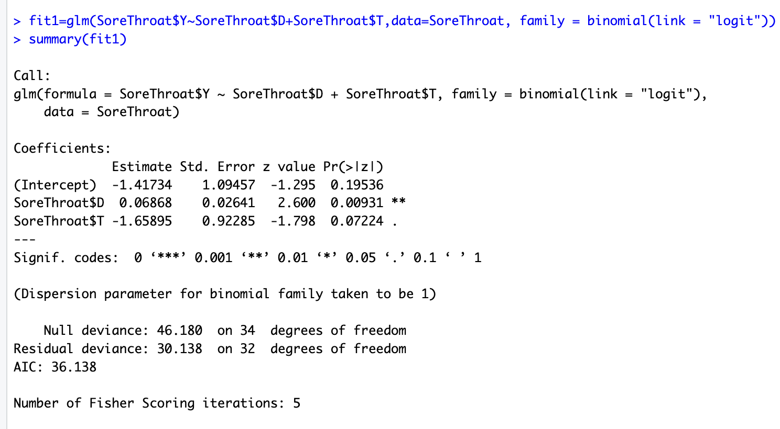

1. Fit 2 is below:

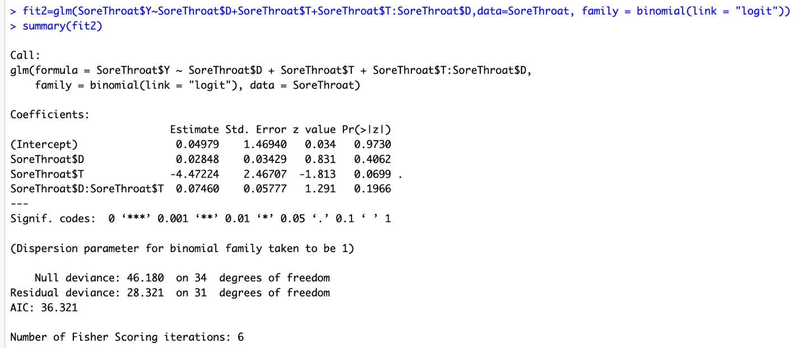

1. The prediction equation for fit 2 is:

Logit(p(Y=1)) =0.049+0.028xDuration-4.472xType+0.074x(D\*T)

For Duration (D):

For every one minute increase in surgery, the estimated odds of sore throat is increased by exp (0.028) =1.02 times while keeping other variables held constant.

For Type of device used (T):

For every other type of device used in surgery, the estimated odds of sore throat is increased by exp (-4.472) =0.011 times while keeping other variables held constant.

For Duration in Duration interacting with Type of device:

For every one-minute increase in surgery for a fixed type of device, the estimated odds of sore throat is increased by exp (0.077) =1.077 times while keeping other variables held constant.

For Type of device used in Duration interacting with Type of device:

For every change in device type used while keeping duration fixed, the estimated odds of sore throat is increased by exp (-4.423) =0.011 times while keeping other variables held constant.

1. LRT test:

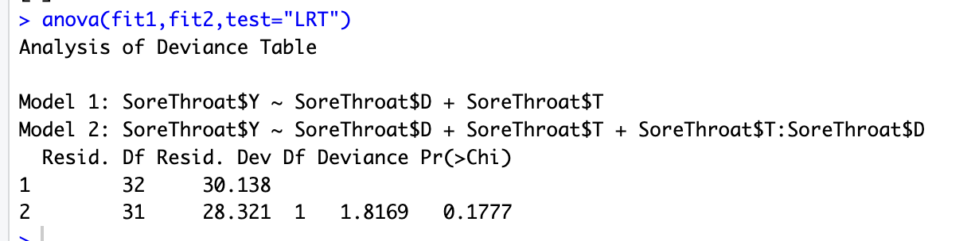

From above, the model with interaction term does not seems adequate in predicting the sore throat and hence fit 1 without interaction seems more adequate with p-value 0.177 > 0.10 at 10% level of significance with deviance of 1.8 for DF=1.

1. Fit 1 is selected without interaction term from comparing above.



For Duration (D):

For every one-minute increase in surgery, the estimated odds of sore throat is increased by exp (0.068) =1.07 times while keeping other variables held constant.

For Type of device used (T):

For every other type of device used in surgery, the estimated odds of sore throat is increased by exp (-1.658) =0.190 times while keeping other variables held constant.

1. Predictive power for model fit 1:

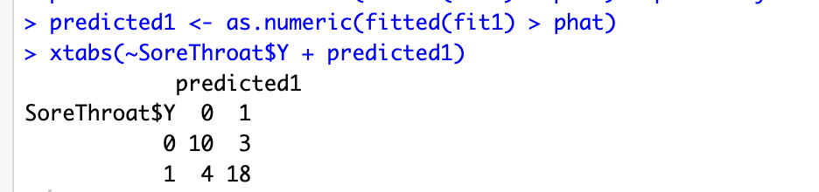

Fit 1 predicts 10 cases with no sore throats out of 13 and 18 cases with sore throats out of 22.

Predictive model for fit2:

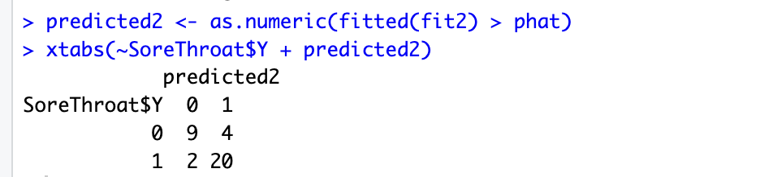

Fit 2 predicts 9 cases with no sore throats out of 13 and 20 cases with sore throats out of 22.

Fit 1 seems adequate with better prediction compared with observed and fitted values.

1. The predicted value is below:



The probability for 39 minutes of duration of surgery with tracheal tube type of device the predicted value is -0.3977.

1. The predicted value is below:



The probability for a patient underwent surgery and experienced sore throat with duration of surgery as 39 minutes when a laryngeal mask airway used has a predicted value of 1.261.

1. The predicted value for tracheal tube as device seems much lower than the predicted value for laryngeal mask as a device for sore throat as the patient with sore throat were much higher for mask airway than tube device type.