Self-Learning Points of Gerrit

Contents

1. What is Gerrit 7

1) Characteristics 7

2) Advantage 7

3) Disadvantage 7

2. Key Points 7

1) Push to Gerrit is same as push to Git. Only target branch name is different: **refs/for/** 7

2) Difference between new change and new patch set 8

=> 8

=>A common scenario: 8

3) How to revert changes in git 9

4) Git has 3 level config 9

5) Merge 9

6) Rebase 11

7) Pull and Push 12

3. FAQ 12

1) What’s SHA1? 12

2) How to allow multiple people push code to a same repository? 13

4. Frequently Used Commands 13

*1)* *git log* 13

*git log --follow pom.xml* 14

*Shows commits that changed pom.xml, including those that occurred before the file was given its present name.* 14

*git log --name-only pom.xml* 14

*Shows the commits for file pom.xml, listing only name* 14

*git log --name-status pom.xml* 14

*Shows the commits for file pom.xml, listing name and status* 14

*git log --stat pom.xml* 14

*Generates a diffsta.* 14

*显示简要的增改行数统计,每次提交文件的变更统计.* 14

*git log -p pom.xml* 14

*Similar to--stat, with more info.* 14

*git log -1 pom.xml* 14

*Limits the number of commits to show to 1* 14

*git shortlog pom.xml* 14

*Shows commit with only name and short description.* 14

*git log --pretty=oneline pom.xml* 14

*Set the output to oneline format* 14

*git log --since=200.days -- pom.xml* 14

*Shows the changes during the last 200 days to the file pom.xml. “-- is necessary to avoid confusion with a branch named pom.xml.* 14

*--since, --after 仅显示指定时间之后的提交。* 14

*git log --until=200.days pom.xml* 14

*--until, --before 仅显示指定时间之前的提交。* 14

*git log rel-5.10 extensions/* 14

*Shows all commits since version rel-5.10 that changed any file in extensions/ subdirectories* 14

*git log --graph pom.xml* 14

*--graph 显示 ASCII 图形表示的分支合并历史。* 14

*git log --branches --not --remotes=origin* 14

*Shows all commits that are in any of local branches but not in any of remote-tracking branches for*origin*(what you have that origin doesn’t).* 14

*git log master --not --remotes=*/master* 14

*Shows all commits that are in local master but not in any remote repository master branches.* 14

*2)* *git cat-file* 14

*git ls-tree* 14

*git cat-file -t 24aa5cbbe229* 16

**Output:** 16

*commit* 16

*git cat-file commit 24aa5cbbe229* 16

**Output:** 16

*git ls-tree 24aa5cbbe229* 16

**Output:** 16

*git cat-file -p master^{tree}* 16

**Output:** 16

100644 blob 05000bc34e374d540116fa83662108a6e96a1da0 .gitignore 16

100644 blob 5ebfd75fb43b68f670c5148e7cfa15834325eadb .gitreview 16

040000 tree e88c475df6e75cbaae601b866a7770948d233c3d container 16

100644 blob b97b4bc1a3129e4f56d2435f42ce9d106ecea1b9 cvom.html_context_Visual Intelligence.xml 16

040000 tree a2ac5ce35313d2f9902151d1eb5634843b987d27 documentation 16

040000 tree 3733cb7468f0aff8a21f91caee9b266e0d07bf5a extension 16

040000 tree 3cd5614b2a8d7a89651f34d76f43c5f99d71a4ce fortify 16

040000 tree d47fd2b8eb9eaeeb82f89d8a037c0eeaeae71d03 info 16

100644 blob 55c0e6df5087017a5783d4ed13035e2a1925c13e pom.xml 16

040000 tree 60df7c4ecef2192d5aa9086a6040b33cff324337 testPnR 16

040000 tree 93d31d1d7f2aaf4cac21735a858ee45c567a7cbe viz 16

040000 tree 2ea8a93bd3e2758031d0f61c37a5d1d056a5fe2d vizPacker 16

*git cat-file blob 05000bc34e374d5* 17

**Output:** 17

*git config --get-all user.name* 17

Get value of a given key. 17

*git config --global gc.auto 0* 17

Disable this behavior permanently without further considerations 17

*git gc* 17

Clean up unnecessary files and optimize the local repository 17

*git log --until=200.days pom.xml* 17

*--until, --before 仅显示指定时间之前的提交。* 17

*git log rel-5.10 extensions/* 17

*Shows all commits since version rel-5.10 that changed any file in extensions/ subdirectories* 17

*git log --graph pom.xml* 17

*--graph 显示 ASCII 图形表示的分支合并历史。* 17

*git log --branches --not --remotes=origin* 17

*Shows all commits that are in any of local branches but not in any of remote-tracking branches for*origin*(what you have that origin doesn’t).* 17

*git log master --not --remotes=*/master* 17

*Shows all commits that are in local master but not in any remote repository master branches.* 17

5. Training Materials 17

1. Gerrit Concepts 18

1) Push 18

2) Push New Patch Set 19

Table 1 Difference of using Soft, Mixed and Hard in git reset B 9

Table 2 Examples of git log 13

Table 3 Examples of git cat-file and git ls-tree 16

Figure 1 Index in git repository: git add 7

Figure 2 Folder objects in git repository: git commit 8

Figure 3 Git has 3 level config 9

Figure 4 Before Fast Forward merge 9

Figure 5 After Fast Forward merge 9

Figure 6 Before Cherry-Pick merge 10

Figure 7 After Cherry-Pick merge 10

Figure 8 Git before rebase 11

Figure 9 Git after rebase: fast forward merge is possible 11

Gerrit

# What is Gerrit

Gerrit is a git server with 2 extra functions: access management and code review.

## Characteristics

TODO

## Advantage

TODO

## Disadvantage

TODO

# Key Points

## Push to Gerrit is same as push to Git. Only target branch name is different: **refs/for/**

|  |  |  |
| --- | --- | --- |
| Push to Git | Push to Gerrit | Notes |
| git push origin HEAD:master  Git:   * Could has 2 commits in 1 push | git push origin HEAD:refs/for/master  Gerrit:   * Create a new branch for the commit you push * Create a new open Gerrit change in Gerrit DB for **each** push: 2 changes |  |

Table Difference between Git and Gerrit Push

Difference between Change and Patch Set in Gerrit

|  |  |
| --- | --- |
| Term | Description |
| Change | The unit of review.  Results in a single commit when merged to the git repository.  Change numbers are unique and never change. |
| Patch Set | A revision of a Change.  Each time a Change is modified, it will receive a new Patch Set.  Patch Set numbering starts from 1.   * Technically, a Patch Set is a unique git commit. |

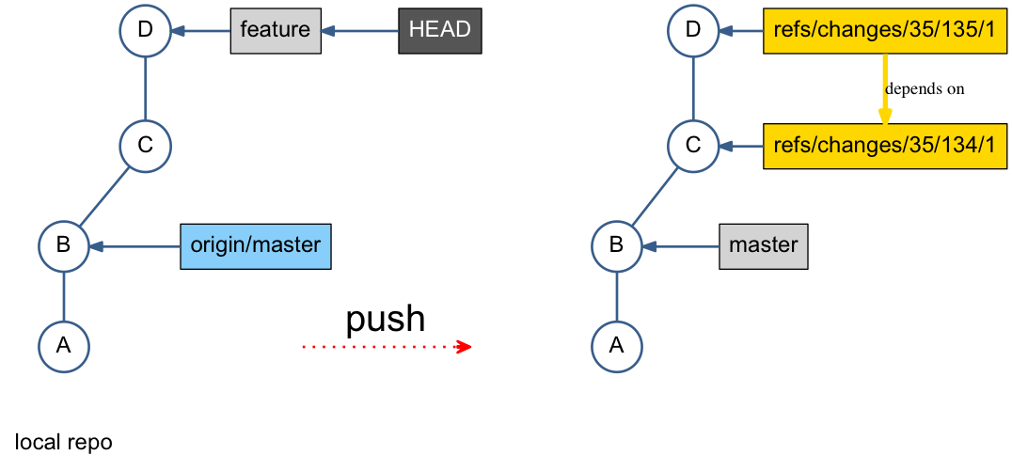

Figure Difference between Git and Gerrit Push

## Difference between new change and new patch set

|  |  |
| --- | --- |
| Change | Patch Set |
| Contains:   * Change-Id * Meta-data (project, owner, etc…) * One or more patch set(s) * Comments * Votes | * New version of an existing change * Only the latest patch set is relevant * No dependencies between patch sets |

Table Difference between Change and Patch Set

## =>

1. git commit –amend pushs a new patch set.
2. git fetch downloads an open change locally for test (using commands created by Gerrit.)

## => A common scenario:

Author of Patch Set 1 is not available and somebody else needs to continue and provide Patch Set 2

1. git fetch
2. Create a new branch based on the fetched path set 1
3. Fix the issue
4. git commit –amend
5. push

## How to revert changes in git

* When change is only in working directory, not staged yet.

TODO

* When change is staged, not committed yet.

TODO

* When change is committed.

TODO

* Difference of using Soft, Mixed and Hard in git reset B

|  |  |  |  |
| --- | --- | --- | --- |
| Reset | Working Directory | Stage (Index) | Remote Repo(Branch) |
| soft | No | No | Yes |
| mixed | No | Yes | Yes |
| hard | Yes | Yes | Yes |

Table Difference of using Soft, Mixed and Hard in git reset B

## Git has 3 level config

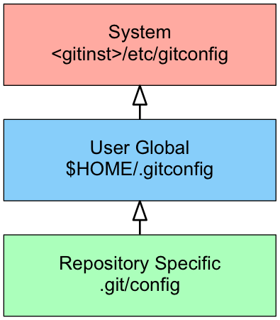

Figure Git has 3 level config

## Merge

* Merge commit is a commit with more than one parent.
* git merge feature1 by default is Fast Forward merge, which just moves the pointer, no new merge commit is created.

<= this is why merge in git is fast.

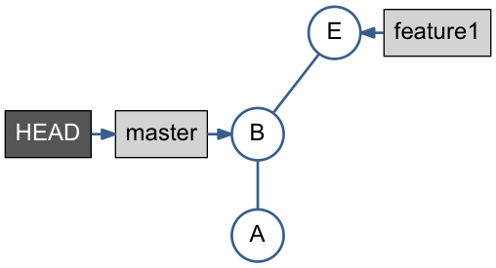

Figure Before Fast Forward merge

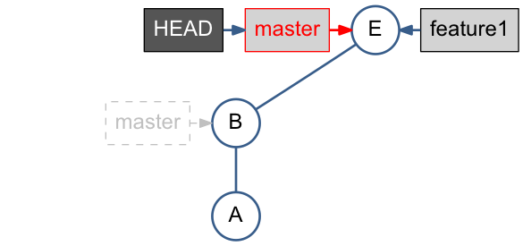

Figure After Fast Forward merge

* git cherry-pick feature1 applies only changes done by F, means the diff-2, has no parent relation to F.

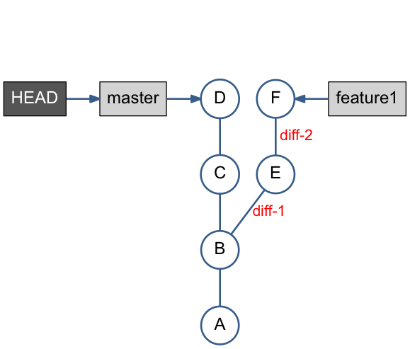

Figure Before Cherry-Pick merge

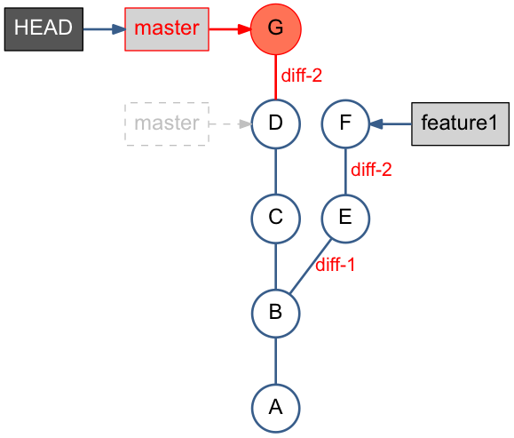

Figure After Cherry-Pick merge

## Rebase

* **重新定义某个分支的参考基准.** 就好比移花接木那樣（稼接），把某個樹枝接到別的樹枝。
* git rebase master redo the work done in teature1 branch on top of the master*.*
* **Alternative to Merge** – Keeping history linear
* Fast Forward merge is possible after rebase.
* git rebase –onto *<new* base *commit> <current base commit>指定要從哪裡開始接枝*

[**https://blog.yorkxin.org/posts/2011/07/29/git-rebase/**](https://blog.yorkxin.org/posts/2011/07/29/git-rebase/)

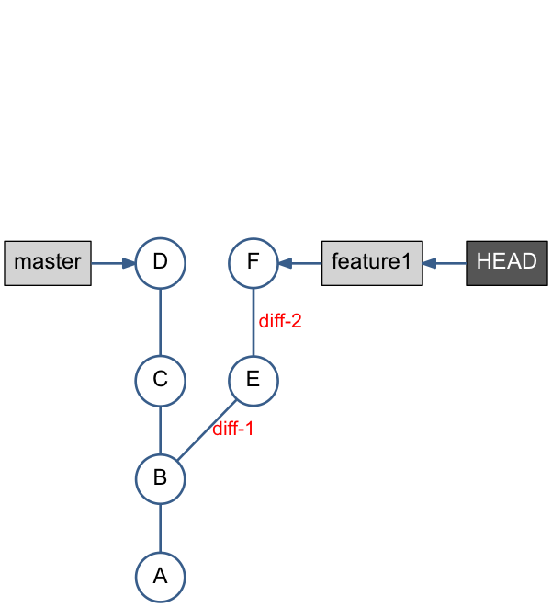

Figure Git before rebase

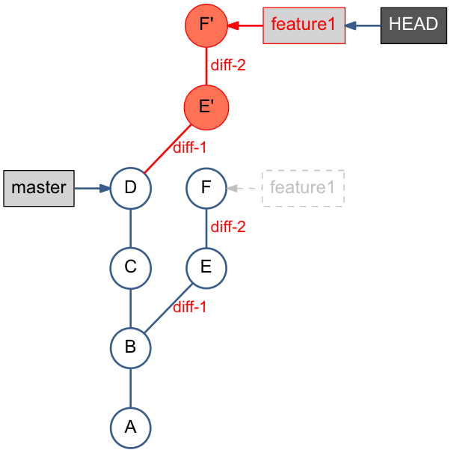

Figure Git after rebase: fast forward merge is possible

## Pull and Push

Pull is equal to 3 possibilities:

* git pull = git fetch + git merge

or

* git pull = git fetch + git rebase

or

* git pull = git fetch

Push could mean to deal with 3 scenarios:

* push (when remote ‘origin’ repo is **NOT** changed)

or

* fetch, merge, push (when remote ‘origin’ repo is changed)

or

* fetch, rebase, push (when remote ‘origin’ repo is changed)

# FAQ

### What’s SHA1?

SHA1 is a globally unique commit ID

SHA1 is a function of the commit object content.

SHA1 is a 40-digit hexadecimal number, seen in git log output, git history view etc. ex. e168254… 23400e6…

### How to allow multiple people push code to a same repository?

Using core.sharedRepository to control access.

Ref: <http://criticallog.thornet.net/2010/01/07/sharing-your-git-repository/>

Steps:

* Create a group git, put multiple people into it.

useradd git

usermod -g git steven

useradd -g git nicholas

chmod 770 /home/git

chmod g+w objects/

* *Update .git/config, adding sharedRepository*

sharedRepository=1

加这个参数的目的是git在objects目录下创建的目录的属性由

drwxr-xr-x 变成 drwxrwsr-x

* Done.

# Frequently Used Commands

TODO