3DGAN - Learning a Probabilistic Latent Space of Object Shapes via 3D GA Modeling

通过概率空间生成3D物体

体积卷积网络(volumetric convolutional networks)+GAN

优点：对抗，从低维度映射到高维度，可用于2D生成3D，3D形状描述符号

结果：生成高质量3D物体(3DGAN)；无监督学习特征用于3D物体识别，即图像转3D模型(3D-VAE-GAN)

模型的discriminator可用于3D物体特征表示，即形状分类

从generator和discriminator产生特征表示(无监督)，再【分别】应用于生成3D模型和物体识别

AC-GAN - Conditional Image Synthesis With Auxiliary Classifier GANs

合成图片（很丑），图片独特，全局一致

HR提供的class信息更多

定量标准检测图片独特性，论文产生图片的比单纯的放大低像素图片的辨识度更高

Variational autoencoders (VAEs)

adding more structure to the GAN latent space along with a specialized cost function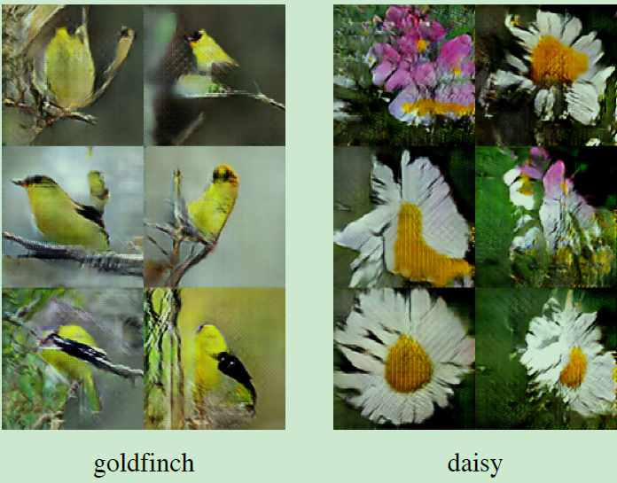

acGAN - Face Aging With Conditional GAN

改变年龄

基础：“Identity-Preserving” latent vector optimization approach allowing to preserve the original person’s identity in the reconstruction

缺点：

1.However, these approaches often require face aging sequences of the same person with wide range of ages which are very costly to collect.

2. the original person’s identity is often lost in the modified image

AdaGAN- Boosting Generative Models

WGAN之前

GAN的问题：collapse mode

强调了这个问题：Ensembles of GAN、MDGAN - Mode Regularized Generative Adversarial Networks

解决：a boosting-style algorithm for GANs

can cover all the modes of the true data distribution

AEGAN - Learning Inverse Mapping by Autoencoder based GANs

问题：当前的generator的倒置映射（inverse model of generator）有许多问题（即X到Z的映射）

propose a new approach of training the inverse model of generator by regarding a pre-trained generator（generator需要预训练） as the decoder part of an autoencoder network

可用于SR（原图质量很差，更真实？）、视频处理、图片检索、重建（Reconstructing Samples？？）

可获得：a universal vector representation of image

对比比较DCGAN、、、ICGAN(this approach requires abundant label information and such data sets are very rare)

没看懂

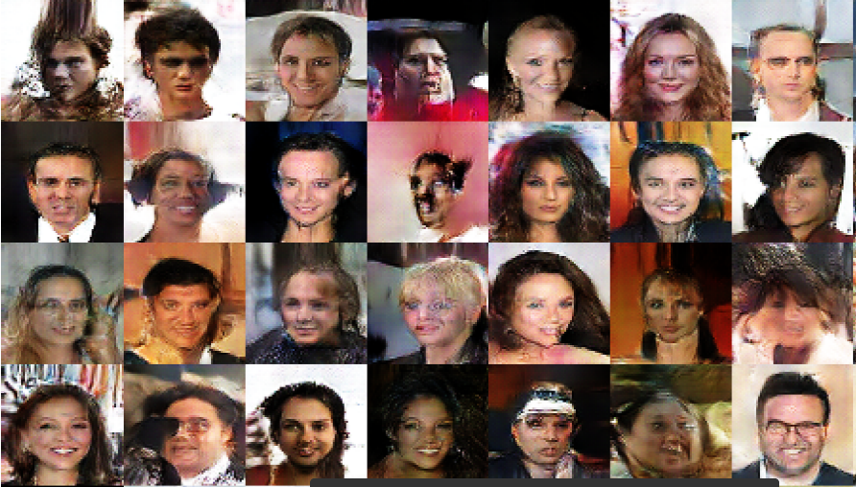

AffGAN

AL-CGAN - Learning to Generate Images of Outdoor Scenes

a novel conditioned GAN(CGAN)

takes its strength from the semantic layout and scene attributes integrated as conditioning variables

semantic layouts，图片中物体有明确界限

transient attributes，可以模拟各种天气状况

主要内容：We propose a new GAN model architecture to generate realistic outdoor scenes, e.g. sea, mountain, urban scenes, conditioned on transient attributes, e.g. sunny, foggy, and on semantic layouts to determine the exact boundaries of where the object should be drawn.

ALI - Adversarially Learned Inference

jointly learns a generation network and an inference network using an adversarial process

ALI是个通过Generation Network（decoder）和Inference Network（encoder）。 两个Model来对怼。也就是将Inference Machine（或encoder）和深度定向G Model（decoder）投入到类似GAN的对抗框架中学习，共同生成类似现实图片，来瞒过discriminator

stochastic latent variables -(generation network)-- the data space

training examples in data space -(inference network)-- the space of latent variables

训练一个鉴别器，以便将来自解码器的联合样本的数据和相应的潜在变量的联合样本与编码器（或近似后验）区分开，而编码器和解码器被一起训练以愚弄鉴别器。我们不仅要求鉴别器区分合成样本与实际数据，而且要求它区分数据空间和潜在变量之间的两个联合分布。生成网络将样本从随机潜在变量映射到数据空间，而推理网络将数据空间中的训练示例映射到潜在变量的空间。

discriminator要判断现实图片/two joint distributions / the data space and the latent variables

AM-GAN - GAN with Labeled Data by Activation Maximization

在WGAN之后，multi-class labels

GAN问题：the current GAN model with labeled data still results in undesirable properties due to the overlay of the gradients from multiple classes

主要内容：analyzed how information about class labels helps GAN training and pointed out the problem of overlayed gradients from multiple classes

AM score：related metrics for evaluating generative models

AM-GAN ：leverages the discriminator to dynamically assign the class label with the highest logit value for each sample and accordingly maximize each sample’s activation on the class logit, which provides a clear gradient guidance to generator.

提到了：

LAPGAN:generate images in a coarse-to-fine fashion；

DCGAN:makes GAN training more stable；

VAE-GAN：combined variational autoencoder()and GAN to provide better training;

MDGAN:proposed to add mode regularizer and train GAN in a manifold-diffusion fashion

Unrolled GAN:proposed to unroll discriminator’s optimization for generator’s objective

():proposed to introduce annealing noise to the input of discriminator to relieve the zero measure of intersection problem

Wasserstein GAN:leveraged the Wasserstein distance as an alternative objective to the log-likelihood of the traditional GAN:avoids the gradient vanishing problem

。。。。。。

AnoGAN - Unsupervised Anomaly Detection with GANs to Guide Marker Discovery

图片(unseen)异常检测(health data)

a deep convolutional GAN to learn a manifold of normal anatomical variability, accompanying a novel anomaly scoring scheme based on the mapping from image space to a latent space

optical coherence tomography 光学相干断层成像术？？

unsupervised

use both components to differentiate between observations that conform to the training data and such data that does not fit.

ArtGAN - Artwork Synthesis with Conditional Categorial GANs

生成艺术画，也可以生成真实照片

对损失函数后向反馈

the feedback from the label information during the back-propagation step improves the quality of the generated artwork

提到了GAN的适用数据库MNIST [9], CIFAR-10 [7], CUB200 [18] and LFW datasets [6]

提到了CGAN/CatGAN/Improved GAN

Bayesian GAN - Deep and Hierarchical Implicit Models

2个模型：hierarchical implicit models、deep implicit models

merging the idea of implicit densities with （hierarchical Bayesian modeling and deep neural networks）

developed a black box variational algorithm for their accurate and scalable inference

We develop likelihood-free variational inference (LFVI).

Key to LFVI is specifying a variational family that is also implicit.

under certain conditions, the KL divergence is the only tractable objective for variational optimization

BEGAN - Boundary Equilibrium GAN

Wasserstein GAN，稳定，更好收敛，但是很慢

a new equilibrium enforcing method（the trade-off between image diversity and visual quality） paired with a loss derived from the Wasserstein distance for training auto-encoder based GAN

uses an auto-encoder as the discriminator（可能不好）

优点：a new approximate convergence measure, fast and stable training and high visual quality

conclusion很详细

VAEs?

WGAN - Wasserstein GAN

GAN的问题：https://zhuanlan.zhihu.com/p/25071913

GAN存在着训练困难、生成器和判别器的loss无法指示训练进程、生成样本缺乏多样性等问题

1.在（近似）最优判别器下，最小化生成器的loss等价于最小化P_r与P_g之间的JS散度，而由于P_r与P_g几乎不可能有不可忽略的重叠，所以无论它们相距多远JS散度都是常数\log 2，最终导致生成器的梯度（近似）为0，梯度消失。

2.最小化第二种生成器loss函数，会等价于最小化一个不合理的距离衡量，导致两个问题，一是梯度不稳定，二是collapse mode即多样性不足。

a.要最小化：KL(P_g || P_r) - 2JS(P_r || P_g)

b.KL(P_g || P_r)对于下面两种错误的惩罚是不一样的，第一种错误对应的是“生成器没能生成真实的样本”，惩罚微小；第二种错误对应的是“生成器生成了不真实的样本” ，惩罚巨大。第一种错误对应的是缺乏多样性，第二种错误对应的是缺乏准确性。这一放一打之下，生成器宁可多生成一些重复但是很“安全”的样本，也不愿意去生成多样性的样本，因为那样一不小心就会产生第二种错误，得不偿失。这种现象就是大家常说的collapse mode。

生成器的梯度迅速增长，说明梯度不稳定

即便两个分布没有重叠，Wasserstein距离(EM距离、Earth Move距离)仍然能够反映它们的远近。

Wasserstein距离却是平滑的，以提供有意义的梯度。(KL/JS不行)

注意原始GAN的判别器做的是真假二分类任务，所以最后一层是sigmoid，但是现在WGAN中的判别器f_w做的是近似拟合Wasserstein距离，属于回归任务，所以要把最后一层的sigmoid拿掉。

《Towards Principled Methods for Training Generative Adversarial Networks》里面推了一堆公式定理，从理论上分析了原始GAN的问题所在

判别器最后一层去掉sigmoid；生成器和判别器的loss不取log；每次更新判别器的参数之后把它们的绝对值截断到不超过一个固定常数c；不要用基于动量的优化算法（包括momentum和Adam），推荐RMSProp，SGD也行

结构：原始GAN究竟出了什么问题？（此部分较长）+WGAN之前的一个过渡解决方案+Wasserstein距离的优越性质+从Wasserstein距离到WGAN+总结

an alternative to traditional GAN training

improve the stability of learning, get rid of problems like mode collapse, and provide meaningful learning curves useful for debugging and hyperparameter searches

the corresponding optimization problem is sound

