BiGAN（Bidirectional GAN） - Adversarial Feature Learning

GAN:Latent distributions(Semantic variation)—G—arbitrarily complex data distribution

问题：深度卷积网络（Deep convolutional networks (convnets)）可以用在图片分类、定位、自然语言理解等方面，但是需要大量手工标注数据，忽略了模型中表示特征的数据。

因此，latent distribution可以当做特征（当语义相关）

但GAN本身没有反向映射（inverse mapping），不能将图片数据映射到潜在空间中。

BiGAN就是这个inverse mapping

特征可以用来 auxiliary supervised discrimination tasks

反向映射灵感来源：paper showed that a GAN trained on a database of human faces learns to associate particular latent directions with gender and the presence of eyeglasses.

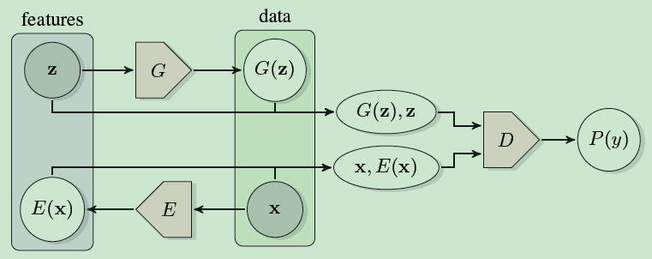

E：encoder（may serve as a useful feature representation for related semantic tasks），G/E独立，都倒置对方（in Section 3, we will both argue intuitively and formally prove that the encoder and generator must learn to invert one another in order to fool the BiGAN discriminator.）



GAN：



另一种方法来做inverse mapping：directly model p(z|G(z)), predicting generator input z given generated data G(z)，叫做：latent regressor

比…好：contemporary approaches to self-supervised and weakly supervised feature learning，对于自然图片（complex data distribution）

Although existing self-supervised approaches have shown impressive performance and thus far tended to outshine purely unsupervised approaches in the complex domain of high-resolution images, purely unsupervised approaches to feature learning or pre-training have several potential benefits

BS-GAN - Boundary-Seeking Generative Adversarial Networks

<http://it.sohu.com/20170301/n482035521.shtml>应用背景 实验

在每次更新的训练中，训练一个G以产生位于当前D的判别边界之上的样本，该算法对离散变量和连续变量广泛有效。

问题：GAN要求G/D可微，但离散变量不符合要求。反向传播不能用

数据库：在离散变量设置中，我们使用 MNIST 和量化的 CelebA；在连续变量设置下，我们使用 SVHN 和原始的连续 CelebA

优点：This framework is powerful, as it trains a generator without relying on an explicit formulation（显式，无需迭代，稳定，计算快；隐式） of the probability function which requires marginalizing out latent variables. 它不依赖于需要边际化潜在变量的概率函数的显式公式来训练生成器

比MLE-trained models好, GANs have been shown to generate often-diverse and realistic samples even when trained on high-dimensional large-scale data in the case of continuous variables.

算法：This algorithm estimate the gradient of the discriminator’s output with respect to the generator, as the weighted sum of the gradients of the log-probabilities of the samples generated from the generator. 这个算法估计鉴别器相对于生成器的输出的梯度，将其作为生成器产生的样本的对数几率的梯度加权总和。

其中：权重（The weights are given by the discriminator’s performance on the samples, such that those samples, that look similar to true, training examples, are weighted more (because they would be scored highly by the discriminator) and vice versa.）

This objective can further be interpreted as an alternative loss on the discriminator output, which allows us to derive a novel learning algorithm for GANs even with continuous variables

CaloGAN - Simulating 3D High Energy Particle Showers in Multi-Layer Electromagnetic Calorimeters with Generative Adversarial Networks

在具有生成对抗网络的多层电磁量热仪中模拟3D高能粒子阵列

CatGAN - Unsupervised and Semi-supervised Learning with Categorical Generative Adversarial Networks

Unsupervised and Semi-supervised /Categorical Generative Adversarial Networks

目的：learning a discriminative classifier from unlabeled or partially labeled data

非监督：训练集图片有结构可追寻，we assume that the input distribution p(x) contains information about p(y| x) – where y denotes the unknown label

use labeled + unlabeled examples，有标记的数据越多，结果越好另一篇分类

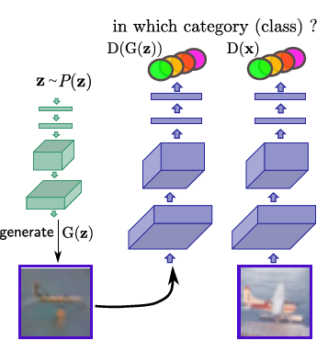信息流的可视化

方法：

(1) generative clustering methods ：directly try to model the data distribution p(x) (or its geometric properties); K-Means

(2) discriminative clustering methods：directly group the unlabeled data into well separated categories through some classification mechanism without explicitly modeling p(x).

CCGAN - Semi-Supervised Learning with Context-Conditional Generative Adversarial Networks

图像修补（in-painting）,unlabeled，用G生成，D判断是否真实

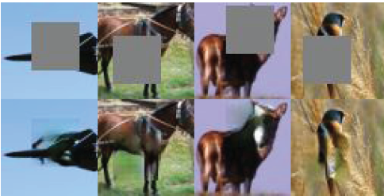

有程序LUA

CGAN - Conditional Generative Adversarial Nets

condition on to both the generator and discriminator

y could be any kind of auxiliary information, such as class labels or data from other modalities

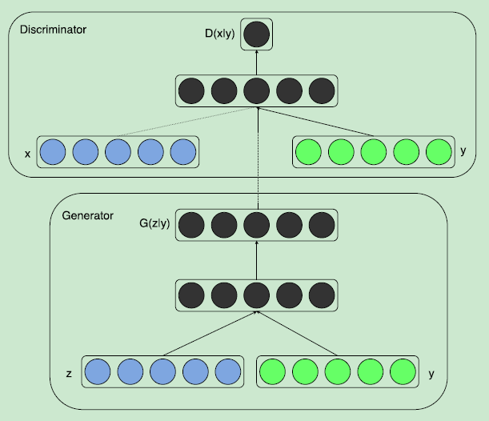



CoGAN - Coupled Generative Adversarial Networks

learning a joint distribution of multi-domain images from data

问题：building a dataset with tuples of corresponding images is often a challenging task.

结构：CoGAN consists of a tuple of GANs, each for one image domain.

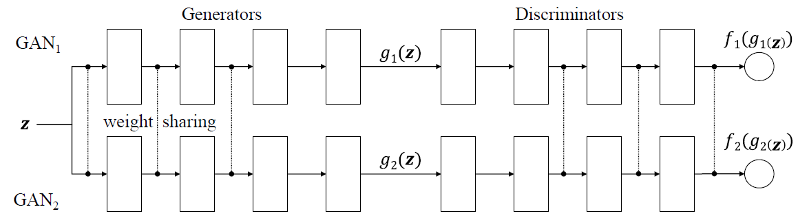

tie the weights

pairs of images sharing the same high-level abstraction but having different low-level realizations.

unsupervised domain adaptation

生成模型可以逐渐的从抽象的概念出来一点点解码出具体地细节出来。因此generator的前面几层解码的是高层的语义信息，比如目标的轮廓，而后面几层解码的是细节，比如边缘。由于我们需要保证高层信息的相关性，因此我们需要g1和g2的前几个层是共享权值的。后面几层的权值就不同了，这样可以根绝高层语义信息解码出不同的细节出来，用来fool各自的判别器。

Caffe / pyTorch

Context-RNN-GAN - Contextual RNN-GANs for Abstract Reasoning Diagram Generation

功能：can generate images for sequential reasoning scenarios

可以用在下一帧预测生成：general enough to be useful for tasks such as next frame generations in a video (where we also achieve strong results on the Moving-MNIST dataset) and other similarly important AI tasks such as forecasting and simulation.

Diagrammatic Abstract Reasoning（DAR--proficiency in DAT-DARs were predictors in engineering training）： an avenue in which diagrams evolve in complex patterns and one needs to infer the underlying pattern sequence and generate the next image in the sequence.

Context-RNN-GANs： both the generator and the discriminator modules are based on contextual history (modeled as RNNs) and the adversarial discriminator guides the generator to produce realistic images for the particular time step in the image sequence.

效果：10th-grade human performance

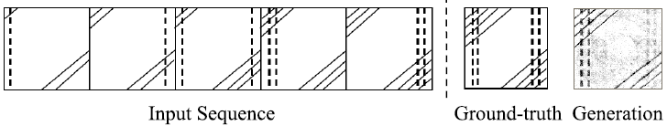

a standard video next-frame prediction task： achieving improved performance over comparable state-of-the-art.

CS-GAN - Improving Neural Machine Translation with Conditional Sequence Generative Adversarial Nets

中英翻译，G翻译，D判断准确

CycleGAN - Unpaired Image-to-Image Translation using Cycle-Consistent Adversarial Networks

Image-to-image translation

for many tasks, paired training data will not be available.

G将原图转化为艺术图片（goal），D分辨生成图片与目标样式（adversarial loss）

模型：an approach for learning to translate an image from a source

domain X to a target domain Y in the absence of paired examples

Because this mapping is highly under-constrained, we couple it with an inverse mapping F : Y🡪X and introduce a cycle-consistency loss to push F(G(X)) 🡪 X (and vice

versa).

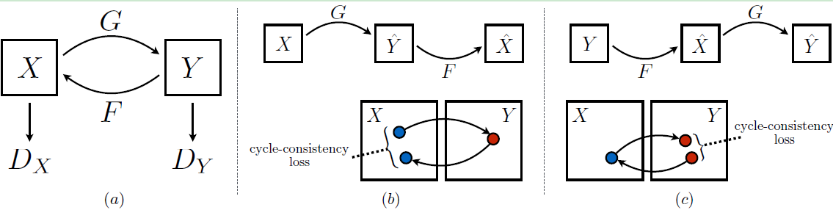

有程序：LUA+Torch

DiscoGAN - Learning to Discover Cross-Domain Relations with Generative Adversarial Networks

Cross-domain relations

目的：transfers style from one domain to another while preserving key attributes such as orientation and face identity

优点：works without any explicit pair labels and learns to relate datasets from very different domains（性别、发色、眼镜、鞋包）

效果：high-quality images with transferred style

DR-GAN - Disentangled Representation Learning GAN for Pose-Invariant Face Recognition代码

pose-invariant face recognition and face synthesis

three distinct novelties

DTN - Unsupervised Cross-Domain Image Generation

目的：transferring a sample in one domain to an analog sample in another domain

图片🡪emoji

DualGAN - Unsupervised Dual Learning for Image-to-Image Translation

Inspired by the success of dual learning paradigm in natural language translation

目的：unsupervised learning framework for general-purpose image-to-image translation, which only relies on unlabeled image data, such as two sets of photos and sketches for the photo-to-sketch conversion task

模型：image translators to be trained from two sets of unlabeled images each representing a domain

结果：For some tasks, our model can even achieve comparable or slightly better results to conditional GAN trained on fully labeled data.

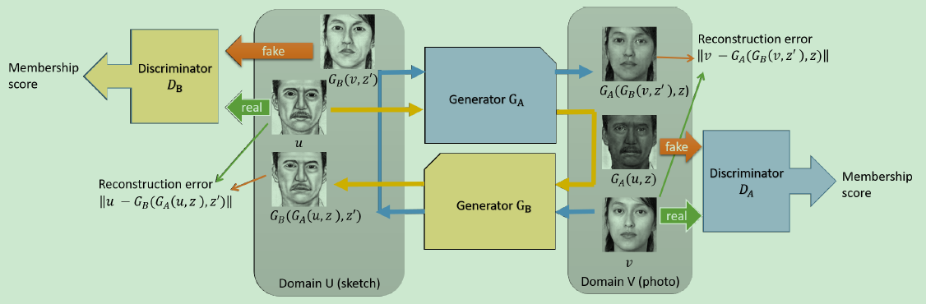

EBGAN - Energy-based Generative Adversarial Network

对GAN的改进，比DCGAN好，效果

the energy-based model (LeCun et al., 2006) is to build a function that maps each

point of an input space to a single scalar, which is called “energy”

The energy function computed by the discriminator can be viewed as a trainable cost function for the generator. The discriminator is trained to assign low energy values to the regions of high data density, and higher energy values outside these regions.

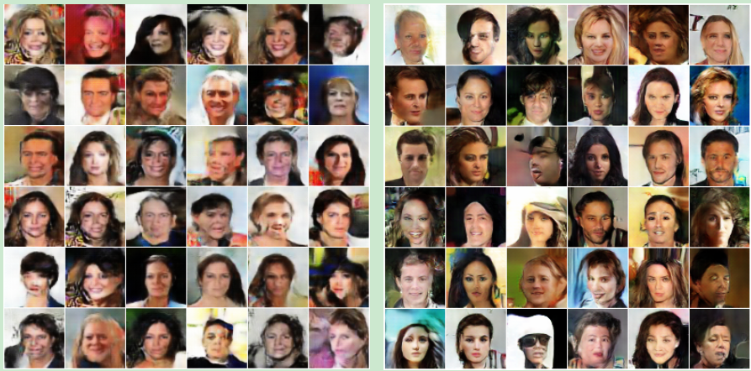

FF-GAN - Towards Large-Pose Face Frontalization in the Wild

目的：to frontalize faces under all pose ranges including extreme profile views（expand pose ranges to 90 degree）

结构：Incorporating 3DMM（deep 3D Morphable Model三维形变模型） into the GAN structure

f-GAN - Training Generative Neural Samplers using Variational Divergence Minimization

any f-divergence can be used for training generative neural samplers

The original GAN is a special case of f-GAN.

f-GAN minimizes the variational estimate of f-divergence（这句话来自下一篇）

f-divergence，散度，表示两个概率分布的相似程度，特例有KL散度、JS散度、H散度、X2散度、alpha散度等。

贡献：We derive the GAN training objectives for all f-divergences and the Kullback-Leibler and Pearson divergences.

Such probabilistic feedforward neural network models were first considered in [22] and [3], here we call these models generative neural samplers. GAN is also of this type, as is the decoder model of a variational autoencoder [18].

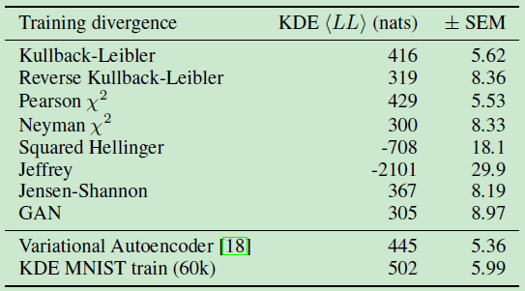

b-GAN - Unified Framework of Generative Adversarial Networks

Multiple viewpoints：what divergence is stable and relative density ratio is useful.

模型：a novel algorithm inspired by GANs from the perspective of density ratio estimation based on the Bregman divergence

The proposed algorithm iterates density ratio estimation and f-divergence minimization based on the obtained density ratio.

GAWWN - Learning What and Where to Draw

问题：While existing models can synthesize images based on global constraints such as a class label or caption, they do not provide control over pose or object location.

目的：Generating realistic images from informal descriptions

算法：Our system exposes control over both the bounding box around the bird and its constituent parts

By modeling the conditional distributions over part locations, our system also enables conditioning on arbitrary subsets of parts (e.g. only the beak and tail), yielding an efficient interface for picking part locations.

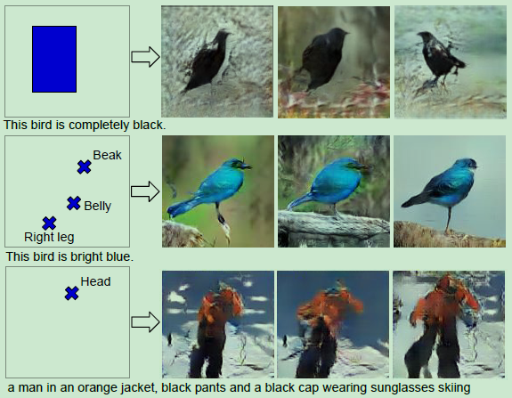

GeneGAN - Learning Object Transfiguration and Attribute Subspace from Unpaired Data

模型是：a deterministic conditional generative model that can perform object transfiguration task

即：extract an object feature vector from a single image and transplanted it to another image, hence allows fine-grained control of generated images, like “putting eyeglasses of A onto noses of B”

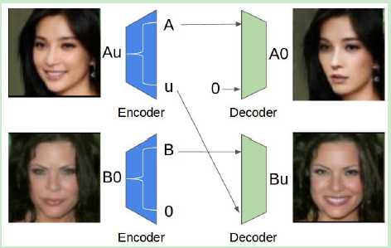

McGan - Mean and Covariance Feature Matching GAN

是什么：Mean and covariance feature matching IPMs（Integral Probability Metrics）allow for stable training of GANs, which we will call McGan.

IPM可以用来度量同一空间中两个概率分布P和Q的距离，W-GAN是最小化Integral Probability Metric（IPM）的一个特例

McGan minimizes a meaningful loss between distributions.

（1）搜索分类超平面：寻找线性分类器的分类超平面。

（2）判别器向远离分类超平面方向更新：判别器参数利用随机梯度下降方法（SGD）向远离分类超平面方向更新。

（3）生成器朝向分类超平面方向更新：生成器参数利用随机梯度下降方法（SGD）沿分类超平面法向量方向更新。

路程：GAN🡪WGAN🡪McGAN (IPM)🡪 geometric GAN

In this paper, inspired by the MMD distance（Maximum Mean Discrepancy objective） and the kernel mean embedding of distributions，we propose to embed distributions in a finite dimensional feature space and to match them based on their mean and covariance feature statistics.

we show in this work that it is theoretically grounded: similarly to the EM distance in (Arjovsky et al., 2017), mean and covariance feature matching of two distributions can be written as a distance in the framework of Integral Probability Metrics (IPM)

Geometric GAN - Geometric GAN

http://mp.weixin.qq.com/s?src=3&timestamp=1496643546&ver=1&signature=CAV3zJ7hrt4i\*\*QDVaXgsYQoGrC8taNGvZpoAutP5s4uNynSFc-upa-ZihCoPrcP7pwLyAu75KzMEGBeRhsG57z7YmA1t0q\*KgTCfq06qnEoD8ohP2rIHEQjkVRBTprBZqvNG5VDwWHdKEdXfNZfjOszSU-k9QymvTbjT3GEP2E=

将线性分类器SVM引入生成对抗网络

主要内容：proposed a novel geometric GAN using SVM separating hyperplane 即：show that the adversarial generative model training can be decomposed into three geometric steps:

separating hyperplane search,

discriminator parameter update away from the separating hyperplane,

generator update toward the separating hyperplane

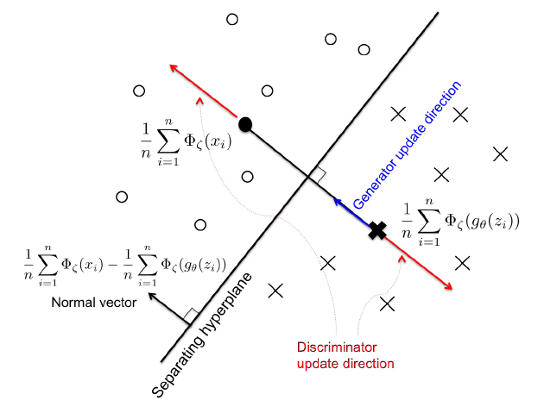

当已知一个分类超平面后，判别器利用随机梯度方法（SGD）更新参数，让真实样本和生成样本在分类超平面法方向上最大程度的远离，即Margin最大；另一方面，生成器也利用随机梯度方法（SGD）更新参数，使生成样本沿分类超平面法方向向分类超平面靠近。

优点：This geometric interpretation proves to be very general, so it can be applied to most of the existing GAN and its variants，可（论文有）应用于GAN [1], f-GAN [3], EB-GAN [13], and W-GAN [7]

InfoGAN - Interpretable Representation Learning by Information Maximizing Generative Adversarial Nets

http://mp.weixin.qq.com/s?src=3&timestamp=1496643102&ver=1&signature=wdjnR4tgs4US\*sGZEYOOnklYzIIbu6OWgr36vfSbOqoRyO\*bH0ov3Xvc9FP7EmZgz7\*3iW6-4DC\*usfWZO8\*XLL1K7w\*QrImXpIeQOtWy95foTAL3biObRLV7ZN09--rmpCQQ5KMBSXIehXTNDyF1Ij90-t-sEx2NrYh-XOxHJI=

一般的GAN的generator输入是“噪声”（noise，也称为latent code，姑且称为“图编码”），输出是根据“图编码”产生的图像【PS：我觉得这种做法有问题，但是想不到改进的方法】。我们完全不知道generator会怎样利用“图编码”，“图编码”可能完全交织在一起，很难确定“图编码”每个维度的具体语义，或者说，不知道“图编码”的每个维度分别控制着图像的哪些特征。

作者认为这种generator的输入是unstructured latent code，并不能很好地解释图像产生的参数，应该将generator的输入分为两部分，一部分还是noise，不可压缩的噪声向量，记为z；另一部分是structured latent code，控制数据分布的语义特征，如视角、光照等，记为c。简而言之，noise负责控制生成图像的内容，structure latent code负责控制图像的一些属性特征。

一般来说，一张图像具有很多属性特征，设有L个属性，不妨假设它们是相互独立的。

控制图像属性的structure latent code应该是与图像内容无关的变量，也就是说，p(c|x)的熵应该尽可能地小，也就是说，c与G(z,c)的互信息I(c, G(z,c))应该尽可能地大。换句话说，当c给定以后，图像x的不确定性减少量应该尽可能地大。

为了实现最大化互信息，以使structured latentcode能够控制图像的属性，作者在loss function中引入互信息正则化项，因此，InfoGAN是如下的minmax博弈：



从上式可以看出，互信息正则项只对generator起作用。

然而，通过上式我们并不能启动训练，因为它实际上需要知道后验概率p(c|x)，而这是我们无法得知的。没办法得到后验概率，那我们就让模型自己学后验概率...

作者从理论上推导了，如果用Q(c|x)来逼近后验概率P(c|x)，那么互信息I(c, G(z,c))具有如下的下界：

看论文：

Train：哪部分，以什么为目的，loss方向是什么，train了什么

Test：用了哪一支路，怎么test

实验：

了解经典数据库，提供图？标签？

看了在这个数据库上做了什么

做什么的+大概方法