Transfer Reports SFTP
V1.0.2
Description-
The module allows you to transfer a report securely as a csv file using SFTP. The module has an hourly cron that will check preferences and triggering your upload. To limit resources used, it can only upload a report once per day. You can also trigger the module with a button or a data entry trigger.
The module uses phpseclib, one of the best ways to implement SFTP in PHP. According to AI and SFTP Cloud, here are some of the reasons why:
- Comprehensive Security: phpseclib is a pure PHP implementation, supporting a wide range of cryptographic algorithms, ensuring secure file transfers[1].
- Wide Compatibility: It works with various PHP versions, including older ones, and doesn't require external dependencies[1].
- Ease of Use: The library offers a straightforward API, making it easy to perform complex tasks with minimal code[1].
- Advanced Features: It includes features like directory sorting, resuming transfers, and more[1].
- Active Development: phpseclib is actively maintained and regularly updated[1].
Reference: SFTP Cloud

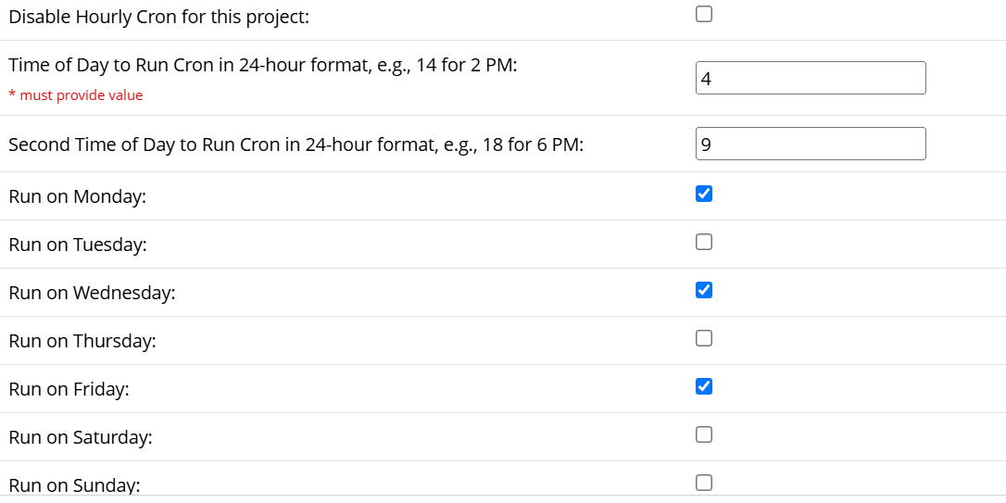

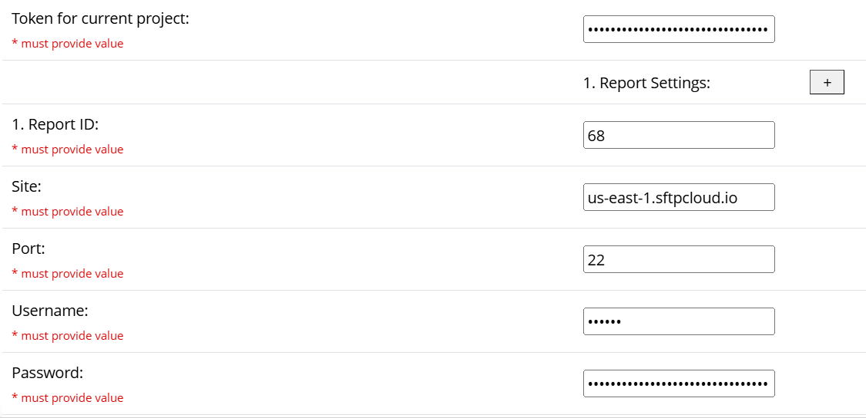
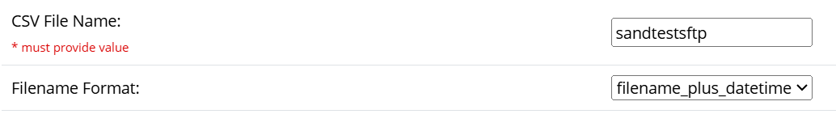

Super users and project builders can transfer the report by clicking the following button under External Modules. To give all users the ability to transfer data you will need to create a bookmark.

Contact for issues-
Gary Rains
IT Analyst for Duke University School of Medicine
Gary.Rains@duke.edu

