Test case 1: Compile the Module
simple.ko -
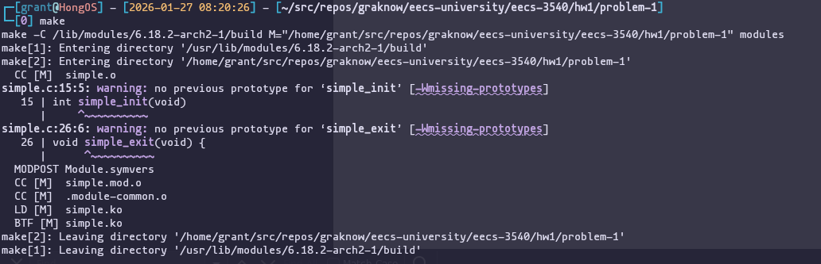
seconds.ko -
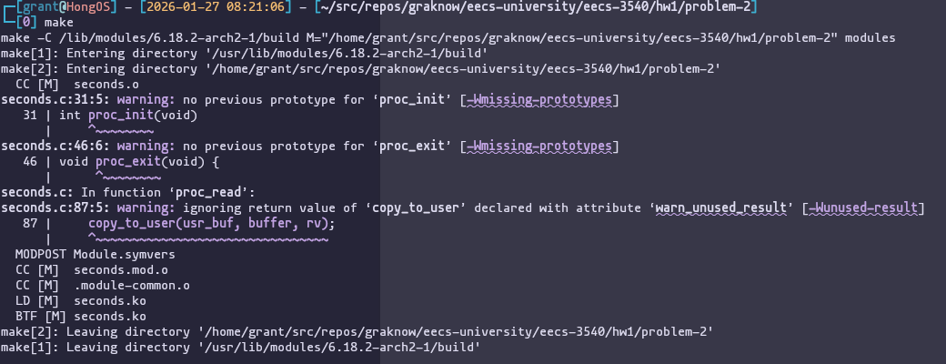
Test case 2: Load the Kernel Module
simple.ko -
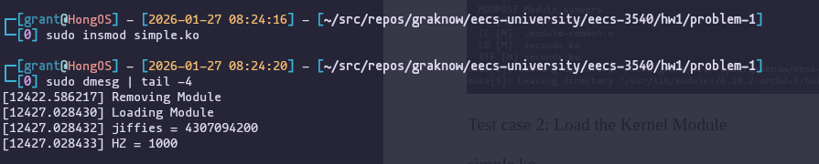
seconds.ko -
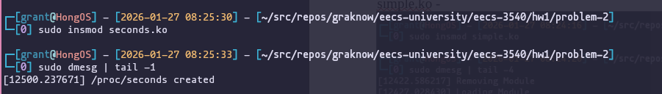
Test case 3: Verify /proc/seconds
Test case 4: Read /proc/seconds
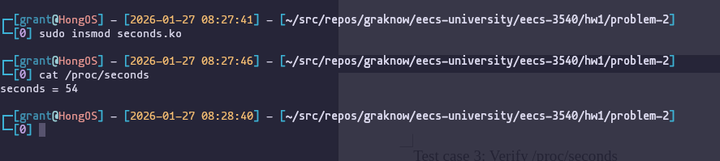
Math - Elapsed time from 08:27:46 to 08:28:40 is 54 seconds.

Test case 5: Remove the Kernel Modules
simple.ko -
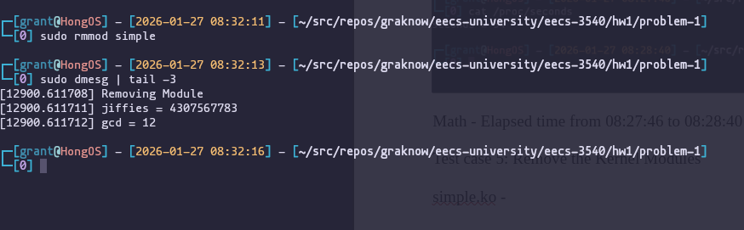
seconds.ko -
