Test Case 1: Validate All Puzzles
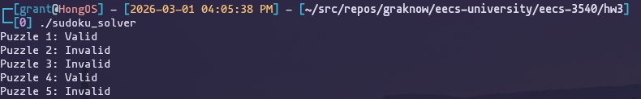
Test Case 2: Validate Single Puzzle
Test Case 3: Validate Invalid Puzzles
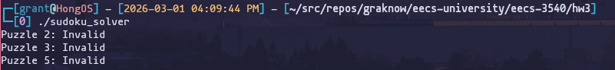
Test Case 4: Measure Execution Time with Different Thread Counts (Much variation in timing results)
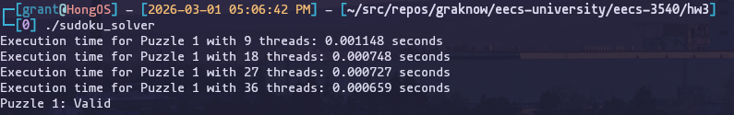
Test Case 5: Thread Progress Logging
