Test Case 1: Single Producer and Single Consumer
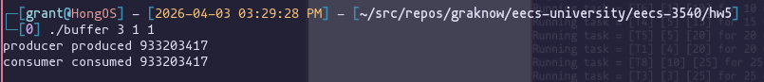
Test Case 2: Multiple Producers and Multiple Consumers
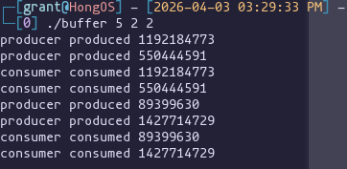
Test Case 3: Buffer Full Condition
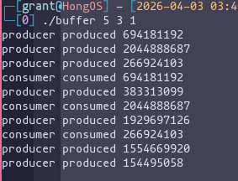
Test Case 4: Buffer Empty Condition
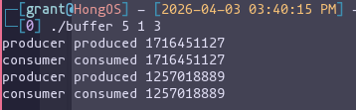
Test Case 5: Rapid Alternation Between Producers and Consumers
