Test Case 1: ps -ael
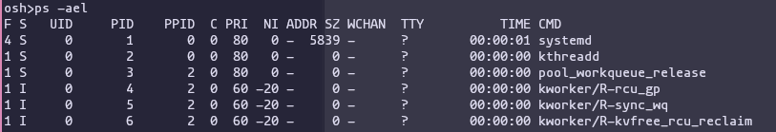
Test Case 2: !!
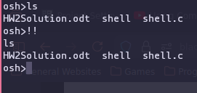
Test Case 3: ls > output.txt
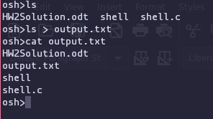
Test Case 4: sort < input.txt
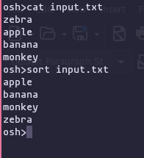

Test Case 5: ls -l | grep shell
