Test Case 1: Shortest-Job-First (SJF)
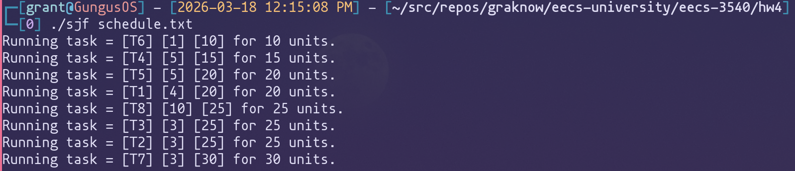
Test Case 2: Priority Scheduling
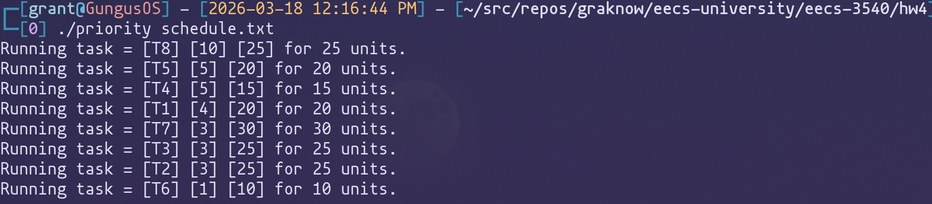
Test Case 3: Round-Robin (RR)
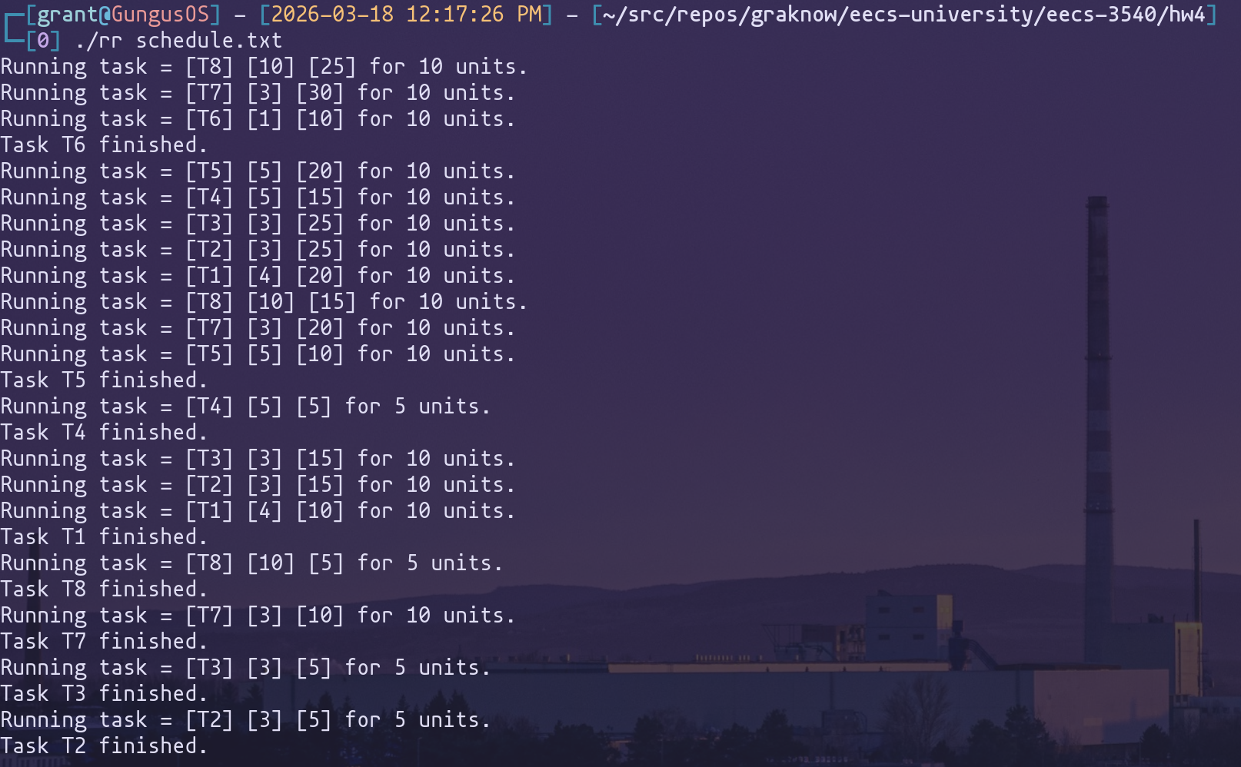
Test Case 4: Priority with Round-Robin
