For the following:
Product: Desktop FFF 3D Printer
Model: LulzBot TAZ 6
Serial number: KT-PR0041-****

Manufacturer:
Aleph Objects, Inc.
626 West 66th Street
Loveland, Colorado 80538 USA
+1-970-377-1111

Year of declaration: 2016
We hereby declare under our sole responsibility that the product above is in compliance with the essential requirements of the Low Voltage Directive (2014/35/EU), Electromagnetic Compatibility Directive (2014/30/EU) and Restriction of the use of certain hazardous substances (2011/65/EU) by the application of:

Standard: Title:
FCC 47 CFR 15 Subpart B Unintentional Radiators
ICES-003 Issue 5 (2012-11) Information Technology Equipment
EN 55022: Ed 6 (2010-12) Radio Disturbance Characteristics
EN 55024: Ed 2 (2010-11) Immunity Characteristics
EN 55032: Ed 1 (2012-10) Emissions Requirements
CISPR 22: Ed 6 (2008-29) Radio Disturbance Characteristics
CISPR 24: Ed 2 (2015-04) Immunity Characteristics
CISPR 32: Ed 2 (2015-03) Emissions Requirements
AS/NZS CISPR22(2010-12) Radio Disturbance Characteristics
AS/NZS CISPR24 (2013-06) Immunity Characteristics
AS/NZS CISPR32 (2013) Emissions Requirements
EN 61000-4-2 Electrostatic Discharge
EN 61000-4-3 Radiated RF Immunity
EN 61000-4-4 Electrical Fast Transients/Burst
EN 61000-4-5 Surge Immunity
EN 61000-4-6 Conducted RF Immunity
EN 61000-4-11 Voltage Dips and Interruptions
EN 61000-3-2 AC Power line harmonics
EN 61000-3-3 Flicker

The technical documentation is kept at the Manufacturer's address.

Jeffrey S. Moe, CEO
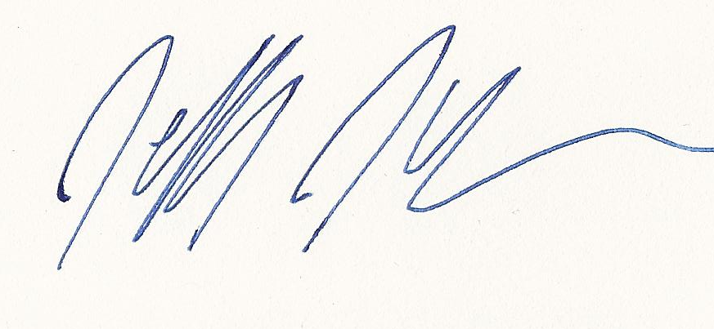
Date of issue: March 29th, 2016
Place of issue: Loveland, Colorado, USA

