GrALoG FX

User Manual

Viktor Engelmann

General
GrALoG FX is a java-framework for (finite) graphs, automata, games and any other (finite) algebraic structure. It applies modern programming-paradigms (in particular Liskovs substitution principle, inversion of control and reflection) to achieve easy extensibility. Its main goal is to allow you to write plug-ins with minimal friction.

At the moment, GrALoG FX contains these 4 projects:

- GrALoG Core
contains the base-classes for structures, algorithms, generators, import and export-filters. It also contains the (reflection-based) plugin-management, event-classes and some basic functionality like storing and loading files, a spring-embedder and a rendering-engine that renders graphs on an abstract GraphicsContext.
- GrALoG FX
is the Java-FX based GUI. It mainly just invokes the methods of GrALoG Core, shows results and implements a concrete GraphicsContext, which is passed to the rendering-enginge of GrALoG Core.
- GrALoG Automaton
is a plug-in that adds classes for automata and the usual algorithms, like acceptance-test, powerset-construction and minimization. It also adds generators that generate automata from search-patterns (Knuth-Morris-Pratt algorithm) and regular expressions (Thompson-construction).
- GrALoG Modal Logic
is a plug-in which adds classes for Kripke-structures and Model-checking of modal-logic formulas on them.

Program Startup

We assume you have aquired the GrALoG FX projects sources and installed Oracle NetBeans. To get started, launch NetBeans, go to File → Open Project...:
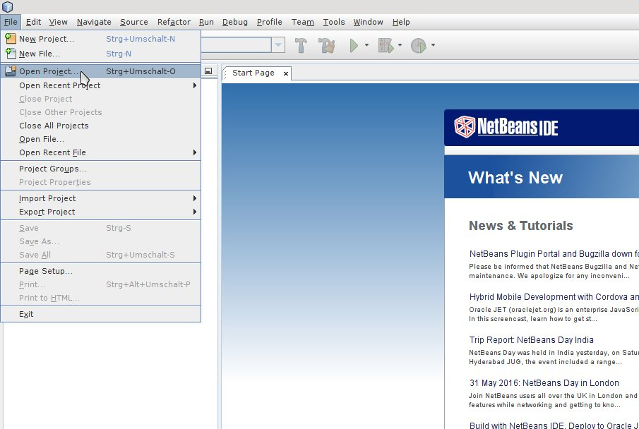

Navigate to the directory that contains the projects, select all of them and click „Open Project“:

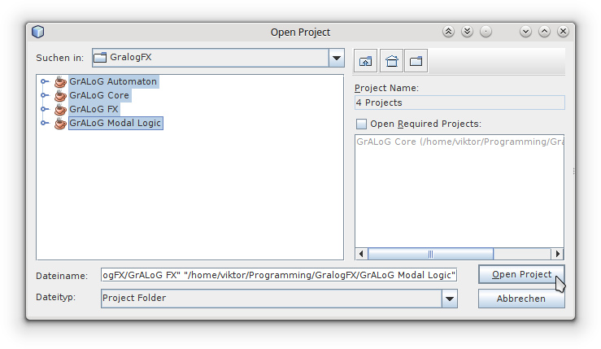

Your working environment should now look similar to this:
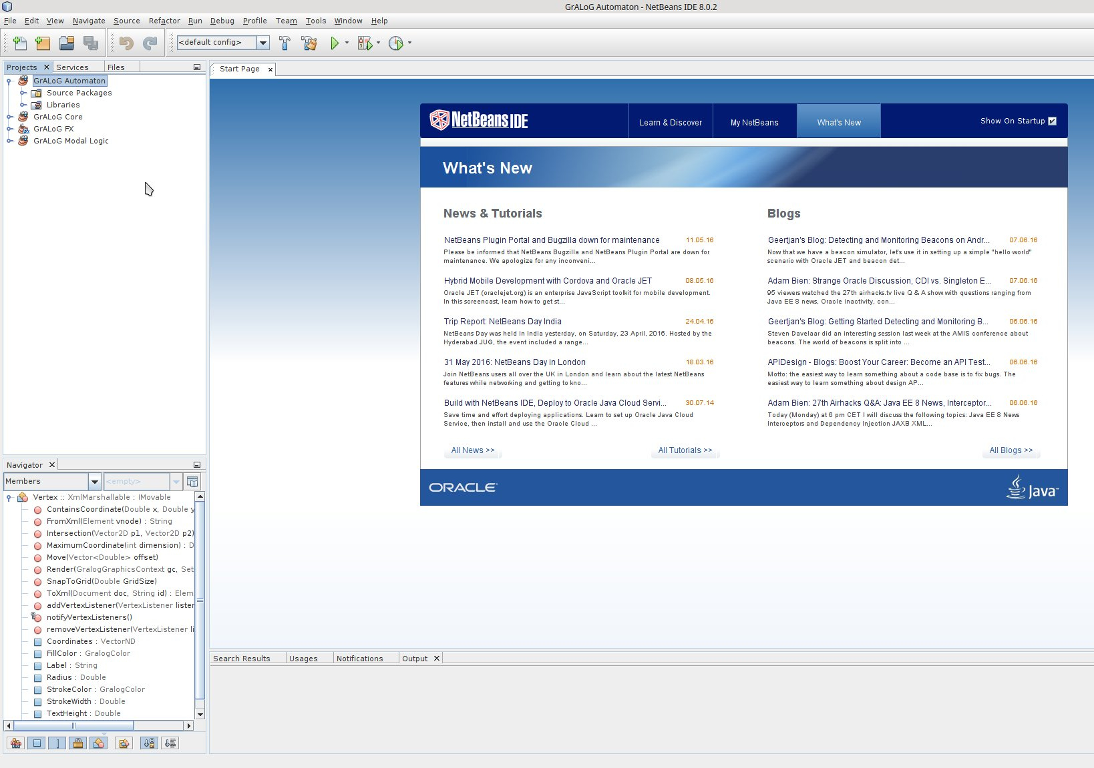

To launch GrALoG FX, right-click on the project „GrALoG FX“ and choose „Run“:
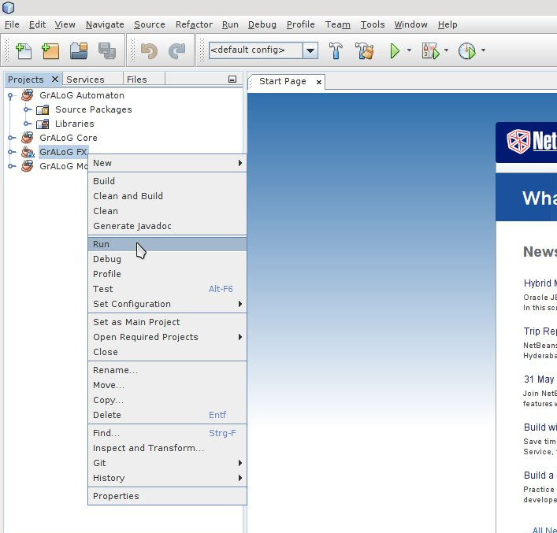

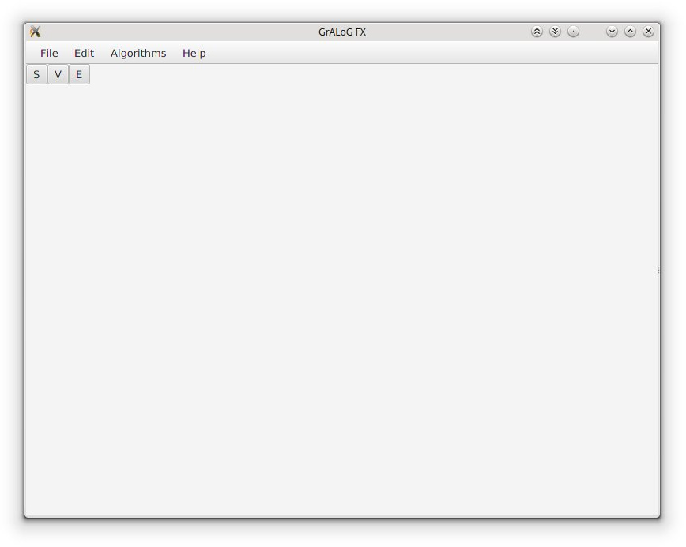
You will get a window like this:

Known Issues
- On some machines, netbeans seems to execute GrALoG FX in a different directory. Because of this, GrALoG does not find the plugins in the relative directories, which causes Exceptions to be thrown on startup

Creating and Editing Structures

Go to File → New → and select the kind of structure you want to create (e.g. Directed Graph):

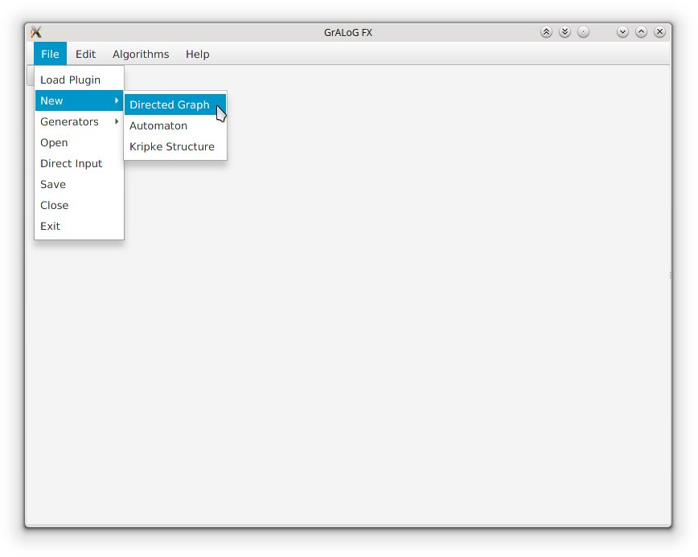
GrALoG FX will open a new tab with an empty digraph:
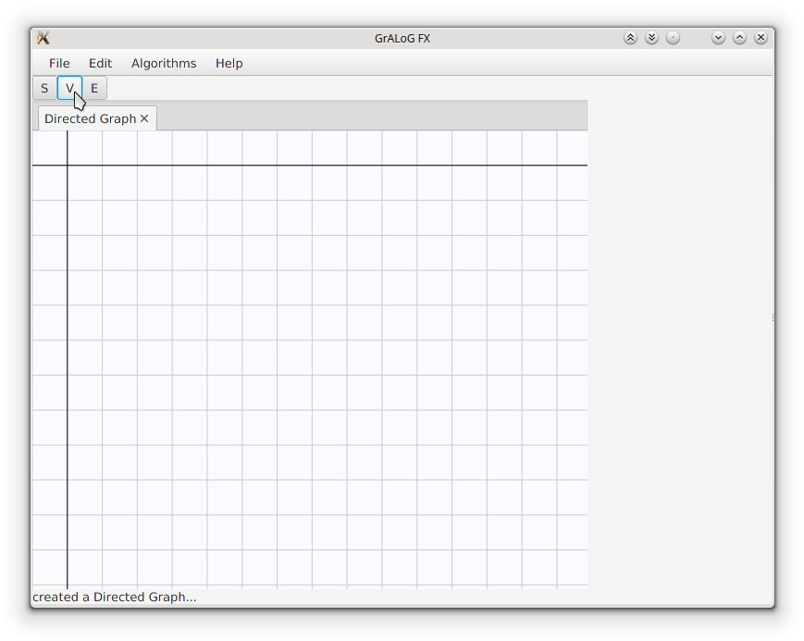

Click on the „V“ in the button-bar. You can now create vertices by clicking into the grid:

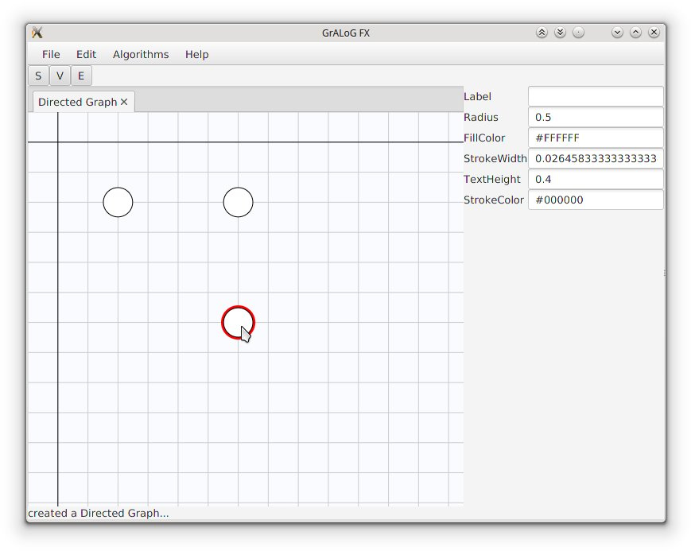
Notice how the side-bar on the right shows several properties of the last created vertex.

Now click on the „E“ in the button-bar:
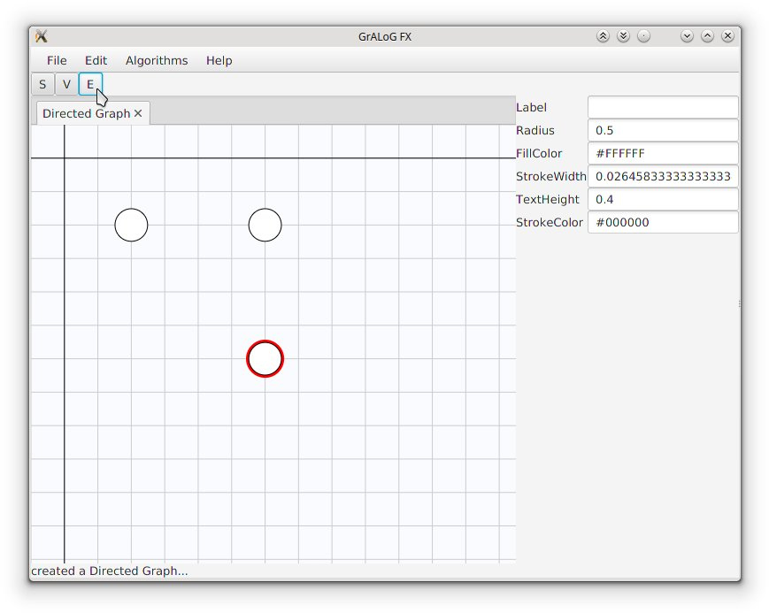

Press the left mouse button on one vertex and release it over another vertex to create an edge:
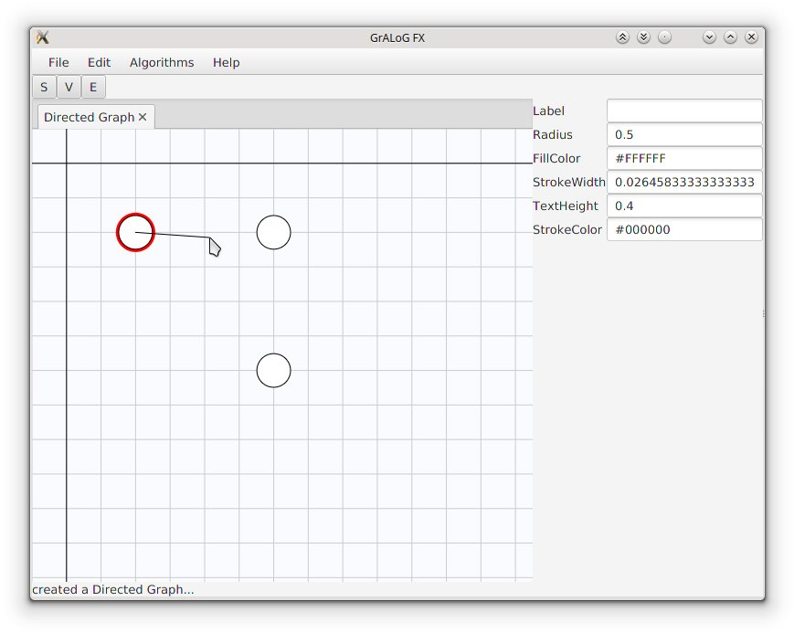
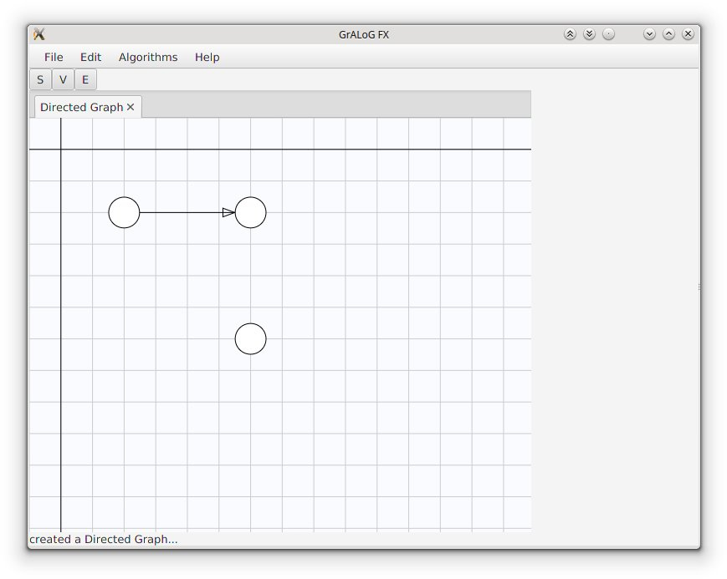

If you click on an existing edge while in edge-mode, you insert an intermediate point into it:

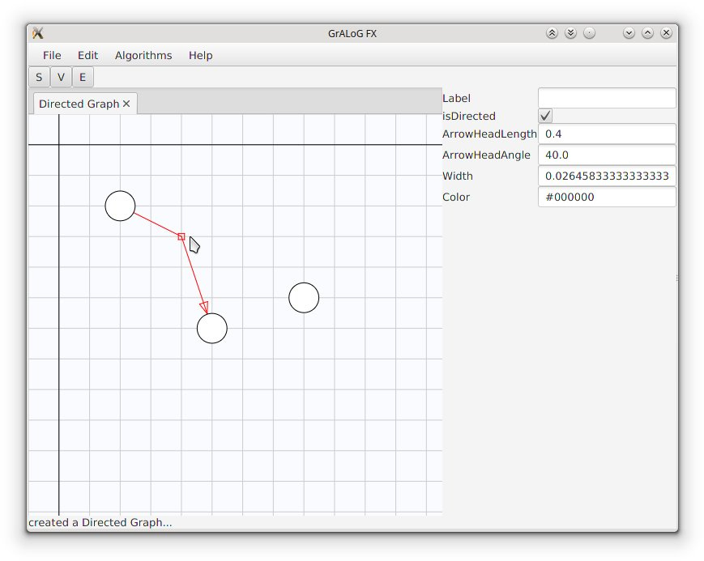
Click on the „S“ in the button-bar, You can now drag vertices.
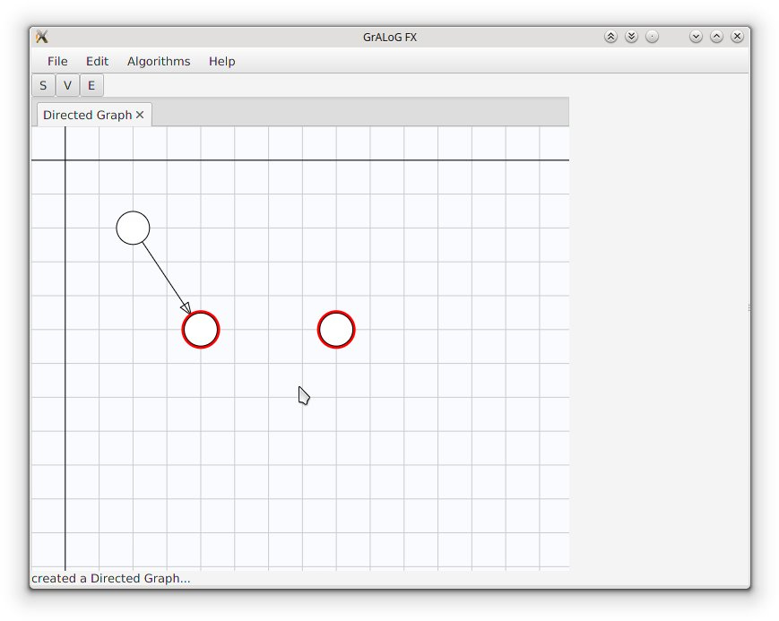

If you hold the ctrl-key, you can select multiple vertices together.

You can also select edges to edit their properties in the side-bar on the right:

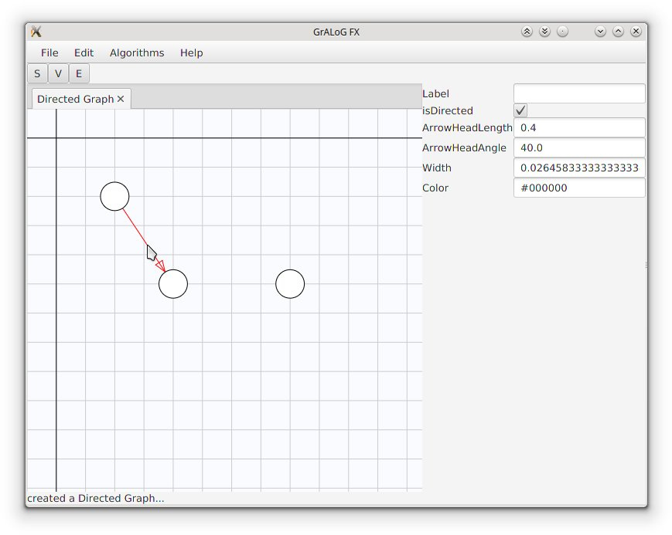
For common structure-classes, you can use generators instead of creating them manually (at the moment, there are only few generators, but this is supposed to change over time).

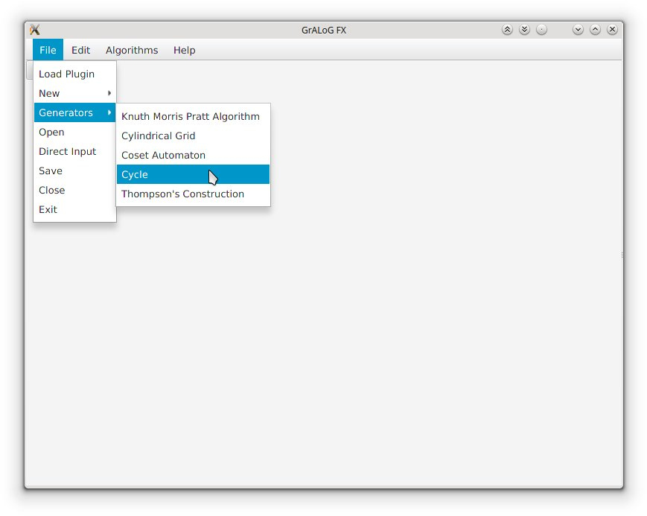

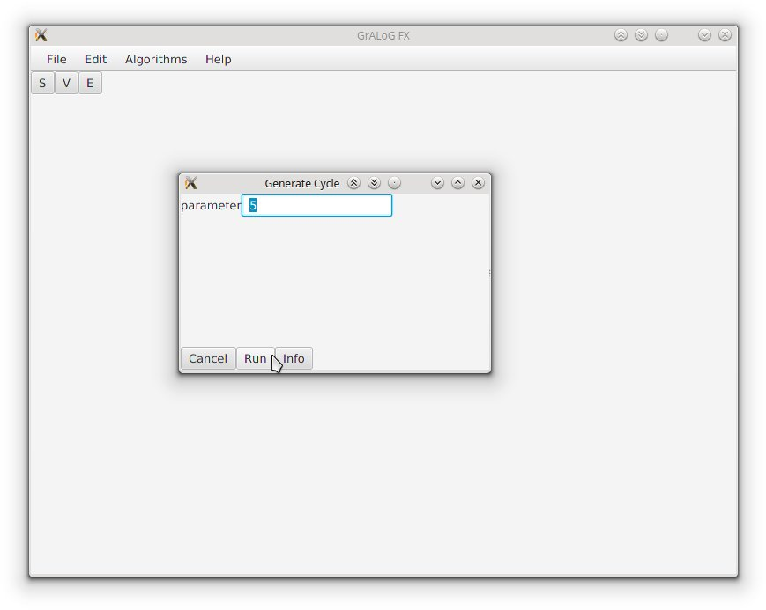
Most generators will offer options to specify certain properties of the result (e.g. the number of vertices):

Clicking „Info“ (if present) will open a website containing informations about the structure class.

Click „Run“ to generate the structure:
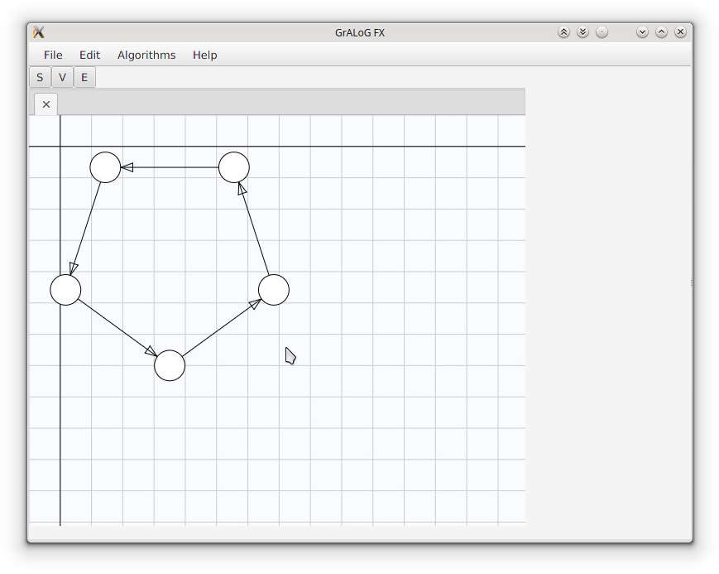

If you are familiar with a file-type that GrALoG supports, you can also go to File → Direct Input:

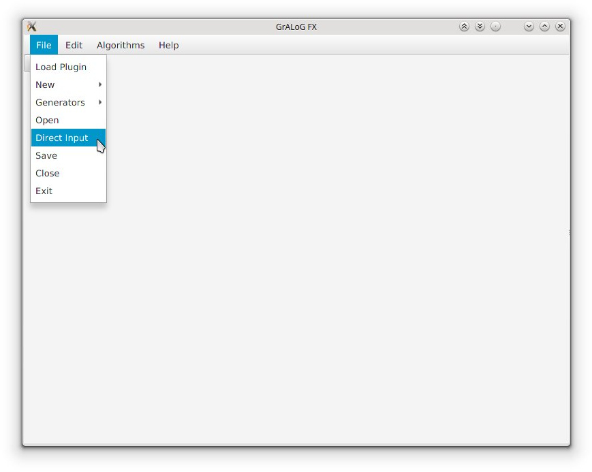
Select the file-type (e.g. Trivial Graph Format):
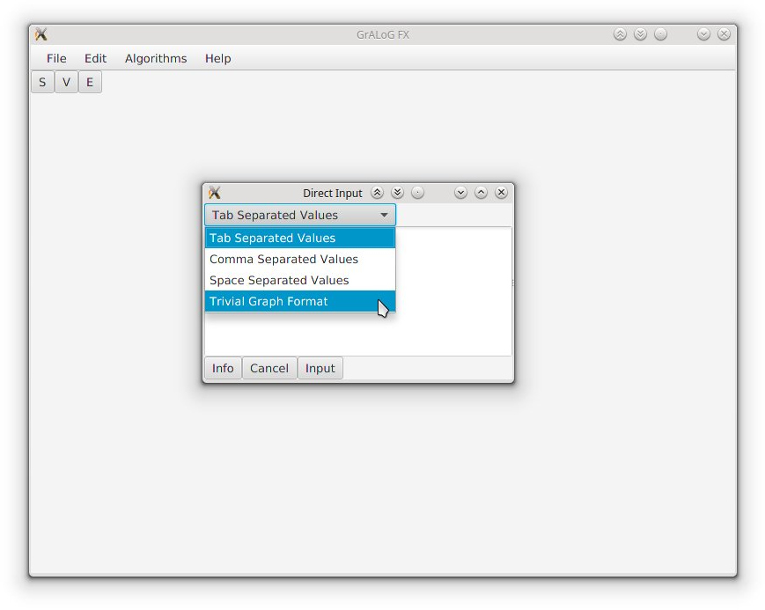

Then you can type in a structure in the selected format:

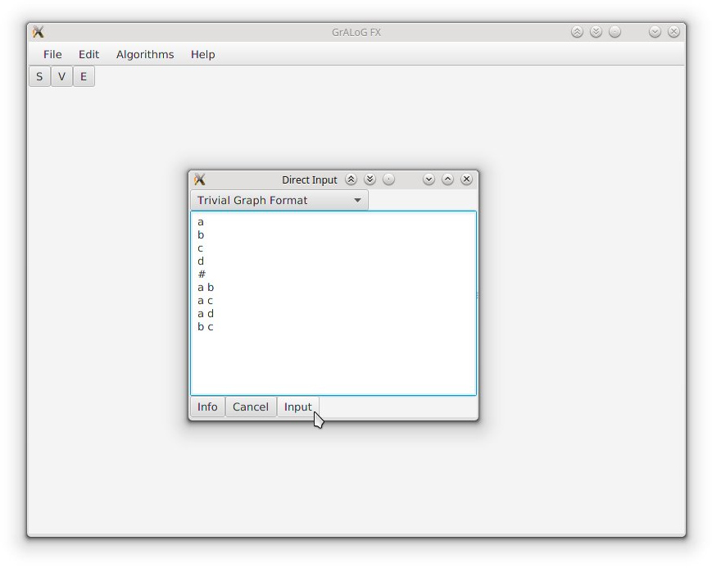
Clicking „Info“ (if present) will open a website containing informations about the selected file format (possibly telling you how to type in the structure). Clicking „Input“ will create the structure you typed in:
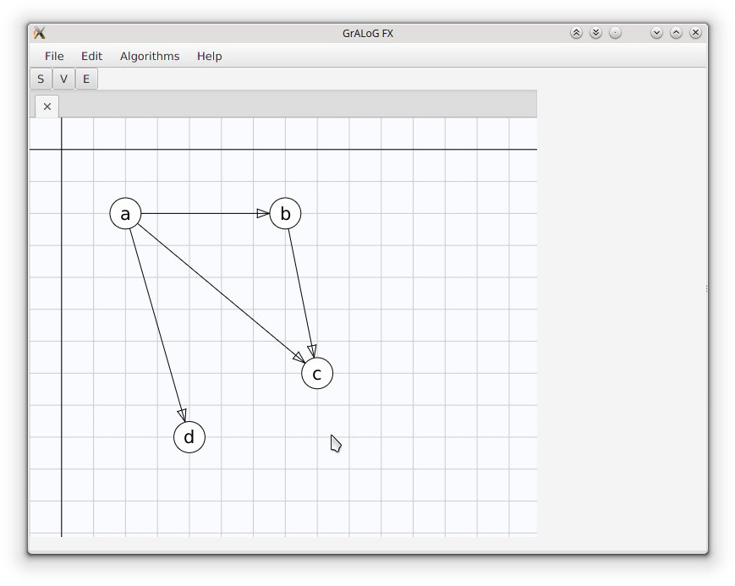

Saving and Loading

To save a structure to a file, go to File → Save:

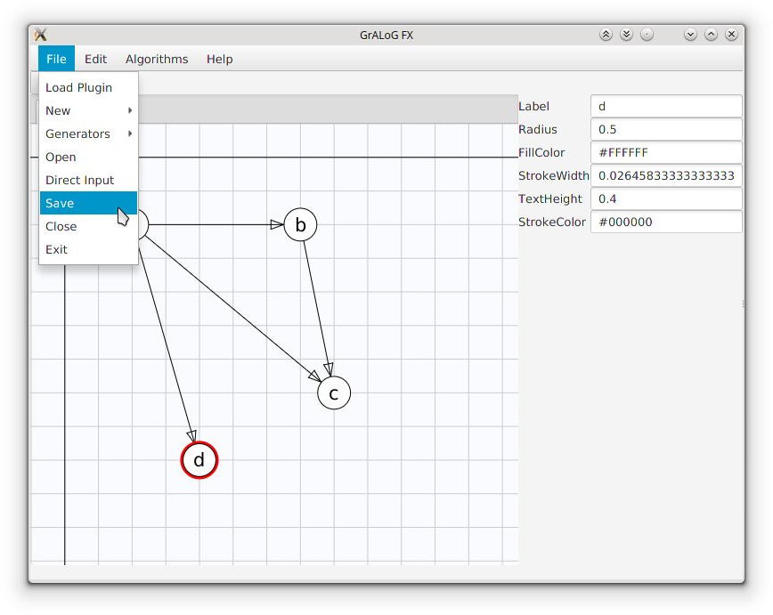
Select a directory, file-name and file-type. Then Click „Save“
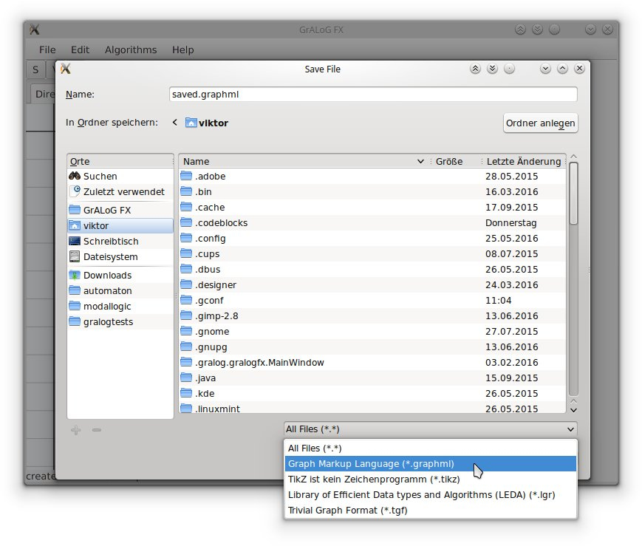

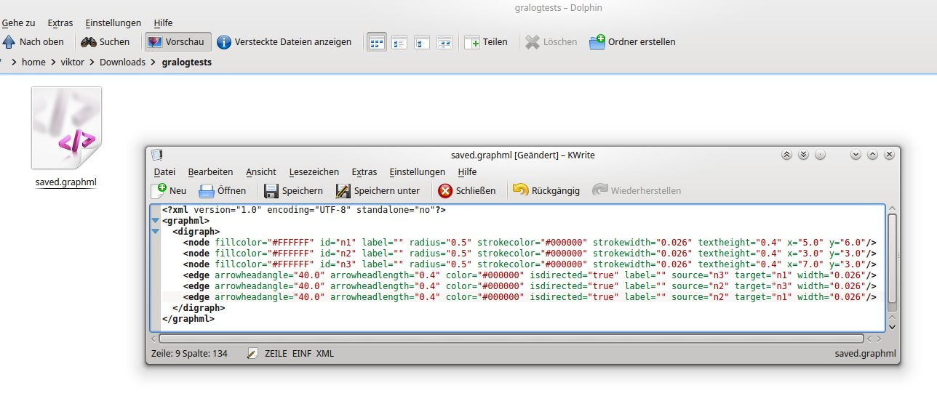
Expectedly, GrALoG creates the file:

Then you can load the file later by going to File → Open and locating it in the open-menu:
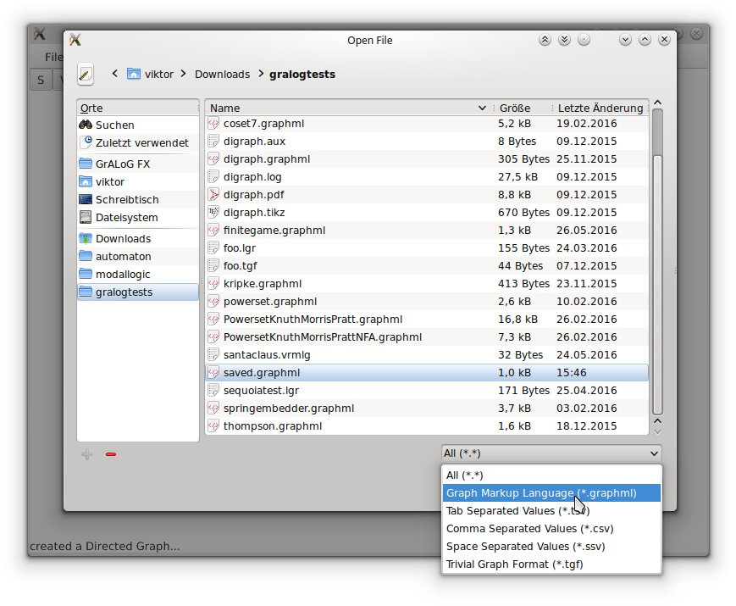

Notes
- GrALoG only offers file-types that are compatible to the currently selected structure. For example it does not offer file-types for automata, if you have selected a directed graph.
- Some file-types (like TikZ) are only for exporting and have no corresponding import-filters.
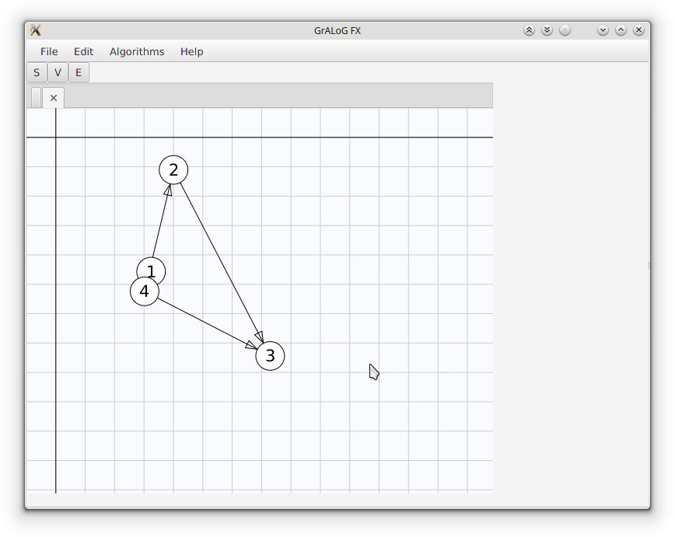
- Not all export-formats support all features of the structure-classes. For example TGF has no way of specifying coordinates, colors or labels, so these informations are unrecoverably lost if you save a graph to *.tgf and load it again.
GraphML is GrALoGs native file format and supports all of its features. We strongly recommend using this format.

