PAPER Template for SMC 2009

First author | Second author | Third author
School  Email | Company  Email | Company  Email

ABSTRACT
The abstract should be placed at the top left column and should contain about 150-200 words.

INTRODUCTION
This template includes all the information about formatting manuscripts for the SMC 2009. Please follow these guidelines to give the final proceedings a uniform look. If you have any questions, please contact the conference Programme Chairs.
This template (in Word and Latex formats) can be downloaded from the SMC 2009 web site (http://smc2009.smcnetwork.org/). (Some users may recognize that this template is an adaptation of the ISMIR template.)

PAGE size
The proceedings will be printed on letter-size paper (21.6 x 27.9 cm or 8.5" x 11"). All material on each page should fit within a rectangle of 7" x 9" (17.78cm x 22.86cm), centered on the page, beginning 1" (2.54cm) from the top of the page and ending with 1" (2.54cm) from the bottom. The left and right margins should be 0.75" (1.9cm). The text should be in two 3.3" (8.4cm) columns with a 0.4" (1cm) gutter. All text must be in a two-column format. Text must be fully justified.

Typeset Text

Normal or Body Text
Please use a 10pt (point) Times font, or other Roman font with serifs, as close as possible in appearance to Times. Please use sans-serif or non-proportional fonts only for special purposes, such as distinguishing source code text.
The first paragraph in each section should not be indented, but all other paragraphs should be.

Title and Authors

SMC 2009, July 23-25, Porto, Portugal
Copyrights remain with the authors
The title is 14pt Times, bold, caps, upper case, centered. Authors' names are centered. The lead author's name is to be listed first (left-most), and the co-authors' names after. If the addresses for all authors are the same, include the address only once, centered. If the authors have different addresses, put the addresses, evenly spaced, under each authors' name.
Reviews are double-blind. Author information should be removed from this page in initial submissions, and only added later by the authors when sending camera-ready versions.

Page Numbering, Headers and Footers
Do not include headers, footers or page numbers in your submission. These will be added when the publications are assembled.

First level headings
First level headings are in Times 10pt bold, centered with 1 line of space above the section head, and 1/2 space below it. For a section header immediately followed by a subsection header, the space should be merged.

Second Level Headings
Second level headings are in Times 10pt bold, flush left, with 1 line of space above the section head, and 1/2 space below it. The first letter of each significant word is capitalized.

Third Level Headings
Third level headings are in Times 10pt italic, flush left, with 1/2 line of space above the section head, and 1/2 space below it. The first letter of each significant word is capitalized.
Using more than three levels of headings is highly discouraged.

Footnotes and Figures

Footnotes
Indicate footnotes with a number in the text. Use 8pt type for footnotes. Place the footnotes at the bottom of the page on which they appear. Precede the footnote with a 0.5pt horizontal rule.

String value | Numeric value
hello SMC | 1073
Table 1. Table captions should be placed below the table
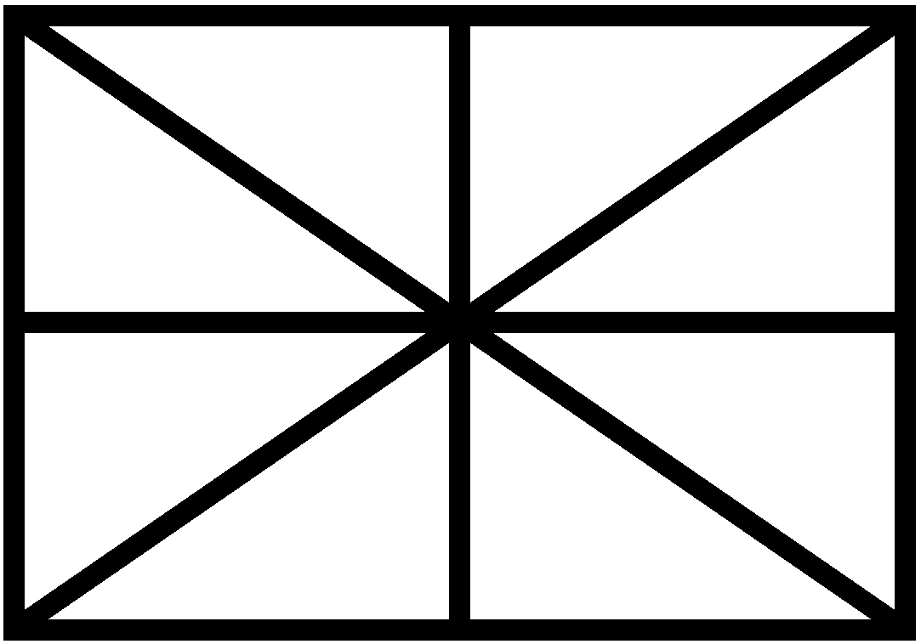
Figure 1. Figure captions should be placed below the figure

Figures, Tables, and Captions
All artwork must be centred, neat, clean, and legible. All lines should be very dark for purposes of reproduction and art work should not be hand-drawn. The proceedings are not in colour, and therefore all figures must make sense in black-and-white form. Figure and table numbers and captions always appear below the figure. Leave 1 line space between the figure or table and the caption. Each figure or table is numbered consecutively. Captions should be Times 10pt. Place tables/figures in text as close to the reference as possible. References to tables and figures should be capitalized, for example: see Figure 1 and Table 1. Figures and tables may extend across both columns to a maximum width of 7" (17.78cm).

Equations
Equations should be placed on separated lines and numbered. The number should be on the right side, in parentheses.
(1)

Citations
All bibliographical references should be listed at the end, inside a section named ``REFERENCES''. All references listed should be cited in the text. When refering to a document, type the numbering square brackets [1].

REFERENCES
- Author, E. ''The title of the conference paper'', Proceedings of the 5th Sound and music Computing Conference, Berlin, Germany, 2008.
- Someone, A. Title of the book. Editorial Acme, Barcelona, 2004.

This a footnote

