**Fertility Optimization Tool**

**USER MANUAL**

**TABLE OF CONTENTS**

Section One: Server Configuration 3

1.1. Overview 3

1.2. Windows Components 3

1.3. Installing ASP.NET v4.5 4

Section Two: Mobile Client 5

2.1. Overview 5

2.2. New Calculation Operations 5

2.3. Previous Calculation Operations 7

Section Three: Web Client 1

3.1 Overview 1

3.2 Regions 1

3.3 Reports 3

3.4 Resources 5

**ACRONYMS**

|  |  |
| --- | --- |
| **SQL** | Structured Query Language |
| **CD-ROM** | Compact Disc – Read Only Memory |
| **IIS** | Internet Information System |
| **IP** | Internet Protocol |
| **DVD-RW** | Digital Video Drive – Re-Writable |
| **RAM** | Random Access Memory |
| **DIMM** | Dual In-line Memory Module |
| **NIC** | Network Interface Card |
|  |  |
|  |  |

# Section One: Server Configuration

## Overview

The Fertility Optimization Tool runs off a **Microsoft Windows Server 2008 R2 64-bit** operating system. This section presents the necessary configurations needed to enable proper functioning of the tool



## Windows Components

The Fertility Optimization Tool was built on the Microsoft ASP.NET framework but by default windows components that are necessary for hosting asp.net web applications are not enabled, therefore it’s advisable to enable the relevant components as follows

* Navigate to control panel and select uninstall programs. Click ***Turn Windows features on or off*** link located on the left of the Control Panel Home. This opens a windows features dialog box
* Ensure that the three major features required to host asp.net applications are selected (i.e. Internet Information Services, Internet Information Services Hostable Web Core and Microsoft.NET Framework 3.5.1)

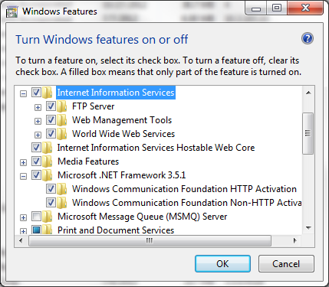

* Click **OK** to proceed and complete the installation which requires a reboot of the system on completion
* After the system reboot check to ensure that a folder path ***C:\inetpub\wwwroot*** is created and typing ***inetmgr*** shotcut in the run programs dialog “ CTL+R“ opens up an Internet Information Service Manager

## Installing ASP.NET v4.5

Enabling of the windows components installs the asp.net v2.0 framework but asp.net v4.0 is also required.

* Browse to <http://www.microsoft.com/en-us/download/details.aspx?id=30653> and click the download button to get an executable offline setup of the Microsoft .NET Framework 4.5

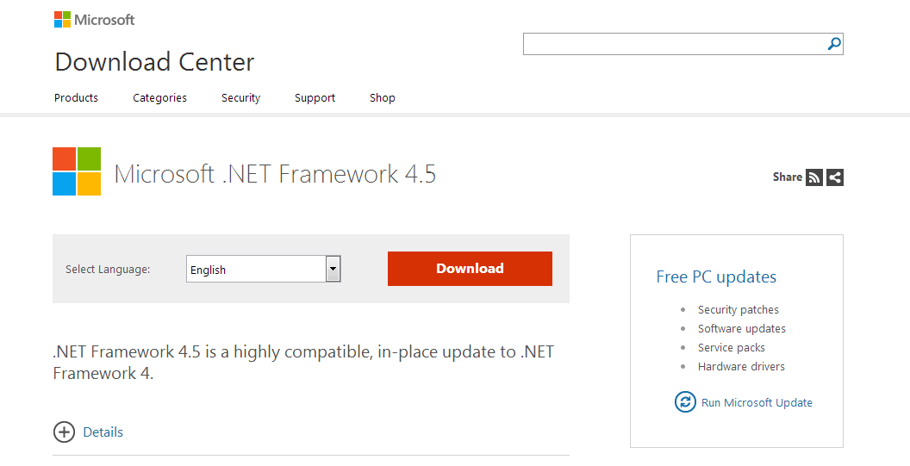

* On completion of the download, run the setup as administrator by right clicking the file and selecting ***run as administrator*** option. Follow the prompts to complete the installation process. On completion the system will require a reboot so as to apply the changes made to the operating system
* After the system reboot open the IIS Manager and check whether ASP.NET v4.0 application pools are added. If successful the server is now capable of hosting both asp.net v2.0+ and asp.net v4.0+

# Section Two: Mobile Client



## Overview

The Fertility Optimization Tool has a mobile client / application which is used to carry out the optimization calculations. This section details what components are available and how to use them

## New Calculation Operations

1. To start a new calculation, swipe from left to right or tap the three lines at the top left corner to reveal the left side menu below. Tap the New Calculation menu item

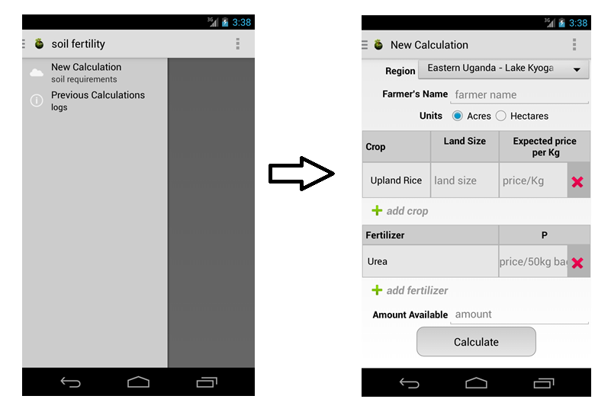

1. On selection of the New Calculation menu item the form below for calculating the respective optimization requirement using the fields below
   * **Region**

All the uploaded spread sheets belong to a specific region. All these regions are shown with in the region dropdown for ease of selection

* + **Farmer’s Name**

The farmer is expected to enter their name in the “farmer name” textbox. This is a mandatory field

* + **Units**

The units in which the calculation results need to be presented to the client are chosen. They can either be Acres or Hectares

* + **Crop**

In this section, crops available in the spread sheet for the given region can be added to be included in the calculation by taping the “add crop” button.

To change a specific crop, simply tap that name to access a popup containing all the available crops in that region. To ignore, simply tap away from the popup to cause it to disappear.

To remove a crop from the calculation, tap the “X” at the extreme right of that crop, this causes it to disappear from the display

Both the Land size and expected price per Kg are required entries for each crop added into the calculation.

* + **Fertilizer**
  + **Amount Available**
  + **Calculate Button**

1. An Example of a new calculation in the region of Eastern Uganda- Lake Kyoga by farmer josh is shown below
2. 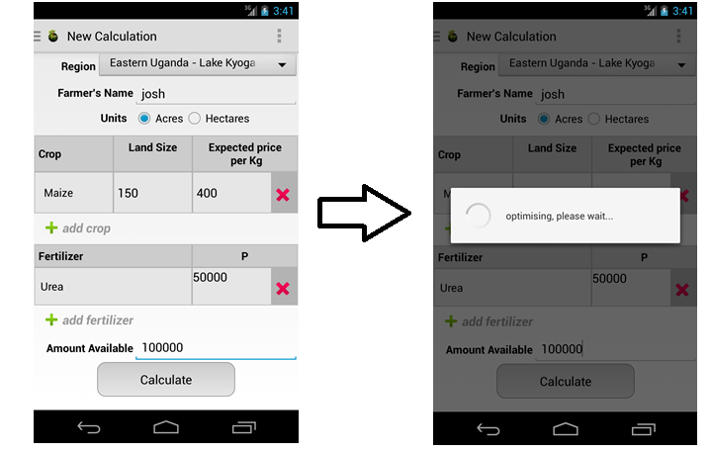

The results of the above calculation would be represented as shown below

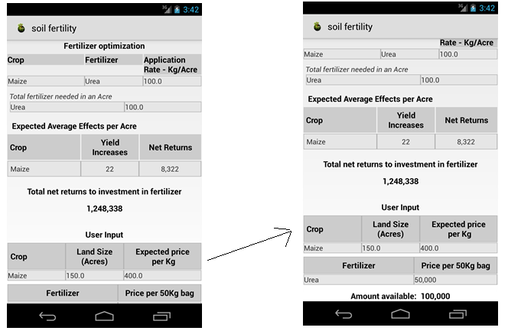

1. .

## Previous Calculation Operations

# Section Three: Web Client



## Overview

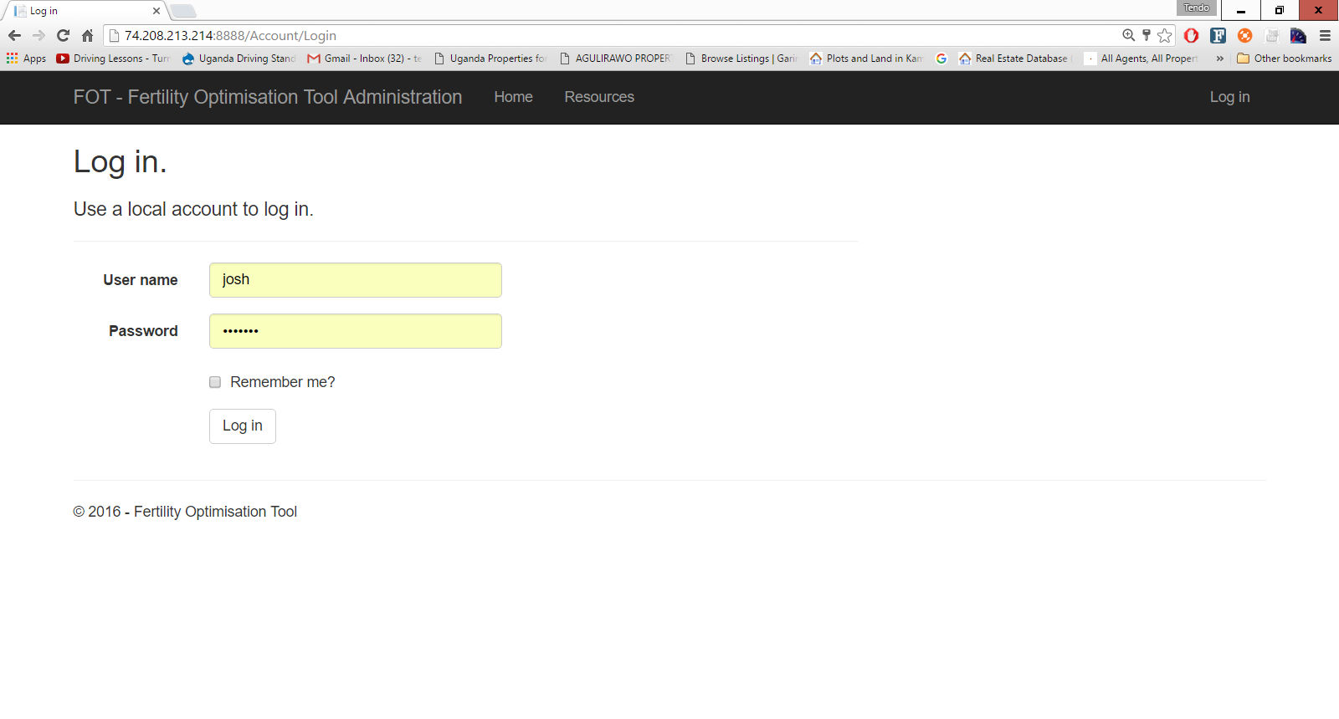

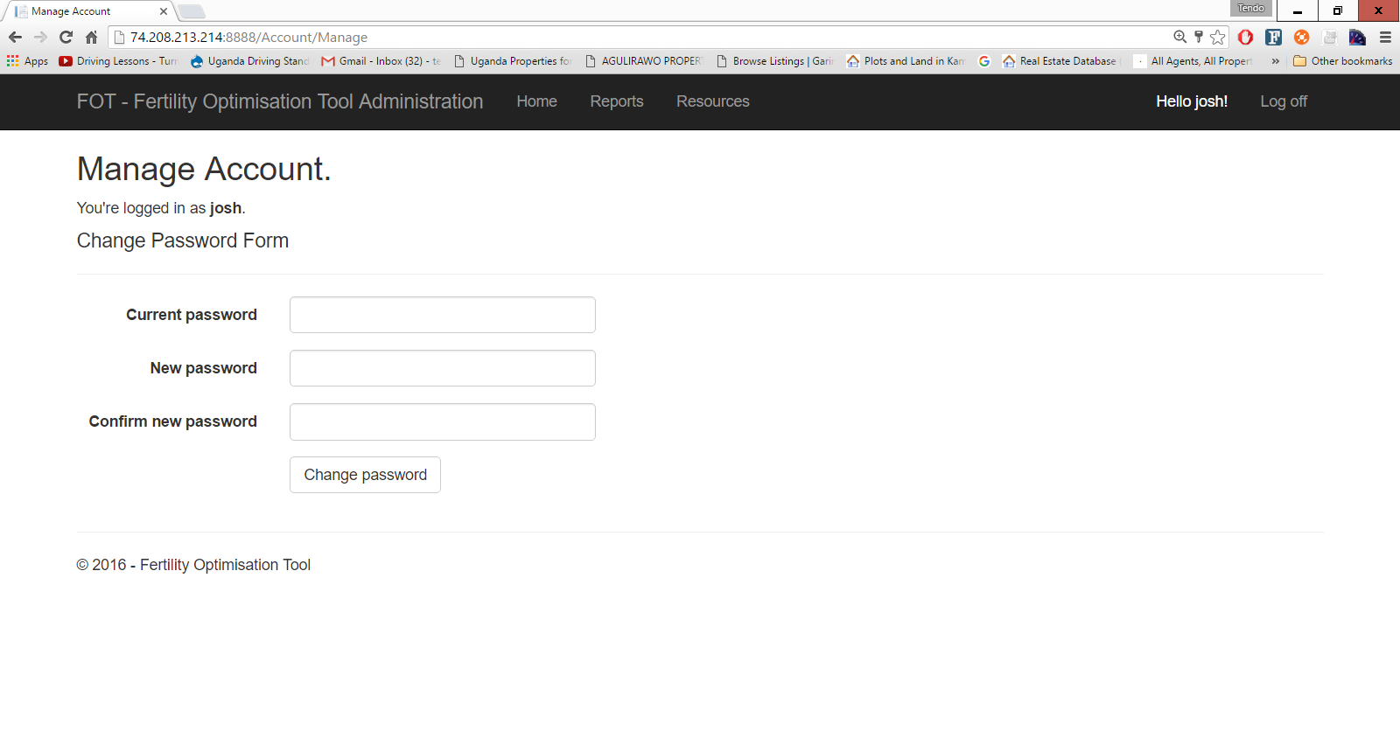

## Regions

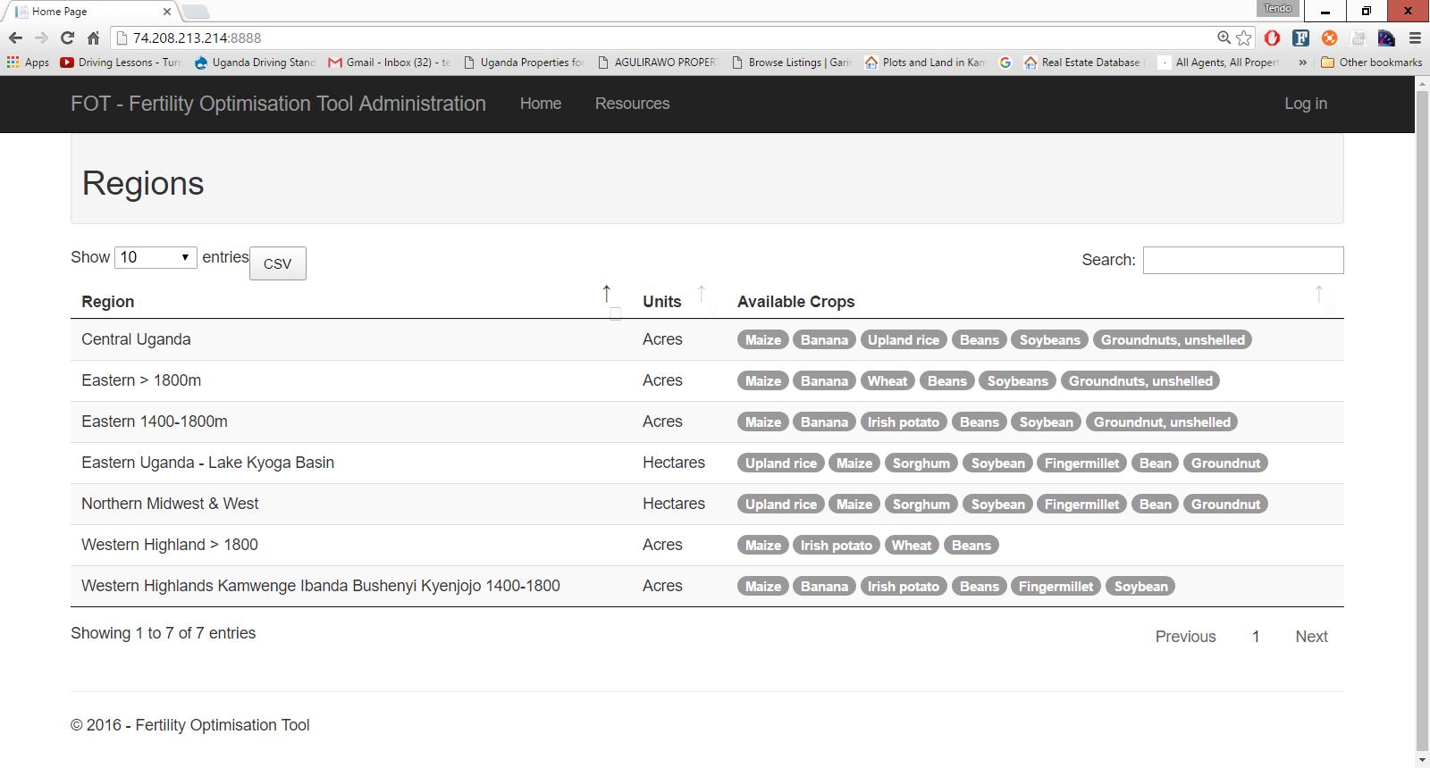

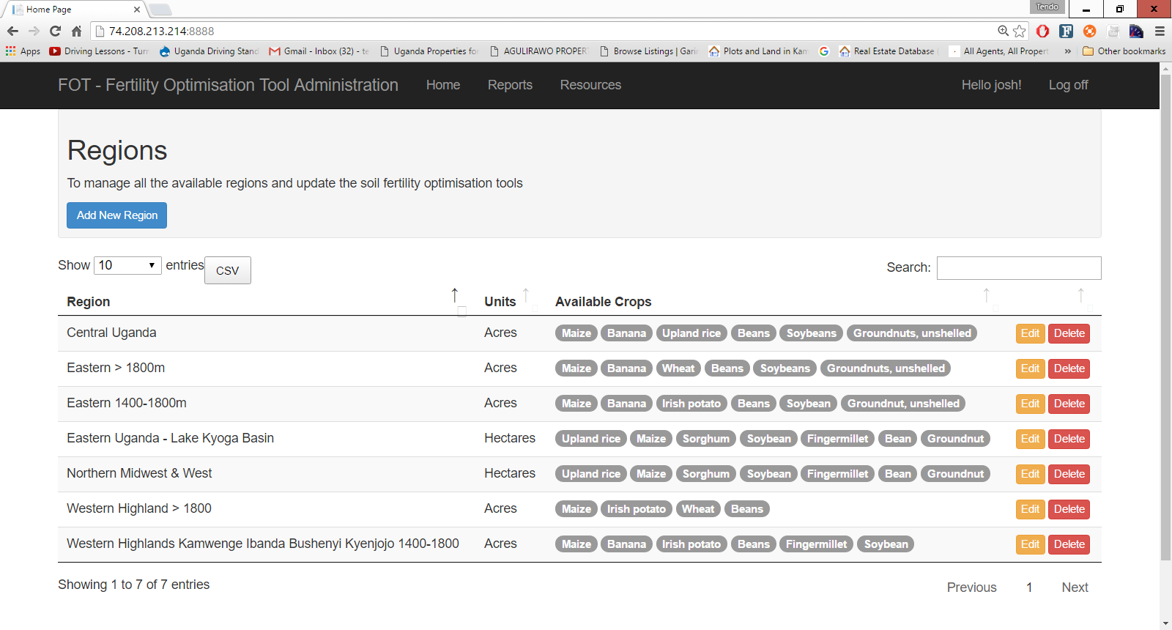

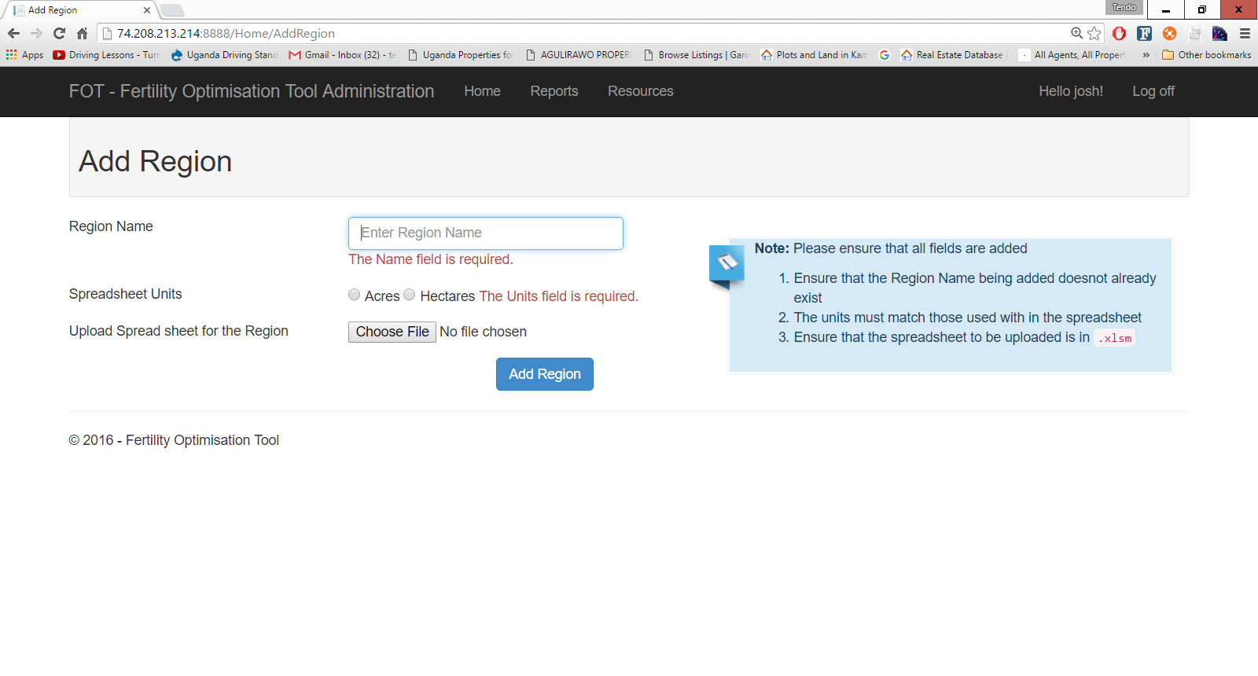

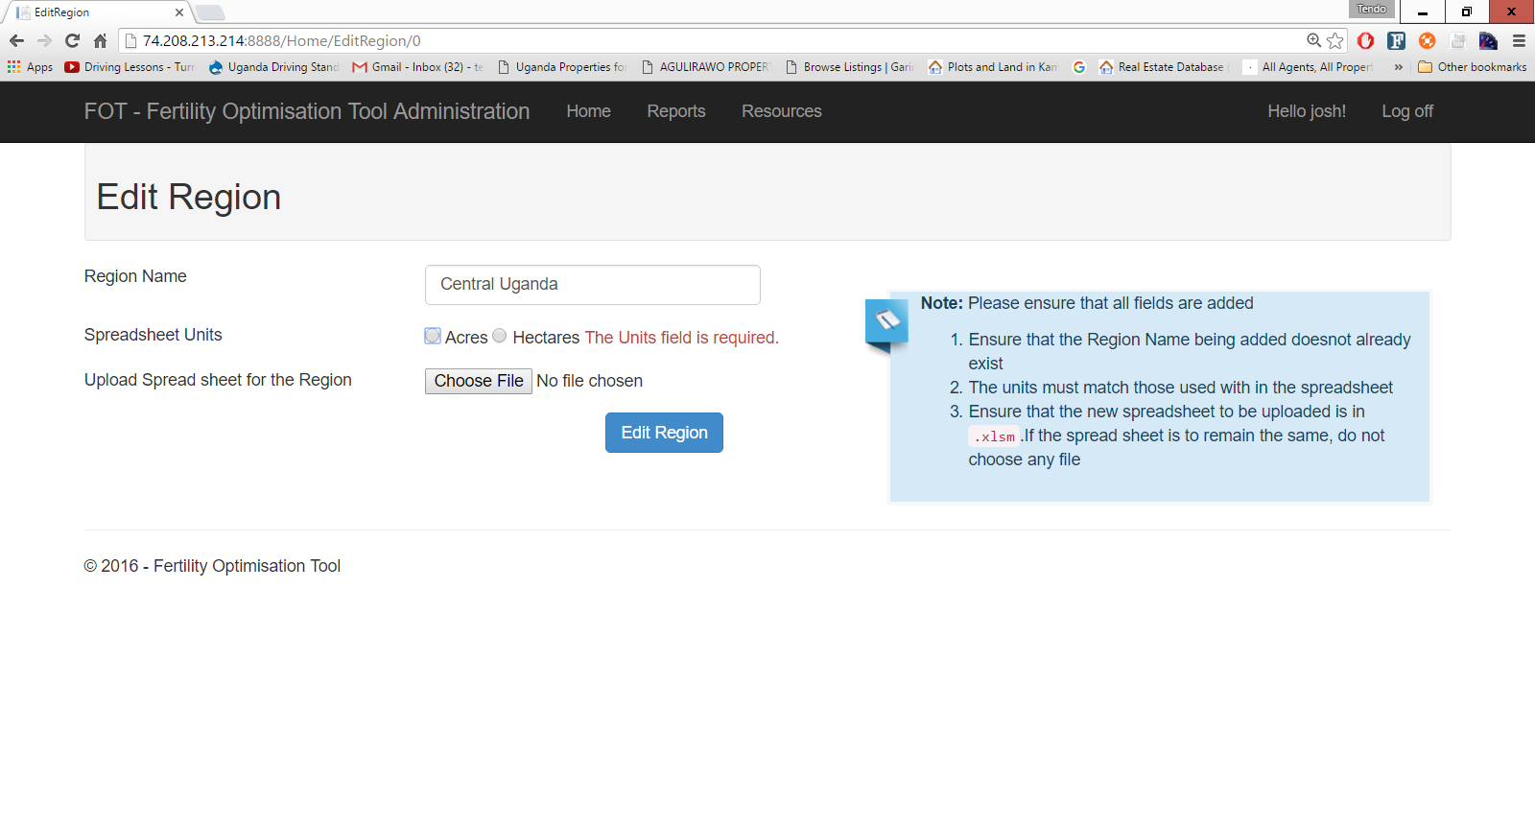

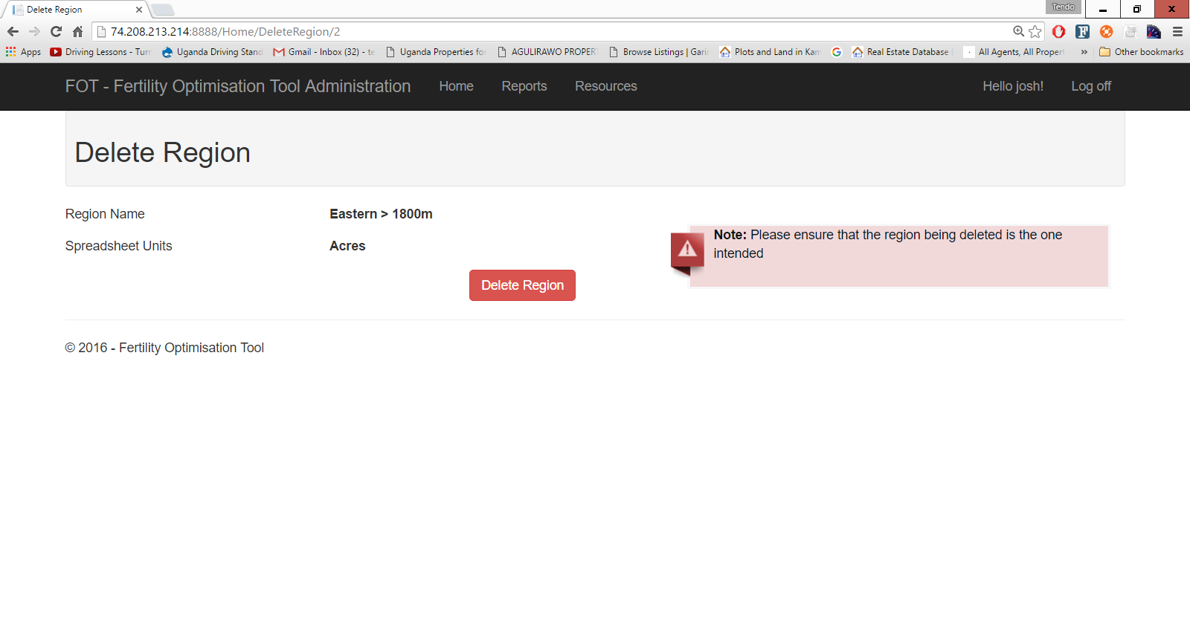

## Reports

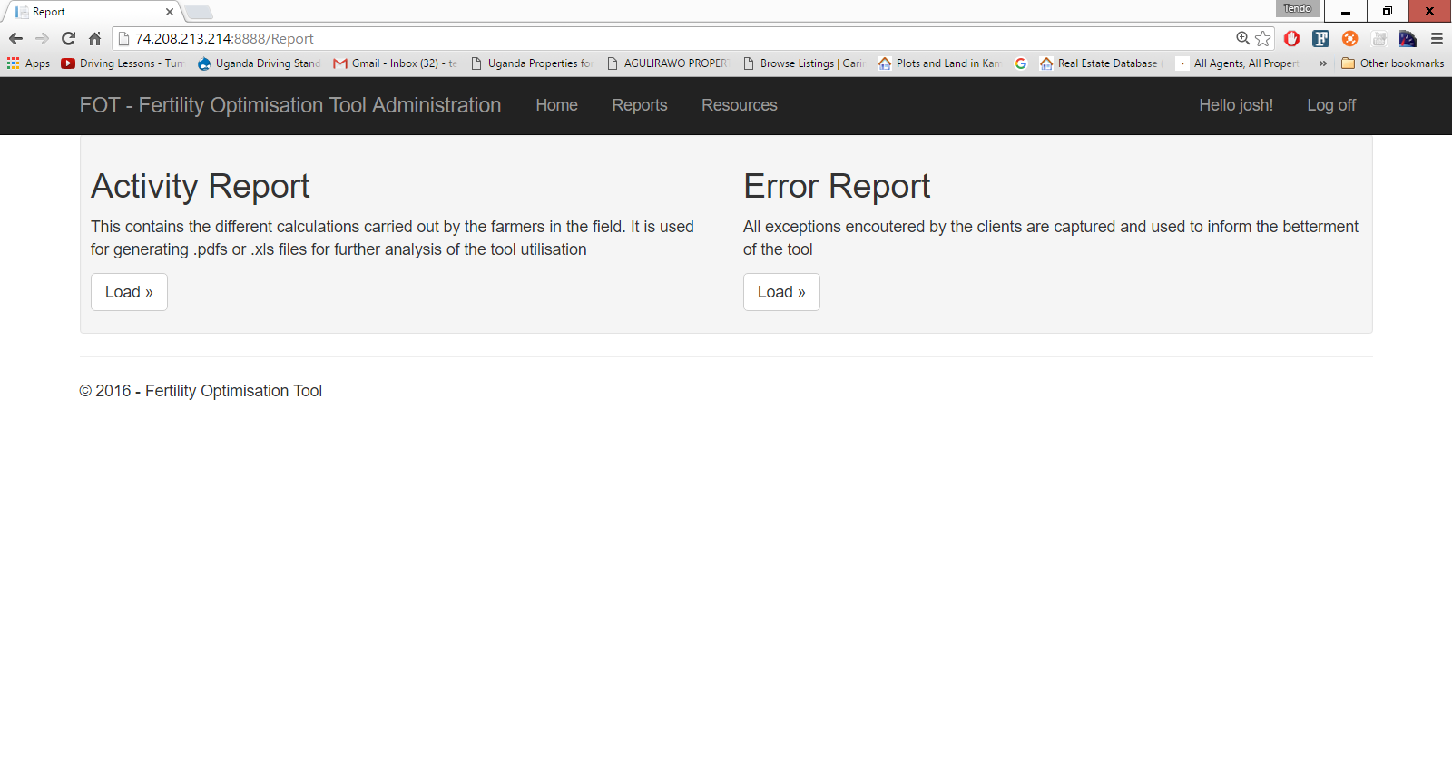

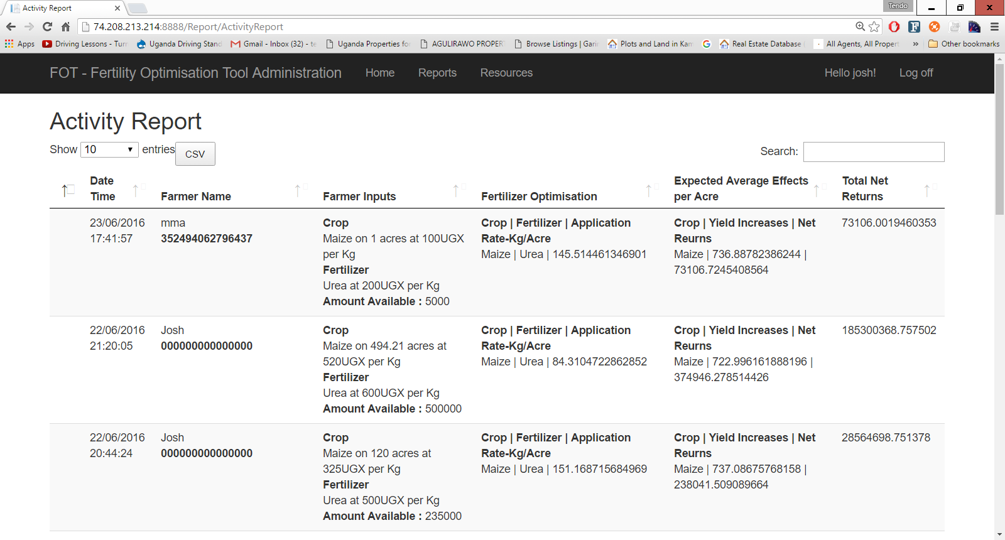

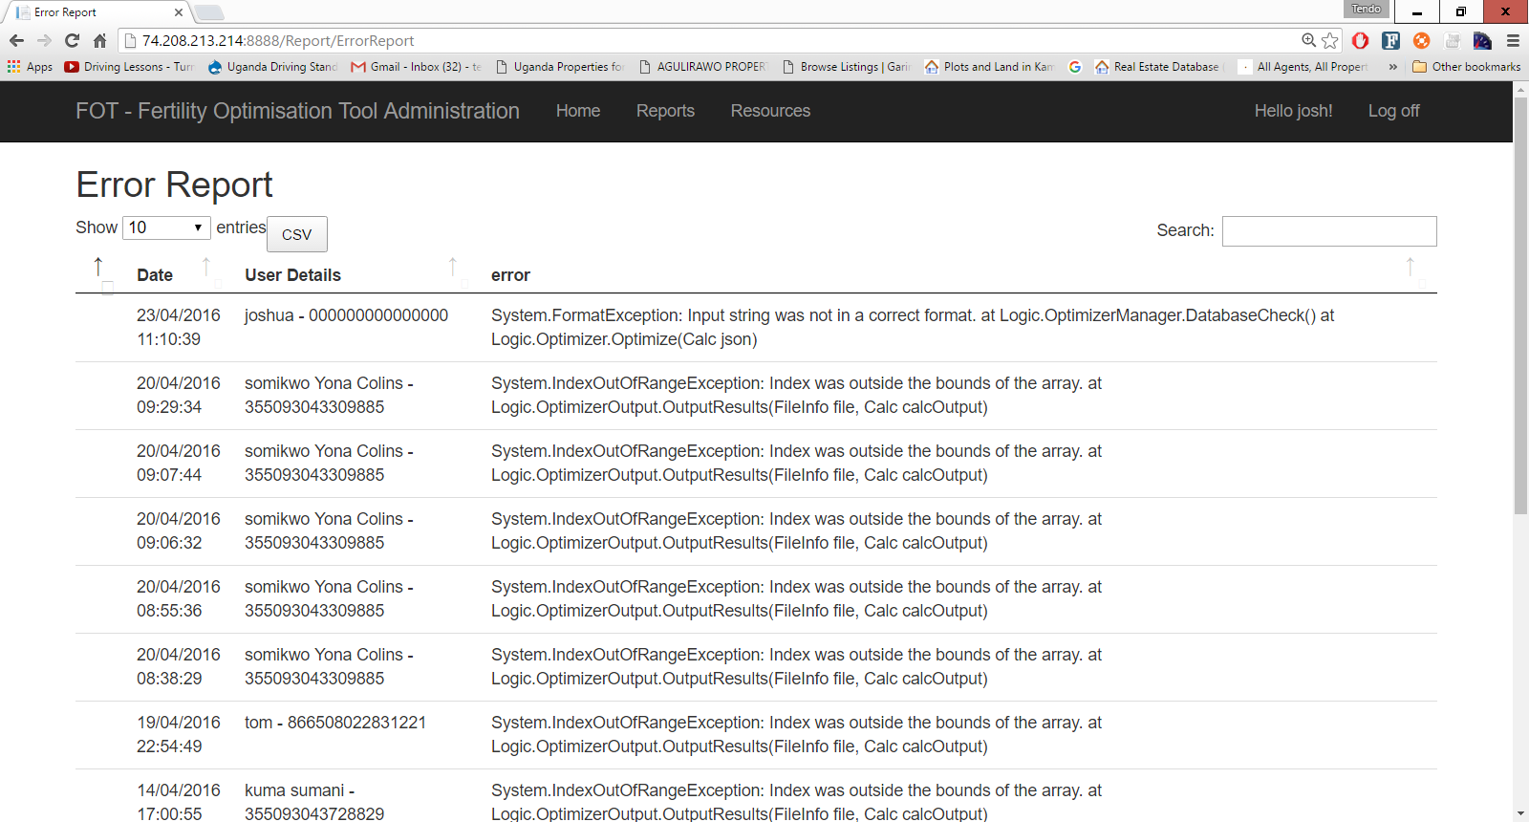

## Resources

