TECHNOLOGICAL INSTITUTE OF THE PHILIPPINES

938 Aurora Blvd., Cubao, Quezon City

Experiment No. 2

**DC MOTOR CONSTRUCTION**

EE 408 / EC42FB2

Leader: Date Performed: November 12, 2016

Mañaol, Regina Claire C. Date Submitted: November 19, 2016

Members:

Belisario, Francis Dave C.

Magdayo, Mark Niño D.

Rivera, Allen Kristoff C.

Pangalan Ni Ate

Pangalan ni Kuya

Engr. Alvin Dela Cruz

**Experiment No. 2**

**DC MOTOR CONSTRUCTION**

**1. Objective(s):**

The course activity aims to recognize the essential parts and component of DC motor, parameters, and standard assembly.

**2. Intended Learning Outcomes (ILOs):**

The student shall be able to:

2.1 Identify the essential parts of DC machine.

2.2 Differentiate DC rotor and DC stator.

2.3 Evaluate the parameters, air gap and rating DC machine.

**3. Principles and Discussion:**

Electrical machines that are operating in direct current are categorized into two (2) general concepts. These are dynamo or generation and DC motors where stator and rotor are its major component which is responsible in lifting mechanical loads and the production of electrical power.

**DC Motor and DC Generator Design and Construction Principles**

Armature is virtually the heart of dynamo and DC motor. In DC motor, the back voltage is generated to develop torque while in DC generator, voltage is generated at the armature so that the electric power is produced.

The armature is designed and constructed with a stack of steel laminations but it is circular in section. The circumferential edge is slotted to a convenient depth to receive the copper armature winding as shown in Figure 2.1

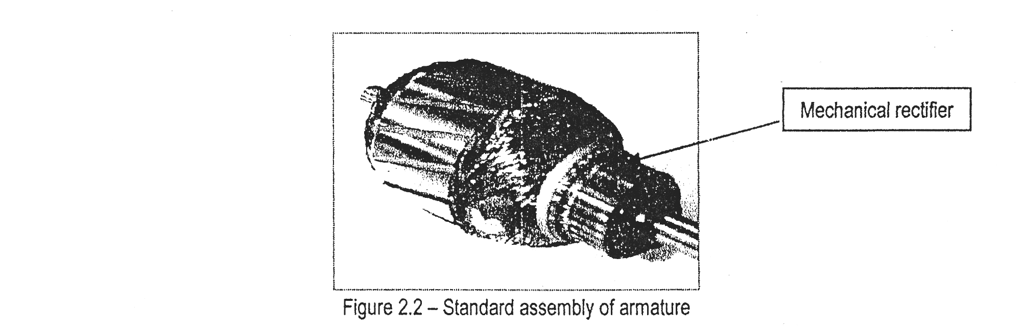

Figure 2.1 – Armature core is wounded with many turns of magnetic conductors

Commutator is a group of hard-drawn copper bars, wedge shape in section when viewed on one end. It is also a device in direct-current (DC) electric motor that reverses the current flowing in the armature coils as the armature rotates. A DC generator uses a commutator to convert the alternating current (AC) generated in the armature coils into DC. A commutator consists of opposite pairs of copper bars insulated from one another, and contact to an external circuit is provided by carbon or metal brushes which as shown in Figure 2.2.

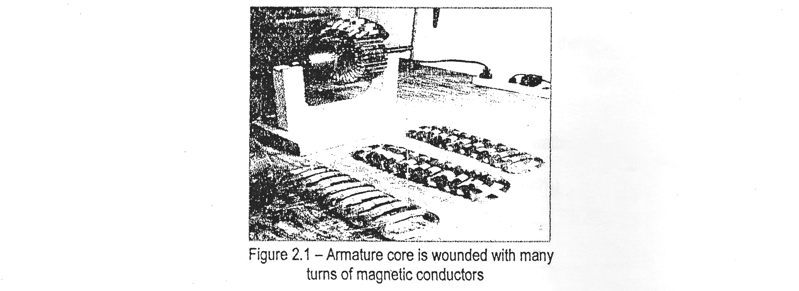

Figure 2.2 – Standard assembly of armature

**Induce Voltage in a Conductor:** When current is passed through the armature of a DC motor, a torque is generated by magnetic reaction, and the armature revolves. The revolution of the armature induces a voltage in the armature windings. This induced voltage is opposite in direction to the outside voltage applied to the armature, and hence is called back voltage or counter electromotive force (emf). As the motor rotates more rapidly, the back voltage rises until it is almost equal to the applied voltage. The back emf can be calculated using the general voltage equation below.

**Power Stages and Efficiency Motor:** Horsepower is the unit of power in the English system, for measuring the rate at which a motor or prime mover can perform mechanical work. In physics, efficiency is the ratio of the amount of power produced by a machine to the amount of power put into it. The power stages in DC motor based on efficiency can be calculated through the following equations:

1. The mechanical efficiency is the ratio of converted power output (watts) to the power developed in the armature (watts).
2. The electrical efficiency is the ratio of converted power output (watts) to the electrical power (watts).
3. The commercial efficiency is the ratio of armature developed power (watts) to the electrical power (watts).

**4. Resources:**

1 set Open-Lab Machine Trainer

1 unit Rotor with commutator

1 unit DC Stator

1 unit Mechanical Power Measurement Module

1 unit Electrical measurement module

1 pc. Allen wrench

1 pc. Steel tape

1 pc. Vernier Caliper

1 pc. Ruler

1 pc. Pencil (No. 2)

**5. Procedures:**

ACTIVITY 1 – **INVESTIGATING THE INTERNAL PARTS AND COMPONENT OF DC MOTOR:**

5.1 Prepare the open-lab machine, rubber hammer and wrenches.

5.2 Carefully separate the DC rotor from the DC stator using rubber hammer as shown in Figure 2.3.

(Reminder; Do not apply pressure to remove the rotor from stator)

5.6 Examine thoroughly the standard design and construction of DC rotor and stator.

5.7 Identify the essential component of DC rotor and DC stator using Table 2.1 and Table 2.2.

5.8 Then state briefly the function of each component.

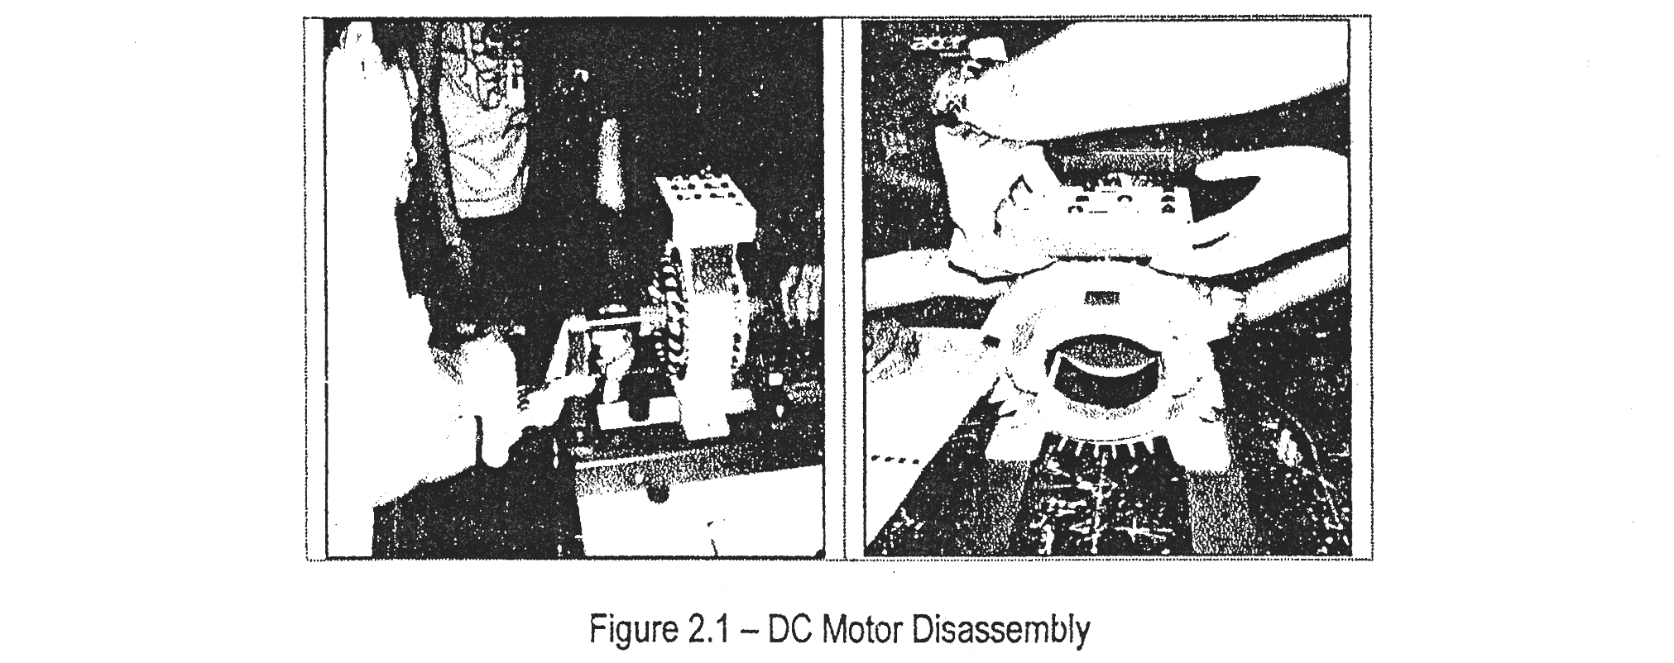

Figure 2.3 – DC Motor Disassembly

ACTIVITY 2 – **DETERMINING THE DC ROTOR AND STATOR DESIGN AIR GAP AND RATING:**

5.9 From Table 2.3, fill out the required data according to each component of rotor and stator using

the appropriate measuring tools.

5.10 Evaluate the thickness of the stator yoke based on the equation below.

Where: Tf = thickness of stator’s yoke / frame

Do = outside diameter of stator’s yoke / frame

Di = inside diameter of stator’s yoke / frame

5.11 Calculate the air-gap between the rotor and stator based on the equation below.

Where: Dr = diameter of rotor, mm

5.12 Then verify the wattage rating of DC machine based on the applicable parameters determined

in the group. (Note: Place your computation on Table 2.4)

|  |  |  |
| --- | --- | --- |
| Table 2.1– **DC ROTOR PARTS AND COMPONENT** | | |
| **DC Rotor Assembly with Labeled Parts** | **Identified Parts and Component** | **Function / Purpose** |
|  | Rotor Shaft | The function of the rotor shaft is to task a pack of magnetic sheet irons is fixed, where the slots suitable to contain the rotor winding are set. |
| Commutator Bars | To provide exceptional mechanical and electrical stability, commutator bars are placed. |
| Armature | A part which a current is induced by a magnetic field. The armature usually consists of a series of coils or groups of insulated conductors surrounding a core of iron. |
| Cage Rotor | The cage is carried out by setting in every rotor slot some conducting bars that are closed in short-circuit at both ends by means of some conducting rings. |
| Carbon Brushes | The brushes are two for each phase and they are subordinate to an external terminal board that shows the synoptic of the rotor winding. |
| DC Rotor | The DC Rotor is composed of a shaft to which the segment commutator is fixed and of a magnetic sheet iron pack where 20 semi-closed slots suitable to contain the electrical winding are set. The winding is subordinate to the 40 segments of the commutator on which two brushes are supported by a brush holder graze. The brushes are subordinate to terminals set on two external boards that show the synoptic of the rotor winding. |
| Ring Rotor | The Ring Rotor is composed of a shaft to which the collector rings and a magnetic sheet iron pack are fixed: the iron pack has 21 semi-closed slots suitable to contain the winding. To avoid a noisy mechanical running the rotor slots are inclined as regards the stator ones. The rotor winding is composed of coils and it is two pole three-phase. The terminals of the rotor winding are accessible by means of the collector rings on which the bushes supported by a brush holder graze. |

|  |  |  |
| --- | --- | --- |
| Table 2.2– **DC STATOR PARTS AND COMPONENT** | | |
| **DC Stator Assembly with Labeled Parts** | **Identified Parts and Component** | **Function / Purpose** |
|  | Terminal Block for DC Machine | The rotor winding is composed of coils and it is two pole three-phase. The winding is a double layer one of the long coil lap type, with winding span 9 (1-10). Every slot contains two coils of 8 turns each of enameled wire of diameter 1.5 mm. The winding is star connected and it is subordinate to the collector rings while the star center is internal and not accessible. The terminals of the rotor winding are accessible by means of the collector rings on which the bushes supported by a brush holder graze. |
| Terminal Block for AC Machine | The winding is subordinate to the 40 segments of the commutator on which two brushes are supported by a brush holder graze. The brushes are subordinate to terminals set on two external boards that show the synoptic of the rotor winding. The rotor winding can be therefore considered a multi-phase winding, so it does not present its proper pole number. |
| DC Stator | The DC Stator is composed of a metal frame supporting the laminated magnetic circuit, with 2 main poles and 2 inter poles, and the electrical windings. The sheet iron pack is 60 mm long, with internal diameter of 80 mm. On the poles the coils are wound whose terminals are shown on a suitable educational terminal board. |
| AC Stator | The AC Stator is composed of a metal frame supporting the laminated magnetic circuit, because interested by a flux variable in time, and the electrical winding. The sheet iron pack is 60 mm long, with internal diameter of 80 mm and external one of 150 mm of which there is a double three-phase winding: the beginnings and the ends of the different phases are shown outside the stator on a suitable educational terminal board. |

|  |  |  |
| --- | --- | --- |
| Table 2.3 **– DC MACHINE COMPONENT AND PARAMETERS** | | |
| **Item** | **Value** | **Unit** |
| Number of field poles | 4 | pieces |
| Length of pole arc | 3.45 | inches |
| Area of pole face | 8.28 | sq. inch |
| Distance between opposite field pole faces | 3 | inches |
| Number of teeth | 3 | pieces |
| Diameter of commutator | 6.6 | inches |
| Length of commutator | 1.3 | inches |
| Number of commutator bars | 2 | pieces |
| Number of commutator segment | 40 | pieces |
| Diameter of rotor | 3.15 | inches |
| Diameter of shaft | 1.21 | inches |
| Length of shaft | 8.9 | inches |
| Outside diameter of stator’s yoke ring | 5.8 | inches |
| Inside diameter of stator’s yoke ring | 3.1 | inches |
| Thickness of stator’s yoke ring | 1.3 | inches |
| Length of stator’s frame | 2.65 | inches |
| Air gap | 0.05 | inches |
| Number of carbon brush | 6 | pieces |
| Wattage rating of DC rotor | 300 | watts |

|  |  |  |
| --- | --- | --- |
| Table 2.4 – **SUMMARY OF DESIGN CALCULATION** | | |
| **Stator’s Yoke Thickness** | **Air Gap** | **Power Rating of DC Machine** |
|  |  | *Computation:* |

**7. Interpretation of Data and Results:**

**8. Conclusion:**

**9. Question(s) and Answer(s):**

1. Discuss the operating principle of mechanical rectifier.

2. A four-pole motor has an armature having 276 conductors. Each pole face is designed and constructed with 25 square inches with flux density of 47,500 lines per square inch. If the armature current is designed at 75 amperes and the structure of windings is wave (2 parallel paths), verify the rated torque of this motor.

3. During operation of DC motor and DC generator, explain how rotor and stator works.

4. The car of Light Railway Transit (LRT) is propelled by a 660-volt DC motor connected to the DC feeder lines of rectifier station. This car is required to exert a tractive effort of 4,500 kg at a velocity of 50 km/hr. How much current will be drawn from the feeder lines if the overall efficiency of motor and the flywheel drive is 65%?

(Note: Support your answer in a separate sheet)

**10. Assessment (Use the standard Engineering Laboratory Rubric):**