List of API endpoints used

// PRODUCTS
GET /products
GET /products/:id
POST /products
PUT /products/:id
DELETE /products/:id

// SUPPLIERS
GET /suppliers
GET /suppliers/:id
POST /suppliers
PUT /suppliers/:id
DELETE /suppliers/:id

// ORDERS
GET /orders
GET /orders/:id
POST /orders
PUT /orders/:id
DELETE /orders/:id

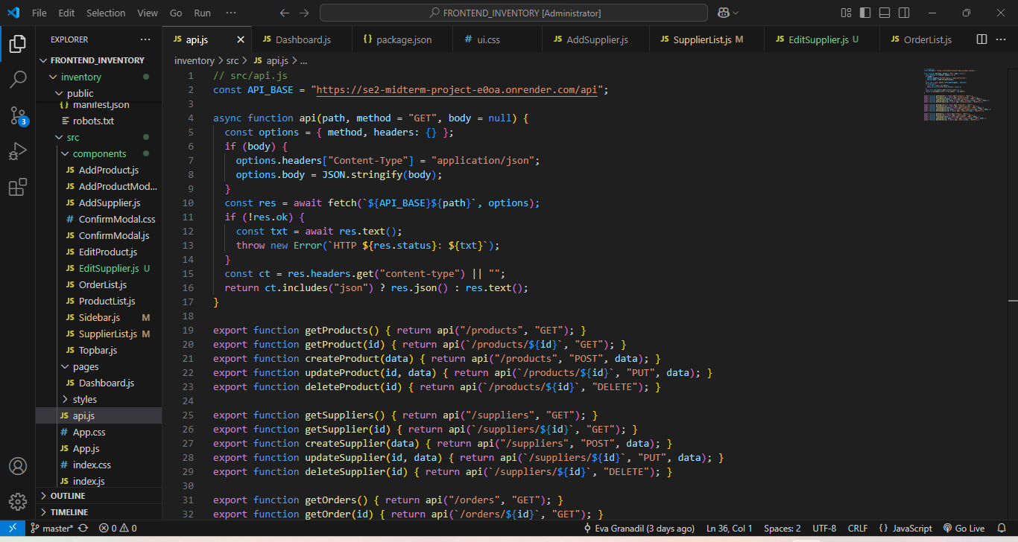

PRODUCTS

getSuppliers().then(setSuppliers).catch(() => {});

if (editId) {
// Editing a product
getProduct(editId)
.then((p) => {
setForm({
name: p.name ?? "",
sku: p.sku ?? "",
price: p.price ?? "",
stock: p.stock ?? "",
supplierId: p.supplierId?._id ?? "",
description: p.description ?? ""
});
})
.catch(() => {});
} else {

setForm({
...emptyForm,
sku: generateSKU()
});
}

if (editId) {
await updateProduct(editId, payload);
} else {
await createProduct(payload);
}

const payload = {
name: form.name,
sku: form.sku,
price: Number(form.price) || 0,
stock: Number(form.stock) || 0,
supplierId: form.supplierId || null,
description: form.description
};

function generateSKU(name = "") {
const prefix = name.trim().slice(0, 3).toUpperCase() || "SKU";
const random = Math.floor(10000 + Math.random() * 90000);
return `${prefix}-${random}`;
}
<button
className="btn btn-primary"
type="submit"
disabled={saving}
>
{saving ? "Saving..." : "Save Product"}
</button>

SUPPLIERS

async function load() {
try {
const data = await getSuppliers();
setSuppliers(data);
} catch (err) {
console.error(err);
alert("Failed to load suppliers");
}
}

useEffect(() => {
load();
}, []);

async function handleDelete(id) {
if (!window.confirm("Delete this supplier?")) return;

try {
await deleteSupplier(id);
load();
} catch (err) {
console.error(err);
alert("Failed to delete supplier");
}
}

<button
className="btn btn-warning"
onClick={() => setEditing(s)}
>
Edit
</button>
{adding && (
<AddSupplier
onDone={() => {
setAdding(false);
load();
}}
/>
)}

{editing && (
<EditSupplier
supplier={editing}
onDone={() => {
setEditing(null);
load();
}}
/>
)}

<tbody>
{suppliers.map((s) => (
<tr key={s._id}>
<td>{s.name}</td>
<td>{s.contact}</td>
<td>

ORDERS

async function loadOrders() {
setErrorMessage("");
setLoadingOrders(true);
try {
const data = await getOrders();
setOrders(data || []);
} catch (err) {
console.error("Failed to load orders:", err);
setErrorMessage("Failed to load orders. Check backend or network.");
} finally {
setLoadingOrders(false);
}
}
useEffect(() => {
loadOrders();
}, []);

await deleteOrder(deleteId);
setShowConfirm(false);
loadOrders();

<button
className="btn btn-danger"
onClick={() => {
setDeleteId(o._id);
setShowConfirm(true);
}}
>
Delete
</button>

{showConfirm && (
<ConfirmModal
message="Are you sure you want to delete this order?"
onConfirm={async () => {
try {
await deleteOrder(deleteId);
setShowConfirm(false);
loadOrders();
} catch (err) {
console.error("Delete order failed:", err);
alert("Failed to delete order");
}
}}
onCancel={() => setShowConfirm(false)}
/>
)}

orders.map((o) => {
<td>{o._id}</td>
<td>{o.supplierId?._id || o.supplierId || "No Supplier Assigned"}</td>

o.items?.reduce(
(sum, item) => sum + (item.price || 0) * (item.qty || 0),
0
) || 0;

