**Collections in Java**

The **Collection in Java** is a framework that provides an architecture to store and manipulate the group of objects.

Java Collections can achieve all the operations that you perform on a data such as searching, sorting, insertion, manipulation, and deletion.

Java Collection means a single unit of objects. Java Collection framework provides many interfaces (Set, List, Queue, Deque) and classes (ArrayList, Vector, LinkedList, PriorityQueue, HashSet, LinkedHashSet, TreeSet).

**What is Collection in Java**

A Collection represents a single unit of objects, i.e., a group.

**What is a framework in Java**

* It provides readymade architecture.
* It represents a set of classes and interfaces.
* It is optional.

**What is Collection framework**

The Collection framework represents a unified architecture for storing and manipulating a group of objects. It has:

1. Interfaces and its implementations, i.e., classes
2. Algorithm

Do You Know?

* What are the two ways to iterate the elements of a collection?
* What is the difference between ArrayList and LinkedList classes in collection framework?
* What is the difference between ArrayList and Vector classes in collection framework?
* What is the difference between HashSet and HashMap classes in collection framework?
* What is the difference between HashMap and Hashtable class?
* What is the difference between Iterator and Enumeration interface in collection framework?
* How can we sort the elements of an object? What is the difference between Comparable and Comparator interfaces?
* What does the hashcode() method?
* What is the difference between Java collection and Java collections?

**Hierarchy of Collection Framework**

Let us see the hierarchy of Collection framework. The **java.util** package contains all the classes and interfaces for the Collection framework.

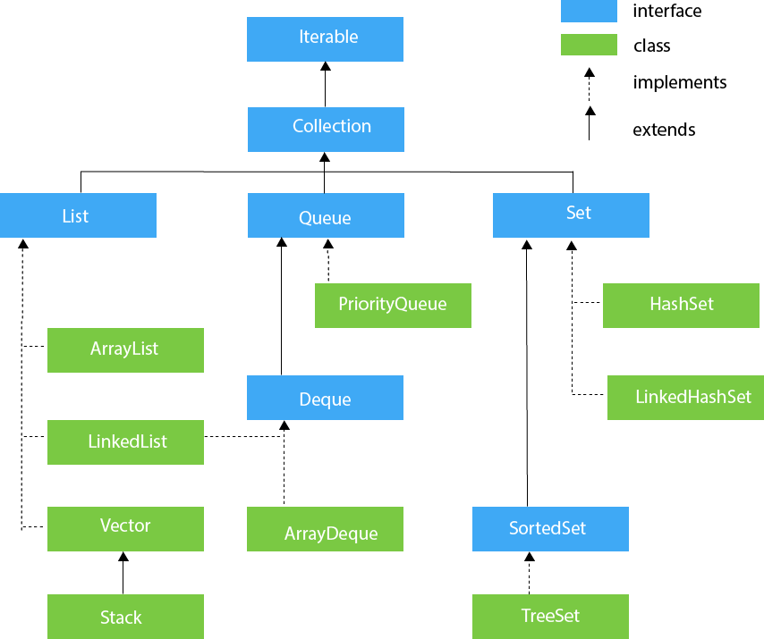

**Methods of Collection interface**

There are many methods declared in the Collection interface. They are as follows:

|  |  |  |
| --- | --- | --- |
| **No.** | **Method** | **Description** |
| 1 | public boolean add(E e) | It is used to insert an element in this collection. |
| 2 | public boolean addAll(Collection<? extends E> c) | It is used to insert the specified collection elements in the invoking collection. |
| 3 | public boolean remove(Object element) | It is used to delete an element from the collection. |
| 4 | public boolean removeAll(Collection<?> c) | It is used to delete all the elements of the specified collection from the invoking collection. |
| 5 | default boolean removeIf(Predicate<? super E> filter) | It is used to delete all the elements of the collection that satisfy the specified predicate. |
| 6 | public boolean retainAll(Collection<?> c) | It is used to delete all the elements of invoking collection except the specified collection. |
| 7 | public int size() | It returns the total number of elements in the collection. |
| 8 | public void clear() | It removes the total number of elements from the collection. |
| 9 | public boolean contains(Object element) | It is used to search an element. |
| 10 | public boolean containsAll(Collection<?> c) | It is used to search the specified collection in the collection. |
| 11 | public Iterator iterator() | It returns an iterator. |
| 12 | public Object[] toArray() | It converts collection into array. |
| 13 | public <T> T[] toArray(T[] a) | It converts collection into array. Here, the runtime type of the returned array is that of the specified array. |
| 14 | public boolean isEmpty() | It checks if collection is empty. |
| 15 | default Stream<E> parallelStream() | It returns a possibly parallel Stream with the collection as its source. |
| 16 | default Stream<E> stream() | It returns a sequential Stream with the collection as its source. |
| 17 | default Spliterator<E> spliterator() | It generates a Spliterator over the specified elements in the collection. |
| 18 | public boolean equals(Object element) | It matches two collections. |
| 19 | public int hashCode() | It returns the hash code number of the collection. |

**Iterator interface**

|  |
| --- |
| Iterator interface provides the facility of iterating the elements in a forward direction only. |

**Methods of Iterator interface**

There are only three methods in the Iterator interface. They are:

|  |  |  |
| --- | --- | --- |
| **No.** | **Method** | **Description** |
| 1 | public boolean hasNext() | It returns true if the iterator has more elements otherwise it returns false. |
| 2 | public Object next() | It returns the element and moves the cursor pointer to the next element. |
| 3 | public void remove() | It removes the last elements returned by the iterator. It is less used. |

**Iterable Interface**

The Iterable interface is the root interface for all the collection classes. The Collection interface extends the Iterable interface and therefore all the subclasses of Collection interface also implement the Iterable interface.

It contains only one abstract method. i.e.,

1. Iterator<T> iterator()

It returns the iterator over the elements of type T.

**Collection Interface**

The Collection interface is the interface which is implemented by all the classes in the collection framework. It declares the methods that every collection will have. In other words, we can say that the Collection interface builds the foundation on which the collection framework depends.

Some of the methods of Collection interface are Boolean add ( Object obj), Boolean addAll ( Collection c), void clear(), etc. which are implemented by all the subclasses of Collection interface.

**List Interface**

List interface is the child interface of Collection interface. It inhibits a list type data structure in which we can store the ordered collection of objects. It can have duplicate values.

List interface is implemented by the classes ArrayList, LinkedList, Vector, and Stack.

To instantiate the List interface, we must use :

1. List <data-type> list1= new ArrayList();
2. List <data-type> list2 = new LinkedList();
3. List <data-type> list3 = new Vector();
4. List <data-type> list4 = new Stack();

There are various methods in List interface that can be used to insert, delete, and access the elements from the list.

The classes that implement the List interface are given below.

**ArrayList**

The ArrayList class implements the List interface. It uses a dynamic array to store the duplicate element of different data types. The ArrayList class maintains the insertion order and is non-synchronized. The elements stored in the ArrayList class can be randomly accessed. Consider the following example.

import java.util.*;

class TestJavaCollection1{

public static void main(String args[]){

ArrayList<String> list=new ArrayList<String>();//Creating arraylist

list.add("Ravi");//Adding object in arraylist

list.add("Vijay");

list.add("Ravi");

list.add("Ajay");

//Traversing list through Iterator

Iterator itr=list.iterator();

while(itr.hasNext()){

System.out.println(itr.next());

}

}

}

Output:

Ravi

Vijay

Ravi

Ajay

**LinkedList**

LinkedList implements the Collection interface. It uses a doubly linked list internally to store the elements. It can store the duplicate elements. It maintains the insertion order and is not synchronized. In LinkedList, the manipulation is fast because no shifting is required.

Consider the following example.

import java.util.*;

public class TestJavaCollection2{

public static void main(String args[]){

LinkedList<String> al=new LinkedList<String>();

al.add("Ravi");

al.add("Vijay");

al.add("Ravi");

al.add("Ajay");

Iterator<String> itr=al.iterator();

while(itr.hasNext()){

System.out.println(itr.next());

}

}

}

Output:

Ravi

Vijay

Ravi

Ajay

**Vector**

Vector uses a dynamic array to store the data elements. It is similar to ArrayList. However, It is synchronized and contains many methods that are not the part of Collection framework.

Consider the following example.

import java.util.*;

public class TestJavaCollection3{

public static void main(String args[]){

Vector<String> v=new Vector<String>();

v.add("Ayush");

v.add("Amit");

v.add("Ashish");

v.add("Garima");

Iterator<String> itr=v.iterator();

while(itr.hasNext()){

System.out.println(itr.next());

}

}

}

Output:

Ayush

Amit

Ashish

Garima

**Stack**

The stack is the subclass of Vector. It implements the last-in-first-out data structure, i.e., Stack. The stack contains all of the methods of Vector class and also provides its methods like boolean push(), boolean peek(), boolean push(object o), which defines its properties.

Consider the following example.

import java.util.*;

public class TestJavaCollection4{

public static void main(String args[]){

Stack<String> stack = new Stack<String>();

stack.push("Ayush");

stack.push("Garvit");

stack.push("Amit");

stack.push("Ashish");

stack.push("Garima");

stack.pop();

Iterator<String> itr=stack.iterator();

while(itr.hasNext()){

System.out.println(itr.next());

}

}

}

Output:

Ayush

Garvit

Amit

Ashish

**Set Interface**

Set Interface in Java is present in java.util package. It extends the Collection interface. It represents the unordered set of elements which doesn't allow us to store the duplicate items. We can store at most one null value in Set. Set is implemented by HashSet, LinkedHashSet, and TreeSet.

Set can be instantiated as:

1. Set<data-type> s1 = new HashSet<data-type>();
2. Set<data-type> s2 = new LinkedHashSet<data-type>();
3. Set<data-type> s3 = new TreeSet<data-type>();

**HashSet**

HashSet class implements Set Interface. It represents the collection that uses a hash table for storage. Hashing is used to store the elements in the HashSet. It contains unique items.

Consider the following example.

1. import java.util.*;
2. public class TestJavaCollection7{
3. public static void main(String args[]){
4. //Creating HashSet and adding elements
5. HashSet<String> set=new HashSet<String>();
6. set.add("Ravi");
7. set.add("Vijay");
8. set.add("Ravi");
9. set.add("Ajay");
10. //Traversing elements
11. Iterator<String> itr=set.iterator();
12. while(itr.hasNext()){
13. System.out.println(itr.next());
14. }
15. }
16. }

Output:

Vijay

Ravi

Ajay

**LinkedHashSet**

LinkedHashSet class represents the LinkedList implementation of Set Interface. It extends the HashSet class and implements Set interface. Like HashSet, It also contains unique elements. It maintains the insertion order and permits null elements.

Consider the following example.

1. import java.util.*;
2. public class TestJavaCollection8{
3. public static void main(String args[]){
4. LinkedHashSet<String> set=new LinkedHashSet<String>();
5. set.add("Ravi");
6. set.add("Vijay");
7. set.add("Ravi");
8. set.add("Ajay");
9. Iterator<String> itr=set.iterator();
10. while(itr.hasNext()){
11. System.out.println(itr.next());
12. }
13. }
14. }

Output:

Ravi

Vijay

Ajay

**SortedSet Interface**

SortedSet is the alternate of Set interface that provides a total ordering on its elements. The elements of the SortedSet are arranged in the increasing (ascending) order. The SortedSet provides the additional methods that inhibit the natural ordering of the elements.

The SortedSet can be instantiated as:

1. SortedSet<data-type> set = new TreeSet();

**TreeSet**

Java TreeSet class implements the Set interface that uses a tree for storage. Like HashSet, TreeSet also contains unique elements. However, the access and retrieval time of TreeSet is quite fast. The elements in TreeSet stored in ascending order.

Consider the following example:

1. import java.util.*;
2. public class TestJavaCollection9{
3. public static void main(String args[]){
4. //Creating and adding elements
5. TreeSet<String> set=new TreeSet<String>();
6. set.add("Ravi");
7. set.add("Vijay");
8. set.add("Ravi");
9. set.add("Ajay");
10. //traversing elements
11. Iterator<String> itr=set.iterator();
12. while(itr.hasNext()){
13. System.out.println(itr.next());
14. }
15. }
16. }

Output:

Ajay

Ravi

Vijay