Preliminary analysis notes
  - P17c-marc-comparison
  - Benjamin S. Grandey, August 2017

Contents
Contents 1
AMWG diagnostics – year-2000 simulations 2
CCN Concentration (CCN3) 2
Liquid water path (TGCLDLWP) 4
Ice water path (TGCLDIWP) 5
Radiative flux perturbations 6
Direct effect RFP 6
Surface albedo RFP 7
Cloud shortwave RFP 8
Cloud longwave RFP 9
Net RFP 10
Aerosol column burdens – year-2000 simulations 11
Total sulphate burden 11
Organic carbon aerosol burden 12
Black carbon aerosol burden 13

Note:
- Apart from the AMWG diagnostics results, the maps presented in this analysis are based on output from commit 88e726b of cdo_analysis_prelim_p17c.sh (2017-08-21).
- These results are very much work-in-progress, and have not been carefully checked.

AMWG diagnostics – year-2000 simulations

Daniel has configured the AMWG diagnostics package to produce some comparison figures. Some interesting results are included in this section.

CCN Concentration (CCN3)
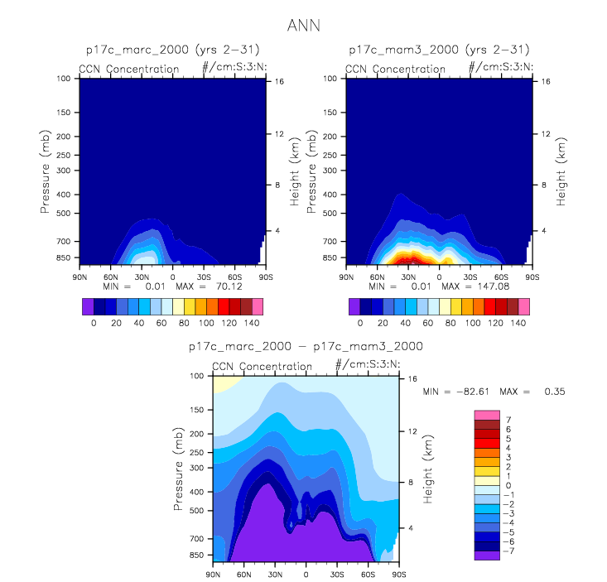
Figure 1: MARC vs MAM3 zonal average CCN concentration
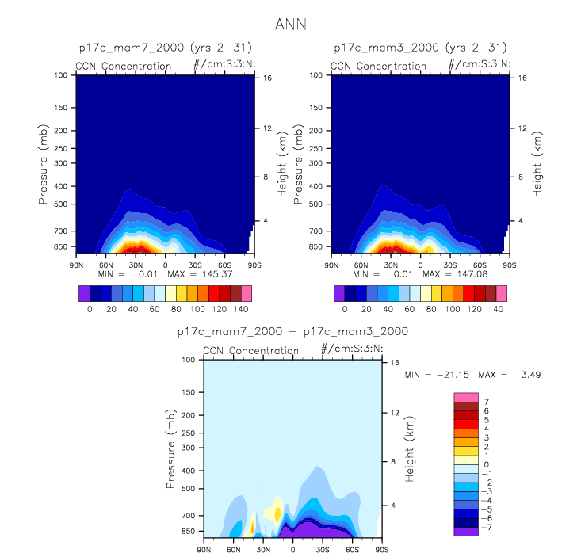
Figure 2: MAM7 vs MAM3 zonal average CCN concentration

The year-2000 CCN concentration produced by MARC tends to be much lower than that produced by MAM3. MAM7 produces lower concentrations than MAM3, but still much higher than MARC.

Liquid water path (TGCLDLWP)

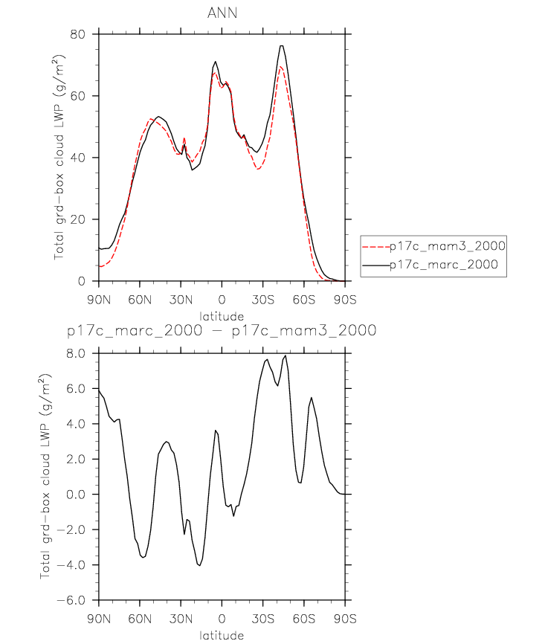
Figure 3: MARC vs MAM3 zonal average total grid-box cloud liquid water path (LWP)

Zonal average LWP differs by up to 8 g/m2 between MAM3 and MARC, with the LWP in MARC tending to be higher than in MAM3 in the Northern Hemisphere. The MAM7 results (not shown) tend to be similar to those for MAM3, with differences of up to 2 g/m2.

In Grandey et al. (2016), we found that “negative cloud shortwave RFPs are generally associated with increases in grid-box average liquid water path and total water path”. However, note that the results above are for year-2000 simulations, whereas RFPs are calculated using differences between simulations (often 2000 – 1850).

Ice water path (TGCLDIWP)

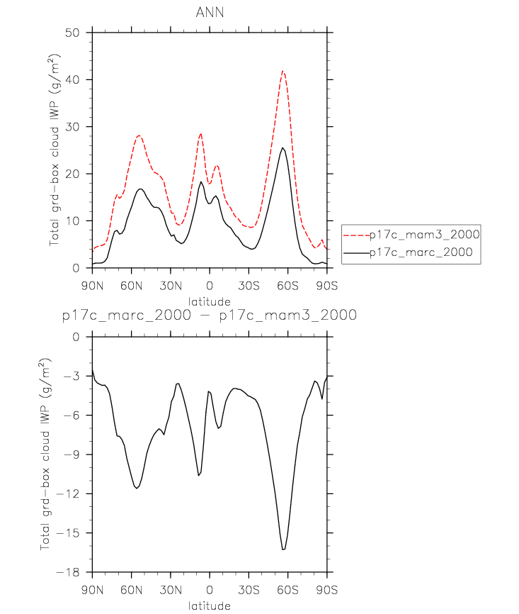
Figure 4: MARC vs MAM3 zonal average grid-box average cloud ice water path (IWP)

Zonal average IWP is consistently lower in the MARC simulations than in the MAM3 simulations, with large differences up to 15 g/m2. The MAM7 results (not shown) are very similar to those for MAM3.

In Grandey et al. (2016), we pointed out that “Negative cloud longwave RFPs are generally associated with decreases in ice water path”. However, note that the results above are for year-2000 simulations, whereas RFPs are calculated using differences between simulations (often 2000 – 1850). Having said this, since the IWP sensitivity differs between the MARC and MAM3 simulations, we would expect the cloud longwave RFP response to also differ between the MARC and MAM3 simulations – see below.

Radiative flux perturbations

Direct effect RFP
Figure 5: MAM3 direct effect RFP
Figure 6: MARC direct effect RFP
In MAM3, global mean direct effect is close to zero. In MARC, the global mean direct effect exerts a cooling of ~0.2W/m2. Hypothesis: BC warming effect is weaker in MARC than in MAM3.

Surface albedo RFP
Figure 7: MAM3 surface albedo RFP
Figure 8: MARC surface albedo RFP
In MAM3, surface albedo RFP is close to zero. In MARC, the surface albedo RFP exerts a cooling of ~0.1W/m2.

Cloud shortwave RFP
Figure 9: MAM3 cloud shortwave RFP
Figure 10: MARC cloud shortwave RFP
Compared to MAM3, MARC often exerts a stronger cloud SW cooling effect over land, but often weaker over ocean. Both MARC and MAM3 have a global mean cooling effect of ~2.1W/m2

Cloud longwave RFP
Figure 11: MAM3 cloud longwave RFP
Figure 12: MARC cloud longwave RFP
Compared to MAM3, MARC exerts a slightly stronger global average cloud longwave warming effect.

Net RFP
Figure 13: MAM3 net RFP
Figure 14: MARC net RFP
MARC often exerts stronger cooling effect than MAM3 over land, but often weaker over ocean. Overall, the cooling effect in the MARC simulations is almost 0.2W/m2 stronger than in the MAM3 simulations.

Aerosol column burdens – year-2000 simulations

Total sulphate burden
Figure 15: MAM3 sulphate burden (BURDENSO4)
Figure 16: MARC total sulphate column loading (SUL_LDG)

Organic carbon aerosol burden
Figure 17: MAM3 organic carbon aerosol burden (BURDENPOM)
Figure 18: MARC organic carbon column loading (OC_LDG). This does not include OC in MOS.

Black carbon aerosol burden
Figure 19: MAM3 black carbon aerosol burden (BURDENBC)
Figure 20: MARC black carbon column loading (BC_LDG). This does not include BC in MBS.

Minor edits to text in September 2017.

