INTELLIGENT TCP CONGESTION CONTROL
USING HYBRID MACHINE LEARNING AND REINFORCEMENT LEARNING
PROJECT REPORT
Submitted in partial fulfilment of the requirements for the
Bachelor of Technology in Computer Science and Engineering
Student: ______________________________
Register Number: _______________________
Project Guide: __________________________
Institution: _____________________________
Academic Year: _________________________

Abstract
Transmission Control Protocol (TCP) congestion control regulates the amount of outstanding data sent over a network. This project implements an experimental hybrid controller in ns-3 that combines a Random Forest (RF) congestion-state classifier with a Proximal Policy Optimization (PPO) action policy. The RF component classifies conditions as Low, Medium, or High, while PPO selects Decrease, Maintain, or Increase. The models are exported to ONNX and loaded by C++ code integrated into an ns-3 TCP controller. The hybrid controller is compared with TCP Reno in six bandwidth-delay scenarios using recorded throughput, mean delay, and FlowMonitor-reported loss metrics. In the recorded results, Hybrid mean delay is lower in all six scenarios, while throughput is higher in two. The largest recorded delay reduction is 30.13% in the 1 Mbps / 100 ms scenario, where throughput is also 5.63% higher. These results are preliminary: PPO was trained in a synthetic environment rather than directly against live ns-3 feedback, runtime inputs include proxies for training features, and the scenario comparisons do not establish statistical significance.
Keywords: TCP congestion control, ns-3, Random Forest, PPO, ONNX Runtime, throughput, delay, FlowMonitor.

1. Introduction
TCP congestion control adapts the congestion window (CWND) to share network capacity and respond to congestion. Its decisions affect throughput, delay, and robustness under changing network conditions. Conventional algorithms such as TCP Reno use predefined control rules. This project investigates a hybrid design in which supervised learning classifies the current state and reinforcement learning proposes a control action.

1.1 Problem Statement
The project investigates whether combining an RF congestion-state classifier with a PPO action policy can produce useful throughput and delay behaviour across different simulated bandwidth and delay configurations.

1.2 Objectives
- Implement a reproducible ns-3 experiment for TCP Reno and the hybrid ML-RL controller.
- Train and export an RF classifier and PPO policy to ONNX.
- Integrate model inference into a C++ TCP controller.
- Record controller decisions, CWND behaviour, and flow-level metrics.
- Compare throughput, mean delay, and reported-loss metrics across six scenarios.
- Document limitations and identify improvements for future evaluation.

2. Background and Technologies

2.1 TCP congestion control
The congestion window limits the amount of unacknowledged data that can be outstanding. TCP Reno is the baseline in this project. Throughput and delay are measured alongside the CWND trajectory.

2.2 Random Forest
Random Forest is an ensemble method that combines decision-tree predictions. The RF model classifies network conditions as Low, Medium, or High. The training dataset contains 1,330 samples across seven scenarios, with 190 samples per scenario. Leave-one-scenario-out evaluation reported average accuracy of 0.8571 across the seven held-out scenarios. This is a dataset-specific evaluation, not a guarantee of performance on unseen real networks.
Training feature order: bandwidth_mbps, configured_delay_ms, cwnd_bytes, total_rx_bytes, instant_throughput_mbps, flow_mean_delay_ms, flow_loss_rate_percent, flow_lost_packets.

2.3 Proximal Policy Optimization
PPO is a policy-gradient reinforcement-learning algorithm. The policy consumes a seven-value observation and selects Decrease (CWND factor ×0.8), Maintain, or Increase (CWND factor ×1.2), with the action factor bounded between 0.5 and 1.5. The PPO environment is synthetic; generated samples are held for four steps in 20-step episodes. It was not trained directly through interaction with the evaluated ns-3 simulation.
In the synthetic policy evaluation over 100 episodes (2,000 steps), actions were Decrease 638 times (31.9%), Maintain 858 times (42.9%), and Increase 504 times (25.2%), with average reward 62.3319. These are synthetic evaluation figures, not network-performance measurements.

2.4 ns-3 and ONNX Runtime
ns-3 provides the network simulation. The RF and PPO models are exported to ONNX and loaded by C++ through ONNX Runtime. Prior checks reported matching RF predictions for 70 of 70 dataset examples and matching PPO outputs for 1,000 random observations between the original policy and ONNX inference.

3. System Design and Implementation

3.1 Processing flow
- Configure a network scenario in ns-3 using the selected bandwidth, delay, and simulation duration.
- Collect runtime indicators such as CWND, acknowledgement-derived bytes, throughput estimates, RTT, and loss-related values.
- Run RF inference to classify the congestion state as Low, Medium, or High.
- Run PPO inference to choose Decrease, Maintain, or Increase.
- Apply bounded CWND actions while ACK-driven growth continues between decision points.
- Record decision traces and FlowMonitor statistics for comparison with Reno.

3.2 Principal files
File or directory | Purpose
ns-3/src/internet/model/tcp-hybrid-ml-rl.h | Hybrid TCP controller declaration.
ns-3/src/internet/model/tcp-hybrid-ml-rl.cc | Controller implementation and ONNX inference.
ns-3/scratch/tcp-hybrid-ml-rl-experiment.cc | Experiment setup and FlowMonitor output.
ml/congestion_model.onnx | Exported RF model.
ml/ppo_policy.onnx | Exported PPO policy.
results/csv/hybrid_vs_reno_comparison.csv | Six-scenario comparison table.
results/graphs/ | Four result plots.

3.3 Runtime feature mismatch
The RF training features include total received bytes, instantaneous throughput, flow mean delay, FlowMonitor loss rate, and lost-packet count. The current C++ runtime instead uses acknowledgement-derived bytes, an interval throughput estimate, latest RTT as a delay proxy, a heuristic loss-rate estimate, and a congestion-avoidance loss-event count. These quantities are not identical. The PPO observation also uses latest RTT as a proxy for mean delay. This training-serving mismatch can affect inference quality and is a major limitation.
The runtime loss-event counter is not equivalent to FlowMonitor's packet-loss count. No explicit packet error model is configured. FlowMonitor LostPackets should be interpreted as the simulator-reported metric and not as TxPackets minus RxPackets.

4. Experimental Methodology
Parameter | Configuration / note
Simulator | ns-3
Baseline | TCP Reno
Proposed controller | Hybrid RF classifier + PPO policy
Model format | ONNX
Simulation duration | 20 seconds per recorded scenario
Metrics | Flow 1 throughput, mean delay, FlowMonitor-reported lost packets
Additional traces | CWND and controller decision logs
Scenarios | Six bandwidth / configured-delay combinations

4.1 Scenario configurations
Scenario | Bandwidth | Delay
A | 10 Mbps | 150 ms
B | 10 Mbps | 25 ms
C | 10 Mbps | 50 ms
D | 1 Mbps | 100 ms
E | 2 Mbps | 50 ms
F | 5 Mbps | 100 ms

4.2 Repeatability check
Two runs of the 10 Mbps / 50 ms Hybrid scenario produced identical FlowMonitor values and identical 19,926-row CWND traces. Each run had 188 decision records. Because the logger appends to existing files, the uncleaned Trial 2 file contained 376 records: two identical sequences of 188 records. A separate clean Trial 2 copy was created with 188 records. This demonstrates repeatability for the tested setup but does not estimate run-to-run variability.

5. Results
Throughput change is calculated as (Hybrid − Reno) / Reno × 100. Delay change uses the same formula; a negative value indicates lower recorded mean delay for Hybrid.
Scenario | Reno Mbps | Hybrid Mbps | Throughput change | Reno delay ms | Hybrid delay ms | Delay change | Reno lost | Hybrid lost
10 Mbps / 150 ms | 3.36057 | 3.17984 | −5.38% | 151.312 | 151.288 | −0.02% | 0 | 0
10 Mbps / 25 ms | 9.27320 | 9.28939 | +0.17% | 56.339 | 53.141 | −5.68% | 8 | 3
10 Mbps / 50 ms | 9.20700 | 9.10505 | −1.11% | 65.710 | 65.608 | −0.15% | 0 | 0
1 Mbps / 100 ms | 0.846205 | 0.893834 | +5.63% | 359.698 | 251.312 | −30.13% | 35 | 34
2 Mbps / 50 ms | 1.85574 | 1.84495 | −0.58% | 229.646 | 213.230 | −7.15% | 29 | 0
5 Mbps / 100 ms | 4.47391 | 4.34868 | −2.80% | 131.531 | 130.947 | −0.44% | 0 | 0

5.1 Findings
- Hybrid throughput was higher than Reno in 2 of 6 recorded scenarios and lower in the other 4.
- Hybrid mean delay was lower in all 6 recorded scenarios. The largest recorded reduction was 30.13% at 1 Mbps / 100 ms.
- At 10 Mbps / 25 ms, Hybrid throughput was 0.17% higher and mean delay was 5.68% lower.
- At 10 Mbps / 150 ms, Hybrid throughput was 5.38% lower while mean delay was almost unchanged.
- At 2 Mbps / 50 ms, FlowMonitor reported 0 lost packets for Hybrid and 29 for Reno. This is a simulator metric, not proof of a general loss reduction.

5.2 Decision trace at 10 Mbps / 50 ms
The 188 decision records contained 15 Low and 173 Medium RF classifications, with no High classifications. PPO selected Maintain 175 times, Increase 13 times, and Decrease 0 times. Final recorded CWND was 10,863,714 bytes. The policy therefore selected Maintain at most decision points, while ACK-driven growth continued between decisions. This trace suggests that the current integration does not yet demonstrate strong, sustained CWND regulation.

6. Discussion
The recorded results are mixed. Hybrid reduced mean delay in all six scenarios, but throughput improved in only two. The strongest combined result is the 1 Mbps / 100 ms scenario, while the 10 Mbps / 150 ms scenario shows lower throughput with almost no delay change. Each scenario comparison is based on recorded runs, so the data do not establish statistical significance or generalization across seeds and traffic patterns.
The results should be interpreted in light of synthetic PPO training, runtime feature mismatch, and the controller's preference for Maintain. The RF held-out-scenario score is more informative than training-set accuracy but remains specific to the constructed dataset. PPO's synthetic reward does not directly establish utility in a network simulation.

7. Limitations
- PPO was trained in a synthetic environment rather than directly in the evaluated ns-3 network.
- Some runtime features are proxies and do not exactly match model-training features.
- The inspected Hybrid trace selected Maintain frequently and did not select Decrease.
- The six-scenario comparison does not include enough independent runs to calculate reliable confidence intervals or significance tests.
- Two identical runs check reproducibility but do not establish variability.
- Fairness, competing flows, explicit random packet errors, and real-network generalization have not been established.
- FlowMonitor-reported loss counts should not be confused with the difference between transmitted and received packet counts.

8. Future Work
- Align runtime features and preprocessing exactly with training definitions.
- Train PPO in the same ns-3 environment or validate a simulator-matched environment.
- Investigate why Decrease is rarely selected and review the reward's throughput-delay-loss trade-off.
- Add controlled bottleneck queues, explicit packet-error scenarios, and competing TCP flows.
- Run multiple independent seeds per scenario and report means, standard deviations, and confidence intervals.
- Compare against additional established congestion-control algorithms and measure fairness.
- Use per-run output filenames or truncate decision logs automatically to prevent duplicate records.

9. Conclusion
This project implemented a hybrid ML-RL TCP congestion-control prototype in ns-3 using an ONNX Random Forest classifier and PPO policy. Across six recorded scenarios, Hybrid mean delay was lower in all scenarios and throughput was higher in two. The largest observed delay reduction was 30.13% at 1 Mbps / 100 ms. However, these results are preliminary and do not establish universal improvement. Synthetic PPO training, runtime feature mismatch, limited independent trials, and the policy's strong preference for Maintain constrain the conclusions. The implementation provides a foundation for further work, with feature alignment, simulator-matched training, better action behaviour, and multi-seed evaluation as priorities.

References
- Jacobson, V. (1988). Congestion avoidance and control. Proceedings of the ACM SIGCOMM '88 Symposium on Communications Architectures and Protocols, 314–329.
- Floyd, S., & Henderson, T. (1999). The NewReno Modification to TCP's Fast Recovery Algorithm (RFC 2582). Internet Engineering Task Force.
- Allman, M., Paxson, V., & Blanton, E. (2009). TCP Congestion Control (RFC 5681). Internet Engineering Task Force.
- Breiman, L. (2001). Random forests. Machine Learning, 45, 5–32.
- Schulman, J., Wolski, F., Dhariwal, P., Radford, A., & Klimov, O. (2017). Proximal policy optimization algorithms. arXiv:1707.06347.
- The ns-3 Project. ns-3 Network Simulator documentation and model library.
- ONNX Runtime. ONNX Runtime documentation.

Appendix A. Results artifacts
- results/csv/hybrid_vs_reno_comparison.csv — six-scenario comparison table.
- results/graphs/throughput_comparison.png — throughput comparison.
- results/graphs/delay_comparison.png — mean-delay comparison.
- results/graphs/throughput_change.png — percentage throughput change.
- results/graphs/cwnd_comparison_10Mbps_50ms.png — CWND trace comparison.
- results/csv/trial1_backup/ — preserved Trial 1 output files.
- results/csv/trial2_clean/ — clean Trial 2 outputs, including 188 decision records.
Before submission: fill in the cover-page details and apply any required institutional formatting.

Figure-based Results and Interpretation
The following figures visualize the six-scenario comparison and the 10 Mbps / 50 ms congestion-window trace. They should be read together: CWND is a controller state, while throughput and delay describe observed flow performance.
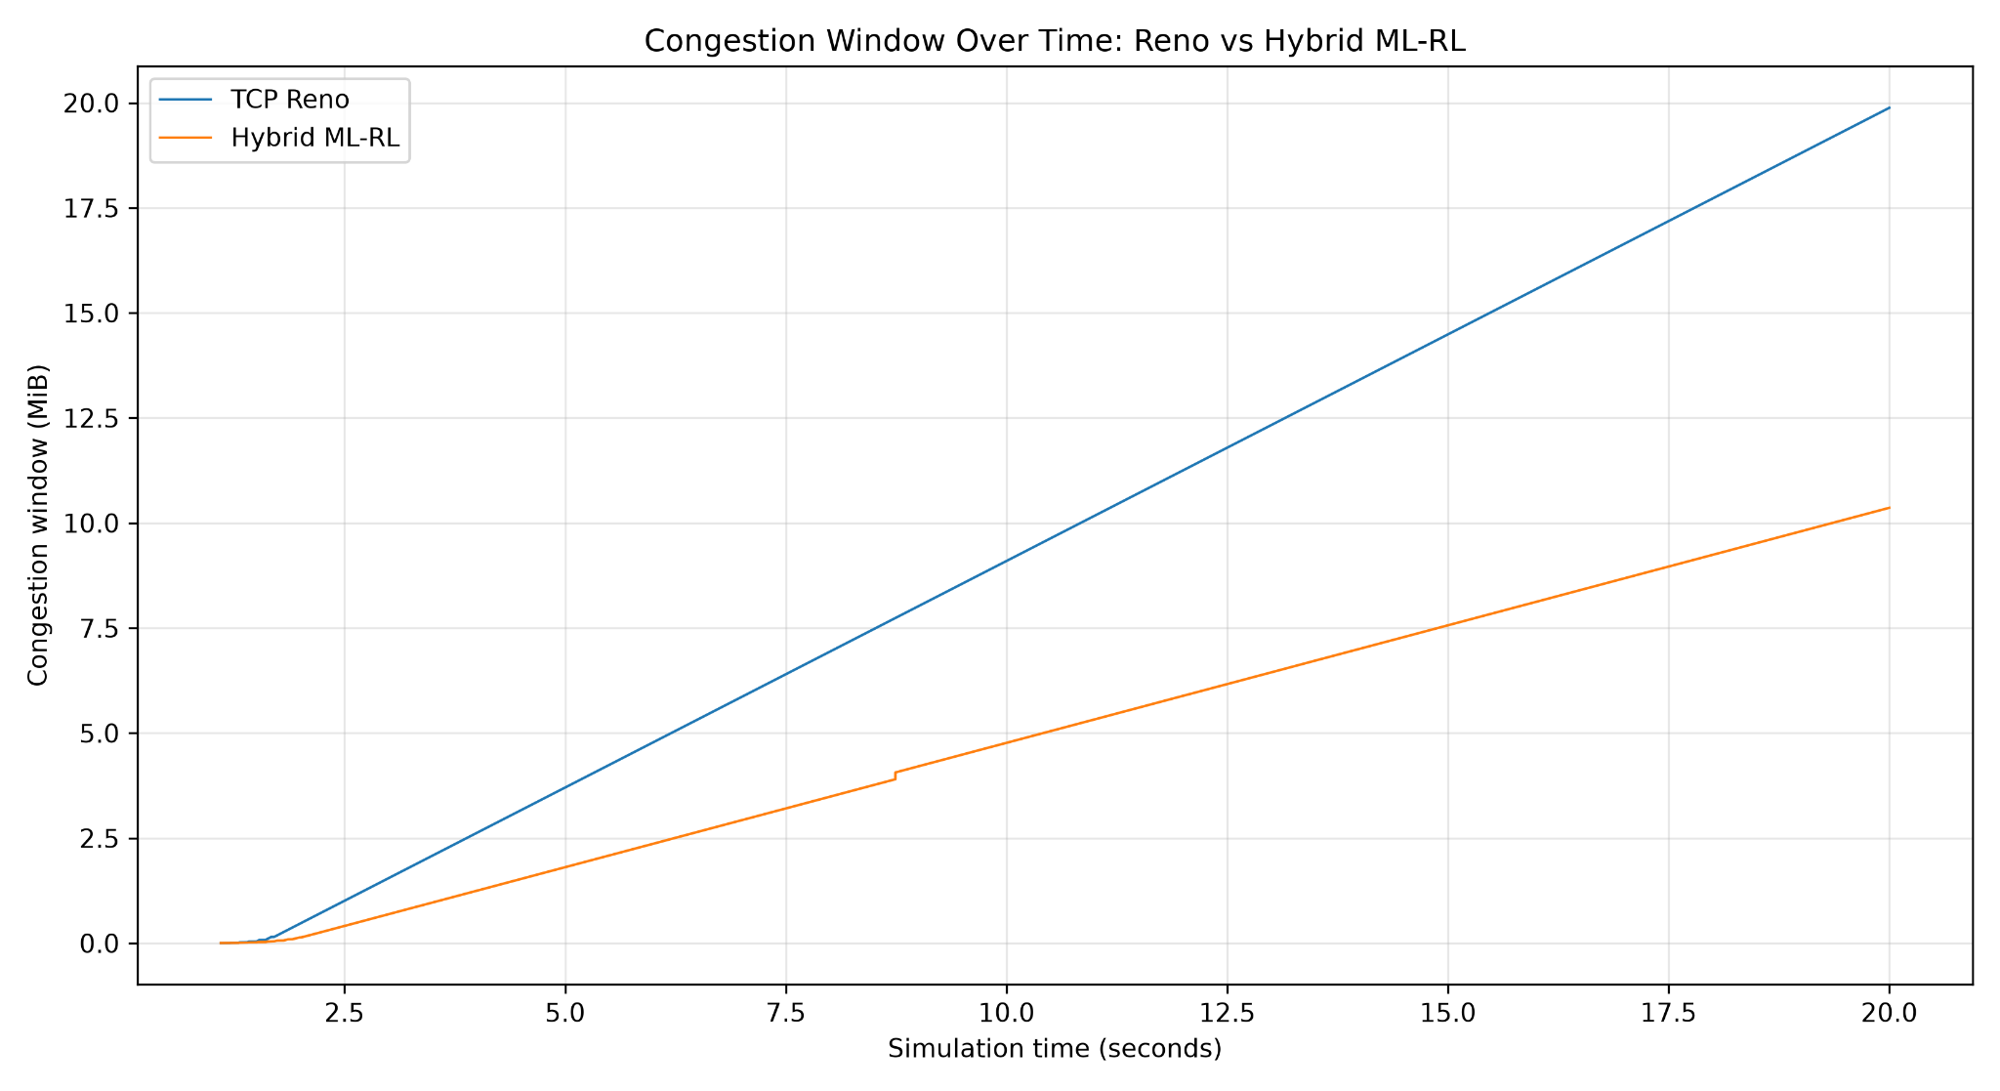
Figure 1. TCP Reno and Hybrid ML-RL throughput across six network scenarios.
Hybrid throughput is higher in two scenarios and lower in four. The largest recorded increase is in the 1 Mbps / 100 ms scenario; the largest reduction is in the 10 Mbps / 150 ms scenario.
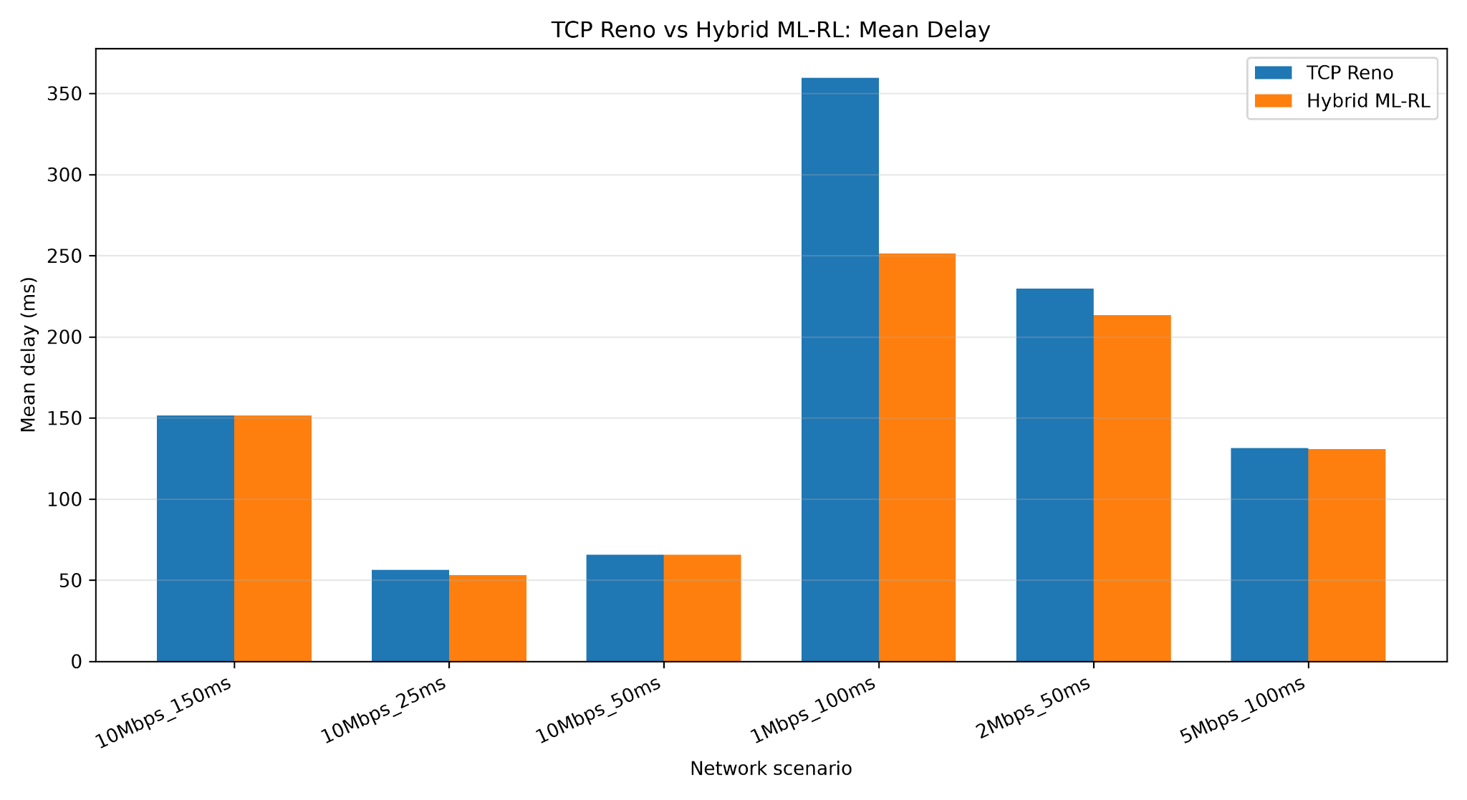
Figure 2. Congestion-window evolution over time for TCP Reno and Hybrid ML-RL at 10 Mbps / 50 ms.
The plotted Hybrid CWND remains below the Reno trace through the simulation. This is an observed window trajectory, not by itself proof of better congestion control; it should be interpreted alongside throughput and delay.
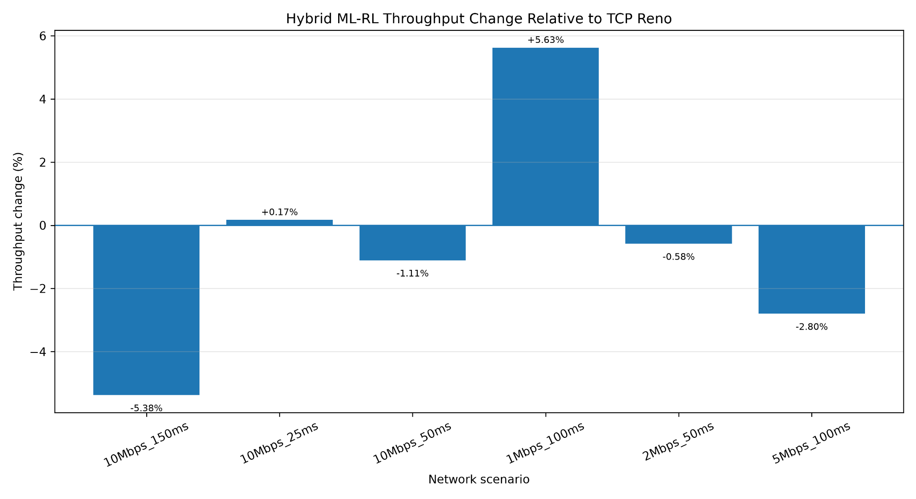
Figure 3. Mean delay comparison between TCP Reno and Hybrid ML-RL across six scenarios.
The recorded Hybrid mean delay is lower in all six scenarios, with the largest reduction at 1 Mbps / 100 ms. The 10 Mbps / 150 ms values are nearly identical.
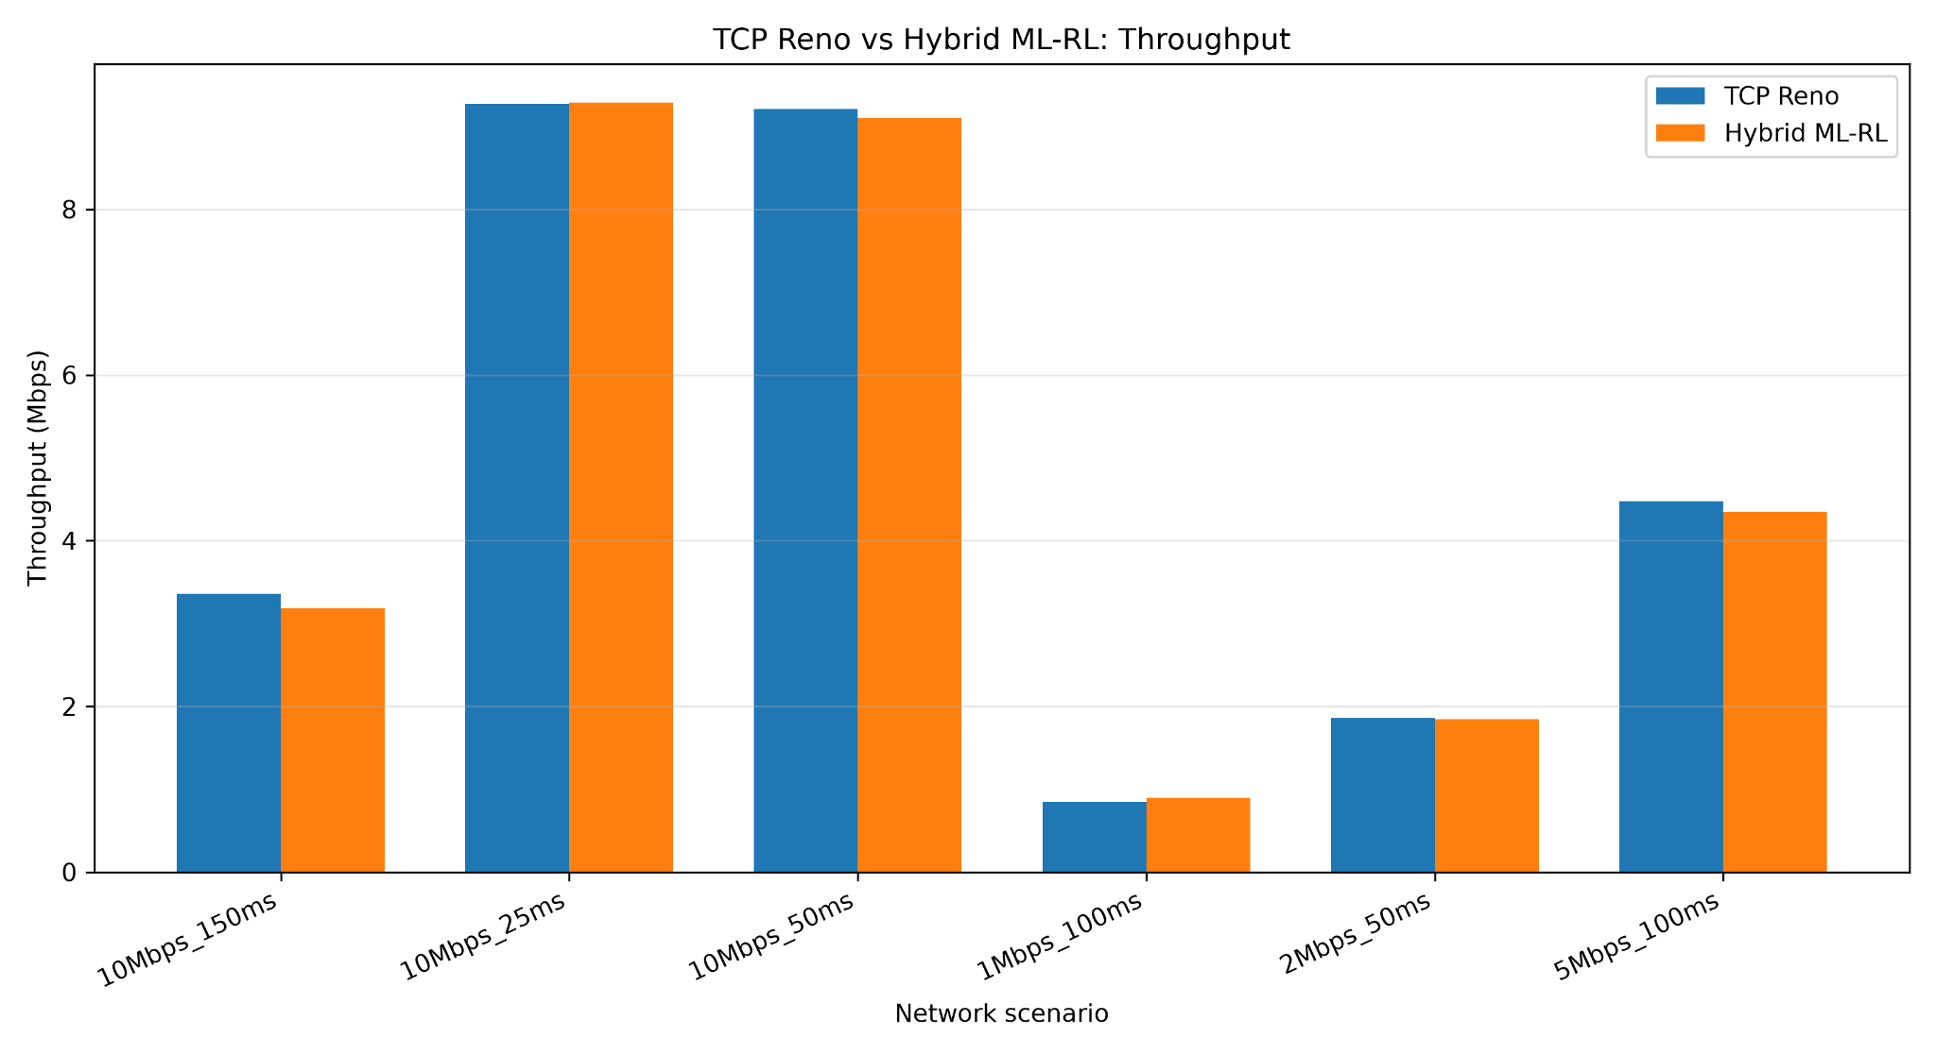
Figure 4. Percentage change in Hybrid throughput relative to TCP Reno.
Positive bars indicate higher Hybrid throughput and negative bars indicate lower throughput. Hybrid throughput is higher in two of six scenarios.

Updated Results Discussion
Figure 1 shows that the Hybrid controller does not increase throughput in every configuration: throughput is higher in two scenarios and lower in four. Figure 3 shows lower recorded mean delay in all six scenarios, with the largest reduction at 1 Mbps / 100 ms. Figure 4 makes the throughput trade-off explicit, including a 5.38% reduction at 10 Mbps / 150 ms and a 5.63% increase at 1 Mbps / 100 ms. Figure 2 shows a smaller Hybrid congestion window than Reno in the 10 Mbps / 50 ms run. A lower CWND is not inherently better; its significance depends on whether it maintains useful throughput and avoids excessive delay or loss.
Note: The images are embedded from the graphs supplied in this conversation. The report's numerical table should remain the authoritative source for exact values, and those values should be checked against the comparison CSV before final submission.

