Integra guard Surveillance System

Project Proposal



Supervisor

MR.AFZAL HUSSAIN

Co-Supervisor

MR.MUSTAFA ALI

Submitted by

Zainab Khalid

{2326-2021 / IT-21-346}

Nida Aamir

{2458-2021 / IT-21-349}

Department of Computer Science, Hamdard University, Karachi.

[27-June-2024]

**Table of Contents**

1. Introduction 3
2. Objective 3
3. Problem Description 3
4. Methodology 3
5. Project Scope 4
6. Flowchart 6
7. Feasibility Study 6-7
8. Solution Application Area 7
9. Tools/Technology 7
10. Responsibilities of the Team Members 8
11. Planning. 9

# **Introduction**

The IntegraGuard project is a real-time weapon detection and alerting system designed to enhance security in sensitive environments such as ATMs, banks, schools, and public spaces. By leveraging advanced computer vision and cloud technologies, the system aims to automatically detect weapons in live video feeds and promptly notify security personnel, thereby reducing response times and improving overall safety

# **Objective**

* To develop an automated system capable of detecting weapons (e.g.,guns and knives ) in real-time video streams.
* To provide instant alerts to monitoring and security personnel upon detection of a potential threat.
* To log detection events and store weapon type for evidence.
* To create a user-friendly dashboard for live monitoring and alert management

To ensure the system is scalable, reliable, and adaptable to various deployment scenarios

# **Problem Description**

Traditional surveillance systems rely heavily on human operators to monitor video feeds, which can lead to delayed responses and missed threats due to fatigue or distraction. There is a critical need for an intelligent, automated solution that can continuously analyze video streams, detect weapons , and alert the appropriate personnel in real time. The lack of such systems increases the risk of security breaches and reduces the effectiveness of existing surveillance infrastructure.

# **Methodology**

### Project Approach (Evolutionary Prototyping)

In this project, we will use the evolutionary prototyping approach, focusing on developing a working prototype early and refining it through multiple iterations based on feedback.

**Iterative Development:** Progress through a series of refined prototypes, each building on the previous one.

**Frequent Reviews:** Conduct daily stand-up meetings, lasting 15 minutes, to review progress and plan the next steps.

**Continuous Feedback:** Gather feedback from stakeholders for each prototype, refining functionality and GUI design.

**Requirements Analysis:** Initial analysis provides a baseline, but requirements evolve with each prototype.

**Flexible Modifications:** Add and delete features early to ensure the system evolves effectively.

By using evolutionary prototyping, we continuously improve the project through regular iterations, ensuring a user-centered and effective suspicious activity detector.

# **Project Scope:**

The scope of the project includes the development of a **web-based surveillance system** that uses live camera feeds and AI models to **detect weapons**. Once a weapon is identified, the system triggers **automatic alerts** via SMS, email, or dashboard notifications to authorized users.

Key functions include:

* Weapon detection through video feeds.
* Integration with existing CCTV infrastructure.
* Web application dashboard for monitoring alerts.
* Real-time notifications to security personnel.
* Cloud-based storage and access to detection logs.

.

##### Out of Scope

* **Detection of concealed weapons** (e.g., under clothing or hidden objects).
* **Audio-based threat detection**, such as gunshot detection or aggressive sounds.
* **Facial recognition**, identity tracking, or biometric analysis.
* **Detection of facial expressions**, stress, or emotional states.
* **Analysis or prediction of malicious intent or suspicious behavior**.
* **Crowd behavior monitoring**, tracking individuals, or group analysis.
* **Automated physical responses**, such as triggering barriers or alarms.
* **General anomaly detection** not directly related to **visible weapons**.

# **Feasibility Study**

* **Technical Feasibility:** The project leverages proven technologies such as YOLOv8 for object detection, Flask for backend development, React for frontend, and Firebase for cloud services, all of which are well-supported and suitable for real-time applications.
* **Economic Feasibility:** The use of open-source tools and cloud-based services minimizes development and deployment costs, making the solution affordable for a wide range of organizations.
* **Operational Feasibility:** The system is designed for ease of use, requiring minimal training for operators. Its modular architecture allows for easy updates and maintenance.
* **Legal and Ethical Feasibility:** The system is designed with privacy in mind, storing only necessary data and providing secure access controls.

**8. Solution Application Areas**

* ATMs and Banks: Enhance security by detecting weapons during potential robbery attempts.
* Educational Institutions: Monitor school premises for unauthorized weapons and alert authorities instantly.
* Public Spaces: Improve safety in parks, malls, and transportation hubs by providing real-time threat detection.
* Corporate Offices: Protect employees and assets by monitoring entrances and sensitive areas.
* Critical Infrastructure: Secure power plants, data centers, and other vital facilities against armed intrusions.

**9. Tools/Technology**

* Python & Flask: Backend development and API management.
* YOLOv8 (Ultralytics): Real-time object detection in video streams.
* OpenCV: Video capture and frame processing.
* Firebase: User authentication, real-time database, and push notifications.
* React: Frontend development for the user dashboard.
* Node.js & npm: Frontend build and dependency management.
* Google Chrome: Primary browser for testing and debugging.
* Microsoft Word/Excel: Documentation and test case management.
* Git & GitHub: Version control and collaborative development.

# **FLOWCHART**

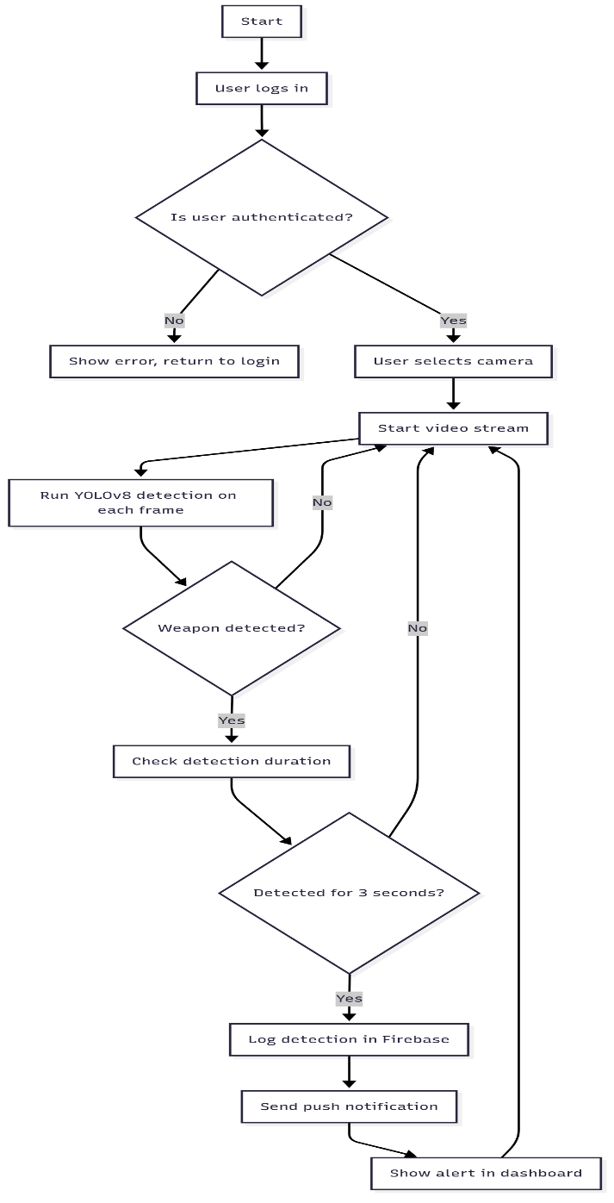

Milestones

##### 1st Evaluation:

* + Application design
  + Device models creation
  + Database design
  + Design documentation

##### 2nd Evaluation:

* + Cloud server setup
  + Image processing
  + Machine learning integration
  + GUI, database, and cloud server integration
  + Running application