***Final Exam Practical Exam***

*Support all of your results statements with statistics. State which statistical test you used. Be sure to interpret the biological meaning of all results*. *It is your responsibility to confirm that all test assumptions have been met, in order to do the analysis correctly, but you do not need to show evidence of the assumptions having been met. Use R for all of your statistical analyses and graphs. You only need to provide graphs where indicated.*

1. (15 pts) Maria from the Robertson Lab wants to know the weight of the frogs she finds in the field, but it is not convenient to carry a balance into remote field sites. It is much easier to measure snout-vent length (SVL). She wants to know whether this is a good predictor of the weight of the frog. She catches 100 frogs and brings them back to the lab in Costa Rica to measure their SVL and weight. Her data are in the file *TreeFrog.csv*.

Are weight and SVL significantly related?

Yes SVL has a significant effect on the weight of treefrogs (F-stat= 1016, p<0.001).

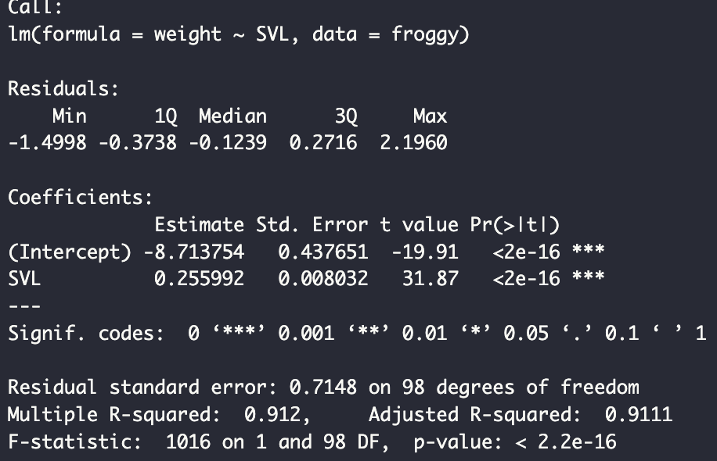

How strongly?

Given a particular SVL, what equation would she use to predict the weight?

y = a + b(x) → Weight = -8.714 + 0.256(SVL)

2. (15 pts) As you drive the remote back roads to your field study site, you notice that the number of dead animals you see along the road seem different from what you see closer to home. You start counting. You divide the roads you travel evenly into rural or urban. After a year, you have counted 214 road-killed animals. The data are: 119 animals on rural roads and 95 animals on urban roads. Was there a difference in the number of animals killed along rural roads compared to urban roads?

3. Sophia is a psychologist studying the effects of cognitive behavioral therapy (CBT) on anorexia nervosa. She found 55 people to participate in the study. Each person was randomly assigned to the control treatment (no therapy) or assigned to receive cognitive behavioral therapy once a week for four months. She measured the weight of each person at the beginning and end of the study and determined their change in weight over four months. The data are in the file *anorexia.csv*.

1. (10 pts) Use R to determine the following descriptive statistics for weight change. Are the data normally distributed?

Mean

Median

S.D.

S.E.M.

C.V.

1. (10 pts) Use an appropriate test to determine whether CBT affects weight change. Include a graph that illustrates the result.

4. Erin in the Steele Lab studied kelp bass at several different sites along the coast of California. She wanted to know if density of this fish was related to the habitat attributes of the site. At each site she sampled the site using four independent transects. In addition to recording the number of kelp bass on each transect at each of the 7 sites, she recorded six attributes of the habitat: the approximate volume of space occupied by kelp, water temperature, salinity, and the percent cover of sand, seagrass, and rock. The data are in the file *habitats.csv*.

(a) (5 pts) First, convert all habitat variables to z-scores and then use Principal Components Analysis (PCA) to derive components that summarize the variation in the **six** habitat variables (do not include kelp bass density). How many components would you need to include to capture 70% of the variance in the original data? How much variance in the original data is explained by the first two principal components? Which variables are most strongly related to PC1 and PC2?

(b) (5 pts) Use perMANOVA with the original (i.e. use the raw data, not z-scores) six habitat variables to determine whether the seven sites differ in habitat variables. Does habitat differ among sites?

(c) (5 pts) Finally, let’s return to Erin’s original question about kelp bass densities. Use multiple regression to determine whether the original (raw data) six habitat variables have any effect on kelp bass density. Describe any significant effects.

5. (10 pts) Jeffrey is studying armadillos and interested in whether the type of soil affects where they choose to make a burrow. He visits many sites and at each one, he measures the average particle size of the soil, and whether or not he finds an armadillo burrow there. The data are in the file *armadillos.csv*. In the file, 0 means no burrow was found, 1 means that at least one burrow was found. Determine whether grain size affects the probability of finding armadillos at a site. Include a graph to illustrate your results.

6. (15 pts) Luisa studies the growth of cancer cells in the human body. She developed two slightly different versions of a new drug that might reduce the rate of proliferation of cancer cells. She treated cancer cells in tissue culture with each of the new drugs (Drug A and Drug B). She also included a control in which only saline was added to the culture. She had 30 replicates of each treatment and measured the growth of cancer cells in each. The data are in the file *cancerdrug.csv*. Use these data to determine the effectiveness of these drugs.

7. (10 pts) Kate is working on a recovery plan for the green sea turtle. As part of this plan, she needs to build a demographic model that will project population growth (or decline). To build a more accurate model, she wants to know if per-capita reproductive output of females varies among sites. She has access to a data set that gives reproductive output (eggs laid per nesting female) at three sites, pooled over a 30 year time span. Bear in mind that reproductive output is often a function of body size in animals, and this effect should be controlled for statistically. The file *SeaTurtle.csv* also includes the carapace length (i.e., shell length) as a measure of size. Based on the data, does per-capita reproductive output differ among sites? Is it a function of body size? Does the effect of body size differ among sites? Include a graph illustrating your results.