*Midterm 2*

*Practical Exam (50 pts)*

*Support all of your results statements with statistics. Be sure to interpret the biological meaning of all results*. *It is your responsibility to confirm that all test assumptions have been met, but you do not need to show the probability plots, etc. you used to confirm assumptions. All datasets are available on Canvas.*

1. Marisa is interested in how Red Bull affects student performance on exams. She administered three treatments to different students: a can of Red Bull, a can of Coke, or a bottle of water, consumed just before the exam. Red Bull and Coke both contain sugar and caffeine, but **Red Bull contains more caffeine (111mg)** than **Coke (34mg)**. The **water serves as a control** for fluid intake. In the class of **45 students, 15 students each get one of the three treatments**, with students assigned randomly to treatments. Marisa recorded the score of each student on the exam.

(5pts) Use the data file “redbull.csv” to perform an ANOVA testing the effects of these treatments. Perform Tukey’s post-hoc tests. Does beverage treatment have an effect? What do the post-hoc tests tell you about whether sugar and/or caffeine might affect test performance?

(5pts) Make a graph to show differences among treatments, including letters to show which treatments are different from each other.

**ANOVA** shows that beverage treatment has a statistcally significant effect on exam score (p<0.01, F= 5.9219).

**Tukey** test shows that sugar and caffeine affect test performance (Redbull score mean = 75.67, Coke score mean = 76.07, Water score mean = 69.13). There is no significant difference between the redbull and coke but each of them is significantly different to water.

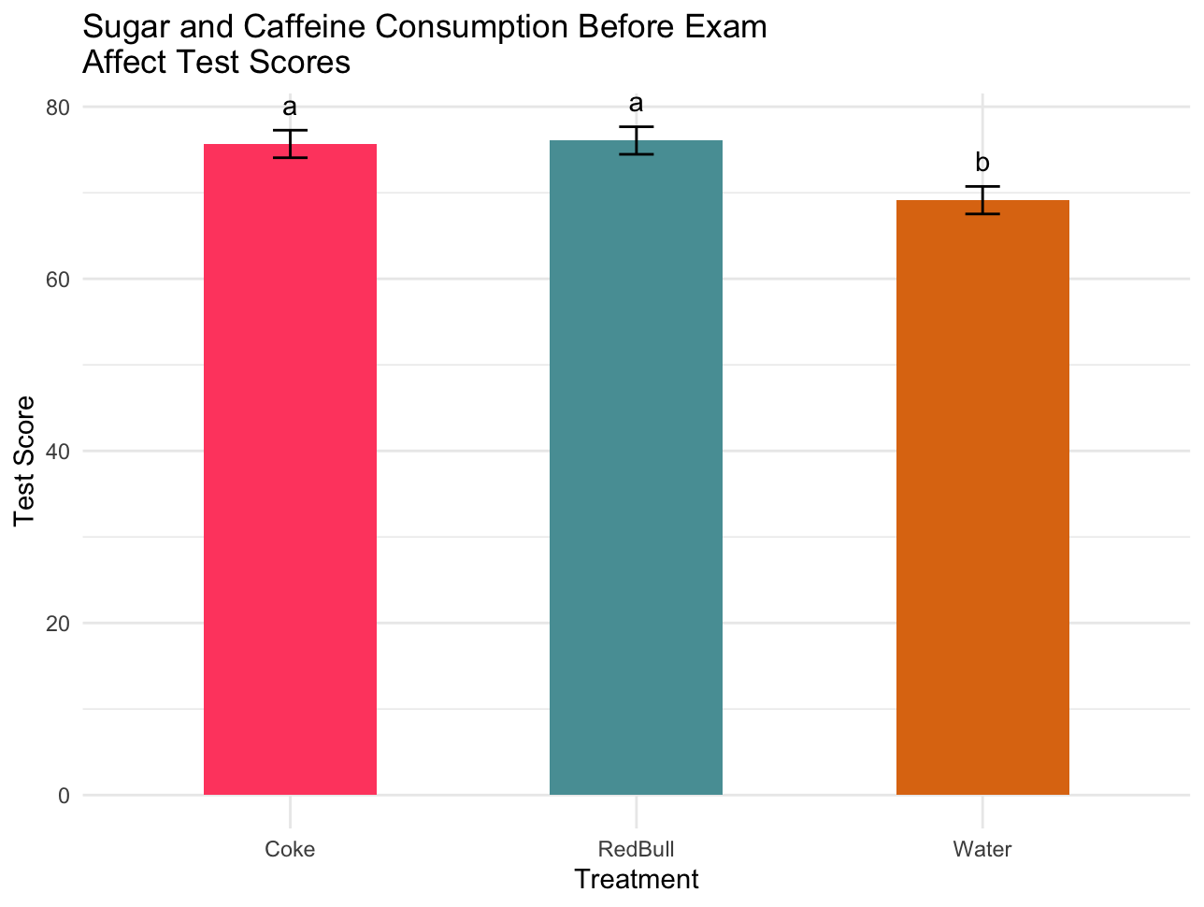

1. Tina conducted a field experiment to test whether the amount of shelter affects recruitment of blue-banded gobies. She constructed replicate habitats with different numbers of holes drilled in them; the gobies used the holes as shelter. She used three shelter treatments: **20, 40, or 60 holes per habitat (“gobitat”)**. She was also interested in whether **predators affect habitat use**, so she manipulated the presence of predators using **cages that kept predators away** from the gobitats and compared these to **uncaged gobitats**. She set up the experiment in an area where there was a **depth gradient**, so she divided the entire experiment **two depth blocks, one shallow and one deep**. Because Tina was specifically interested in these different depths and whether treatment effects were different between depths, so she included **block as a fixed factor** to test the effect of depth. Each of the shelter*predator treatment combinations was **replicated twice in each block**, for a total of 24 gobitats. A month after she installed the gobitats, she surveyed the total number of young blue-banded gobies that had accumulated (“recruited”) on each gobitat.

(10pts) Use the data file “gobyshelter.csv” to **test the effects of shelter, predators, depth, and their interactions**. You may either interpret the results of your full model, with p-values for each main effect and interaction, or perform model selection and give p-values for only the terms in the final model. Include a table with the results from your analysis (columns should be Source, df, MS, F, P). Describe the biological interpretation in a couple of sentences.

**Mixed model ANOVA** shows statistically significant separate effects of Block Depth (p<0.05), Shelter (P<0.001) and Predation (P<0.001) on goby recruits. Block Depth had the most effect (F=30.9751).

Cells with statistically significant results highlighted green.

| Effect on recruits | DF | Mean of Squares | F value | P value |
| --- | --- | --- | --- | --- |
| Block | 1 | 240.67 | 5.5220 | **0.0367199** |
| Shelter | 2 | 771.17 | 17.6941 | **0.0002637** |
| Predators | 1 | 1350.00 | **30.9751** | **0.0001227** |
| Block:Shelter | 2 | 12.17 | 0.2792 | 0.7611999 |
| Block:Predators | 1 | 0.67 | 0.0153 | 0.9036173 |
| Shelter:Predators | 2 | 158.00 | 3.6252 | 0.0586730 |
| Block:Shelter:Predators | 2 | 21.17 | 0.4857 | 0.6268773 |
| Residuals | 12 | 43.58 |  |  |

1. Hannah is concerned that **increased abundance of octocorals on coral reefs is decreasing the health of stony corals**. She establishes **40 plots**. I**n half of the plots, she removes all octocorals**. **In the other half, she leaves octocorals intact**. After one month, she **measures the photosynthetic rate of one randomly chosen stony coral colony in each plot**. She also suspects that **photosynthetic rate might be affected by the size of the coral, so she also measures coral colony diameter (cm)**.

(5pts) Analyze the data in the file “octocorals.csv” and using an appropriate GLM, and provide an ANOVA table.

(10pts) Provide a graph that summarizes your results and interpret the effects of octocorals and coral colony size on photosynthetic rate, in a couple of sentences.

The **ANOVA** was done on a model looking at the effects of Octocoral Colony Diameter, Treatment, and their interaction on the photosynthetic rate of Stony coral.

All 3 had a statistically significant effect (p<0.001) on the photosynthetic rate of stony coral with Treatment as the strongest predictor (F=7916.89).

| Effects on Photosynthetic Rate | DF | Sum of Squares | Mean of Squares | F value | P value |
| --- | --- | --- | --- | --- | --- |
| Colony Diameter | 1 | 0.001376 | 0.001376 | 144.06 | **3.822e-14** |
| Treatment | 1 | 0.075639 | 0.075639 | **7916.89** | **< 2.2e-16** |
| ColonyDiameter*Treatment | 1 | 0.048385 | 0.048385 | 5064.28 | **< 2.2e-16** |
| Residuals | 36 | 0.000344 | 0.000010 |  |  |

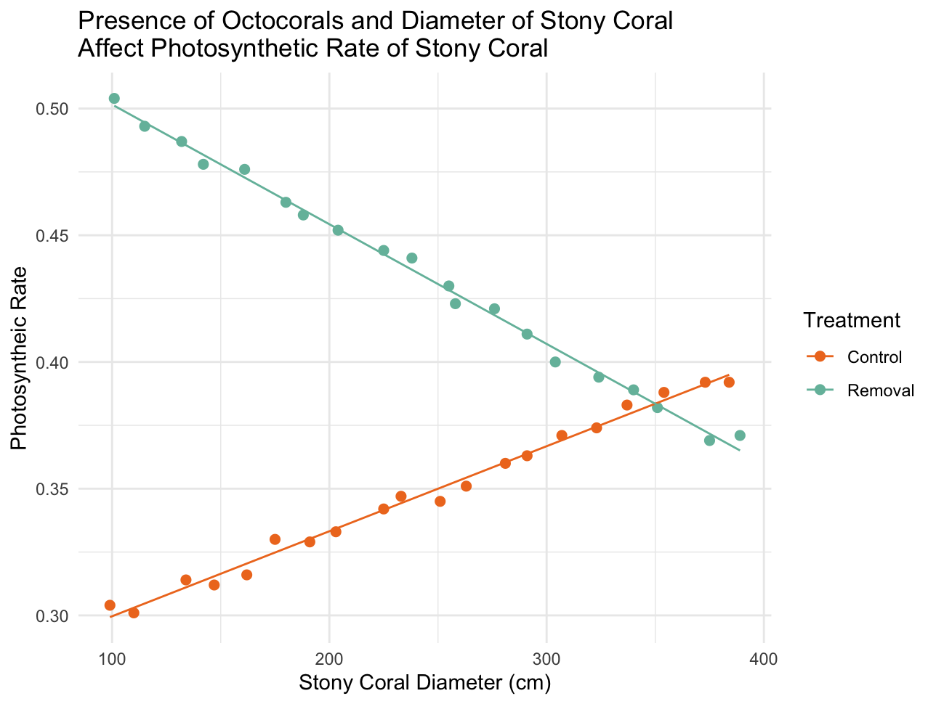

4. One cold February day in 1898, an “an uncommonly severe” storm passed over New England. After the storm, the zoologist Hermon Bumpus collected 136 house sparrows that had been brought down by the storm in the vicinity of his laboratory at Brown University in. More than half of the birds recovered, but the rest died from exposure. Bumpus took this as an opportunity to study natural selection in action, and measured a number of skeletal features on all the birds, as well as recording whether they survived the storm, their sex, and (in the males) whether they were adults or yearlings. Bumpus’s data are in the file “bumpus.csv.”

(10pts) You hypothesize that the sparrows that survived the storm weigh more (or less) for their body size (length) than sparrows that did not survive. Use Bumpus’s data to model the relationship(s) between weight and l**ength, sex, and survival** in a GLM that includes all these predictors, then use model comparison methods to identify the minimum set of these three predictors that best explains variation in the sparrows’ weights. Provide the biological interpretation of your results in a sentence or two.

Model comparison shows Length is the strongest predictor of Sparrow’s weights. The AIC scores were best in models looking at length alone or at least having length present. **ANCOVA**  on a model with Length, Sex, and Survival without interaction was the best fit to answer the question with Length (p<0.001) having a statistically significant impact on Weight.

Larger/Heavier Sparrows seem to have a lower chance of survival in storms.

(5pts) Provide a figure that illustrates the relationship between length and weight, broken down by sex and by survival status, and give an appropriate caption.

