**Problem Set #4: General Linear Models**

(1) (10pts) To evaluate the effect of an electromagnetic field on formation of white blood cells from stem cells, stem cell cultures were taken from 10 randomly chosen women. Stem cells were exposed to an electromagnetic field (EMF) or not (Control). The number of white blood cell colonies that grew on agar plates was then counted. There were three replicates for each treatment for each woman. The data are given in the file **electromagnetic_effects.csv**. Use ANOVA to test for an effect of the EMF treatment. State the type of ANOVA model used, analyze the data, and interpret the results.

I used a linear mixed model (lmer) to view the effects of EMF on WBCcolonies with the Donor as a random factor.

**Two-way Nested ANOVA** suggests an overall significant positive effect of EMF treatment (F=7.4941) on WBCcolony growth. Using donor as a random factor shows that variance in WBCcolony count can be explained (76.15%) by the donor.

(2) (10pts) Sarah, a former student in Polly Schiffman’s lab, is interested in the ability of plants to tolerate herbivory and whether herbivory affects their ability to compete against other plants at the Carrizo Plain. She is particularly interested in whether invasive species respond differently than a common native species. She chooses to study four species: the invasive forb *Erodium cicutarium*, a native forb with a similar morphology *Tripidocarpum gracile*, and two invasive grasses *Bromus madritensis* and *Vulpia myuros*. **She does an experiment in which she manipulates two factors: simulated grazing (clipped or not) and competition (weeded to remove competitors or not).** At the end of the growing season, she counts the number of flowers on each plant. The data are in the file **plantcompetition.csv**. Conduct a three-way ANOVA to test the effects of species, clipping, and weeding. State the type of ANOVA model used (e.g., fixed, random, mixed), analyze the data, and interpret the results in light of the biological questions.

**Three-way mixed ANOVA** with Species as random and interactions between factors. The data was normalized with a square root transformation, log transformation produced too many NA’s for the ANOVA.

There is a significant negative effect of the clipping/weeding interaction on the number of flowers (p<0.01). Variance in flower growth is explained by Species type by only 10.45% which confirms the effects of herbivory and competition.

(3) (15pts) Rebecca (former student in Peter Edmunds’ lab) wants to determine if the photosynthetic physiology of corals (i.e., the endosymbiotic zooxanthellae) can acclimate to increased temperatures such as might occur in our changing climate. She collected 30 coral fragments and established the following laboratory experiment with them:

Ten coral fragments were randomly assigned to each of three treatments: ambient temperature, ambient + 2°C, and ambient + 4°C. Following exposure to these experimental conditions, she measured Fv/Fm (the variable fluorescence of photosystem II) as a proxy for efficiency of photosynthesis. To determine if corals acclimate over time, she measured fluorescence of each coral daily for 6 days. The data are in the file **coral_acclimation.csv**.

State the type of model you would use to analyze this data. Analyze the data and present it (in a publication-quality graph). Interpret the results in the context of whether or not these corals acclimate to temperature.

**The repeated measures ANOVA** was done on a model with coral fragment and temperature as a random factor and, interaction between temperature and day.

There is a overall significant effect of temperature, day and their interaction on coral FvFm (p< 0.001). The interaction between temperature and day had the strongest effect with an F= 50.3835.

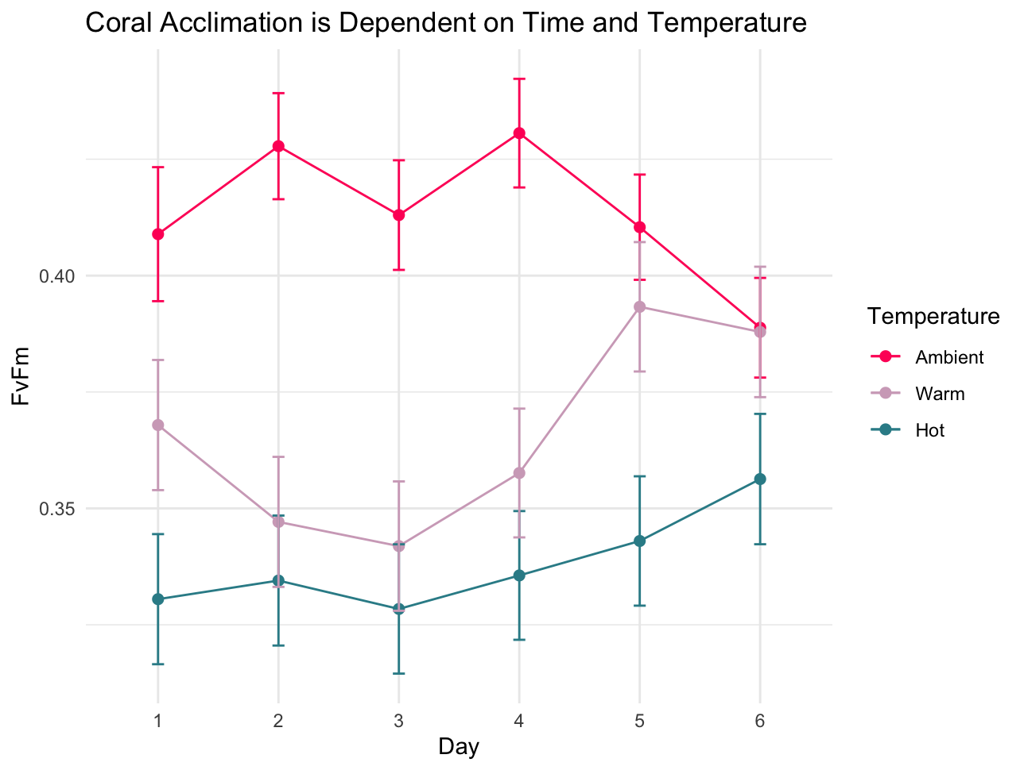

(4) (15pts) Amy, a collaborator with Steve Dudgeon, is comparing the tissue strengths of two closely related seaweeds, *Chondrus crispus* and *Mastocarpus stellatus*, to test if mechanical differences of their tissues **account for the greater likelihood of dislodgment** of one species by storm waves. The mechanical strength of tissues may vary with size, so for each individual of both species, the **thickness** of the load-bearing portion of the thallus is recorded in addition to the **force** per cross sectional area required to break the thallus. The data are in the file **stipe_strength.csv**.

State the type of model you would use to analyze this data. Analyze the data and present the results in a publication-quality graph. Interpret whether or not there is a difference in tissue strength between species.

**The type III ANCOVA** performed on logged data shows a statistically significant effect of tissue thickness on break force (p<0.001, F= 58.908) levels of seaweed. The interaction between tissue thickness and species did not statistically affect break force (p=0.885, F=0.0211).

