**Home Page: Within a matter of seconds, your website needs to communicate to visitors what you have to offer. You will require a headline with sub-headline or paragraph text that should provide a clear description of your business and what you do or the services you provide. You need supporting images/graphics, social proofs, navigation.**

* **Company name**

YouTube

* **Slogan**

"Broadcast Yourself"

* **Logo**

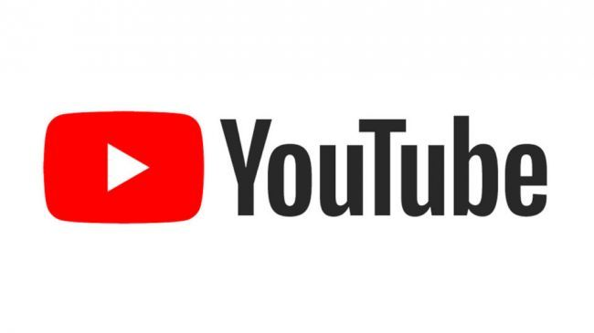

* **Clear description of the company**

Youtube is a broadcasting site and social media site that connects people. YouTube is empowered by its content creator’s and remains free to use. Its main revenue is derived from their services and ad revenue.

**Product/Services Page:**

* **List of products and their descriptions.**

YouTube Streamlined is a service that will add emotes or emoticons to YouTube shorts similar to how it’s Livestreaming service has. The emotes will include the livestream subscription as a merge between them resulting in universal usage. This is a paid subscription.

* **Product/services images**.

Unsure

About Us Page

* **History**

Made in 2005, Chad Hurley, Steve Chen, and Jawed Karim create YouTube as a video sharing platform. As a first of its kind it aimed to provide an easy to use and upload site for the general public.

* **Mission statement**

“Our mission is to give everyone a voice and show them the world.”

* **Company Overview/Description**

A video sharing platform available to the entire world. YouTube allows communities to connect and for the easy upload of videos.

**Contact us page**

* **Location**

Google LLC, D/B/A YouTube

901 Cherry Ave.

San Bruno, CA 94066

USA

* **hours of operation**

24/7

* **email address**

None