Approximating Continuous

Functions and Curves using Bernstein Polynomials

Grant Timmerman

Math 336

June 2, 2014

**Abstract**

This paper examines the various mathematical representations and approximations of functions and 2D curves. Using Bernstein basis polynomials, we can approximate the core ingredients that make up a function and refine the approximation to any desired precision. By the Weierstrass Approximation Theorem, we can prove that these Bernstein polynomials do in fact converge to the function we input. Remarkably, it does not take many Bernstein polynomials combined together to achieve fair approximations of most functions.

Lastly, we describe how Bézier curves, which also use Bernstein polynomials, can also be used to describe parameterized curves in 2D space and how their representation is advantageous and well suited for uses in CAD software. Along the way we provide thorough definitions and useful applications of each topic and illustrations that are vital to understanding this highly visual topic.

**Key Words:** Bernstein polynomials, Curves, Weierstrass Approximation Theorem, Control Points, Line interpolation, Computer Aided Design, Bézier curves

**1 Introduction**

Describing curves is a very important task in mathematics and computer graphics. In the mathematical world, one common approach to describing curves is by using an explicit representation in terms of one variable, . [10]

However, this representation by itself has many problems with it. For example, the vertical line $x=c$ cannot be represented using this model.In addition, sometimes we have some very complicated function that we’d like to approximate as a linear combination of polynomials so we can compute points on it efficiently and store it and transform it easily. Taylor’s theorem will only approximate a differentiable function at specific points and can produce a Taylor series that doesn’t converge to the original function. Thus, we need to find a better technique to approximate our curve.

The paper will first describe Bernstein polynomials to setup a foundation for the rest of the paper. Then we’ll see how these polynomials can be used to approximate any continuous function with Weierstrass Approximation Theorem. After, we’ll introduce a practical parametric representation of a curve with the introduction to Bézier curves. Finally, the last section closes the paper with our final remarks.

**2 Bernstein Polynomials**

**2.1 Introduction**

Polynomials are incredibly useful mathematical tools as they are simply defined, can be computed very quickly on computer systems, and can represent a variety of functions. They can also be integrated easily and pieced together to form spline curves that can approximate any function to any accuracy desired. Most students face polynomials for the first time at a very early stage of their studies and most likely recall them in the form:

$$p\left(t\right)=a_{0}+a_{1}t+…+a_{n-1}t^{n-1}+a_{n}t^{n}$$

which represents a polynomial as a linear combination of monomials $a_{i}t^{n-i}$. Notice that the set of functions $\{1, t, t^{2}, …, t^{n}\}$ form a basis for this vector space – that is, any polynomial less than or equal to $n$ can be uniquely described as a linear combination of these functions.[3] [6] [9]

In order to discuss approximations to functions and curves later on in our notes, we first need to understand a specific commonly used basis for the space of polynomials, the *Bernstein basis* (named after Russian mathematician Sergei Bernstein) [2], and discuss its many useful properties.

**2.2 Definitions**

**2.2.1 Bernstein basis polynomials**

A **Bernstein basis polynomial**[7]of degree $n$ is defined by

$$b_{i,n}\left(t\right)=\left(\begin{matrix}n \\ i\end{matrix}\right)t^{i}{\left(1-t\right)}^{n-i}, i=0,…,n$$

where $\left(\begin{aligned}n \\ i\end{aligned}\right)$ is the binomial coefficient,

$$\left(\begin{aligned}n \\ i\end{aligned}\right)=\frac{n!}{i!\left(n-i\right)!}$$

Often, for mathematical convenience, we set $b_{i,n}\left(t\right)=0 if i<0 or i>n$.

(Note on Notation: Bernstein basis polynomials can be written as $b_{i,n}$ or $B_{i,n}$.)

**2.2.2 Bernstein polynomials**

A linear combination Bernstein basis polynomials

$$B_{n}\left(t\right)=\sum_{i=0}^{n}{β_{i}b_{i,n}(t)}$$

is called a **Bernstein polynomial** of degree $n$ where $β_{i}$ are the **Bernstein coefficients**. [7] [11] If $β_{i}$ is not explicitly defined, it is assumed $β_{i}=1$. The Bernstein polynomial of a function $f$ is defined by

$$B_{n}\left(f\right)=B_{n}\left(t;f\right)=\sum_{k=0}^{n}{f\left(\frac{k}{n}\right)b_{i,n}(t)}$$

**2.3 Examples**

The first few Bernstein basis polynomials are:

$b_{0,0}\left(t\right)=1$

$b_{0,1}\left(t\right)=1-t$ $b_{1,1}\left(t\right)=t$

$b_{0,2}\left(t\right)={\left(1-t\right)}^{2}$ $b_{1,2}\left(t\right)=2t(1-t)$ $b_{2,2}\left(t\right)=t^{2}$

$b_{0,3}\left(t\right)={\left(1-t\right)}^{3}$ $b_{1,3}\left(t\right)=3t{\left(1-t\right)}^{2}$ $b_{2,3}\left(t\right)=3t^{2}(1-t)$ $b_{3,3}\left(t\right)=t^{3}$

They can be plotted on the unit square as follows:

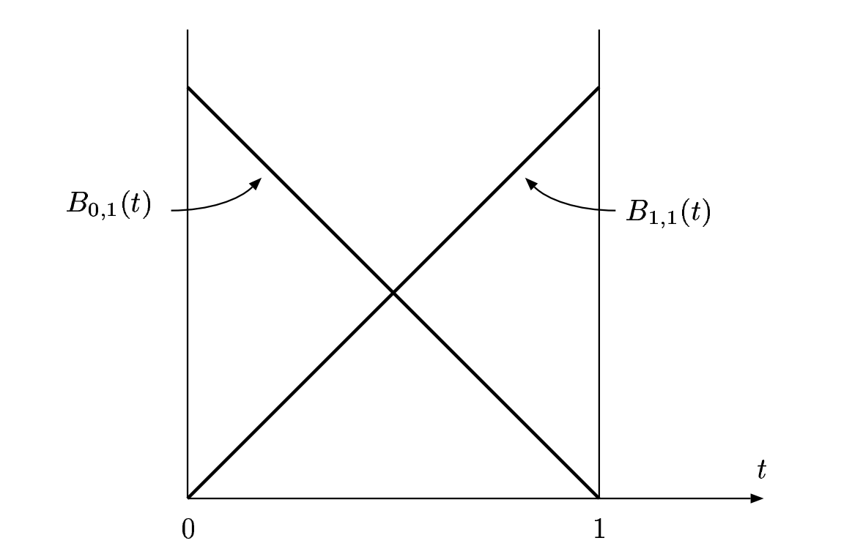

**Figure 1:** Bernstein basis polynomials of degree 1. [6]

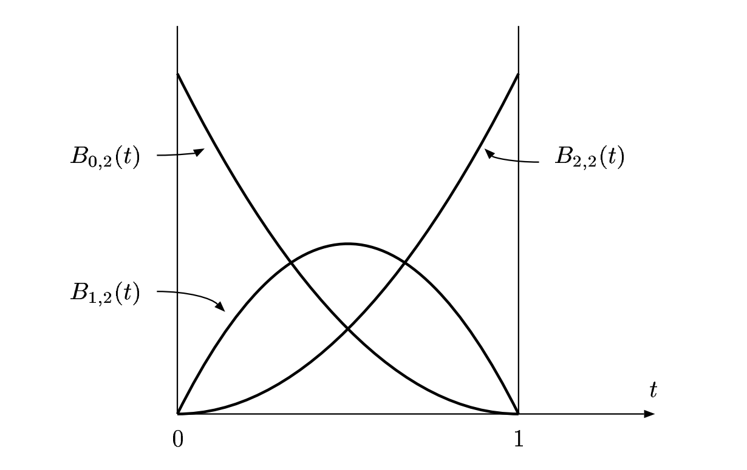

**Figure 2:** Bernstein basis polynomials of degree 2. [6]

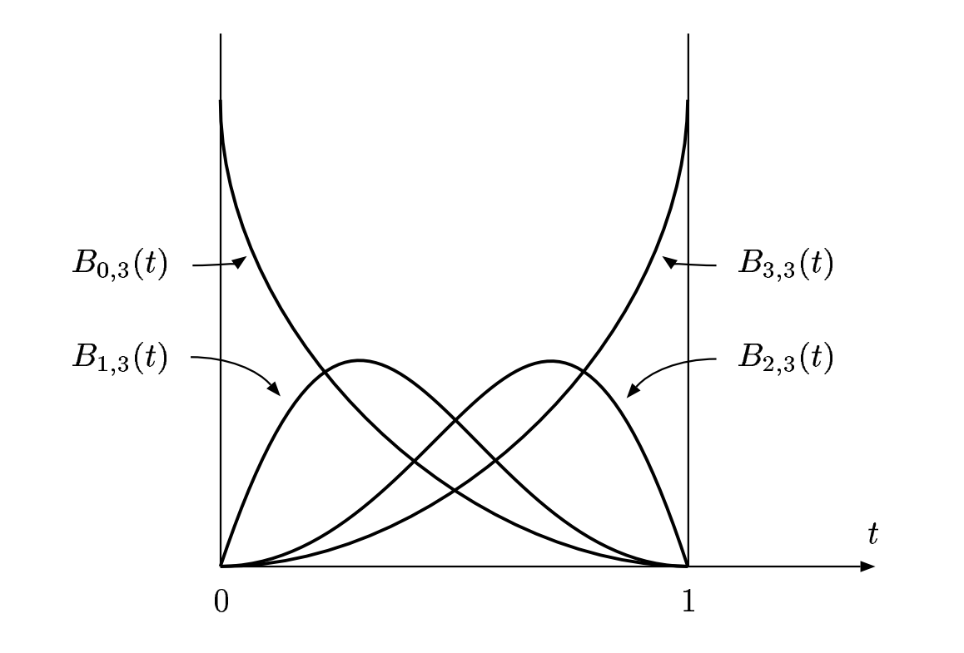

**Figure 3:** Bernstein basis polynomials of degree 3. [6]

**2.4 Properties**

Bernstein basis polynomials have a number of useful properties. Here we will describe and prove a few of the more important ones with regard to this paper.

**2.4.1 Recursive Definition**

A Bernstein basis polynomial of degree $n$ can be defined as the sum of two Bernstein basis polynomials of degree $n-1$ as follow: [6]

**Proof.**

$$b_{k,n}\left(t\right)=\left(\begin{matrix}n \\ k\end{matrix}\right)t^{k}{\left(1-t\right)}^{n-k} \\ =\left[\left(\begin{matrix}n-1 \\ k\end{matrix}\right)+\left(\begin{matrix}n-1 \\ k-1\end{matrix}\right)\right]t^{k}{\left(1-t\right)}^{n-k} \\ =\left(\begin{matrix}n-1 \\ k\end{matrix}\right)t^{k}{\left(1-t\right)}^{n-k}+\left(\begin{matrix}n-1 \\ k-1\end{matrix}\right)t^{k}{\left(1-t\right)}^{n-k} \\ =\left(1-t\right)\left(\begin{matrix}n-1 \\ k\end{matrix}\right)t^{k}{\left(1-t\right)}^{n-1-k}+t\left(\begin{matrix}n-1 \\ k-1\end{matrix}\right)t^{k-1}{\left(1-t\right)}^{n-1-\left(k-1\right)} \\ =\left(1-t\right)b_{k,n-1}\left(t\right)+tb_{k-1,n-1}\left(t\right) ∎$$

**2.4.2 Positivity**

Bernstein basis polynomials are non-negative on $0≤t≤1$ and are strictly positive on the open interval . [6]

**Proof.**

To show this we will proceed by mathematical induction on the recursive definition of Bernstein basis polynomials as described above.

Base case: $b_{0,0}=1≥0$.

Inductive hypothesis: Assume $b_{i,j}≥0, ∀i,∀j<n$ for some $n$.

By our recursive definition:

$$b_{i,n}\left(t\right)=\left(1-t\right)b_{i,n-1}\left(t\right)+tb_{i-1,n-1}(t)$$

Thus $b_{i,n}\left(t\right)≥0 for 0≤t≤1$ since the right-hand side of the equation are all non-negative components on our interval. (Remember, if $i<0$, then $b_{i,n}=0$). By induction, all Bernstein polynomials are non-negative on $0≤t≤1$. In fact, if we modify our hypothesis to be the open set $0<t<1$, we see from our recursive definition that $b_{i,n}$ is strictly positive on $0<t<1$. $∎$

**2.4.3 Bernstein Polynomials form a Partition of Unity**

A set of functions $f_{i}(t)$ is said to partition unity if they sum to $1$ for all values of $t$. The $k+1$ Bernstein basis polynomials for a Bernstein polynomial of degree $k$ form a partition of unity. [6] That is:

$$B_{k}\left(t\right)=\sum_{i=0}^{n}{b_{i,n}(t)}=b_{0,n}+b_{1,n}+…+b_{n,n}=1, 0≤t≤1$$

**Proof.**

To prove this, it is easiest to prove a slightly different fact:

$$B_{k}\left(t\right)=B_{k-1}\left(t\right)$$

This is proved using our recursive definition as follows:

$$B_{k}\left(t\right)=\sum_{i=0}^{k}{\left(\left(1-t\right)b_{i,k-1}\left(t\right)+tb_{i-1,k-1}\left(t\right)\right)} \\ =\left(1-t\right)\left[\sum_{i=0}^{k-1}{b_{i,k-1}\left(t\right)+b_{k,k-1}\left(t\right)}\right]+t\left[\sum_{i=1}^{k}{b_{i-1,k-1}\left(t\right)+b_{-1,k-1}\left(t\right)}\right] \\ =\left(1-t\right)\sum_{i=0}^{k-1}{b_{i,k-1}\left(t\right)}+t\sum_{i=1}^{k}{b_{i-1,k-1}\left(t\right)} \\ =\left(1-t\right)\sum_{i=0}^{k-1}{b_{i,k-1}\left(t\right)}+t\sum_{i=0}^{k-1}{b_{i,k-1}\left(t\right)} \\ =\sum_{i=0}^{k-1}{b_{i,k-1}\left(t\right)} \\ =B_{\left(k-1\right)}\left(t\right)$$

We’ve established that all Bernstein polynomials equal the same thing! So what is it? We know that our “base case”, $B_{0}\left(t\right)=\sum_{i=0}^{k}{b_{i,k}\left(t\right)}=b_{0,0}\left(t\right)=1$ and so we get

$$1=B_{0}\left(t\right)=B_{1}\left(t\right)=B_{2}\left(t\right)=…=B_{k}\left(t\right)$$

Thus $B_{k}\left(t\right)=1 ∀k≥0 where 0≤t≤1.∎$

**3 Weierstrass Approximation Theorem**

Not all functions are which are infinitely differentiable admit a correctly converging Taylor series expansion. (For example, take the classic smooth curve $f\left(x\right)=e^{-\frac{1}{x^{2}}}$ whose Taylor series converges incorrectly.) Even if a function has a Taylor series expansion at some point, the convergence of the series may be extremely slow to compute. However, we can still approximate a continuous function in other ways. Ideally, we would like a method that could compute a uniform approximation of a continuous function by a polynomial of a degree.

This is usually not possible, so instead we can take a finite set of points on closed interval and have a uniform approximation to our function as we increase the number of points. In other words, the polynomials are uniformly dense in $C\left(\left[a,b\right], R\right)$ with respect to the sup-norm. The Weierstrass Approximation Theorem tells us that this is possible for every continuous function, but it does not tell us how to get the actual polynomial approximation. [1] We’ll see that a sequence of Bernstein polynomials is the actual polynomials that uniformly converge to our function.

Karl Weierstrass, a.k.a. the “father of modern analysis” originally proved the Weierstrass Approximation Theorem in 1885 at the age of 70. [2] However, in the 20th century many other alternative proofs emerged. In particular, a more elegant proof was given by Sergei Bernstein in 1911 which only uses elementary methods and gives an explicit algorithm for approximating functions using his own Bernstein polynomials. A more generalized Weierstrass Theorem (the Weierstrass-Stone Theorem) emerged from Marshall Stone in 1937, but this requires too much machinery to prove in this paper. [12]

**3.1 Weierstrass Approximation Theorem (1885)**

*Let $f∈C\left(\left[a,b\right], R\right)$. Then there is a sequence of polynomials $p_{n}(x)$ that converges uniformly to $f(x)$ on .* [6] [8]

**Proof.**

We need to show that for any $f∈C\left(\left[a,b\right]\right)$ there is a sequence of polynomials $p_{n}$ such that $p_{n}→f$ uniformly.

To show this, we will actually prove that this is true on the interval $\left[a,b\right]=\left[0,1\right]$. Define $φ:C\left(\left[a,b\right]\right)→C\left(\left[0,1\right]\right)$ by

$$\left(φf\right)\left(t\right)=f\left(a+\left(b-a\right)t\right)$$

Then $φ$ is linear and invertible with the inverse

$$\left(φ^{-1}f\right)\left(t\right)=f\left(\frac{t-a}{b-a}\right)$$

Moreover, $φ$ is an isometry since $\left\|φf\right\|=\left\|f\right\|$, and for any polynomial $p$, both $φp$ and $φ^{-1}p$ are polynomials. If $p$ is dense in $C\left(\left[0,1\right]\right)$, then for any $f∈C\left(\left[a,b\right]\right)$, we have $p_{n}→φf∈C\left(\left[0,1\right]\right)$. Hence $φ^{-1}p_{n}$ converge to $f$ in $C\left(\left[a,b\right]\right)$.

To show $p_{n}$ is dense in $C\left(\left[0,1\right]\right)$, we will use Bernstein’s proof which will not only suffice, but will also give us an explicit sequence of polynomials that converge uniformly to $f∈C\left(\left[0,1\right]\right)$.

Recall that Bernstein polynomials form a partition of unity, that is

$$B_{k}\left(t\right)=\sum_{i=0}^{n}{b_{i,n}(t)}=\sum_{i=0}^{n}{\left(\begin{matrix}n \\ i\end{matrix}\right)t^{i}{\left(1-t\right)}^{n-i}}=1, 0≤t≤1$$

Therefore, we can write the difference between $f$ and its $n$ th Bernstein polynomial as

$$B_{n}\left(t;f\right)-f\left(t\right)=\sum_{k=0}^{n}{f\left(\frac{k}{n}\right)b_{k,n}\left(t\right)}-\sum_{k=0}^{n}{f\left(t\right)b_{k,n}\left(t\right)} \\ =\sum_{k=0}^{n}{\left[f\left(\frac{k}{n}\right)-f\left(t\right)\right]b_{k,n}(t)}$$

Take the supremum with respect to the absolute value of the equation to get

$$\left\|B_{n}\left(∙;f\right)-f\left(t\right)\right\|=\sup_{0≤t≤1}\left[\sum_{k=0}^{n}{\left|f\left(\frac{k}{n}\right)-f\left(t\right)\right|b_{k,n}(t)}\right]$$

Here we use $B_{n}\left(t;f\right)$ to denote the Bernstein polynomial at $t$, and $B_{n}\left(∙;f\right)$ to denote the corresponding polynomial function.

Since $f$ is uniformly continuous, given $ε>0$ there is a $δ>0$ such that

$$\left|x-y\right|<δ⇒\left|f\left(x\right)-f\left(y\right)\right|<ε, ∀x,y∈\left[0,1\right]$$

To estimate our supremum, we’ll divide our terms into two groups as follow:

$$I\left(t\right)=\left\{k | 0≤k≤n and \left|a-\left(\frac{k}{n}\right)\right|<δ\right\}$$

$$J\left(t\right)=\left\{k | 0≤k≤n and \left|a-\left(\frac{k}{n}\right)\right|≥δ\right\}$$

Combining our last three expressions, we get

$$\left\|B_{n}\left(∙;f\right)-f\left(t\right)\right\|≤ ε\sup_{0≤t≤1}\left[\sum_{k∈I\left(t\right)}{b_{k,n}\left(t\right)}\right]+\sup_{0≤t≤1}\left[\sum_{k∈J\left(t\right)}{\left|f\left(\frac{k}{n}\right)-f\left(t\right)\right|b_{k,n}\left(t\right)}\right] \\ ≤ε+2\left\|f\right\|\sup_{0≤t≤1}\left[\sum_{k∈J\left(t\right)}{b_{k,n}\left(t\right)}\right]$$

Since ${\left[t-\left(\frac{k}{n}\right)\right]}^{2}≥ δ^{2}$ for $k∈J(x)$, we can estimate the right-hand side of the above inequality as follows:

$$\sup_{0≤t≤1}\left[\sum_{k∈J\left(t\right)}{b_{k,n}\left(t\right)}\right]≤\frac{1}{δ^{2}}\sup_{0≤t≤1}\left[\sum_{k∈J\left(t\right)}{{\left(t-\frac{k}{n}\right)}^{2}b_{k,n}\left(t\right)}\right] \\ ≤\frac{1}{δ^{2}}\sup_{0≤t≤1}\left[\sum_{k=0}^{n}{\left(t^{2}-\frac{2kt}{n}+\frac{k^{2}}{n^{2}}\right)b_{k,n}\left(t\right)}\right] \\ ≤\frac{1}{δ^{2}}\sup_{0≤t≤1}\left[t^{2}B_{n}\left(t;1\right)-2tB_{n}\left(t;t\right)+B_{n}\left(t;t^{2}\right)\right]$$

To evaluate these Bernstein polynomials $B_{n}\left(t;1\right), B_{n}\left(t;t\right), and B_{n}\left(t;t^{2}\right)$, we’ll take the first and second derivative (with respect to $t$) of the binomial expansion of the polynomials.

$$\sum_{k=0}^{n}{\left(\begin{matrix}n \\ k\end{matrix}\right)t^{k}y^{n-k}}={\left(t+y\right)}^{n} \\ \sum_{k=0}^{n}{\left(\frac{k}{n}\right)\left(\begin{matrix}n \\ k\end{matrix}\right)t^{k}y^{n-k}}={t\left(t+y\right)}^{n-1} \\ \sum_{k=0}^{n}{{\left(\frac{k}{n}\right)}^{2}\left(\begin{matrix}n \\ k\end{matrix}\right)t^{k}y^{n-k}}=\left(\frac{n-1}{n}\right)t^{2}{\left(t+y\right)}^{n-2}{\frac{t}{n}\left(t+y\right)}^{n-1}$$

Evaluating these at $y=1-t$ (to satisfy the definition of a Bernstein polynomial) gives

$$B_{n}\left(t;1\right)=1 \\ B_{n}\left(t;t\right)=t \\ B_{n}\left(t;t^{2}\right)=\left(\frac{n-1}{n}\right)t^{2}+\left(\frac{1}{n}\right)t$$

for $n≥1$. Plugging these back in to our inequality gives

$$\left\|B_{n}\left(∙;f\right)-f\left(t\right)\right\|≤ε+\frac{\left\|f\right\|}{2nδ^{2}}$$

Take the $lim⁡sup$ to get

$$\underset{n→∞}{lim⁡sup}\left\|B_{n}\left(∙;f\right)-f\left(t\right)\right\|≤ ε$$

Since $ε$ is arbitrary, it follows $\underset{n→∞}{lim⁡sup}\left\|B_{n}\left(∙;f\right)-f\left(t\right)\right\|=0$, so $p_{n}=B_{n}\left(∙;f\right)$ converge uniformly to $f$. $∎$

**3.2 Taylor Series vs Weierstrass Approximation**

It is worthwhile to note the differences between Weierstrass’ approximation theorem and Taylor’s theorem. As we pointed out before, a functions Taylor series expansion is not necessarily accurate for all functions. The requirements for the Weierstrass approximation are a bit more relaxed – we don’t need our function to be differentiable. In addition, Weierstrass’ approximation approximates a function on a whole interval $[a,b]$ rather than at a single point. [6]

**3.3 Application**

*Suppose $f$ is a continuous function defined on $\left[0,1\right]$. Suppose that $f$ satisfy that $\int_{0}^{1}{f\left(t\right)t^{n}dt}=0 ∀n∈N≥0$. Then $f$ is identically 0.* [1]

**Proof.**

By the Weierstrass Approximation Theorem, $B_{n}(f)$ converges uniformly to $f$. From the problem statement, we have $\int_{0}^{1}{f\left(x\right)B_{n}\left(f\right)\left(t\right)dt}=0$. $f$ is continuous and bounded on $[0,1]$, so $fB_{n}\left(f\right)→f^{2}$ uniformly. Therefore

$$\int_{0}^{1}{f^{2}\left(t\right)dt}=\lim_{n→∞}{\int_{0}^{1}{f\left(t\right)B_{n}\left(f\right)\left(t\right)dt}}=0$$

Since $f^{2}≥0$, $\int_{0}^{1}{f^{2}\left(t\right)dt}=0⇒f^{2}=0 on [0,1]$. It follows $f$ is identically 0. $∎$

**4 Bézier curves**

In computer graphics, we are often asked to draw lines and curves. Lines are fairly easy for a computer to draw; given a start point and end point we can use Bresenham’s line algorithm to interpolate the points in between. [4] Curves, on the other hand, are a much bigger problem. While it is ridiculously easy to draw complex curves with pen and paper, describing the same curve as a mathematical function a computer can understand is not trivial. Even more difficult is being able to devise a formula for a curve that is quick to compute.

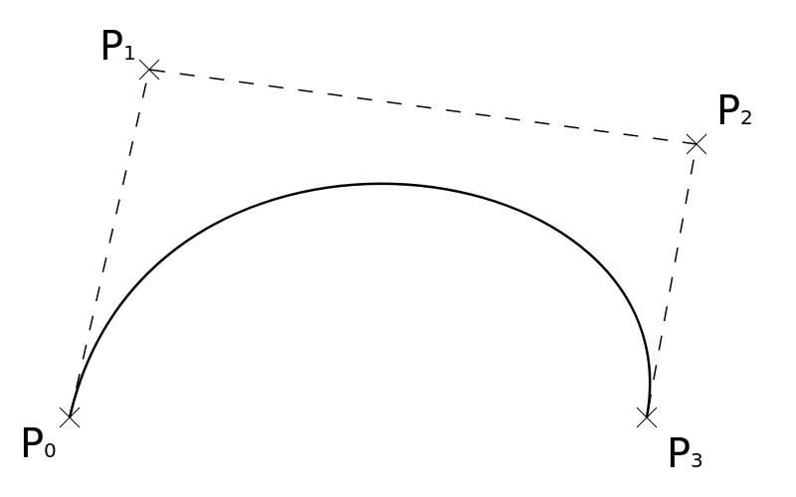

**Figure 4:** A cubic Bézier curve.

It turns out Bézier curves are widely used in computer graphics to model smooth curves. They are smooth, computationally easy to interpolate (for low degree curves), and work well with affine transformation such as translation and rotation since the transformation on the curve can be applied by transforming the control points of the curve. To create complex curves, we can simply connect multiple simple Bézier curves together quite easily.

**4.1 Types of Bézier Curves**

**4.1.1 Simple Bézier Curve**

A **simple Bézier curve** is the straight line from a point $P_{0}$ to $P_{1}$ where $P_{i}$ is a 2D column vector that represents a point in 2D space. The points $P_{i}$ are called the **control points** of our curve.[5] The curve is described with the parametric equation[2]

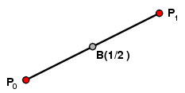

**Figure 5:** A simple Bézier curve. [2]

The points $B\left(t\right)$ along the curve are the barycentric coordinates of the curve, i.e. the weighted average with respect to the points $P_{0}$ and $P_{1}$. Notice that at the endpoints of our interval we have

$$B\left(0\right)=P_{0} \\ B\left(1\right)=P_{1}$$

**4.1.2 Quadratic Bézier Curve**

A **quadratic Bézier curve** is a curve determined by three control points, $P_{0}, P_{1}, and P_{2}$ with the form[2]

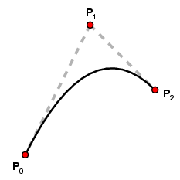

**Figure 6:** A quadratic Bézier curve. [2]

Notice how our curve isn’t guaranteed to go through non-endpoint control points. Again, we see that $B\left(0\right)=P_{0}, B\left(1\right)=P_{2}$.

**4.2 Generic Bézier Curve Definition**

A generic Bézier curve of degree $n$ can be described either recursively or explicitly. In our explicit definition we make use of properties of Bernstein polynomials that we proved earlier in the paper.

**4.2.1 Recursive definition**

Let $B_{P_{0}P_{1}…P_{n}}$ denote a $n$ th degree Bézier curve determined by control points $P_{0},P_{1}…P_{n}$.

$$B_{P_{0}}\left(t\right)=P_{0}$$

$$B\left(t\right)=B_{P_{0}P_{1}…P_{n}}=\left(1-t\right)B_{P_{0}P_{1}…P_{n-1}}\left(t\right)+tB_{P_{1}P_{2}…P_{n}}(t)$$

**4.2.2 Explicit definition**

The recursive definition can also be simplified and stated explicitly using our handy Bernstein basis polynomials:

$$B\left(t\right)=\sum_{i=0}^{n}{b_{i,n}(t)P_{i}}=\sum_{i=0}^{n}{\left(\begin{matrix}n \\ i\end{matrix}\right){\left(1-t\right)}^{n-i}t^{i}P_{i}} \\ ={\left(1-t\right)}^{n}P_{0}+\left(\begin{matrix}n \\ 1\end{matrix}\right){\left(1-t\right)}^{n-1}tP_{t}+…+\left(\begin{matrix}n \\ n-1\end{matrix}\right)\left(1-t\right)t^{n-1}P_{n-1}+t^{n}P_{n}$$

$$t∈[0,1]$$

For example, for $n=5$:

$$B_{P_{0}P_{1}P_{2}P_{3}P_{4}P_{5}}\left(t\right)={\left(1-t\right)}^{5}P_{0}+5t{\left(1-t\right)}^{4}P_{1}+10t^{2}{\left(1-t\right)}^{3}P_{2}+10t^{3}{\left(1-t\right)}^{2}P_{3}+5t^{4}\left(1-t\right)P_{4}+t^{5}P_{5}$$

$$t∈[0,1]$$

**4.2.3 Explanation**

In order to understand why Bernstein basis polynomials construct a smooth curve that follow the control points, it is helpful to look at an example.



**Figure 7:** Bernstein basis polynomials of degree 3. [6]

In figure 7, we revisit a cubic Bézier curve defined as the sum of the product of our points $P_{0}…P_{3}$ and Bernstein basis polynomials $B_{0,3}\left(t\right)…B_{3,3}(t)$. In effect, the Bernstein basis polynomials act as “weights” to our points, that is, the closer $B_{i,n}(t)$ is towards 1, the closer our Bézier curve $B(t)$ is to $P_{i}$ at a specific $t$. It is a good thing that Bernstein polynomials are between 0 and 1 and that the sum of these weights total to 1. Otherwise our curves would follow our control points too tightly or loosely.

Starting at $t=0$, we can see $B_{0,3}(t)$ dominates our Bernstein polynomials and equals 1. As we increase $t$, we see that weight $B_{1,3}(t)$ becomes heavier and so our curve tends towards $P_{1}$, then towards $P_{2}$ and finally $P_{3}$.

A practical example of using this in a computer graphics system would be to evaluate $B\left(t\right)$ for a uniformly distributed set of $t$ between 0 and 1 and connect these points with lines to simulate a curve. We can refine this curve approximation simply by increasing the number of samples $t$ to get a more accurate visual.

**4.3 Properties**

Using the Bézier curve description versus other curve descriptions has many useful advantages that make it very commonly seen in computer graphics.

**4.3.1 Endpoints**

Bézier curves are guaranteed to start and end exactly at the control point endpoints and will have a tangent perpendicular to the neighboring control point at the endpoints.

**4.3.2 Convex hull**

The outermost control points form a convex hull – the smallest convex set that contains the control points. The whole curve is contained inside of this hull. This is very useful for detecting possible existence of an intersection between the curve and lines or shapes.

**4.3.3 Symmetry**

Rearranging the control points $P_{0}…P_{n}$ in the order $P_{n}…P_{0}$ produces the exact same curve but with an opposite parameterization.

**4.3.4 Affine Transformations**

Any affine transformation can be applied to the curve by applying a transformation to the control points, which is easy for any computer to compute.

**5 Conclusion**

As we have seen, Bernstein polynomials have many great properties that make it suitable for approximating functions and curves. With Bernstein’s proof of Weierstrass’ Approximation Theorem, we can relatively painlessly create a sequence of polynomials that uniformly approximate any continuous function. For a more flexible description of curves, we can use Bézier curves, which are easy to compute and store on CAD systems and have nice properties like being easily transformable. These results make up the foundation of research that is being used in computer graphics, computer animation and scientific visualization today.

**References**

[1] Beng, Ng. "Weierstrass Approximation Theorem." . N.p., 27 June 2012. <http://www.math.nus.edu.sg/~matngtb/Calculus/MA3110/Chapter%2010%20Weierstrass%20Approximation.pdf>.

[2] Casselman, Bill. "From Bézier to Bernstein." Feature Column from the AMS. N.p., 4 Mar. 2008. <http://www.ams.org/samplings/feature-column/fcarc-bezier#2>.

[3] Fan, Zhang, Kang Baosheng, Ru Shaofeng, and Zhou Mingquan. "Existence of the Normalized B-basis and a Practical Construction Method of the B-algorithm." IEEE Xplore. Northwest University, Xi’an, P.R.China, 4 Feb. 2004. <http://ieeexplore.ieee.org/stamp/stamp.jsp?arnumber=01290028>.

[4] Flanagan, Colin. "The Bresenham Line-Drawing Algorithm." The Bresenham Line-Drawing Algorithm. University of Helsinki, 13 Nov. 1996. <http://www.cs.helsinki.fi/group/goa/mallinnus/lines/bresenh.html>.

[5] Guy, Stephen. "Spline Curves." . University of North Carolina, 1 Sept. 2010. <http://comp575.web.unc.edu/files/2010/12/splines.pdf>.

[6] Hunter, John. "Continuous Functions." . N.p., 21 July 2005. <https://www.math.ucdavis.edu/~hunter/book/ch2.pdf>.

[7] Joy, Kenneth. "BERNSTEIN POLYNOMIALS." . Visualization and Graphics Research Group, UC Davis <http://www.idav.ucdavis.edu/education/CAGDNotes/Bernstein-Polynomials.pdf>.

[8] K. Weierstrass (1885). Über die analytische Darstellbarkeit sogenannter willkrlicher Functionen einer reellen Vernderlichen. Sitzungsberichte der Kniglich Preuischen Akademie der Wissenschaften zu Berlin, 1885 (11).

[9] Peña. Shape preserving representations in computer-aided geometric design. Commack, N.Y: Nova Science Publishers, 1999. Print.

[10] Pollard, Nancy. "Curves and Surfaces." . Carnegie Mellon Univeresity, 20 Mar. 2004. <http://graphics.cs.cmu.edu/nsp/course/15-462/Spring04/slides/10-curves.pdf>.

[11] R´oth, Agoston. "Control point based exact description of higher dimensional trigonometric and hyperbolic curves and multivariate surfaces." . N.p., 14 Apr. 2014. <http://arxiv.org/pdf/1404.3767.pdf>.

[12] Young, Matt. "The Stone-Weierstrass Theorem." . Queen’s University at Kingston, 16 Dec. 2006. <http://www.mast.queensu.ca/~speicher/Section14.pdf>.