CSci 435: Formal Languages and Automata

Instructor: Dr. M. E. Kim Name: _Grant Haataja _

**Home Assignment 1: 100 points + 10 points (optional)**

Q1. [25] For Σ = {a, b}, construct the minimal DFA that accept the language consisting of

1. [8] all strings with an even number of *a*’s and an odd number of *b*’s.

*Ans:*

1. [8] every ‘*aa’* is followed immediately by a ‘*b’*. For example, the strings *aab*, *aaba*, *aabaabbaab* are in the language, but *aaab* and *aabaa* are not. Construct a DFA with 4 states.

*Ans:*

1. [9] L = {w | ( *na*(*w*) – *nb*(*w*) ) mod 3 = 0 }. Construct a DFA with 3 states.

*Ans:*

Q2. [10] Show that the language L = { *a****n***| *n* ≥ 0, *n* ≠ 3 } is regular.

*Ans:*

Q3. [15] For the language L = {*an* | *n* ≥ 1 } ∪ {*bmak* | *m* ≥ 0, *k* ≥ 0}

1. [8] Construct an NFA with three states that accepts L.

*Ans:*

1. [7] Can you construct an NFA with the fewer states that accepts L? If so, construct it; otherwise, justify why your NFA in 1) is the minimal NFA.

*Ans: Yes.*

Q4. [20] For a given NFA in the figure,

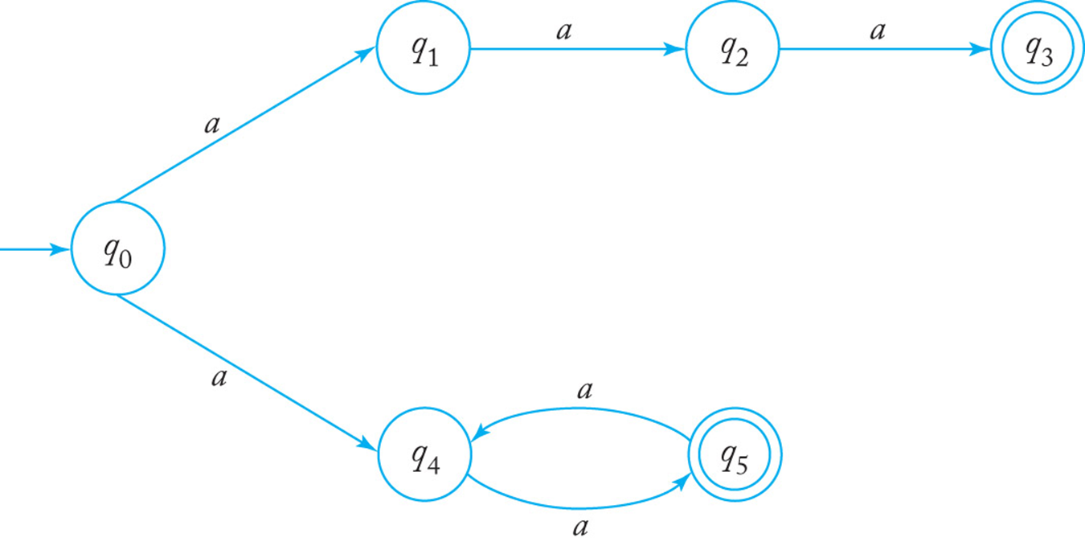

1. [10] Give a language *L* that is accepted by the NFA. Describe L in the proper mathematical format, not in the verbal English description. E.g.) L = { *a****n***| *n* ≥ 0, *n* ≠ 3 }

*Ans: L* = { *a2n* | *n* ≥ 1 } ∪ { *a3* }.

1. [10] Find a *DFA* that accepts the ***complement*** of the language defined by the NFA, i.e. $\overline{L}$.

*Ans: L* = { *a2n+1* | *n* ≥ 2 } ∪ { λ, *a*}.

Q5. [10] Construct an NFA with the ***minimum*** number of states that accepts

*L* = { *an* | *n* ≥ 0 } ∪ { *bna* | *n* ≥ 1 }.

*Ans:*

Q6. [10] Convert the NFA defined by the transitions below with the initial state *q0* and the final state *q2* into an *equivalent DFA*. Draw the transition graph of the DFA.

δ(*q0, a*) = { *q0, q1* }, δ(*q1, b*) = { *q1, q2* }, δ(*q2, a*) = { *q2* }, δ(*q1,* λ) = { *q1, q2* }.

*Ans:*

Q7. [20] For a given language, L = { *anb* | *n* ≥ 1 } ∪ { *bna* | *n* ≥ 1},

1. [10] Construct a *minimal DFA* with the minimum number of states that accepts L.

*Ans:*

1. [10] Prove that your DFA in 1) is minimal. Hint: Check if any pair of the states are indistinguishable to be merged in the same class so that the number of states are minimized

*Ans:* To prove a DFA is minimal, it suffices to show that no state is *unreachable* and no pair of states are *indistinguishable*.

δ(*q0, λ*) = *q0* and *λ* is in L so *q0* is not unreachable.

δ(*q0, a*) = *q1* and *a* is in L so *q1* is not unreachable.

δ(*q0, b*) = *q2* and *b* is in L so *q2* is not unreachable.

δ(*q0, ab*) = *q3* and *ab* is in L so *q3* is not unreachable.

δ(*q0, abb*) = *q4* and *abb* is in L so *q4* is not unreachable.

States *q0* and *q1* are distinguishable since δ*(*q0, ba*) ∈ F but δ*(*q1, ba*) ∉ F.

States *q0* and *q2* are distinguishable since δ*(*q0, ab*) ∈ F but δ*(*q2, ab*) ∉ F.

States *q0* and *q3* are distinguishable since δ*(*q0, ab*) ∈ F but δ*(*q3, ab*) ∉ F.

States *q0* and *q4* are distinguishable since δ*(*q0, ab*) ∈ F but δ*(*q4, ab*) ∉ F.

States *q1* and *q2* are distinguishable since δ*(*q1, b*) ∈ F but δ*(*q2, b*) ∉ F.

States *q1* and *q3* are distinguishable since δ*(*q1, b*) ∈ F but δ*(*q3, b*) ∉ F.

States *q1* and *q4* are distinguishable since δ*(*q1, b*) ∈ F but δ*(*q4, b*) ∉ F.

States *q2* and *q3* are distinguishable since δ*(*q2, a*) ∈ F but δ*(*q3, a*) ∉ F.

States *q2* and *q4* are distinguishable since δ*(*q2, a*) ∈ F but δ*(*q4, a*) ∉ F.

States *q3* and *q4* are distinguishable since δ*(*q3, λ*) ∈ F but δ*(*q4, λ*) ∉ F.

Therefore, the DFA is minimal.

Q8. [10, optional] Prove or disprove the following conjecture: If L is regular, so is LR.

If it is true, construct a NFA MR s.t. L(M’) = LR , from a NFA M that accepts L, i.e. L(M) = L. Then, show that L(M’ ) = LR .

Otherwise, give a counter example.

*Ans:*

If we are given an NFA M that accepts L, we can create an NFA MR that accepts LR. To do this, we reverse all transitions for M, add new initial state q0’, and draw λ-transitions from q0’ to all the final states for M. Then, we switch the final states of M into ordinary states for MR and switch the initial state of M into a final state of MR.