ENGR 200 FALL 2017

**A9: RIVER FLOW ANALYSIS**

**(using a two-dimensional matrix and plotting in MATLAB)**

DUE: December 5, 2017 at 11:59 pm, CST POINTS: 30

**INTRODUCTION:**

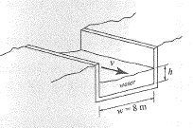Shown to the right is a cross section of a river channel. The amount of water that flows in the channel over a one-year period can be estimated by calculating the area under the curve of the flow rate versus time.

River heights in meters and velocities in meters per second were collected over the one-year period and placed in an input file called **river**. The first row of numbers in the input file are the days that the data was collected, the second row of numbers are the river heights in meters, and the third row of numbers are the velocities in meters per second. The first day of data collection was January 1st, and the last day of data collection was January 1st of the next year.

**ASSIGNMENT:**

Write a MATLAB program that loads the two-dimensional matrix **river**, and performs the following operations in the order given below:

1. Using Matlab’s built-in function, load the river matrix.
2. Using Matlab’s built-in function, transpose the matrix. Select the **Home** tab, select the **downward arrow** under **Help**, and select **Examples** . In the **Search Documentation** box type **transpose**, and select **Transpose vector or matrix**. See the examples given under **Syntax**.
3. Size the matrix.
4. Assign the width of the channel to a variable.
5. Using Matlab’s built-in function, determine average height and average velocity.
6. Using Matlab’s built-in functions, determine minimum height, minimum velocity, maximum

height, and maximum velocity.

1. Using Matlab’s built-in function, determine the matrix locations of the minimum height, maximum height, minimum velocity, and maximum velocity.
2. Compute the flow rate matrix using the following equation:

$$flowrate=velocity.*width.*height$$

where flow rate is in cubic meters per second, velocity is the water velocity in meters per

second, width is the channel width in meters, and height is the water height in meters.

1. Compute the volume of water over the one-year period. The volume of water is estimated by computing the area under the curve of the flow rate versus time using the trapezoidal numerical integration function. The equation is:

*volume = 86400* trapz(time,flowrate)*

where time is days. Since flow rate is computed in cubic meters per second, time must be in seconds, not days. That is the reason for the conversion factor in the above equation.

1. Print the results to the Command Window only. Use the format shown on page 2.

*******************************************

RIVER CHANNEL ANALYSIS

Day Height Speed

(m) (m/s)

xxx x.x x.x

. . .

. . .

. . .

xxx x.x x.x

Average height = x.x meters

Average speed = x.x meters/sec

Minimum height = x.x meters on day xxx

Minimum speed = x.x meters/sec on day xxx

Maximum height = x.x meters on day xxx

Maximum speed = x.x meters/sec on day xxx

Volume per year = x.xxxxxxe+xx cubic meters %12.6e

*******************************************

1. 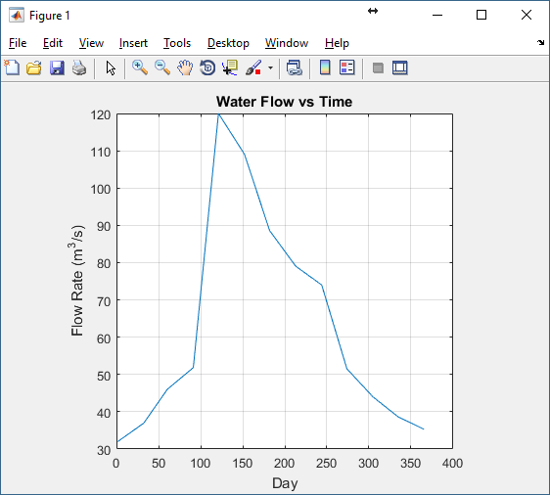Plot the flow rate versus time (days). See the illustration to the right. Develop the plot, add a title, x and y labels, show the grid, and set the axis square.

Your program must demonstrate the use of the following functions: *load, transpose, size, mean, min, max, find, disp, fprintf,* and *plot*.

Your program must have a title block, a program description, and a variable list and descriptions. Include comments for major sections of your program.