BSAI 2017 Simulation Test

Grant Adams

January 11, 2019

**Part 1. Biomass time series**

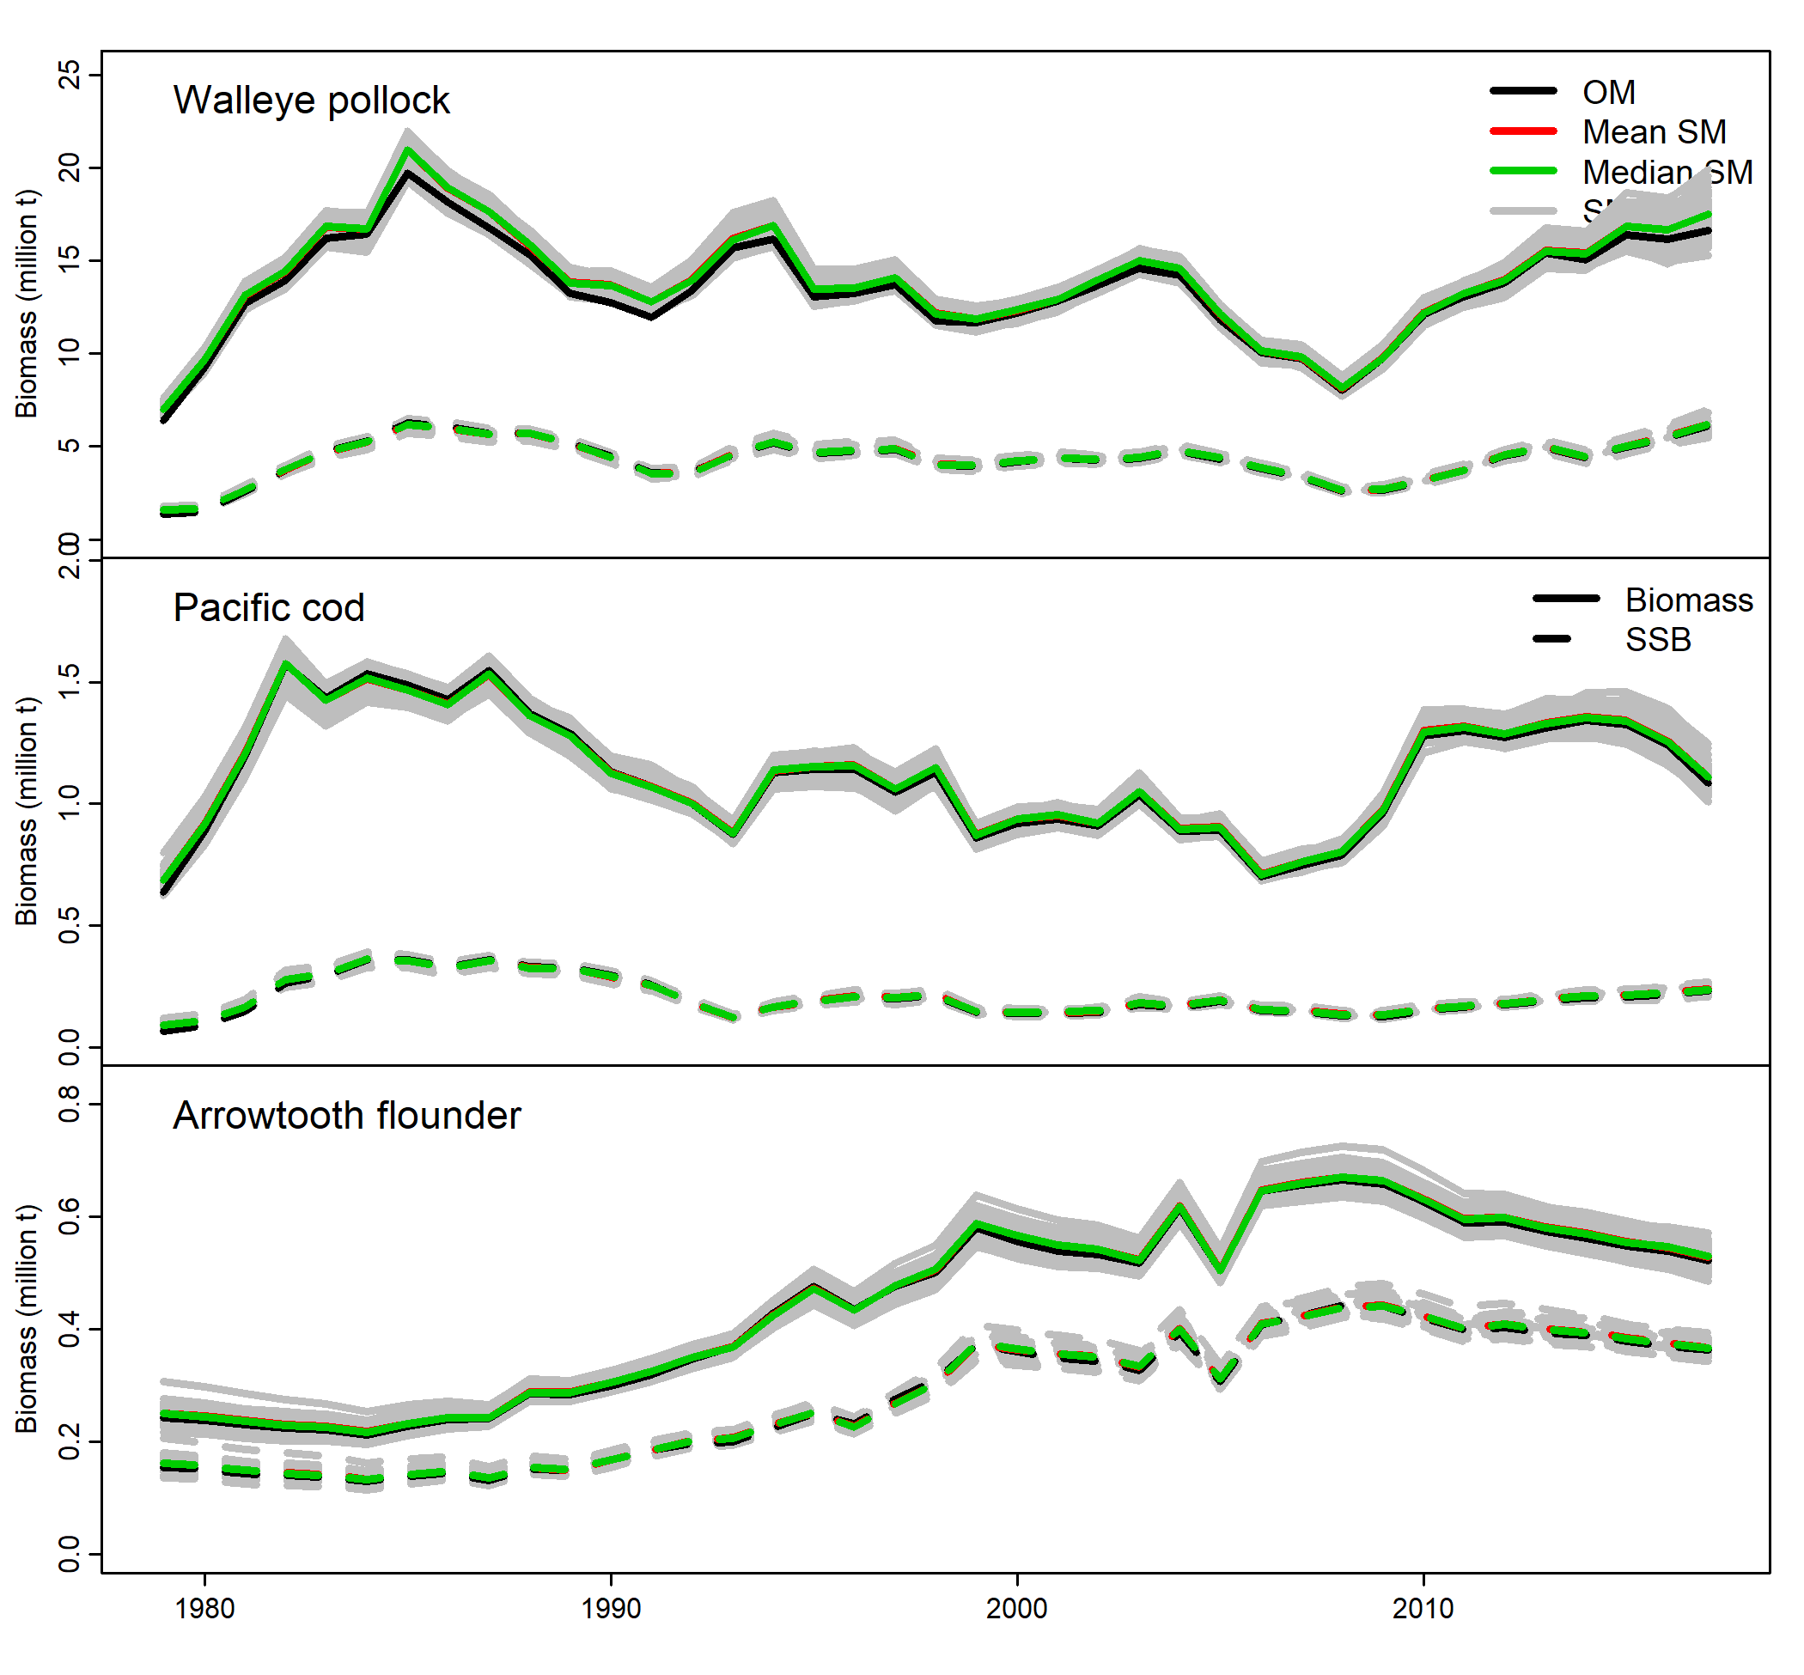

Fig 1. Time series of estimated biomass using penalized likelihood multi-species CEATTLE from an operating model (OM) fit to data, models fit to simulated data (SMs), and mean/median of the SMs.

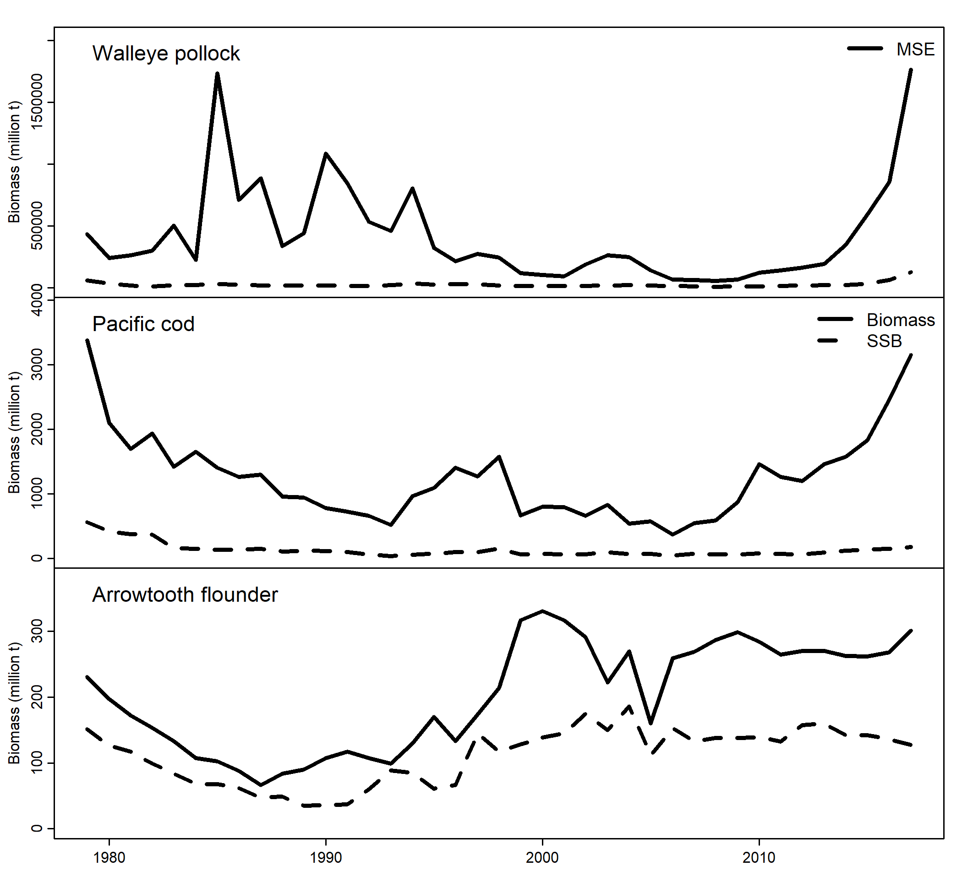

Fig 2. Time series of estimated biomass mean squared error (MSE) of models fit to simulated data from multi-species CEATTLE using penalized likelihood

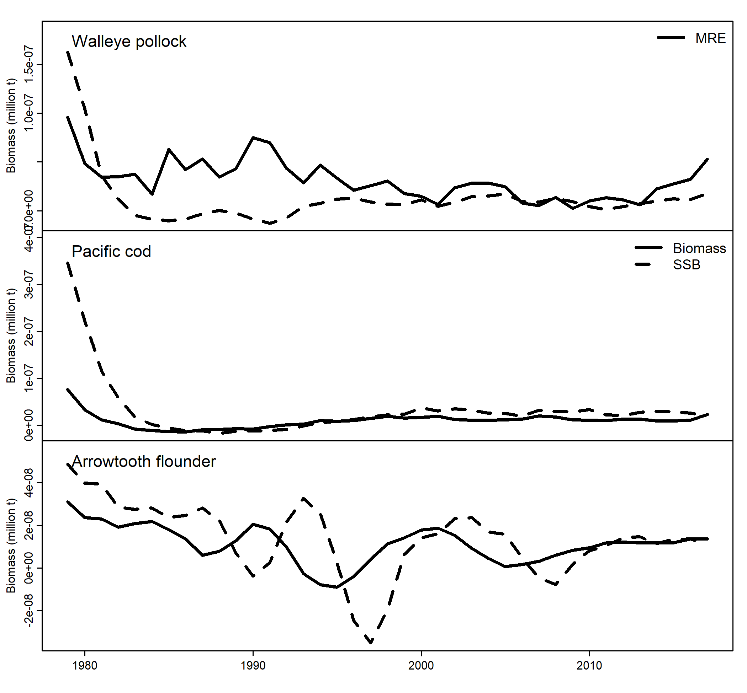

Fig 3. Time series of estimated biomass median relative error (MRE) of models fit to simulated data from multi-species CEATTLE using penalized likelihood

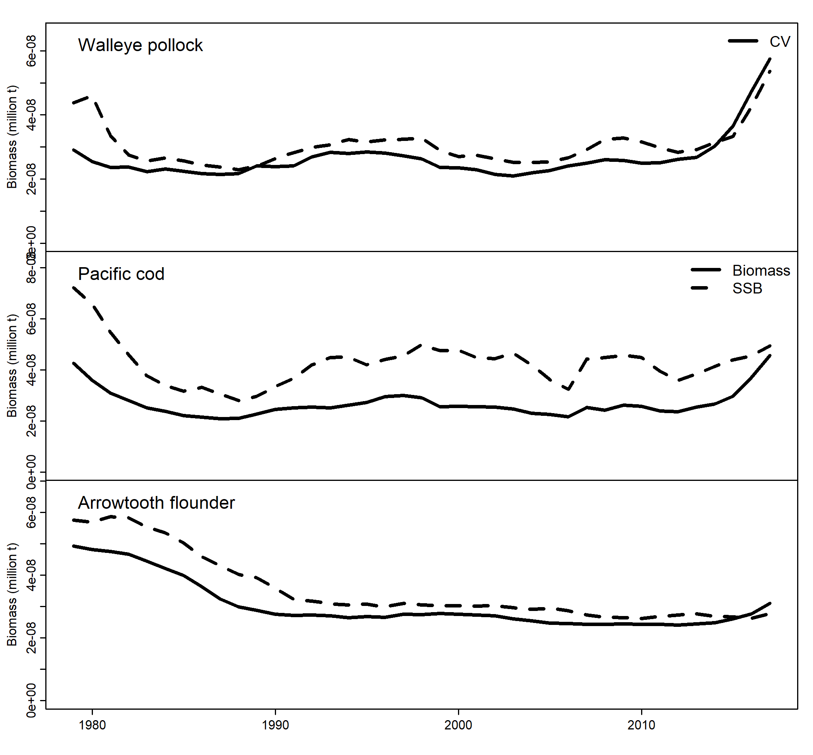

Fig 4. Time series of estimated biomass coefficient of variation (CV) of models fit to simulated data from multi-species CEATTLE using penalized likelihood

**Part 2. Recruitment time series**

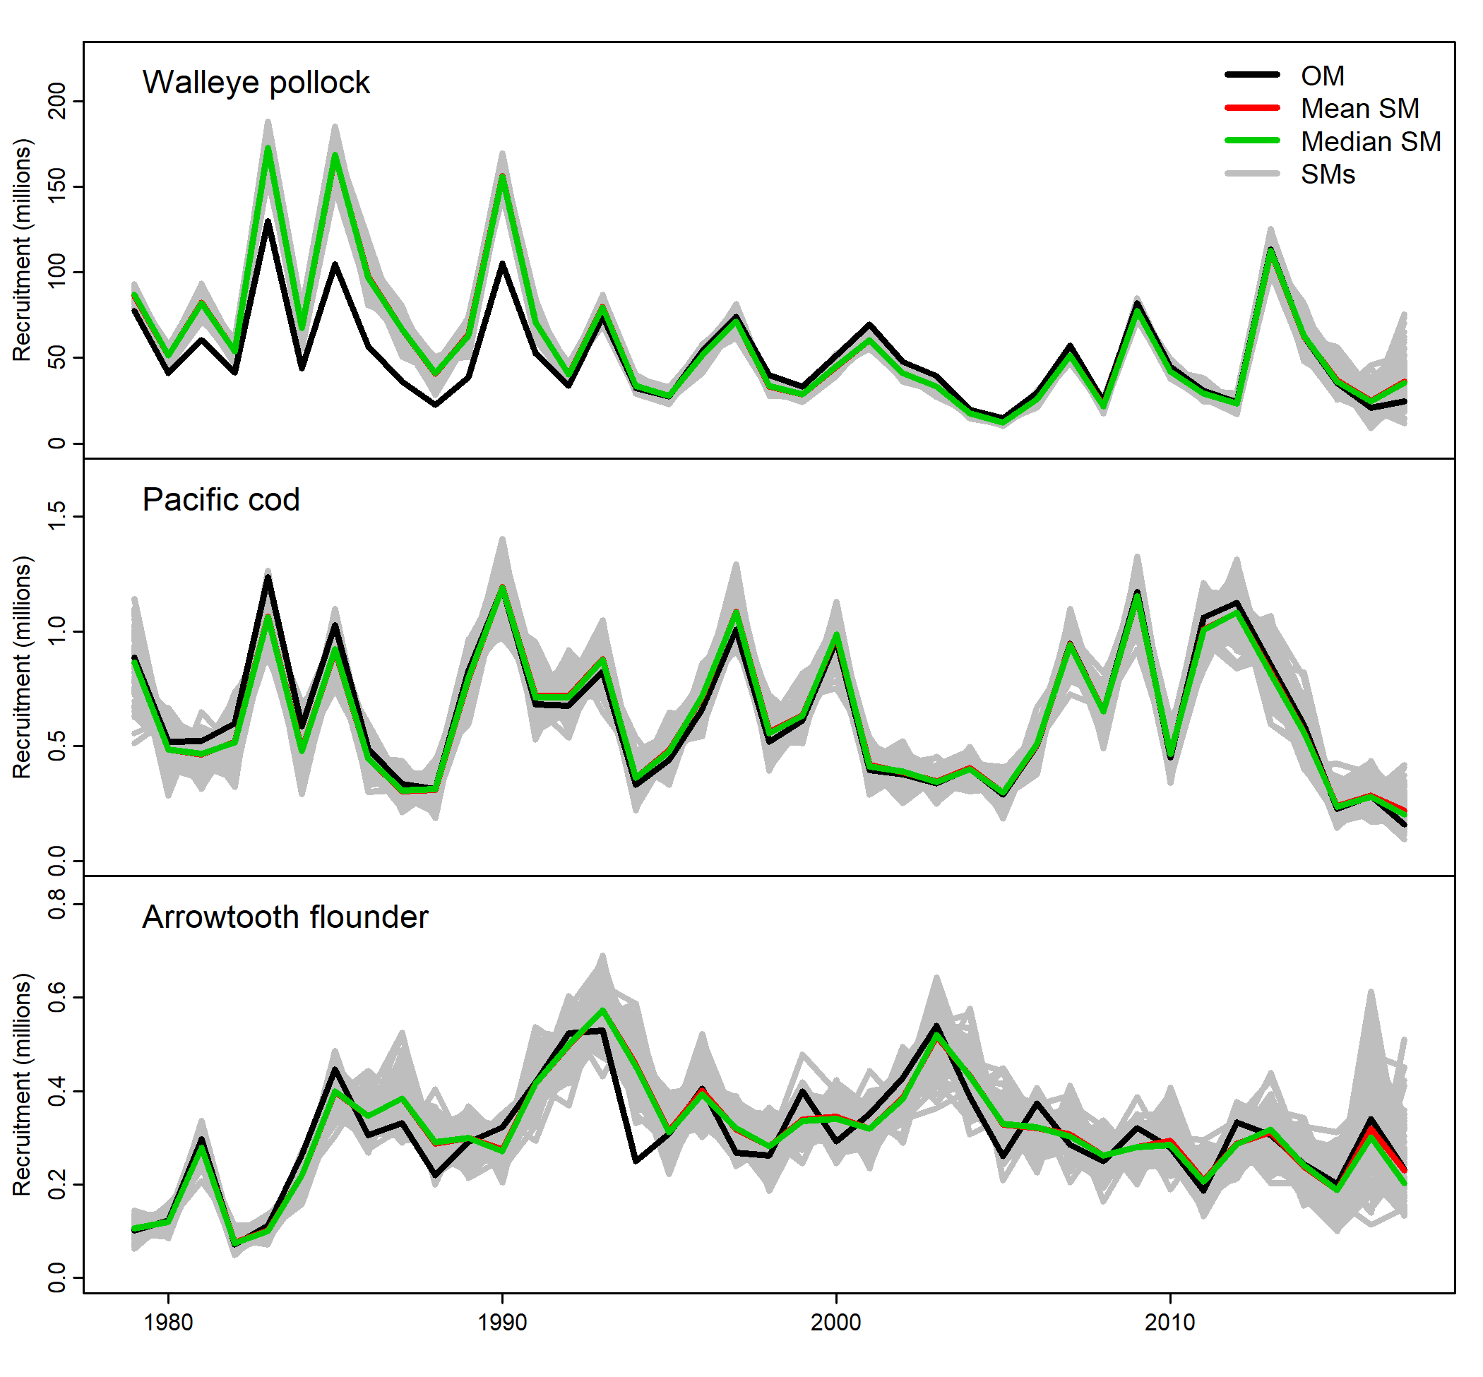

Fig 5. Time series of estimated recruitment using penalized likelihood multi-species CEATTLE from an operating model (OM) fit to data, models fit to simulated data (SMs), and mean/median of the SMs.

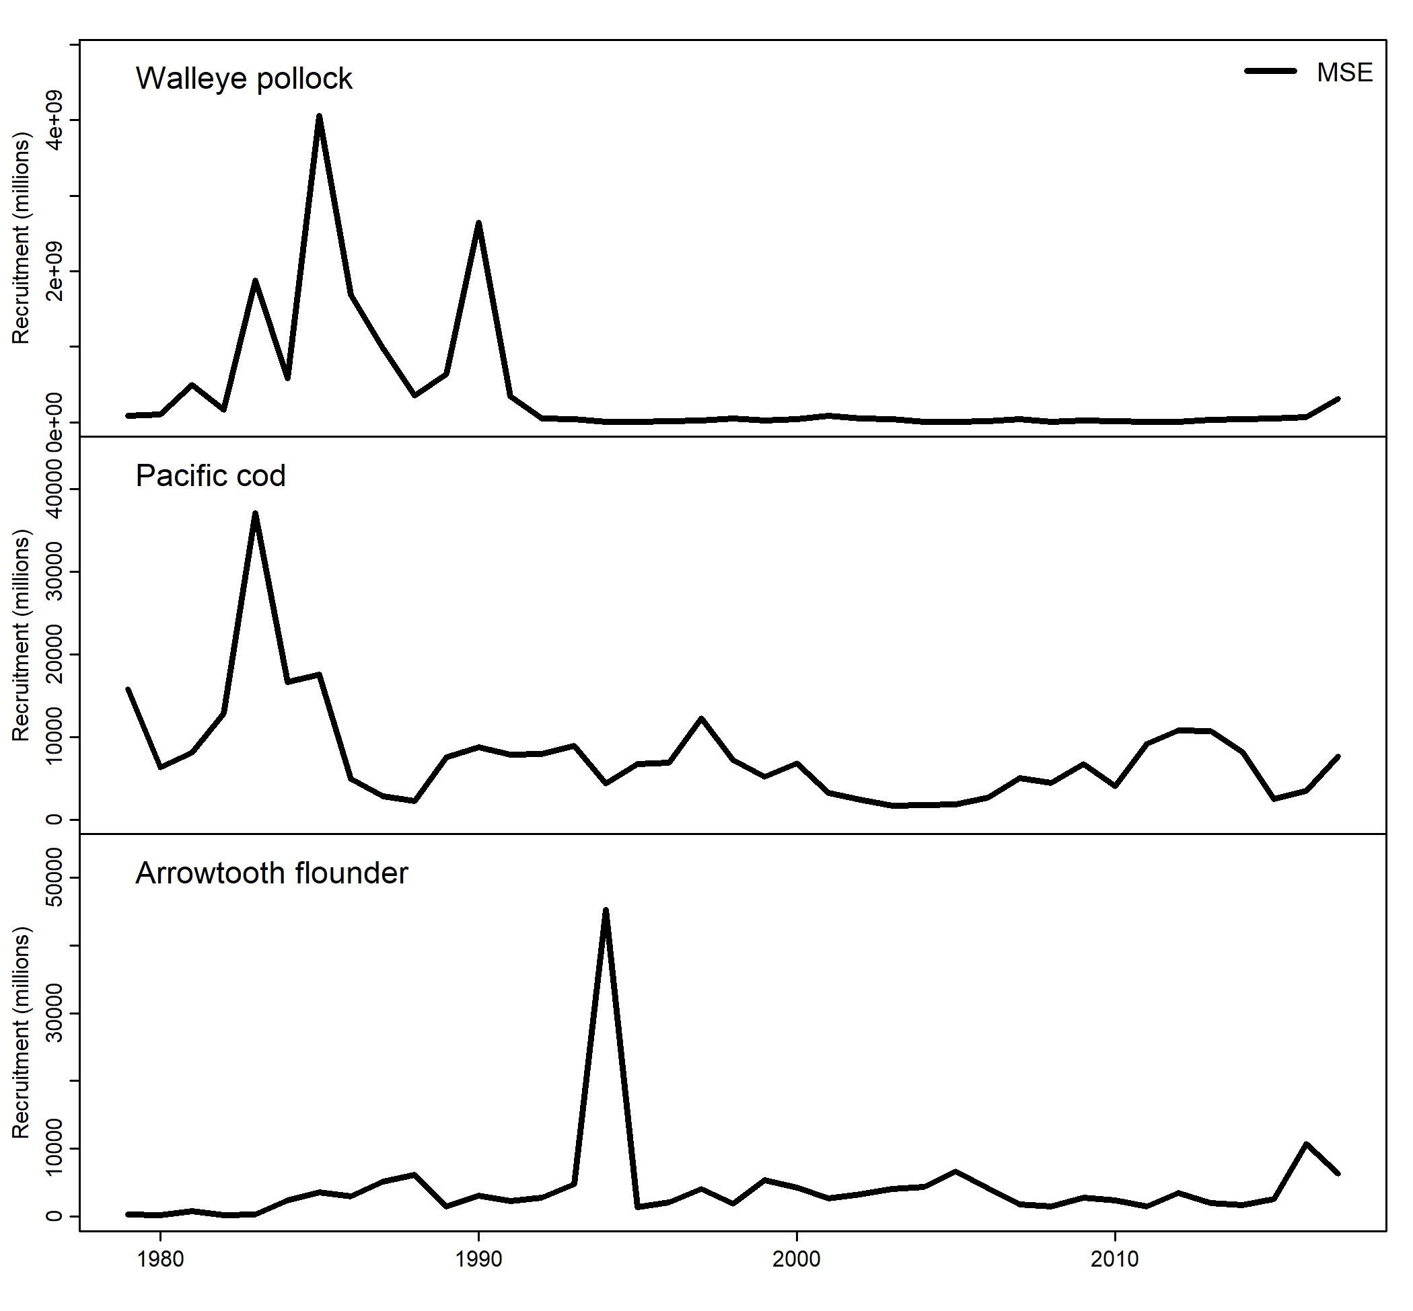

Fig 6. Time series of estimated recruitment mean squared error (MSE) of models fit to simulated data from multi-species CEATTLE using penalized likelihood

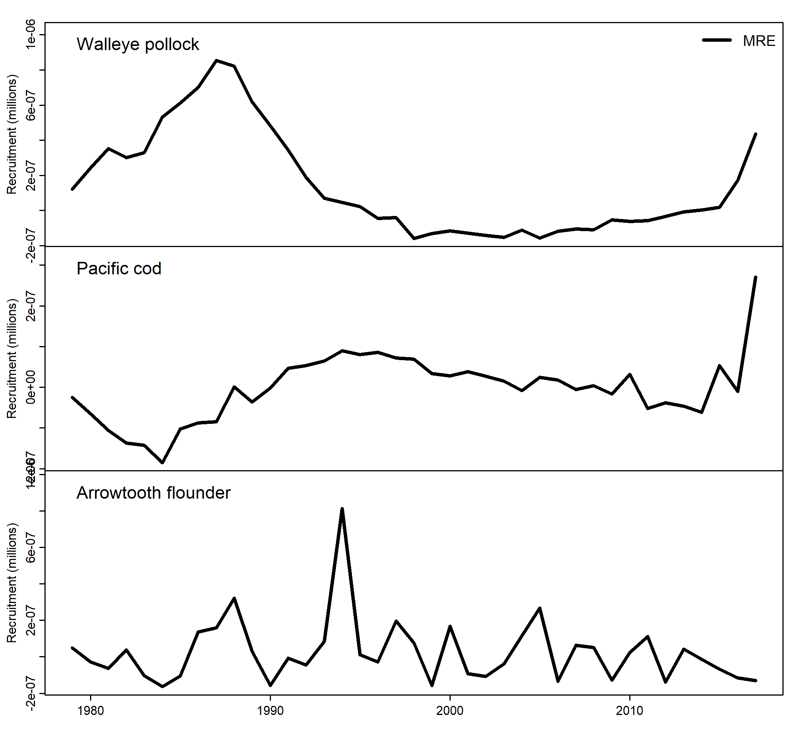

Fig 7. Time series of estimated recruitment median relative error (MRE) of models fit to simulated data from multi-species CEATTLE using penalized likelihood

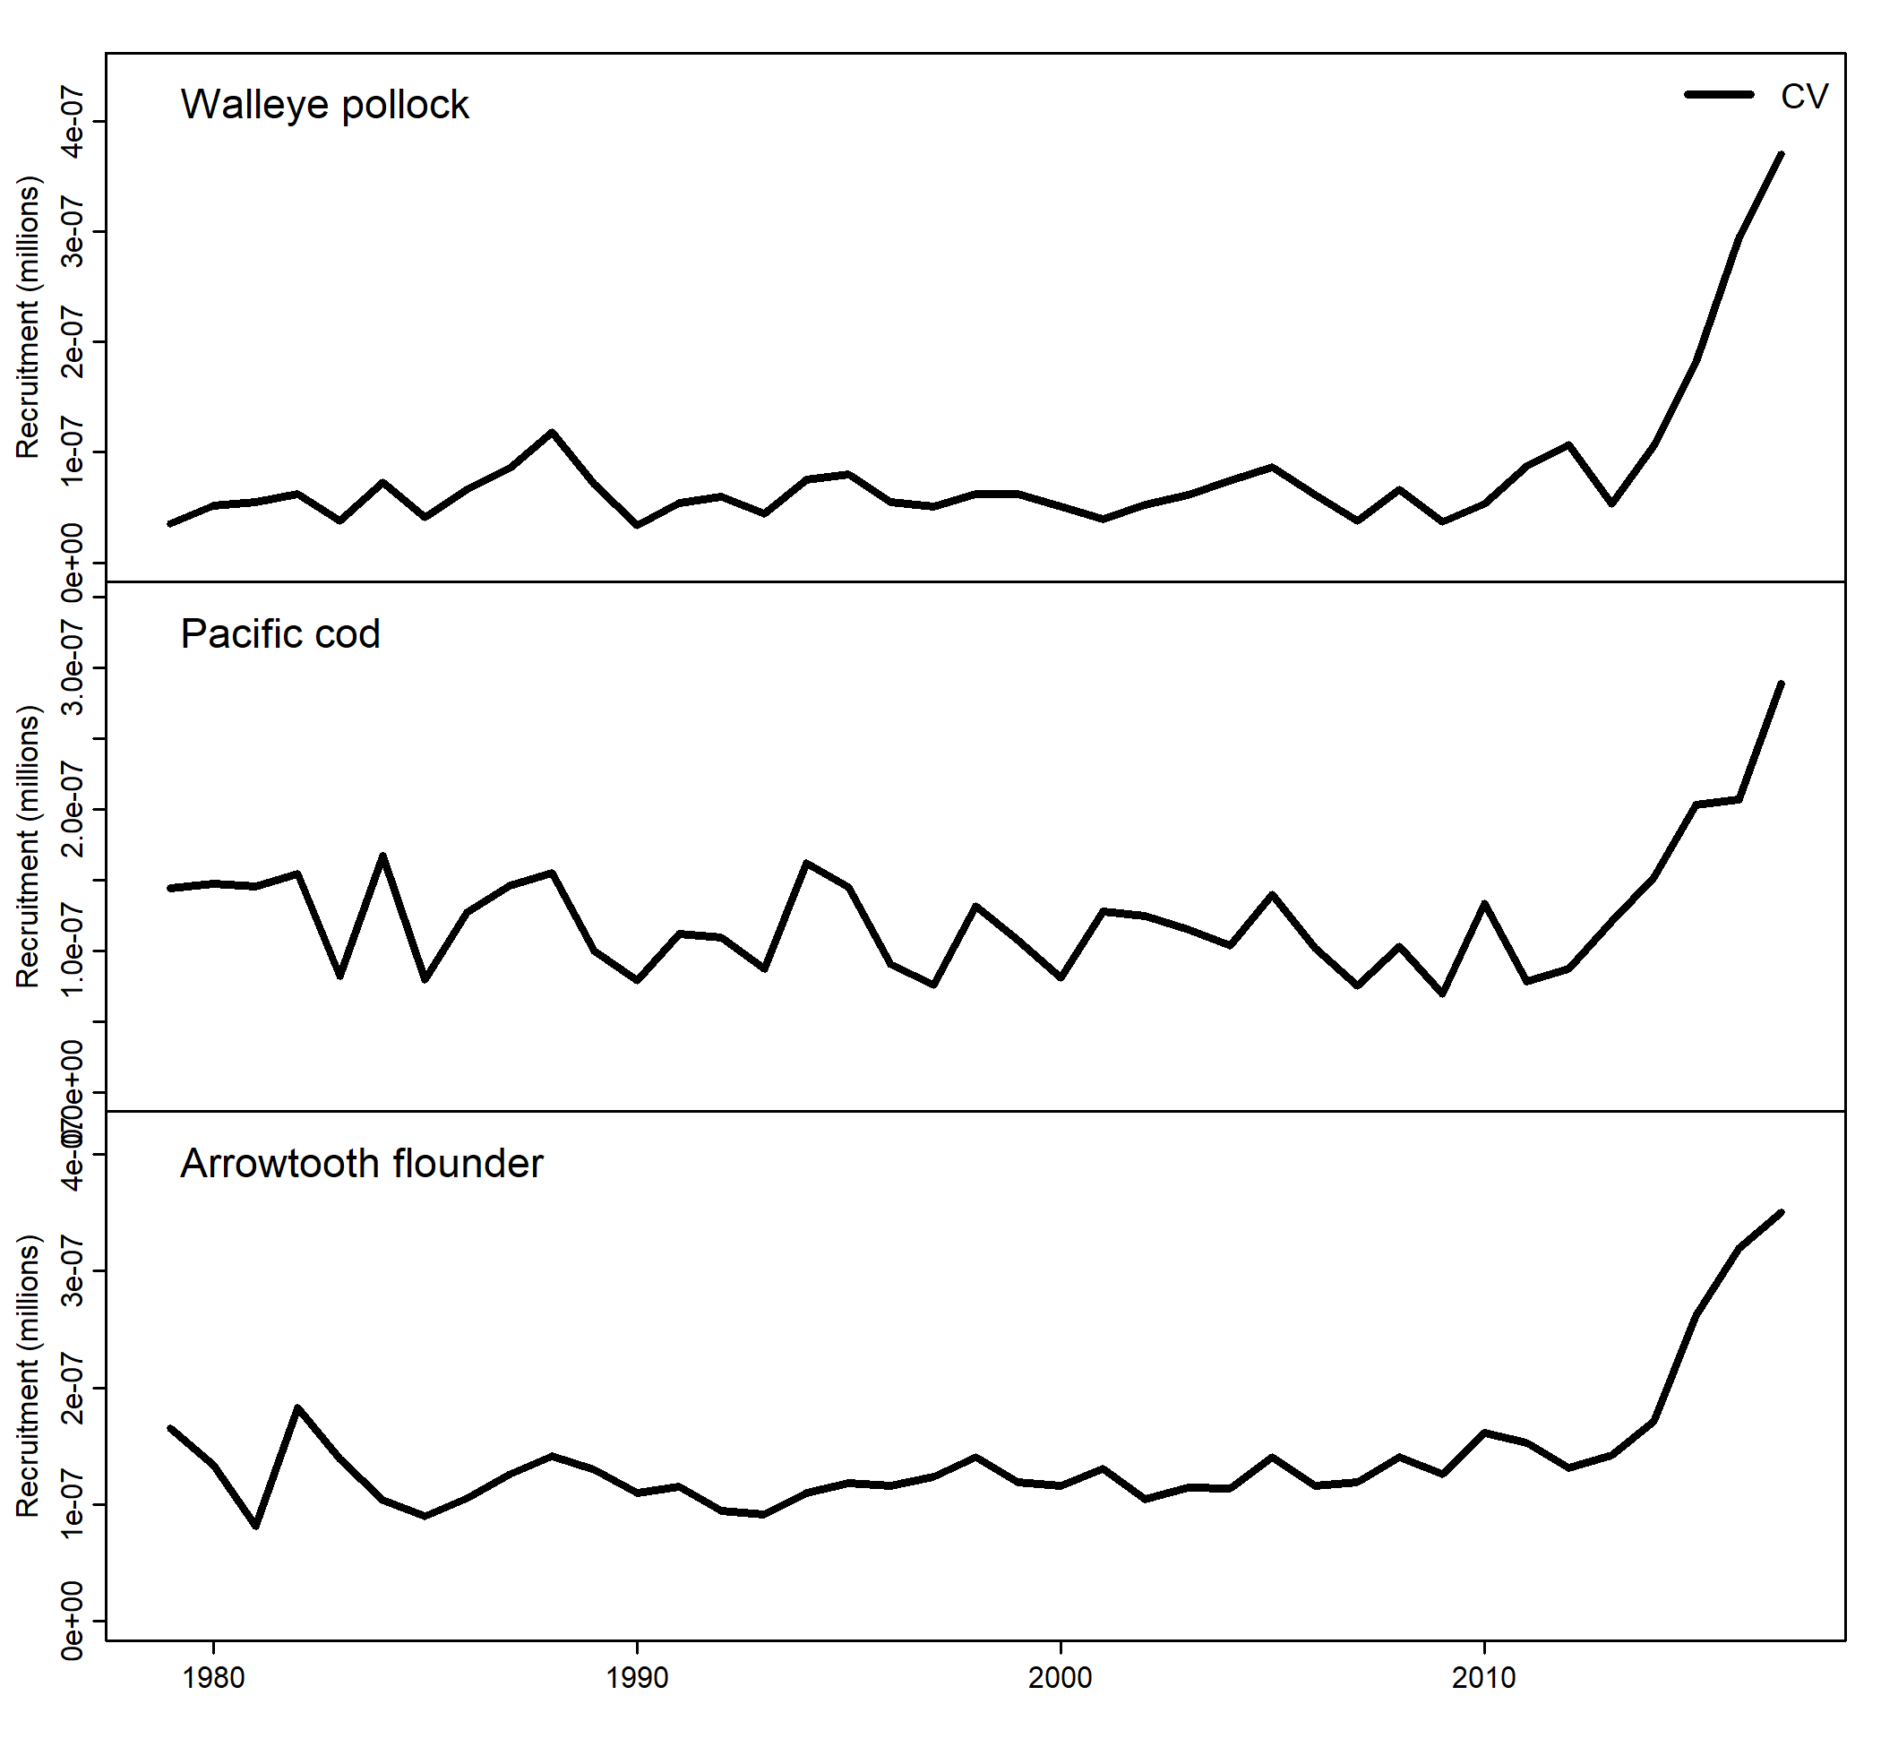

Fig 8. Time series of estimated recruitment coefficient of variation (CV) of models fit to simulated data from multi-species CEATTLE using penalized likelihood

**Part 3. Selectivity**

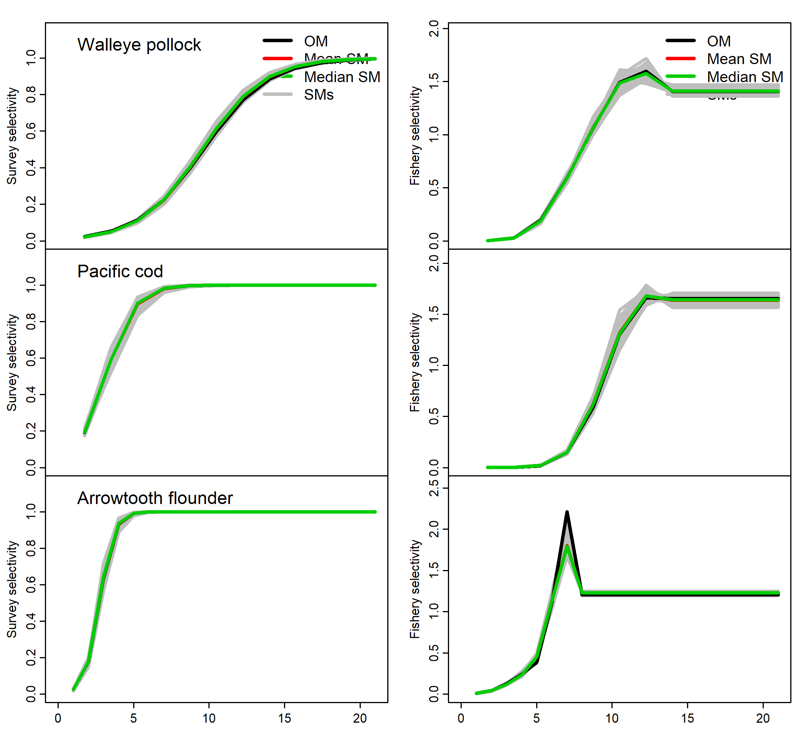

Fig 9. Estimated selectivity using penalized likelihood multi-species CEATTLE from an operating model (OM) fit to data, models fit to simulated data (SMs), and mean/median of the SMs.

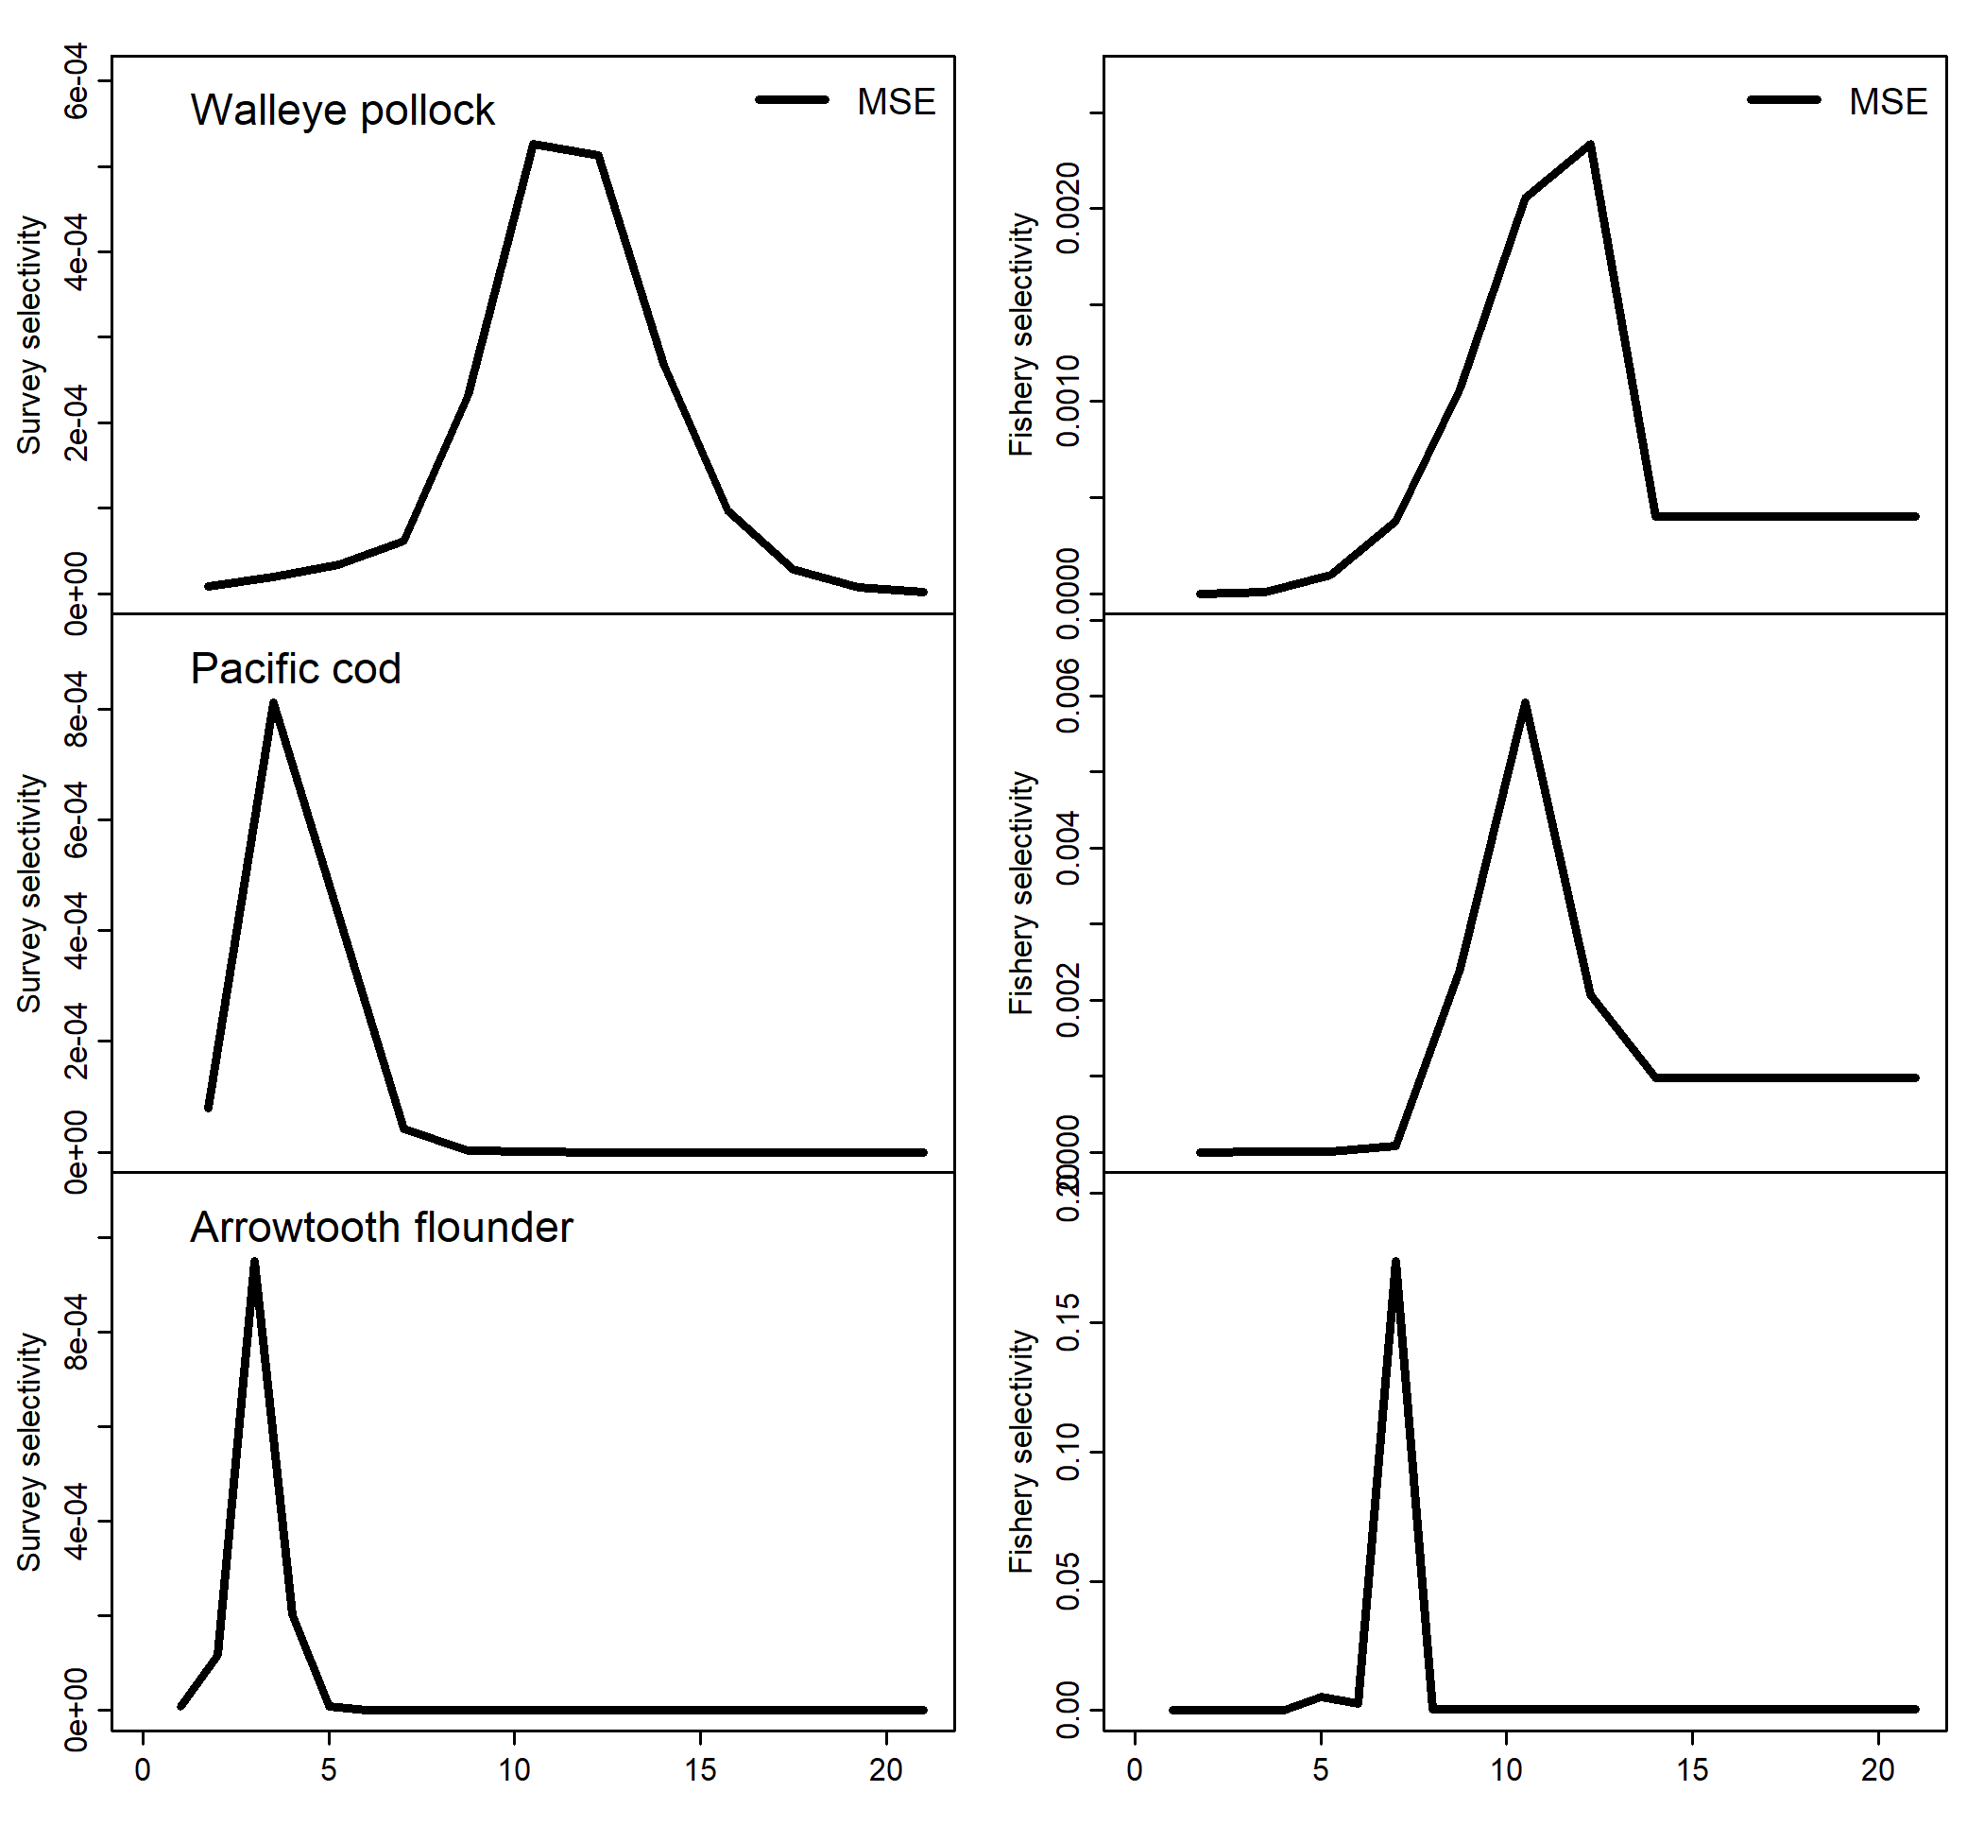

Fig 10. Estimated selectivity mean squared error (MSE) of models fit to simulated data from multi-species CEATTLE using penalized likelihood

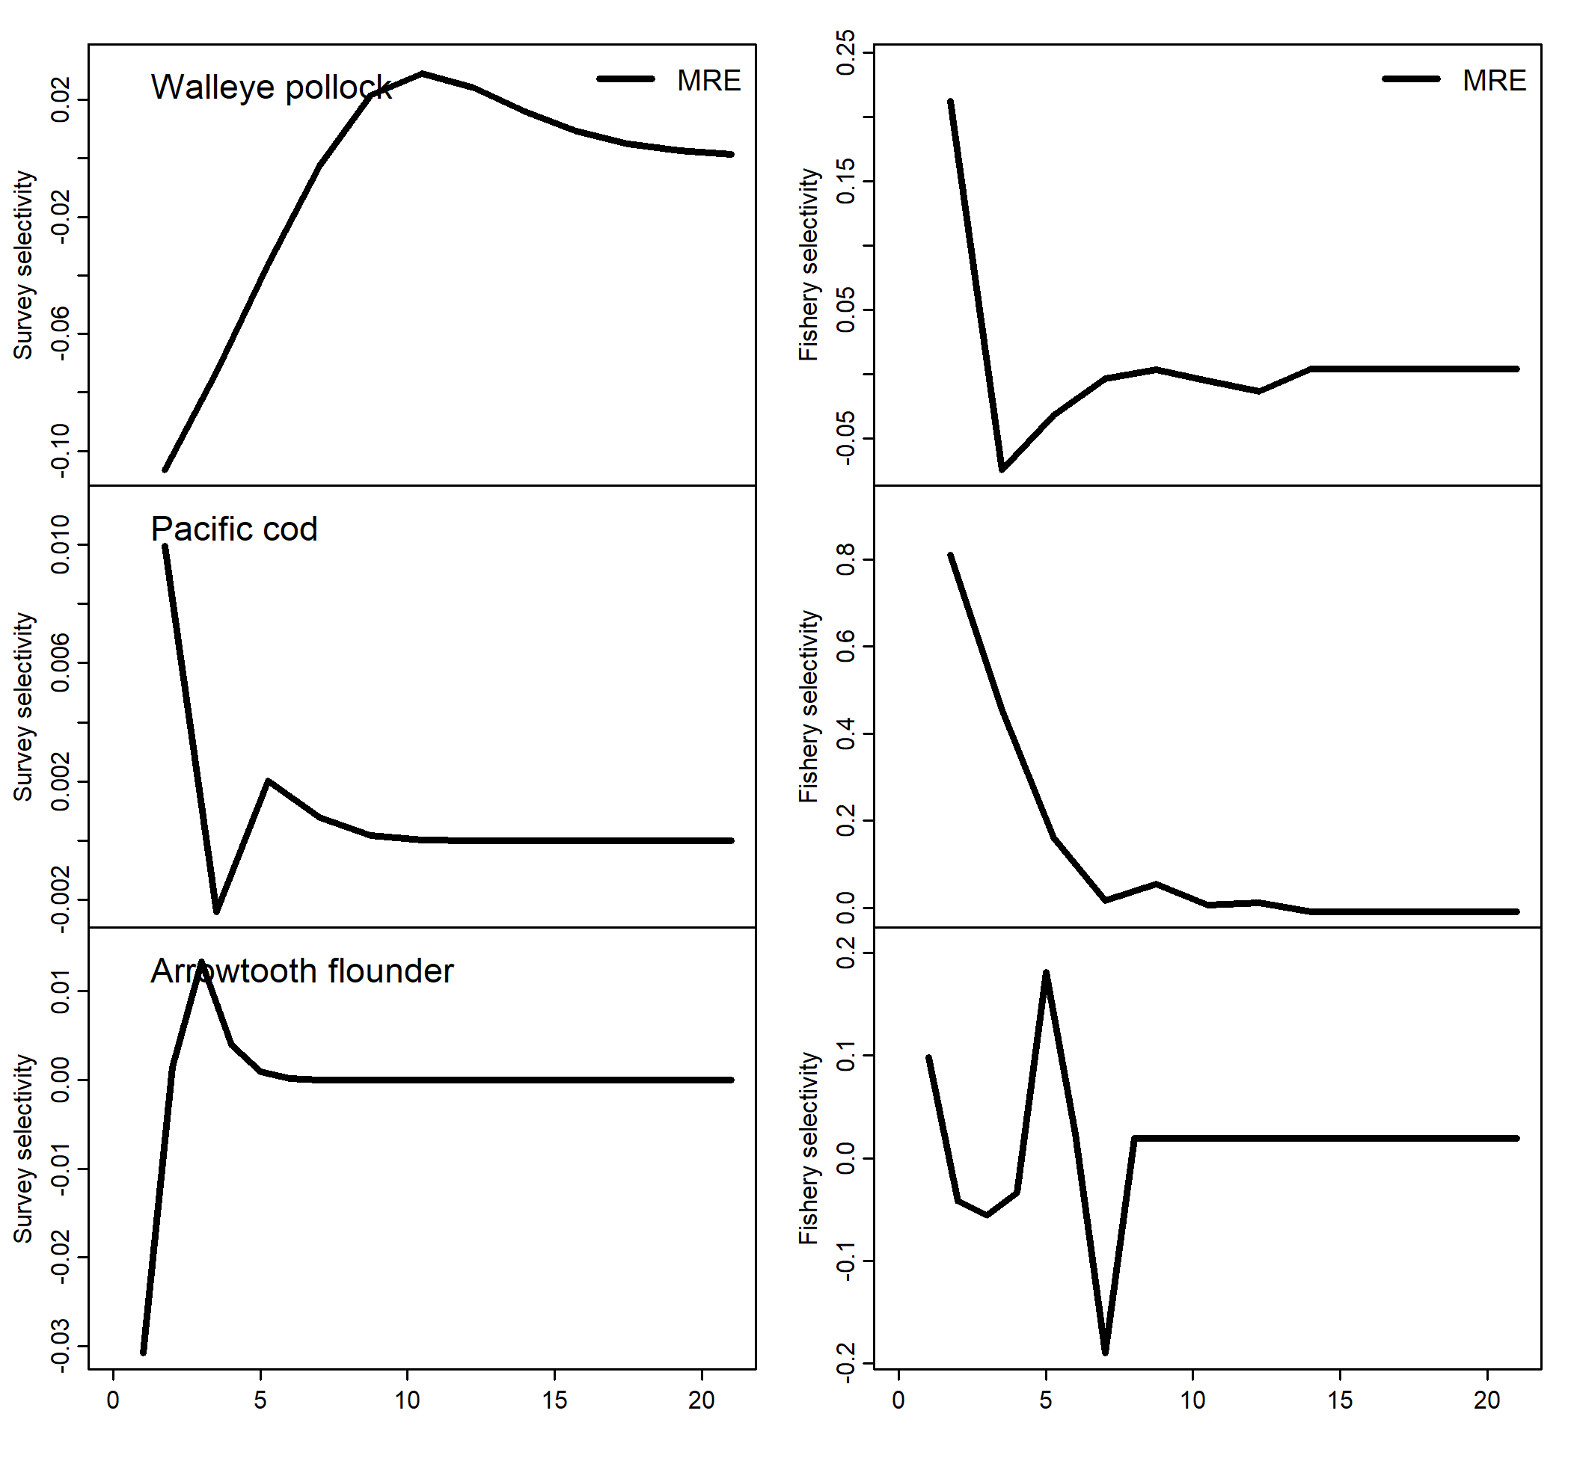

Fig 11. Estimated selectivity median relative error (MRE) of models fit to simulated data from multi-species CEATTLE using penalized likelihood

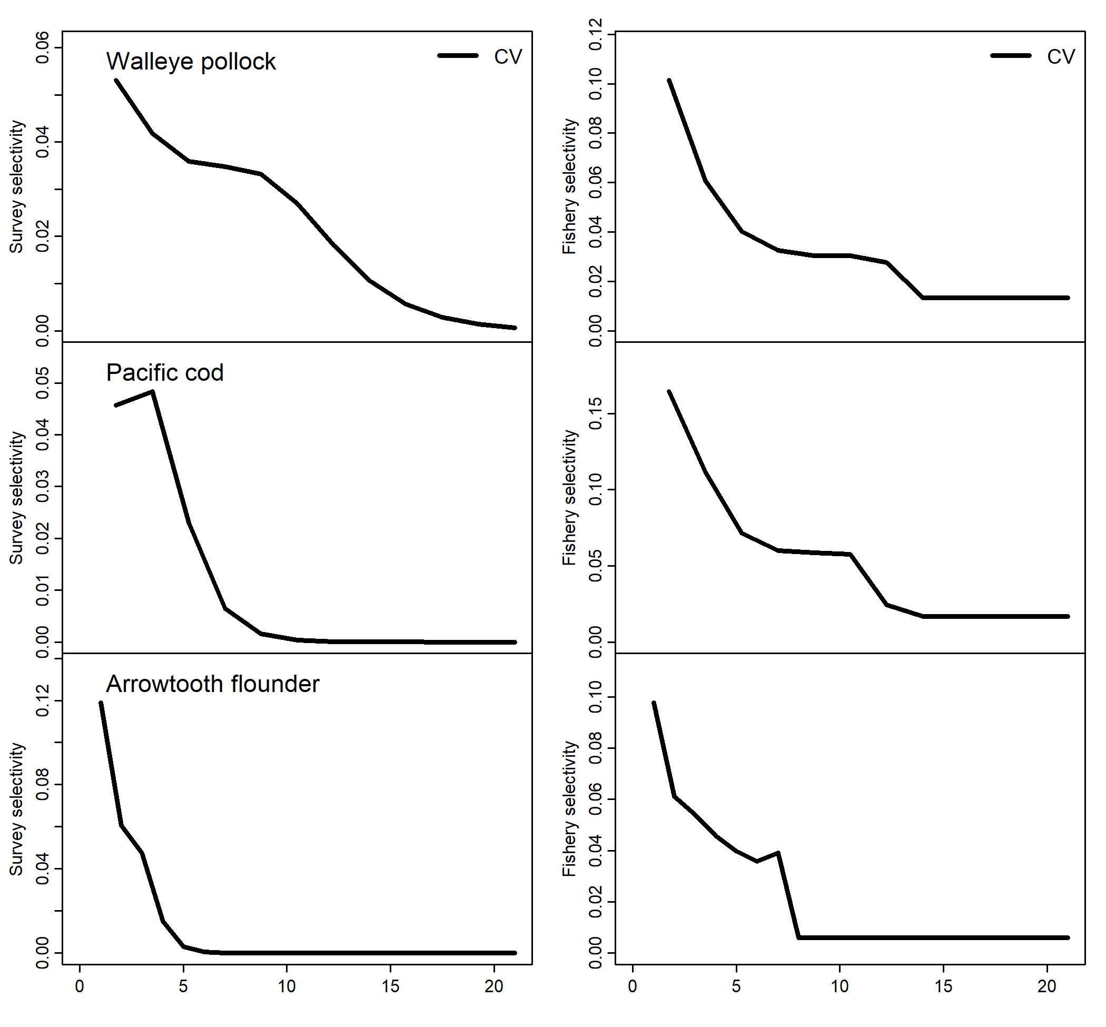

Fig 12. Estimated selectivity coefficient of variation (CV) of models fit to simulated data from multi-species CEATTLE using penalized likelihood