FINAL REPORT

State: Texas Project Number: F-36-R

Project 18: Marine Fisheries Resource Culture and Enhancement

Project 18: Determination of Selected Life History Characteristics
of Black Drum (Pogonias cromis) Along the Texas Gulf Coast

Reporting Period: July 1, 1994 through December 31, 1995

Cost:

Objective: To determine age and size at maturity of black drum in Texas waters.

PREFACE

The attached manuscript "Black Drum Life History in Texas Bays with Emphasis on the Upper Laguna Madre" by Britt W. Bumguardner, Robert L. Colura, Eric Young, David Westbrook and Roberta Buckley is submitted to meet the Federal Aid Final Report requirement for this study.

Prepared by: Robert L. Colura Date: March 22, 1996
Research Leader

Approved by:
Neil E. Carter Date:
Federal Aid Coordinator
Black Drum Life History in Texas Bays with
Emphasis on the Upper Laguna Madre

by

Britt W. Bumguardner, Robert L. Colura,
Eric Young, David Westbrook, and Roberta Buckley

Texas Parks and Wildlife Department
Coastal Fisheries Division
Perry R. Bass Marine Fisheries Research Station
HC 02 Box 385
Palacios, Texas 77465

ABSTRACT

Texas black drum (Pogonias cromis) reproductive biology and age and growth were investigated. Ageing was accomplished using measurements from the center of sectioned otoliths to otolith annuli and margins. Reproductive maturity was determined based on GSI values, presence and percentage of vitellogenic ova, and egg counts and measurements. Black drum from the upper Laguna Madre matured at a younger age and grew slower than black drum from the rest of the Texas coast. Fish from the upper Laguna Madre reached maturity at age 2, as compared to age 5 for fish from other Texas bays. Mean measured size at age for upper Laguna Madre fish was significantly smaller than size of fish from other bays, with a maximum differential of 109 mm at 4.3 years of age. Von Bertalanffy growth models for fish from the upper Laguna Madre and remaining bays were significantly different (P>0.05). Maturity at a younger age and the resulting commitment of energy available to fish in other bays for growth could be expected to induce the observed difference in growth. Reasons for early maturation are not as easily defined, however a difference in mortality rates between the two areas, either natural or due to fishing pressure, might cause juvenescence of black drum in the upper Laguna Madre.

INTRODUCTION

Black drum (Pogonias cromis) is indigenous to the east coast of North and South America ranging from Nova Scotia to Argentina (Gilhen 1986). In Texas it occurs in coastal bays and lagoons throughout the year (Cornelius 1984). Baffin Bay, along with Laguna Madre proper, is considered the center of black drum distribution in Texas (Breuer 1957).

Black drum support an important recreational fishery in Texas. About 5% of the total recreational landings are black drum, 50 % of the recreational catch occurs in Galveston Bay and Sabine Lake (Robinson et al. 1995). Black drum are the sixth most commonly caught fish by Texas sport-boat anglers (Robinson et al. 1995) along with sheepshead (Archosargus probatocephalus). Requests to the Texas Parks and Wildlife Department (TPWD) to open weekends for commercial black drum fishing, requests for exemptions from the maximum size limit, increasing commercial harvest (Robinson et al. 1995) and indications of possible overfishing require information on age of sexual maturity, and age and growth to help make management decisions about black drum in Texas.

Numerous studies have addressed the biology of black drum throughout its' Gulf of Mexico range (Pearson 1929, Simmons and Breuer 1962, Silverman 1979, Cody et al. 1985, Murphy and Taylor 1989, Nieland and Wilson 1993). Studies east of Texas have reported that black drum mature sexually between 5 and 8 years of age (Fitzhugh et al. 1987, Parker et al. 1988, Beckman et al. 1990, Murphy and Taylor 1989, Nieland and Wilson 1993 ). However, Pearson (1929) and Simmons and Breuer (1962) reported maturation at 2 years of age in Texas. General observations by TPWD indicate the findings of Pearson (1929) and Simmons and Breuer (1962) were correct, at least for black drum in the upper Laguna Madre (ULM). Based on these observations, a possibility exists for a major difference in life history characteristics between black drum in Texas and black drum in the northeastern Gulf of Mexico. Potential differences of the magnitude indicated could have substantial management implications, or reflect major differences in the environment inhabited by fish in different locations.

The objectives of this study were to investigate reproductive biology of black drum in Texas bays with emphasis on the upper Laguna Madre. Specifically, we determined size and age at which Texas black drum mature and described their growth.

METHODS

Sample Collection

Black drum were collected monthly from September 1992 to September 1994 from the upper Laguna Madre on the lower Texas coast using standard TPWD gill nets (Anonymous 1995). Additional black drum collections were made from all other bays (Sabine, Galveston, East Matagorda, Matagorda, San Antonio, Aransas, Corpus Christi and the lower Laguna Madre) during routine gill net sampling (McEachron and Fuls 1996) in spring (April-June) 1993-94 and fall (September-October) 1992-93-94. Additional fish were collected from the Sabine Lake, East Matagorda and Matagorda bay systems in January-March 1994 using standard gill nets. Large black drum were also collected by hook-and-line, and oversize fish confiscated by game wardens were obtained when possible. In many cases, fish were stored frozen at TPWD field stations until they could be transported to the Perry R. Bass Marine Fisheries Research Station, where data and samples were collected. All fish were measured (total length mm) and weighed (to .01 kg), and otoliths (sagitta) and gonads collected. All gonads were weighed (to 0.1 g) and two subsamples were collected from near the center of ovaries from selected fish. One subsample was weighed (to 0.01 g) and preserved in Gilson's fluid (Simpson 1951), the second was fixed in 10 % buffered formalin for 24 hours then transferred to 70 % alcohol for storage prior to histological preparation (Hinton 1990). Otoliths were cleaned and stored in labeled paper envelopes.

Otolith Processing and Ageing

The right otolith was embedded in epoxy resin and sectioned transversely with an Isomet high speed saw as near the focus as possible. Sections were mounted on glass slides with thermoplastic cement and examined using a computer assisted image analysis system (Optimas 1992). Measurements were taken from the focus to each annulus and to the margin of the otolith. Ages were assigned to individual fish based on the number of annuli, the date of collection and a standard hatch date (Murphy and Taylor 1989); however, 1 February was selected as a more appropriate hatch date for this more southerly study area than the date of 1 April used by Murphy and Taylor (1989). The Statistical Analysis System (SAS Institute, Inc. 1989) NLIN procedure was used to develop a von Bertalanffy growth model for age-length data. Comparison of von Bertalanffy growth models was conducted using a likelihood ratio test (Kimura 1980). Mean size at age between different areas was compared using a t-test. Marginal increments were plotted by age group to determine season and frequency of annulus formation.

Gonad Processing and Evaluation

Ovarian sections stored in Gilson's fluid were not disturbed for a minimum of three months, after which samples were shaken vigorously to free oocyctes from surrounding connective tissue. The sample was diluted to 1 liter with water, and three 1 ml aliquots obtained with a Hensen-Stemple pipette were counted using a Sedgwick Rafter counting cell at 40X magnification. Oocyte diameter was also measured for the first 50 oocyctes encountered in one of the aliquots. Oocyte diameters were adjusted to account for 30% shrinkage due to preservation (Colura et al. 1988, Lotz et al. 1996). The presence and percentage of oocytes of increased diameter (minimum adjusted diameter of 0.45 mm) was used to indicate sexual maturity and to estimate batch fecundity. Batch fecundity (BF) was estimated using the formula:

BF = IDO X OG X GWT

where IDO is the fraction of increased diameter oocyctes, OG is the number of oocytes per gram of ovarian tissue and GWT is the gonad weight. Percentage of fish with increased diameter oocytes was also used to establish an estimate of spawning frequency.

Ovarian sections stored in 70% alcohol were processed using the procedures described in appendix A (Hinton 1990), and stained sections were examined microscopically at 40X and 100X for definitive structures indicating maturity and spawning (Hunter and Macewicz 1985). Ovaries were assigned a maturity stage from 0 to 5 depending on oocyte stage and presence of internal structures (appendix B).

Gonad weights were used to calculate a gonadosomatic index (GSI) using the formula:

GSI= (GWT / FWT - GWT) X 100

where GWT is gonad weight and FWT is total weight of the fish. Elevated GSI values (>1.5) were used to establish the length of the spawning season and percentage of an age class that was reproductively mature.

Polynomial regression (SAS Institute, Inc. 1989) was also used to develop a model describing the relationship between the number of ova per gram of ovarian tissue and the maturity stage assigned each fish based on examination of histological samples. The same type of analysis was conducted using the number of ova per gram of ovarian tissue and the GSI.

RESULTS AND DISCUSSION

Sample Collection

A total of 2,833 otoliths collected from black drum from all areas of the Texas coast were processed and aged; 1,400 males, 1,400 females and 33 immature or of unknown sex (Table 1). One hundred and nine fish were collected from the Gulf of Mexico off Texas and the remainder from bays. The most fish collected from a single area came from the upper Laguna Madre, which accounted for 950 of the fish sampled. Most fish collected were between 1 and 5 years old; 2,643 of the fish were in these 5 age groups. Egg counts and measurements were made for 125 female black drum, while histological sections were prepared and evaluated for 226 females. A GSI was calculated for 1,359 females and 1,325 males.

Age and Growth

Mean marginal increments for all age groups were greatest between November and April, the maximum marginal increment for an age group occurred in the same period. Plots of mean marginal increments by month for each age group (Figures 1-7) show a pattern of largest means in November, December and January, with a substantial decrease in magnitude by April. Decreases in minimum marginal increments by January indicate that annulus formation began by January. Decreases in maximum marginal increment values occurred by April in most instances, indicating annulus formation was complete. There were no peaks in marginal increment values in the fall that would suggest formation of a second growth ring in black drum, as suggested by previous authors ( Richards 1973). Marginal increment plots indicate annulus formation occurred once each year between November and April, which validates the use of otolith annuli as an indicator of age in black drum. This agrees with the observations of Murphy and Taylor (1989) and Beckman et al. (1990) who both reported the use of otolith annuli as an age indicator for black drum was valid.

Growth comparisons were conducted between black drum from ULM and the rest of the coast, as we were interested in potential differences between black drum coastwide and ULM black drum. Comparisons of growth models for the ULM and individual bays were not made due to small sample sizes of older fish in most individual bays. Fish from the remaining bays were combined to obtain an adequate sample size for growth comparisons to fish in the ULM, where sample sizes were adequate (Table 1). The von Bertalanffy growth models were characterized by higher L_inf and t_{o} values, and lower K values for black drum from the ULM as compared to fish from the remaining bays (Table 2). This implies lower growth rates and a larger maximum size for ULM fish. Comparisons conducted using a likelihood ratio test (Kimura 1980) indicated growth models were different by areas analyzed (ULM and rest of the coast), by sexes between areas, and by sexes coastwide. Differences in models for sexes coastwide were most likely due to differences in black drum between areas, as no differences were found between sexes within areas (Table 3). Growth model fit was much better for black drum outside the upper Laguna Madre as indicated by r² values of about 0.8, while models for black drum within the ULM had r² values of about 0.55. Lower r² values for ULM growth models indicate a greater amount of variability in size at age existed within the ULM than between the remaining bays combined. However, a lower sample size and fewer older fish may have reduced r² values for the ULM. Von Bertalanffy growth model parameters approximated those found by Murphy and Taylor (1989) for combined sexes, of L_inf =1172, K=0.124 and t_{o} = -1.29 . Growth model parameters reported by Doerzbacher et al. (1988) for tagged and recaptured black drum in Texas bays had a lower L_inf (798 mm) and a somewhat faster growth rate (K= 0.219) (Table 2).

Comparisons of predicted total length at age using von Bertalanffy growth models for combined sexes from the ULM and the rest of the coast indicated a substantial difference in estimated total length at age between the two groups, with differences as large as 73 mm at 5 years of age (Table 4). Differences in estimated total length were 49 mm at 2 years, 63 mm at 3 years, 70 mm at 4 years, 73 mm at 5 years, and 70 mm at 6 years after which differences began declining until they reached 36 mm at 10 years. Comparisons of mean measured total length at capture of similar age classes of black drum at 0.1 year intervals indicated fish from the ULM were significantly smaller at age than fish from remaining bays. Significant differences existed for 18 of 25 age groups compared, with fish from the remainder of the coast larger than ULM fish in 17 of the 18 groups (Table 5). The greatest difference between mean sizes was 109 mm at 4.3 years, followed by 108 mm at 3.3 years. Differences in size increases until fish reach 5 years, when fish in the other bays reach sexual maturity, then levels off and begins to decline.

Reproductive Biology

Based on elevated GSI values (Figure 8-9), and presence of vitellogenic ova , age at reproductive maturity was 2 years for black drum from the upper Laguna Madre, whereas age at maturity was 5 years for black drum from other Texas bays. The smallest mature female black drum from the ULM was 280 mm total length, 2.1 years old, had a GSI of 2.86, a maturity stage of 5 and an estimated batch fecundity of 163,300 eggs. Reproductive maturity for age classes 2, 3 and 4 ranged from 24 to 50 % for male and female black drum from the ULM, whereas maximum percent maturity for the same group of fish from other bays was 1.5% (Table 6.). Batch fecundity for female black drum ranged from 39, 400 eggs for a 390 mm 3 year old fish from the ULM to 66, 577,000 eggs for a 995 mm 19 year old fish from Corpus Christi bay. Median batch fecundity was chosen as the best representation of central tendacy as standard deviation for mean batch fecundity was larger than the mean (Sokal and Rohlf 1981). Median estimated batch fecundity of black drum was 1,015,500 eggs for a 460 mm, 3 year old fish with a GSI of 3.2.

We intended to use presence of post-ovulatory follicles in histological preparations of black drum ovaries as a means of estimating spawning frequency of female black drum. However, most fish collected were frozen whole prior to sample collection which made the results of histological examination questionable. Freezing can potentially result in poor-quality histological preparations which may not allow identification of postovulatory follicles, and may also result in lysis of hydrated oocytes (Hunter and Macewicz 1985). In fact, histological sections of black drum ovarian tissue were quite difficult to evaluate, as sections often appeared incomplete, with areas of tissue within the section missing. As a somewhat less reliable method of estimating spawning frequency we used percentage of fish with increased diameter oocytes (0.45 mm) as an indication of the percentage of females spawning in a given 24 hour period. Percentage of black drum females with large diameter oocytes for November through March was 46.4% which provides an estimate of spawning frequency of 2.2 days. Maturity stages assigned based on histological preparations provided an accurate representation of overall reproductive condition. With the exception of one sample, GSI's, mean egg diameter, percentage of large diameter oocytes, and estimated batch fecundity increased with increasing maturity stage until stage 4 was reached, then decreased for stage 5 (presence of atretic oocytes) indicating spawning cessation was imminent. Number of eggs / g of ovarian tissue was inversely correlated to maturity stage, as would be expected for maturing oocytes (Table 7) .

Polynomial regression models that best explained the relationship between the number of eggs / g of ovarian tissue and either maturity stage or GSI were:

Eggwt = 2822758 -1291515MS + 161802MS² r² = 0.609

and:

Eggwt = 2406925 - 1407766GSI + 305546GSI² - 26386GSI³ + 766GSI⁴ r²=0.68

where Eggwt is the number of eggs per gram of ovary, MS is maturity stage based on examination of histological samples of ovarian tissue, and GSI is the gonadosomatic index.

Our results confirm reports of Pearson (1929) and Simmons and Breuer (1962) that black drum on the lower Texas coast can reach sexual maturity at 2 years; however, black drum from the rest of the Texas coast reach sexual maturity at about 5 years, which is consistent with reports of black drum age-at-maturity from the northeastern Gulf of Mexico (Murphy and Taylor 1989, Fitzhugh et al. 1993, and Nieland and Wilson 1993). There are several potential explanations for this difference including differential mortality rates, different environmental conditions, and genetically different groups of fish.

Differential mortality rates, due either to differences in fishing or natural mortality, with higher rates occurring in the ULM, could result in juvenescence of black drum, where younger fish begin reproducing to compensate for low densities of mature fish. Early maturation might also be a response to harsh environmental conditions that cause high natural mortality and require the maximum number of spawners possible to compensate for reduced survival of larvae. The upper Laguna Madre routinely has salinities well above average for other Texas bays , with average annual salinities over 45 o/oo, and average seasonal (spring and fall) salinities over 50 o/oo in years of low rainfall (McEachron and Fuls 1996). Cornelius (1984) reported salinity measurements of 85 o/oo in upper bays and 134 o/oo in isolated pools. Simmons and Breuer (1962) reported collecting black drum from 80 o/oo salinity water, but noted many of the fish had glazed eyes and lesions. Pearson (1929) reported an age at maturity identical to our observations for black drum in 1926-27, so whatever mechanism is influencing black drum reproductive biology in the ULM has apparently been impacting the population for a number of years.

Black drum in the ULM could also be a separate genetic group that has developed a different age at maturity from the rest of the population. Ramsey and Wakeman (1987) identified a "slightly differentiated group" of red drum (Sciaenops ocellatus) in Mosquito Lagoon, a semi-isolated area of the Indian River on Florida's eastern coast that might mature at an earlier age than other red drum. Allozyme surveys of black drum in Texas do not indicate especially high levels of genetic variation. However, several loci in ULM black drum are not in Hardy-Weinberg equilibrium, possibly due to pooling of heterogenous groups (Karel et al. 1996). This could also be due to selective pressures such as harsh environmental conditions or selective mortality, either fishing or natural .

Our estimates of maximum batch fecundity of 66 million were considerably higher than previous reported maximum batch fecundities of 3.4 million by Nieland and Wilson (1993), and 3.8 million by Fitzhugh et al. (1993) for black drum. Both authors used counts of hydrated oocytes (Hunter et al. 1985) to estimate batch fecundity, in contrast to the percentage of advanced oocytes in preserved samples procedure (Colura et al. 1988, Lotz et al. 1996) that we utilized. Our median estimated batch fecundity of 1 million was slightly less than the 1.2 to 1.6 million mean batch fecundity reported by Nieland and Wilson (1993). Lotz et al. (1996) estimated maximum batch fecundity for cobia, Rachycentron canadum, using a method similar to the one used in this study and observed an increase in maximum batch fecundity similar in magnitude to the increase we documented.

There are substantial differences in the life history of black drum in the upper Laguna Madre as compared to black drum in other Texas bays and to literature reports. These differences may be due to environmental conditions in the upper Laguna Madre or to the impact of heavy fishing pressure. Differences in growth rates are most likely due to early reproductive maturation of black drum in the upper Laguna Madre. Reproduction at a younger age would constitute an energy investment not required of same-age fish in other bays, which could use energy spent for reproduction by ULM fish for additional growth. The underlying cause of these differences is unclear, but existence of the differences needs to be considered in future management strategies for black drum in Texas.

ACKNOWLEDGEMENTS

We would like to thank the Coastal Fisheries management teams for each bay system for helping with sample collection and transportation, particularly the upper Laguna Madre team who set nets and collected fish for us year-round, and the teams for Matagorda Bay and Sabine Lake who also set extra nets for our samples. We also want to "thank" Joedy Gray for starting this project and skipping to Austin about the time the real fun started. (Nick, please delete after reading)

LITERATURE CITED

Anonymous 1995. Marine Resource Monitoring Operations Manual. Texas Parks and Wildlife Department. Coastal Fisheries Division. Austin Tx. pp 126.

Beckman, D. W., C. A. Wilson, D. L. Nieland, and A. Louise Stanley. 1990. Age structure, growth rates, and reproductive biology of black drum in the northern Gulf of Mexico. Final Report 1988-89. Coastal Fisheries Institute, Center for Wetland Resources, Louisiana State University, Baton Rouge.

Breuer, J. P. 1957. An ecological survey of Baffin and Alazan bays, Texas. Publ. Inst. Mar. Sci., Univ. Tex. 4:134-155.

Campbell, P., T. Storck, and V. Price. 1992. Trends in Texas commercial fishery landings. Management Data Series Number 82. Texas Parks and Wildlife Department, Coastal Fisheries Branch. Austin, Texas.

Cody, T. J., K. W. Rice, and C. E. Bryan. 1985. Distribution and gonadal development of black drum in Texas Gulf waters. Management Data Series Number 72. Texas Parks and Wildlife Department, Coastal Fisheries Branch. Austin, Texas.

Colura, R. L., A. F. Maciorowski and A. Henderson-Arzapalo. 1988. Gonadal maturation, fecundity, and strip-spawning of female spotted seatrout. Proc. Annu. Conf. Southeast. Assoc. Fish and Wildl. Agencies. 42:80-88.

Cornelius, S. E. 1984. Contribution to the life history of black drum and analysis of the commercial fishery of Baffin Bay. Technical Bulletin Number 6. Caesar Kleberg Wildlife Research Institute.

Doerzbacher, J. F., A. W. Green and G. C. Matlock. 1988. A temperature-compensated von Bertalanffy growth model for tagged red drum and black drum in Texas bays. Fish. Res. 6:135-152.

Dailey, J. A., J. C. Kana and L. W. McEachron. 1991. Trends in Relative Abundance and size of selected finfishes and shellfishes along the Texas coast: November 1975-December 1990. Management Data Series No. 74. Texas Parks and Wildlife Department, Fisheries and Wildlife Division. Coastal Fisheries Branch. Austin, Texas.

Fitzhugh, G. R., T. G. Snider, and B. A. Thompson. 1987. Ovarian development, fecundity, and spawning frequency of black drum, Pogonias cromis. In: G. R. Fitzhugh and D. W. Beckman. Age, growth and reproductive biology of black drum in Louisiana waters. Final report to the Louisiana Board of Regents. 89 pages.

Futch, R. B. and G. E. Bruger. 1976. Age, growth and reproduction of red snapper in Florida waters. Pages 165-184. In: H. R. Bullis and A. C. Jones, editors. Proceedings: Colloquium on snapper-grouper fishery resources.

Gilhen, J. 1986. The second and third records of the black drum Pogonias cromis, from the Canadian Atlantic. Canadian Field-Naturalist. 100(1): 125-126.

Hinton, D. E. 1990. Histological Techniques. In C. B. Schreck and P. B. Moyle (eds.), Methods for Fish Biology, p 191-209. American Fisheries Society, Bethesda MD.

Hunter, J. R., N. C. H. Lo and R. J. H. Leong. 1985. Batch fecundity in multiple spawning fishes, In Lasker, R. L. (ed.), An egg production method for estimating spawning biomass of pelagic fish:application to the northern anchovy, Engraulis mordax, p. 67-77. NOAA Tech. Rep., NMFS 36.

Hunter, J. R. and B. J. Macewicz. 1985. Measurement ot spawning frequency in multiple-spawning fishes. In Lasker, R. L. (ed.), An egg production method for estimating spawning biomass of pelagic fish:application to the northern anchovy, Engraulis mordax, p. 79-94. NOAA Tech. Rep., NMFS 36.

Karel, W. J., R. Ward, and I. R. Blandon. 1966. Allozyme analysis of the population structure in black drum (Pogonias cromis) inhabiting the Texas coast.

Kimura, K. D. 1980. Liklihood methods for the Von Bertalanffy growth curve. Fish. Bull. 77:765-776.

Lotz, J. M., R. M. Overstreet and J. S. Franks. 1996. Gonadal maturation in the cobia, Rachycentron canadum, from the northcentral Gulf of Mexico. Gulf Res. Rep. 9:147-159.

McEachron L. W. and B. Fuls. 1996. Trends in relative abundance and size of selected finfishes and shellfishes along the Texas coast: November 1975-December 1993. Management Data Series Number 115. Texas Parks and Wildlife Department, Coastal Fisheries Division. Austin, Texas.

Murphy, M. D. and R. G. Taylor. 1989. Reproduction and growth of black drum, Pogonias cromis, in northeast Florida. Northeast Gulf Science. 10(2): 127-137.

Nieland, D. L. and C. A. Wilson. 1993. Reproductive biology and annual variation of reproductive variables of black drum in the northern Gulf of Mexico. Trans. Am. Fish. Soc. 122:318-327.

Optimas. 1992. Optimas users guide, 5th ed. Bioscan, Inc. Edmonds, Wa. pp 327.

Overstreet, R. M. 1983. Aspects of the biology of the spotted seatrout, Cynoscion nebulosus, in Mississippi. Gulf Research Reports, Supplement. 1:1-43.

Parker, R. M., D. L. Nieland, D. W. Beckman, and C. A. Wilson. 1988. Reproductive biology of the black drum Pogonias cromis in the northern Gulf of Mexico. In: D. W. Beckman, C. A. Wilson, R. M. Parker, D. L. Nieland, and A. L. Stanley. Age structure, growth rates, and reproductive biology of black drum in the northern Gulf of Mexico off Louisiana. 1986-87 Final Report to U. S. Department of Commerce, Marine Fisheries Initiative (MARFIN) Program.

Pearson, J. C. 1929. Natural history and conservation of redfish and other commercial sciaenids on the Texas coast. Bull. U. S. Bur. Fish. XLIV:129-214.

Ramsey, P. R. and J. M. Wakeman. 1987. Population structure of Sciaenops ocellatus and Cynoscion nebulosus (Pisces:Sciaenidae): Biochemical variation, genetic subdivision and dispersal. Copeia 1987 (3):682-695.

Richards, C. E. 1973. Age, growth and distribution of the black drum (Pogonias cromis) in Virginia. Trans. Am. Fish. Soc. 102:584-590.

Robinson, L., P. Campbell and L. Butler. 1995. Trends in Texas commercial fishery landings, 1972-1994. Management Data Series Number 117. Texas Parks and Wildlife Department, Coastal Fisheries Division. Austin, Texas.

SAS Institute, Inc. 1989. SAS/STAT User's guide,version 6, fourth edition,volume 2, Cary, N. C. SAS Institute, Inc. 846 pp.

Silverman, M. J. 1979. Biological and fisheries data on black drum, Pogonias cromis (Linnaeus). U. S. National Marine Fisheries Service Sandy Hook Laboratory Technical Series Report. 22:1-35.

Simmons, E. G., and J. P. Breuer. 1962. A study of redfish, Sciaenops ocellatus Linneaus, and black drum, Pogonias cromis Linneaus. Publ. Inst. Mar. Sci. Univ. Tex. 8:184-211.

Simpson, A. C. 1951. The fecundity of plaice. Fish. Invest. London, Ser. 2. 17:1-27.

Table 5 . Mean total length and t-statistic values for black drum from the upper laguna Madre (ULM) and remaining bays (OTH) combined.
____________________________________________________________________________________
Mean Total Length (mm)
Age ULM (N) OTH (N) t Prob.

1.0 252 (3) 237 (9) -0.88 .40
1.7 226 (3) 302 (105) 2.97* .004
1.8 243 (3) 300 (55) 2.09* .04
2.0 298 (13) 343 (12) 3.29* .005
2.1 289 (4) 268 (2) -1.03 .36
2.3 311 (2) 377 (33) 2.36* .02
2.6 349 (21) 368 (85) 1.04 .30
2.7 339 (43) 398 (264) 5.39* .000
2.8 368 (30) 404 (71) 2.75* .007
3.0 362 (135) 443 (35) 8.11* .000
3.1 363 (67) 401 (15) 2.58* .01
3.2 356 (40) 436 (295) 7.97* .000
3.3 373 (29) 481 (118) 9.32* .000
3.6 398 (30) 492 (30) 5.07* .000
3.7 432 (34) 499 (33) 3.94* .000
3.8 440 (30) 510 (14) 3.72* .001
4.0 445 (47) 473 (36) 1.89 .078
4.1 437 930) 487 (18) 2.45* .018
4.2 406 (20) 505 (63) 7.31* .000
4.3 432 (59) 541 (39) 9.76* .000
4.6 502 (11) 494 (27) -0.39 .692
4.7 517 (27) 479 (21) -2.22* .038
5.0 536 (2) 622 (3) 5.46* .012
6.0 616 (2) 600 (3) -0.089 .921

*Indicates mean total length is statistically different between the two groups of fish at P>0.05.

Table 2 . Von Bertalanffy growth model parameters for male and female black drum for the upper Laguna Madre (ULM), remaining bays combined (OTH), all bays combined (ALL) and published reports .

Bay Sex N L_inf K To r²

ULM M 444 1178 0.092 -0.917 0.554
ULM F 505 1871 0.020 -1.641 0.520
ULM Both 949 1368 0.072 -1.23 0.532
OTH M 899 982 0.147 -0.819 0.808
OTH F 845 1041 0.134 -0.922 0.793
OTH Both 1744 1022 0.138 -0.863 0.804
ALL M 1343 1014 0.117 -1.253 0.703
ALL F 1350 1082 0.104 -1.48 0.698
ALL Both 2693 1058 0.109 -1.34 0.704
Murphy¹ Both 397 1172 0.124 -1.29 -
Doerzbacher² Both 383 798 0.219 - 0.685

1 Murphy and Taylor (1989)
2 Doerzbacher et al. (1988)

Table 1. Number of black drum samples from individual bay systems and offshore areas.

Area Total fish Males Females Immature/unknown

Sabine 252 135 117 0
Galveston 170 88 77 5
Matagorda 306 156 147 3
San Antonio 199 110 88 1
Aransas 197 92 103 2
Corpus Christi 203 95 100 8
Upper Laguna 950 444 505 1
Lower Laguna 273 137 135 1
E. Matagorda 174 86 78 1
Offshore 109 57 50 2
Total 2833 1400 1400 33

Table 4. Predicted length at age for black drum using Von Bertalanffy growth models for upper Laguna Madre (ULM) and remaining bays combined (OTH).

Total Length (mm) Difference in
Age ULM OTH Total length (mm)

1 203 231 28
2 284 333 49
3 359 422 63
4 429 499 70
5 494 567 73
6 555 625 70
7 611 677 66
8 664 721 57
9 713 760 47
10 758 794 36

Table 6. Percentage of different age group black drum males and females with elevated GSI values (>1.5) from November through April from the upper Laguna Madre (ULM) and remaining bay systems combined (OTH).

Age % elevated
Group Sex Area GSI values N

1 M OTH 0 46
1 M ULM - -
1 F OTH 0 9
1 F ULM 0 4

2 M OTH 1.3% 80
2 M ULM 30% 10
2 F OTH 0 77
2 F ULM 33% 12

3 M OTH 0 176
3 M ULM 50% 139
3 F OTH 0.8% 236
3 F ULM 39% 158

4 M OTH 0 63
4 M ULM 35% 108
4 F OTH 1.5% 66
4 F ULM 24% 79

5+ M OTH 46% 28
5+ M ULM 85% 13
5+ F OTH 80.6% 31
5+ F ULM 100% 11

Table 7. Mean values for gonadosomatic index (GSI), egg diameter (Edia), % large diameter eggs (% LDE), eggs/gram gonad wt. (Eggwt), eggs/gram body weight (Egbwt) total number of eggs (TE) and batch Fecundity (BF) for black drum females in eadch maturity class. Maturity classes were assigned based on evaluation of histological samples of individual ovaries.

Maturity Mean
Classification GSI Edia %LDE Eggwt Ebgwt TE BF

1 0.55 0.08 0 1,686,000 10,491 10,664,000 24,959
2 1.37 .17* 13 959,600 12,412 8,197,800 704,000
3 3.99 .13 9 387,842 10,707 31,066,700 3,029,400
4 6.39 0.18 18 260,110 13,550 170,001,700 20,071,000
5 2.32 0.11 6 412,018 6,919 29,647,074 2,250,520

*One individual with a mean ovarian diameter of 0.64 was assigned to this stage based on examination of histological samples, which may have been degraded by freezing of ovaries before samples were obtained.

Table 3. Comparisons of von Bertalanffy growth models for male and female black drum from different locations on the Texas coast using a likelihood ratio test (Kimura 1980).

Groups Compared
Location Sex X^{2*} Significant at P

Coastwide Males 8.1286 0.05
Coastwide Females

All other bays Combined sexes 540.124 0.001
ULM Combined sexes

ULM Males 7.068 NS
ULM Females

All other bays Males 6.654 NS
All other bays Females

ULM Females 245.68 0.001
All other bays Females

ULM Males 306.33 0.001
All other bays Males

*Critical values of X² at P=0.05 is 7.815
NS = not significant
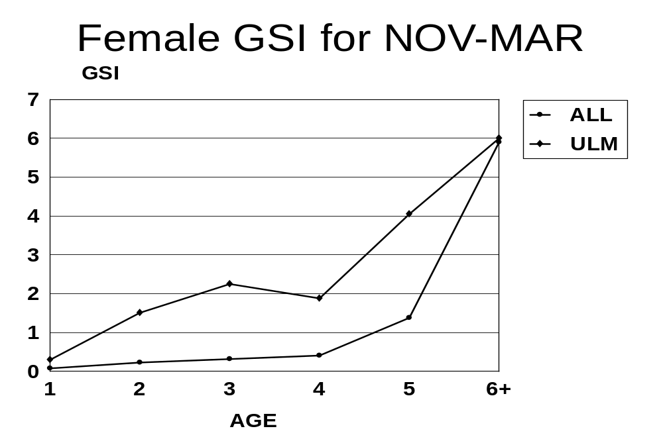
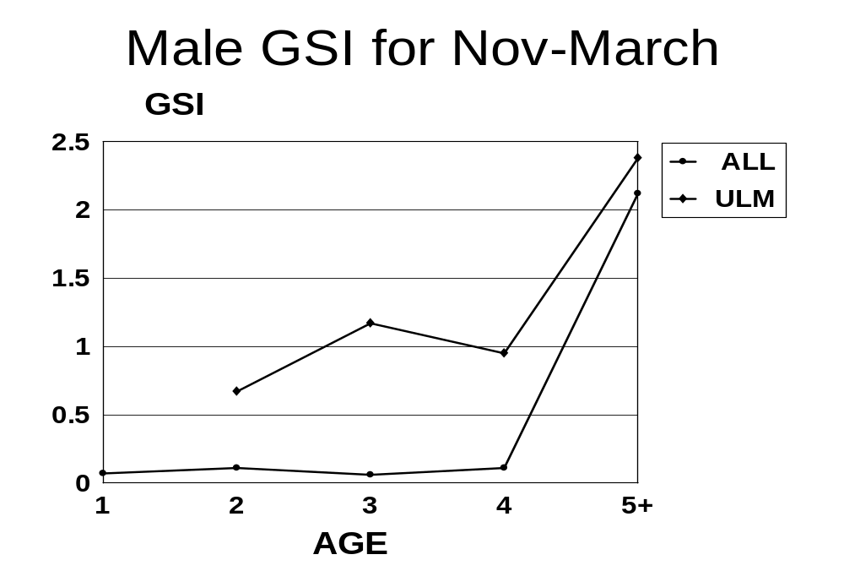

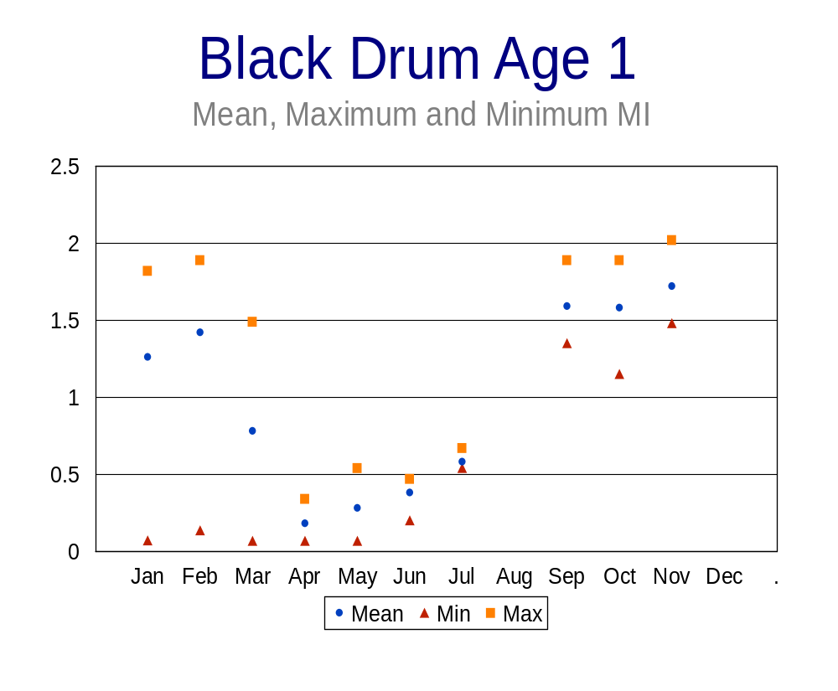

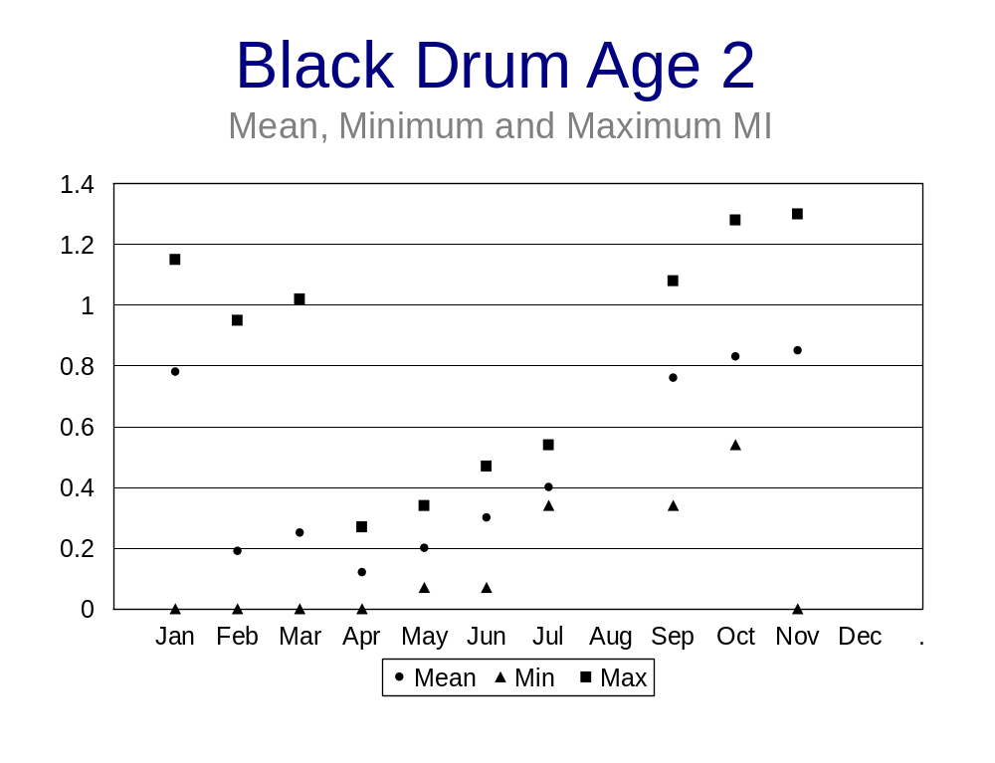

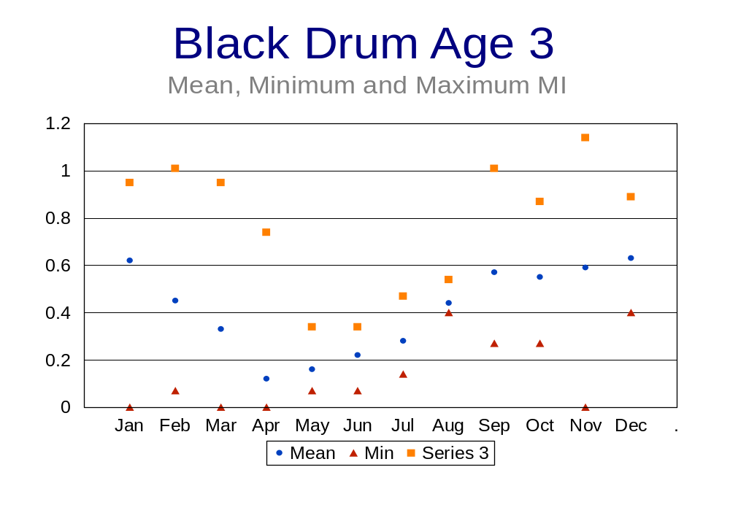

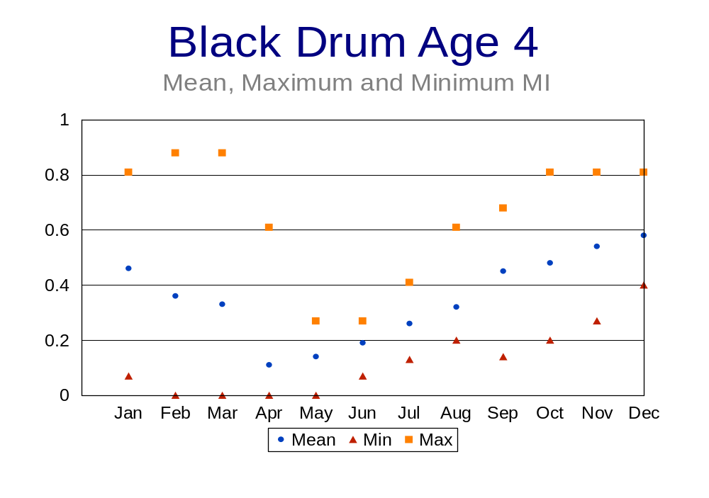

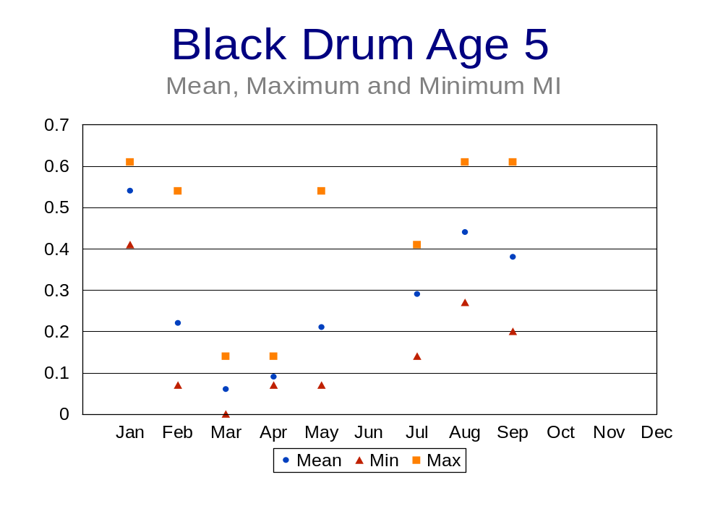

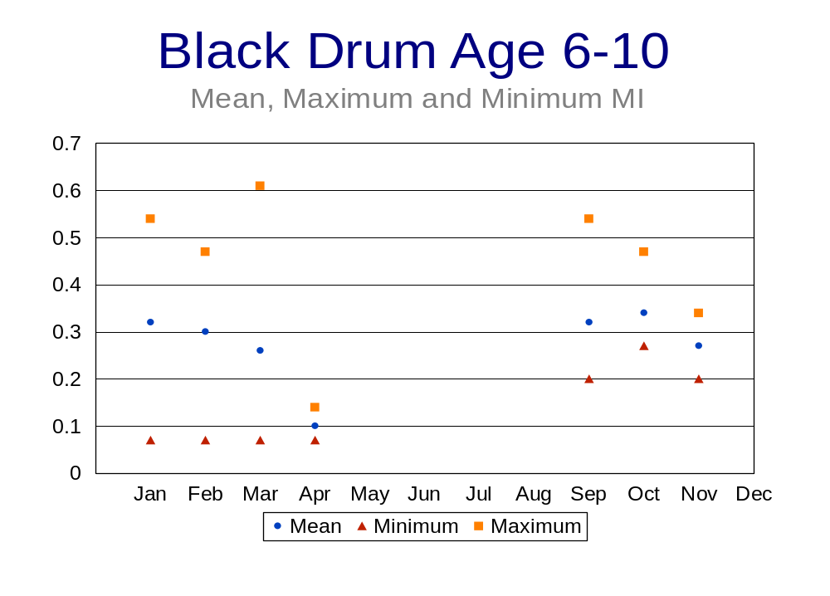

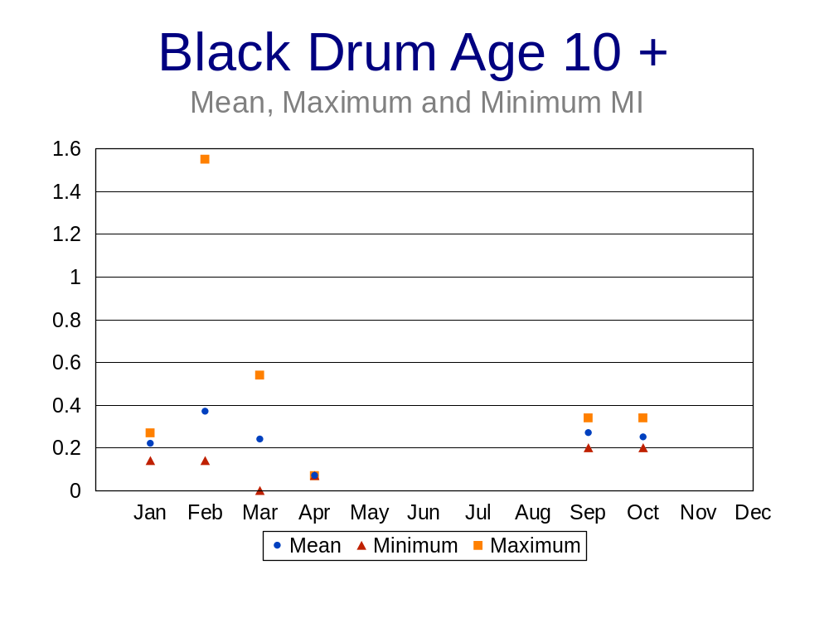
APPENDIX A

PRBMFRS HISTOLOGY PROCEDURES (From Hinton 1990)

Sample Fixation and Storage

1. Fixation

A. Remove a subsample from near the center of either ovary and place it in a glass sample vial labeled with species, bay code, sample number and date.
B. Fill the vial approximately half full with buffered 10 % formalin.
C. Allow the sample to remain in formalin for a minimum of 24 hours before replacing formalin with 70 % alcohol prior to storage.

Dehydration, Clearing, Infiltration and Embedding

1. Dehydration and Clearing

A. Remove sample from 70 % ethanol storage solution and place in 90 % ethanol, allow to stand overnight.
B. Place sample in 100 % ethanol and allow to stand for 6 hours.
C. place sample in 100 % ethanol and allow to stand overnight.
D. Place sample in 50 % ethanol 50 % Hemo-D (commercial xylene substitute) solution and allow to stand overnight.
E. Place sample in 100 % Hemo-D and allow to stand for 6 hours.

2. Infiltration and Embedding

A. Place sample in 50 % Hemo-D and 50 % paraffin solution and allow to stand overnight at 60 ºC.
B. Transfer sample to labeled plastic embedding mold cover sample with melted paraffin, allow paraffin to harden.
C. Remove mold and label paraffin block.

Sectioning and Mounting

1. Sectioning

A. Mount paraffin block containing sample to wooden base with melted paraffin.
B. Trim excess paraffin away from margins of sample to reduce the total area to be sectioned.
C. Place base in microtome clamp, set microtome to make 7 um sections and begin making serial sections of sample.

2. Mounting

A. Place sample sections in a water bath set at 40ºC and place 10 ml of adhesive in 1 L of water in the water bath.

B. Lift the sections out of the water bath onto a clean labeled glass slide, placing as many sections as possible from the same sample on one slide.
C. Place the slide on a slide warmer set at 65ºC and let stand overnight to remove excess paraffin.

Mayer's Hematoxylin and Eosin Staining Technique

1. Deceration and Hydration of mounted Ovary Sections

A. Place slides in Hemo-D for 2-3 minutes.
B. Transfer slides to fresh Hemo-D for 1-2 minutes.
C. Transfer slides to absolute ethanol (100%) for 1-2 minutes.
D. Sequentially transfer slides to 95% ethanol, 70% ethanol and 50% ethanol for 1 minute each.
E. Place slides in distilled water 2-3 minutes.

2. Applying Stains

A. Place slides in Mayer's hematoxylin for 45 seconds to 1 minute.
B. Wash slides in running tap water for 2-5 minutes (optional).
C. Dip slides in 95% ethanol for 2 minutes to remove excess stain.
D. Dip slides in the working eosin solution for 15 seconds to 2 minutes according to the depth of counterstain desired.

3. Differentiate slides by placing them in two 2-minute changes of 95% ethanol until excess eosin is removed (optional). Note: Verify the latter under a microscope; the sections should have a clear background and the cytoplasm of cells should be slightly pink to orange. If necessary, compare the sections to reference slides to ascertain that they are properly differentiated.

A. Transfer slides to fresh 95% ethanol to remove excess differentiating fluid for 2 minutes.
B. Transfer slides to two 2-minute changes of absolute ethanol 100%.
C. Clear the slides (make them transparent) in two 2-minute changes of Hemo-D.

*In sections properly stained with Mayer's H&E, nuclei are blue. Regions of cytoplasm with extensive rough endoplasmic reticulum (such as in hepatocytes and exocrine pancreatic cells) show a wispy blue to purple hue. The remainder of the cytoplasm is various shades of pink.

*Preparing working eosin solution from a 1% alcoholic stock solution.

A. The stock is 1.0 g water-soluble eosin Y, 20 ml distilled water, and 80 ml 95% ethanol.
B. Add 1 part stock solution (25 ml) to 3 parts 80% ethanol (75 ml).
C. Just before use, add 0.5 ml glacial acetic acid for each 100 ml stain and stir.

APPENDIX B

Criteria used to classify histological sections of black drum ovarian samples.

CLASSIFICATION STAGE CRITERIA

0 Spent, few or no primary growth oocyctes, ovarian lumen empty.

1 Immature, primary growth oocytes present, yolked oocytes
beginning to appear.

2 Maturing, cortical alveoli appearing, early stages of vitellogenesis.

3 Mature, Late stages of vitellogenesis, lipid coalescence, nuclear migration.

4 Spawning, Hydrated ova or post-ovulatory follicles present.

5 Post-spawn, Atretic follicles evident, resorption of unspawned ova.

