Emergency Medicine Practice Questions
25 questions | Answer key at the end

Question 1
A 65-year-old male presents to the emergency department with a 4-day history of fever, productive cough with yellowish sputum, and shortness of breath. His chest x-ray is below. What is the most likely diagnosis?
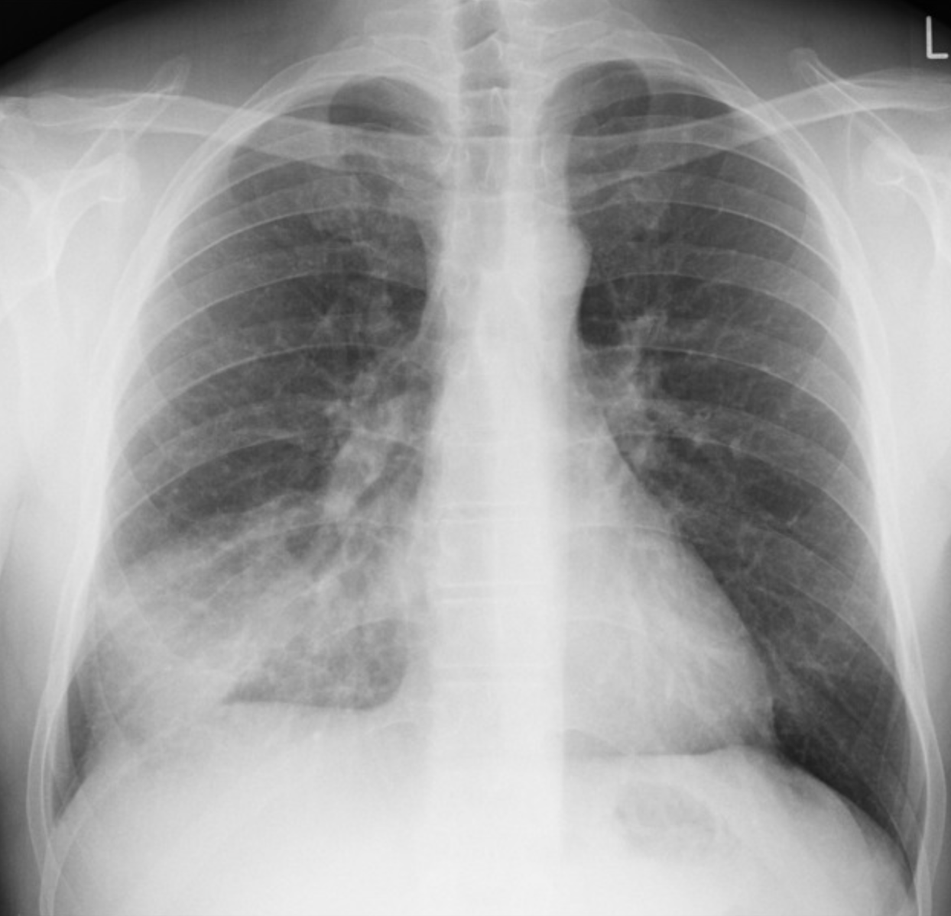
A. Bronchitis
B. Pulmonary embolism
C. Pertussis
D. Tuberculosis
E. Pneumonia

Question 2 Select all that apply
Which of the following treatments are appropriate for a patient presenting with a moderate asthma exacerbation?
A. Administration of ipratropium/albuterol nebulizer
B. Administration of systemic glucocorticoids
C. IV Magnesium
D. Epinephrine
E. Oxygen if SpO2<90%

Question 3
A 58-year-old man with a history of uncontrolled hypertension presents with sudden, severe chest pain described as “tearing,” radiating to his back. On exam, BP is 182/104 mmHg in the right arm and 150/90 mmHg in the left arm. HR 110, RR 22, O₂ sat 96%. Chest X-ray shows a widened mediastinum. Which diagnostic study is most appropriate next?
A. Emergent CT angiography of the chest
B. IV nitroglycerin infusion
C. Aspirin and heparin therapy
D. Immediate coronary angiography

Question 4
A 42-year-old woman presents with sharp chest pain that worsens when lying flat and improves when leaning forward. She had a recent upper respiratory infection. Vitals: BP 118/72, HR 104, Temp 100.9°F, O₂ sat 98%. On exam, a friction rub is heard over the left sternal border.
An EKG is obtained and shown below:
What is the most likely diagnosis?
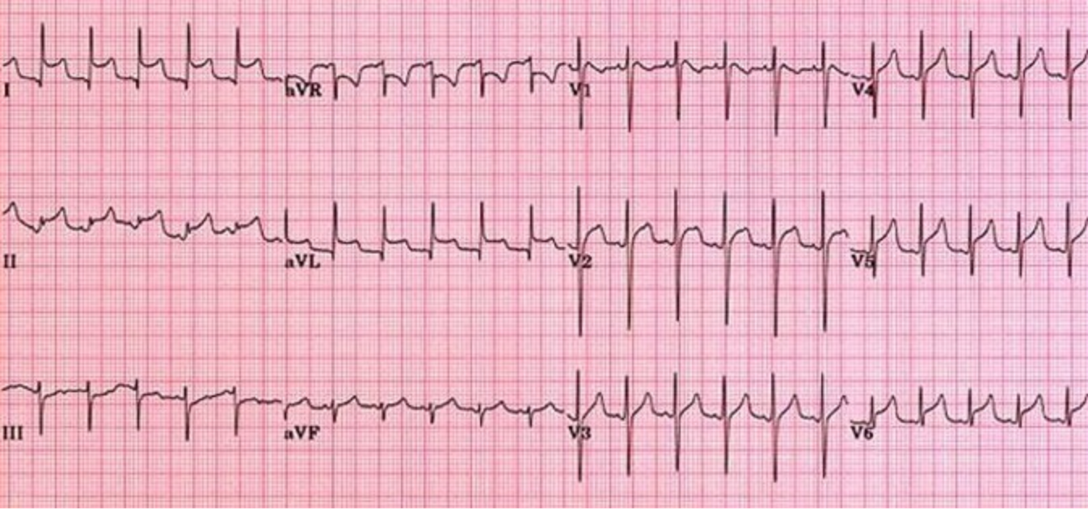
A. STEMI
B. Pulmonary embolism
C. Pericarditis
D. Prinzmetal angina

Question 5
A 62-year-old man with a history of hypertension that is controlled well with lisinopril, hyperlipidemia that is managed with simvastatin, and cocaine use presents to the emergency department via ambulance with chest pain that started approximately 20 minutes ago. He describes the chest pain as an intense pressure in his chest that radiates to his left arm. His vital signs are heart rate of 145 bpm, blood pressure of 150/95 mm Hg, respirations of 38/minute, SpO2 of 92%, and temperature of 98.9°F. Upon physical exam, the patient is noted to be diaphoretic. Cardiac exam is notable for tachycardia with a regular rhythm and no murmurs. A troponin level is drawn and is 1.0 ng/mL. An electrocardiogram is performed and is shown below. Which of the following medications should be avoided in the treatment of this patient?
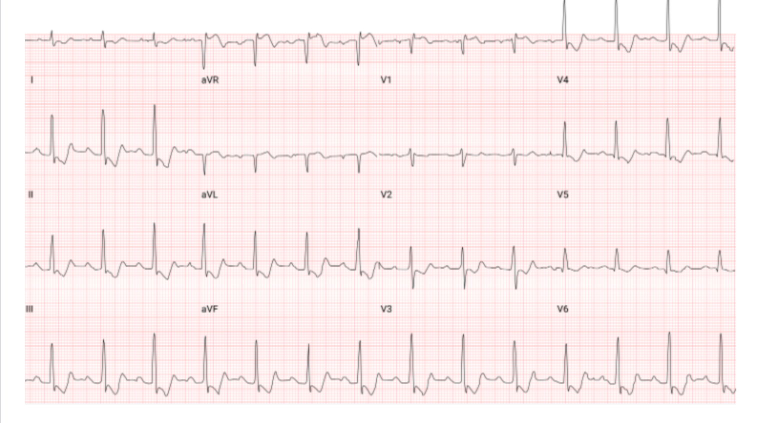
A. Aspirin
B. Labetalol
C. Diltiazem
D. Nitroglycerin

Question 6
A 72-year-old man with a medical history of diabetes mellitus on insulin and hypertension on lisinopril and chlorthalidone presents to the emergency department with substernal aching chest pain that radiates to his right shoulder for the past 6 hours. The episode started when he was doing yard work. He reports having associated diaphoresis and nausea. The patient states that he has not previously had similar episodes of chest pain. His vital signs today include a heart rate of 95 bpm, blood pressure of 142/92 mm Hg, respiratory rate of 20 breaths per minute, pulse oxygenation of 99% on room air, and temperature of 98.6°F. Physical examination reveals a man in no apparent distress with a regular rate and rhythm and lungs that are clear to auscultation bilaterally. He has no lower extremity calf tenderness, edema, or erythema. An initial ECG is obtained. The patient’s initial troponin and 2-hour troponin are 0.03 ng/mL. The patient’s chest radiograph shows no acute cardiopulmonary process. When you reassess the patient in 6 hours, his chest pain has resolved with medical management, his repeat ECG is unchanged, and his 6-hour troponin is normal. Which of the following is the most appropriate next step for this patient?
A. CT angiogram chest to rule out pulmonary embolism and aortic pathology
B. Admit to observation for noninvasive cardiac testing to provoke ischemia
C. Admit to hospital for cardiac catheterization
D. Discharge with aspirin, metoprolol, and atorvastatin without further testing

Question 7
A 23-year-old woman with type 1 diabetes presents with abdominal pain, nausea, and rapid breathing. She has dry mucous membranes, tachycardia, and fruity breath odor. Labs show glucose 610 mg/dL, K⁺ 5.9 mEq/L, and bicarbonate 9 mEq/L. What is the first treatment step?
A. Administer sodium bicarbonate
B. Start insulin drip
C. Start potassium replacement
D. Give IV fluids with 0.9% saline

Question 8
A 46-year-old man with poorly controlled diabetes presents to the emergency department with a 2-day history of severe sore throat, difficulty swallowing, and progressive shortness of breath. He is sitting upright, leaning forward, and drooling. His voice is muffled, and he appears anxious. Temperature is 102.3°F, HR 112 bpm, RR 26/min, and SpO₂ 91% on room air. On exam, there is no obvious tonsillar asymmetry, but he refuses to lie flat for evaluation.
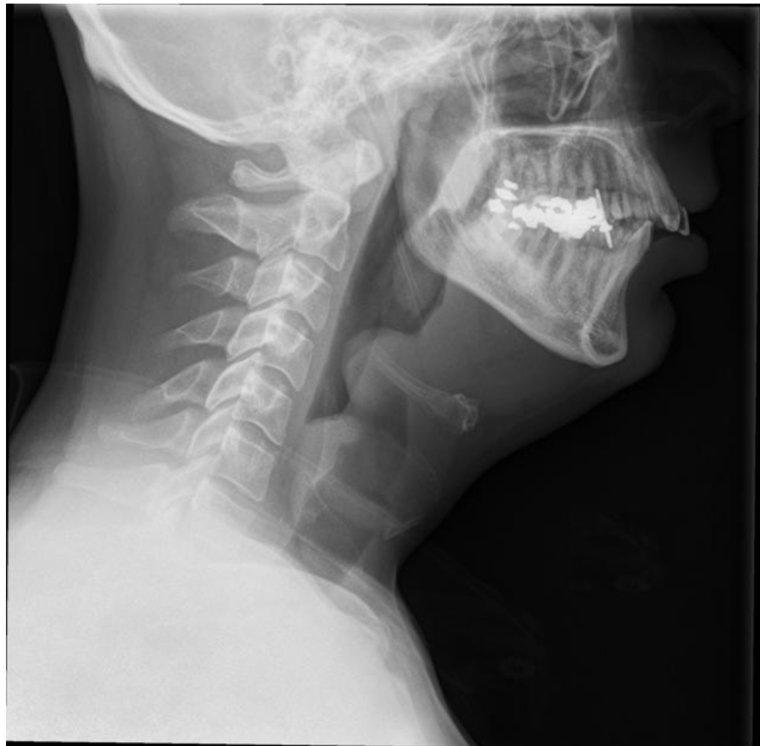
A. Immediate throat swab
B. Laryngoscopy in the ED
C. Administer racemic epinephrine
D. Secure airway in the OR and start IV antibiotics

Question 9
A 40-year-old man with a history of asthma presents to the ED with chest tightness and palpitations. His HR is 185 bpm, BP 116/72 mmHg, and an ECG is obtained as shown below. Vagal maneuvers are unsuccessful. What is the next step?
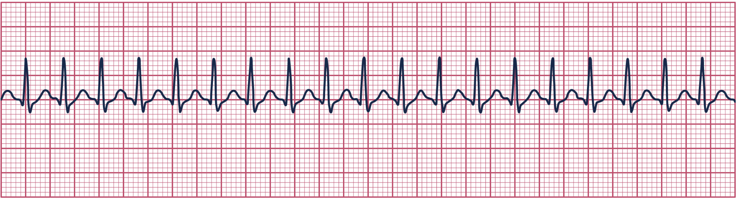
A. Lidocaine 1 mg/kg IV
B. Amiodarone 150 mg IV
C. Adenosine 6 mg rapid IV push
D. Synchronized cardioversion

Question 10
A 58-year-old woman presents with dizziness and near-syncope. HR is 32 bpm and BP is 78/40 mmHg. She appears pale and diaphoretic. ECG shows sinus bradycardia without AV block. What is the initial pharmacologic treatment?
A. Amiodarone 150 mg IV
B. Transcutaneous pacing
C. Atropine 1 mg IV
D. Epinephrine infusion

Question 11
A 23-year-old college student is brought to the ED by friends after being found confused and wandering the dormitory. They report he was “experimenting with motion-sickness pills.” PMHx is unremarkable. On arrival, BP 136/88 mmHg, HR 128 bpm, RR 18 /min, T 101.2°F. He is flushed, dry, and agitated. Pupils are dilated and minimally reactive. Bowel sounds are decreased, and urinary retention is noted on bladder scan. Skin is hot and dry to the touch. Which of the following is the most appropriate treatment?
A. Administer physostigmine under cardiac monitoring
B. Administer N-acetylcysteine infusion
C. Give naloxone 2 mg IV for reversal
D. Administer flumazenil 0.2 mg IV

Question 12
A 60-year-old man with a history of long-standing hypothyroidism presents to the emergency department after being found lethargic and confused by his spouse. She reports that he recently ran out of his levothyroxine prescription two weeks ago. On arrival, he appears pale, edematous, and slow to respond. Vital signs: BP 80/50 mmHg, HR 42 bpm, RR 10/min, T 94°F, SpO₂ 95% on room air. Physical exam reveals periorbital puffiness, dry coarse skin, delayed relaxation of deep tendon reflexes, and hypoventilation. What is the best initial therapy?
A. IV levothyroxine and hydrocortisone
B. T3 IV bolus only
C. Oral levothyroxine
D. Dopamine infusion for bradycardia

Question 13
A 54-year-old woman is brought to the ED by her daughter after being found vomiting and confused. The daughter reports that the patient had a severe headache earlier in the day and took “a handful” of an unknown OTC tablets. She has a history of hypertension and osteoarthritis. On examination, she is tachypneic with deep respirations. Vital signs: BP 118/64 mmHg, HR 110 bpm, RR 32/min, T 100.8°F. The patient is alert but disoriented. Physical exam reveals diaphoresis and tinnitus. Arterial blood gas reveals: pH 7.46, PaCO₂ 24 mmHg, HCO₃⁻ 18 mEq/L. Serum salicylate level is elevated.
Which of the following is the most appropriate initial treatment?
A. Start dialysis once urine output decreases
B. Initiate N-acetylcysteine therapy
C. Administer IV sodium bicarbonate to alkalinize the serum and urine
D. Administer activated charcoal and observe only

Question 14
A 45-year-old man is brought to the emergency department by his wife for progressive confusion, dizziness, and slurred speech over the past two days. He has a history of generalized tonic-clonic seizures managed with phenytoin. He reports no recent illness, alcohol use, or head trauma. His medications include phenytoin and lisinopril. He was recently started on trimethoprim-sulfamethoxazole for a urinary tract infection.
On examination, he is awake but disoriented. Vital signs: BP 108/68 mmHg, HR 58 bpm, RR 14 /min, T 98.7°F. Neurologic exam reveals horizontal nystagmus, truncal ataxia, dysarthria, and mild intention tremor. His ECG shows sinus bradycardia with a prolonged PR interval.
Which of the following best explains this patient’s presentation?
A. Serotonin syndrome from drug interaction
B. Lithium toxicity due to renal impairment
C. Benzodiazepine overdose
D. Antiepileptic toxicity potentiated by CYP450 inhibition

Question 15
A 66-year-old man collapses while mowing his lawn. His wife begins CPR. On arrival, EMS finds him pulseless with a disorganized, chaotic rhythm on the monitor. Two minutes of CPR are performed. What is the next best step in management?
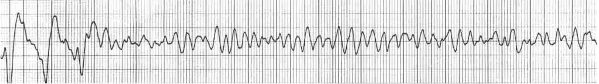
A. Defibrillate and resume CPR immediately
B. Administer amiodarone 300 mg IV
C. Give epinephrine 1 mg IV
D. Perform synchronized cardioversion

Question 16
A 65-year-old man with a history of hypertension and cataract surgery presents to the emergency department with sudden onset of blurry vision in his right eye. He describes seeing flashes of light and numerous dark “floaters,” followed by the sensation of a curtain descending over part of his visual field. He denies pain, redness, or discharge. Pupils are equal and reactive, and intraocular pressure is normal. Fundoscopic exam below. What is the most likely diagnosis?
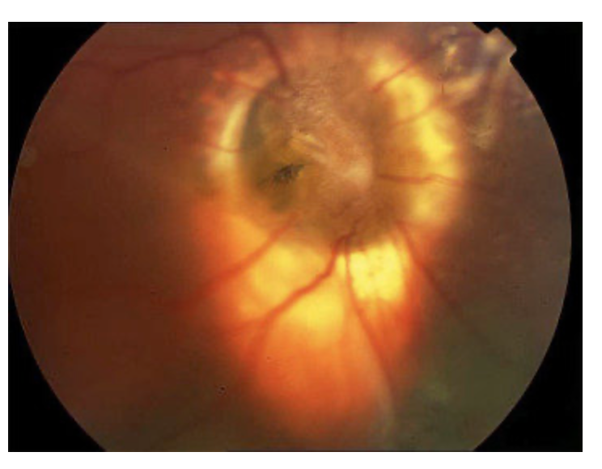
A. Vitreous hemorrhage
B. Central retinal vein occlusion
C. Retinal detachment
D. Acute angle closure glaucoma

Question 17
A 59-year-old man with a history of coronary artery disease is brought to the ED after an intentional ingestion of multiple BP tablets. He is drowsy, diaphoretic, and bradycardic. Vitals: BP 74/40 mmHg, HR 38 bpm, RR 14/min, T 97.8°F. ECG shows sinus bradycardia with first-degree AV block. Point-of-care glucose is 48 mg/dL. Which of the following is the most appropriate initial treatment?
A. IV insulin with dextrose
B. Atropine followed by amiodarone
C. IV calcium gluconate
D. Glucagon administration

Question 18
A 22-year-old man presents to the emergency department after being struck in the face by a baseball during a recreational game. He reports periorbital pain, swelling, and double vision, especially when looking upward. He also describes numbness along his right cheek and upper lip. On examination, he has significant right periorbital ecchymosis and edema. His globe is not ruptured, extraocular movements are restricted in upward gaze, and there is decreased sensation over the maxillary (V2) distribution. Pupils are equal and reactive, and visual acuity is intact.
Which of the following is the most appropriate initial management for this patient?
A. Perform immediate open reduction and internal fixation in the ED to prevent entrapment
B. Prescribe a short course of systemic corticosteroids and arrange outpatient follow-up
C. Obtain a noncontrast CT scan of the orbits, start a nasal decongestant, and consult ENT or ophthalmology
D. Apply a pressure patch and prescribe oral antibiotics for home observation

Question 19
A 42-year-old woman is brought to the emergency department with severe weakness, nausea, and confusion. Her husband reports that she has had poor oral intake and diarrhea for the past two days. She has a known history of autoimmune disease and has been inconsistent with her steroid replacement therapy. On arrival, she appears lethargic and hypotensive with BP 76/44 mmHg, HR 118 bpm, RR 20/min, and T 98.6°F. She is noted to have diffuse skin hyperpigmentation on her palms and gums.
Laboratory studies show:
Sodium: 122 mEq/L
Potassium: 6.4 mEq/L
Glucose: 58 mg/dL
BUN/Creatinine: elevated
Cortisol: pending
An ECG demonstrates peaked T waves and a prolonged PR interval. After securing IV access and beginning aggressive fluid resuscitation with isotonic saline, what electrolyte abnormalities are most characteristic of this patient’s presentation?
A. Hyponatremia and hyperkalemia
B. Hypernatremia and hyperkalemia
C. Hypernatremia and hypokalemia
D. Hyponatremia and hypocalcemia

Question 20
A 72-year-old woman with a history of congestive heart failure, chronic kidney disease, and hypertension is found unresponsive in her nursing home. Staff report that she had complained of shortness of breath earlier in the morning. On arrival to the emergency department, she is pulseless and unresponsive. The cardiac monitor shows organized electrical activity at a rate of 60 beats per minute. There is no palpable pulse, and pupils are nonreactive. High-quality CPR is initiated immediately, IV access is established, and the patient is being ventilated with 100% oxygen via bag-valve mask. What is the next appropriate step?
A. Give amiodarone 300 mg IV
B. Continue CPR and give epinephrine 1 mg IV
C. Deliver one shock at 200 J
D. Begin synchronized cardioversion

Question 21
A 31-year-old man with a history of intravenous drug use is brought to the ED by EMS after being found unresponsive in an alley. Paramedics note shallow respirations. He has track marks on both antecubital fossae. There are no signs of trauma. Vital signs: BP 88/56 mmHg, HR 54 bpm, RR 6 /min, T 97.5°F, SpO₂ 82% on room air. Pupils are pinpoint, and his skin is cool and clammy. Which of the following is the next best step in management?
A. Begin flumazenil to reverse CNS depression
B. Intubate immediately without medications
C. Administer naloxone and provide assisted ventilation with bag-valve mask
D. Administer atropine to correct bradycardia

Question 22
A 30-year-old woman at 34 weeks gestation collapses in the ED waiting area. CPR is initiated. Despite defibrillation for ventricular fibrillation, there is no return of spontaneous circulation after 4 minutes. What is the next step?
A. Perform perimortem cesarean delivery
B. Give magnesium sulfate 2 g IV
C. Continue compressions for 10 more minutes before considering surgery
D. Administer amiodarone 300 mg IV

Question 23
A 68-year-old man with hypertension, hyperlipidemia, and coronary artery disease presents to the ED with substernal chest pain radiating to his left arm. The pain began one hour ago while he was climbing stairs. On arrival, BP 78/52 mmHg, HR 118 bpm, RR 24/min, SpO₂ 91% on room air. Jugular venous distention and bibasilar rales are noted. ECG shows ST-segment elevation in leads II, III, and aVF. Which of the following best describes the pathophysiologic mechanism of this patient’s hypotension?
A. Decreased cardiac output due to pump failure
B. Decreased systemic vascular resistance from vasodilation
C. Loss of vascular tone due to sympathetic blockade
D. Reduced venous return from decreased preload

Question 24
A 72-year-old man with a history of type 2 diabetes mellitus is brought to the emergency department by his family due to progressive confusion, extreme thirst, and weakness over the past several days. They report that he recently developed a respiratory infection and stopped taking his diabetes medication because of poor appetite. On arrival, he is obtunded but arousable to painful stimuli. Vital signs: BP 92/58 mmHg, HR 118 bpm, RR 22/min, T 100.4°F, and SpO₂ 97% on room air. Physical exam reveals poor skin turgor and dry mucous membranes.
Laboratory results:
Glucose: 1,020 mg/dL
Sodium: 154 mEq/L
Potassium: 4.3 mEq/L
Bicarbonate: 20 mEq/L
BUN/Creatinine: elevated
Serum osmolality: 345 mOsm/kg
Urinalysis: trace ketones
Which of the following best describes this patient’s underlying condition?
A. Euglycemic ketoacidosis due to SGLT2 inhibitor use
B. Hypoglycemic crisis due to sulfonylurea overdose
C. Hyperosmolar hyperglycemic state due to relative insulin deficiency and profound dehydration
D. Diabetic ketoacidosis due to insulin deficiency

Question 25
A 45-year-old man presents to the emergency department with rapidly worsening swelling under his jaw and difficulty swallowing for the past 24 hours. He reports severe mouth pain and drooling. His medical history is notable for poorly controlled type 2 diabetes and poor dental hygiene. He denies recent trauma. On arrival, he appears anxious and is speaking with a muffled “hot potato” voice. Vital signs: BP 106/68 mmHg, HR 118 bpm, RR 24/min, T 101.6°F, SpO₂ 93% on room air. Physical examination reveals firm, indurated, tender swelling of the submandibular and sublingual areas with elevation of the tongue and no fluctuance. There is no trismus, and the floor of the mouth feels “woody.”
Which of the following is the most appropriate next step in management?
A. Perform incision and drainage in the ED without imaging
B. Administer oral amoxicillin-clavulanate and discharge home
C. Obtain CT scan of the neck with contrast before treatment
D. Secure the airway and initiate broad-spectrum IV antibiotics

Answer Key
1. E — Pneumonia
2. A, B, E — Administration of ipratropium/albuterol nebulizer; Administration of systemic glucocorticoids; Oxygen if SpO2<90%
3. A — Emergent CT angiography of the chest
4. C — Pericarditis
5. B — Labetalol
6. B — Admit to observation for noninvasive cardiac testing to provoke ischemia
7. D — Give IV fluids with 0.9% saline
8. D — Secure airway in the OR and start IV antibiotics
9. C — Adenosine 6 mg rapid IV push
10. C — Atropine 1 mg IV
11. A — Administer physostigmine under cardiac monitoring
12. A — IV levothyroxine and hydrocortisone
13. C — Administer IV sodium bicarbonate to alkalinize the serum and urine
14. D — Antiepileptic toxicity potentiated by CYP450 inhibition
15. A — Defibrillate and resume CPR immediately
16. C — Retinal detachment
17. D — Glucagon administration
18. C — Obtain a noncontrast CT scan of the orbits, start a nasal decongestant, and consult ENT or ophthalmology
19. A — Hyponatremia and hyperkalemia
20. B — Continue CPR and give epinephrine 1 mg IV
21. C — Administer naloxone and provide assisted ventilation with bag-valve mask
22. A — Perform perimortem cesarean delivery
23. A — Decreased cardiac output due to pump failure
24. C — Hyperosmolar hyperglycemic state due to relative insulin deficiency and profound dehydration
25. D — Secure the airway and initiate broad-spectrum IV antibiotics

