Name: _____Dae Yoon Cho_______________________________________

Python for Data Analytics

1. What is Python and why is it useful?

It is a programming language that is easy to use and can be applied to different functions in the data analytics field.

1. Are the following variable names allowed in python?
   1. 1_message
   2. **Greeting_message**
   3. **Message_1**
   4. First name
   5. **Full_name**
2. Create a variable that holds the string “hello there!”

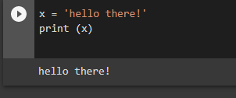

1. Create a variable for first name, last name and an email extension. Concatenating all three together to form an email address. For example: [firstnamelastname@gmail.com](mailto:firstnamelastname@gmail.com)

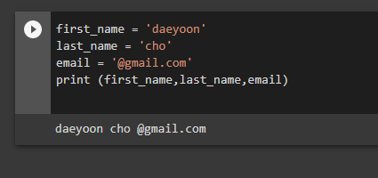

1. Store someone you know name in a variable called name. Print their name in lower and uppercase using a method.

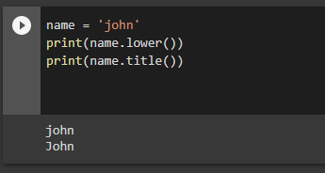

1. Using a variable, ask your friend if they want to hang out on the 15th of the month. For example, “Do you want to hang out on the 15th of this month?” You should have to convert the number to a string.

