Project Phoenix

Doors Conversion to S4

# Project Overview

Owens Corning is migrating the newly acquired Doors business to S4/HANA.

The Doors business consists of the divisions:

* Door Components
* Entry Doors
* Interior Doors
* DorFab

The Door Components division will be deployed first and is the target of this initial RFQ. The sites include:

* Sacopan, Quebec, CA
* Laurel, MS, USA
* Wahpeton, ND, USA
* Verdi, NV USA

This deployment is a multi-year initiative that will cover 30 plants [full list in Appendix A]. Once the Components division is complete, OC anticipates delivering 12 plants at a time over the succeeding two years.

Ignition will be used as the shop floor standard platform to fulfill multiple MES requirements and to serve as the digital foundation for the future.

## Key requirements

1. SAP Integration
   1. Bi-directional communication to S4/HANA
   2. Ignition to serve as a local cache in WAN/cloud outage scenario
2. Automation Integration
   1. Ignition to replace existing flat file integration to automation equipment
   2. Ignition to integrate with specific automation equipment to improve inventory visibility
3. Labeling & Confirmation
   1. Ignition will be responsible for label printing from production order & material info
   2. Actual label printing will be via a local Loftware API that Ignition can call
4. Production Dashboards
   1. Ignition will provide an operation specific dashboard
5. Driver Check-In Application
   1. Ignition to provide an application allowing truck drivers to check-in & check-out of Laurel facility
   2. Ignition will integrate with existing load cell system for incoming & outgoing truck weights

## Timeline

All work must be delivered in production by 2/6/26.

* Integration work should be prioritized through quality testing by 12/19/25

# SAP Integration

## System Integration Overview

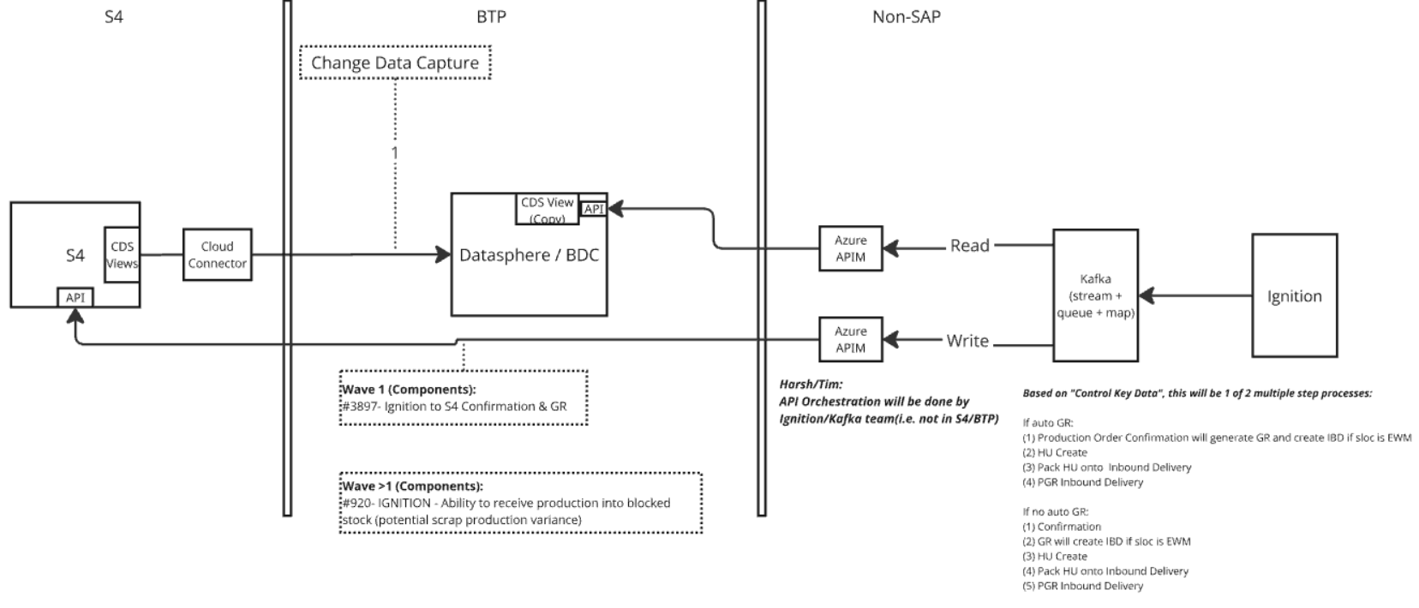

## SAP -> Ignition

### Production Order Core Data

* Order Number
* Material Number
* Quantity
* Planned Start/End Dates
* Routing/Operations
* Work Center

### Control Key Data

* Control Key (from routing operations)
* Flags for:
  + Automatic Confirmation
  + Automatic GR
  + External Processing
  + Print Control

### MTO Specific Configuration

* Sales Order Reference
* Customer-Specific Drawing/Specs
* Variant Configuration (if applicable)
* Pass configuration values (e.g., Material, Sales Order, Variant Config) to Ignition.
* Ignition uses these to fetch and display the correct drawing from a document management system or shared repository.

## Ignition -> SAP

### Overview

There are two scenarios for confirmations:

Automatically read the data from PLC/PI system on the dropouts and post the confirmation via the appropriate API calls.

Manual confirmations performed via labeling application will also pass thru Ignition to S4

To support the integration between SAP S/4HANA and Ignition for Make-To-Stock (MTS) production scenarios, here's a structured outline of the confirmation interface and additional requirements:  
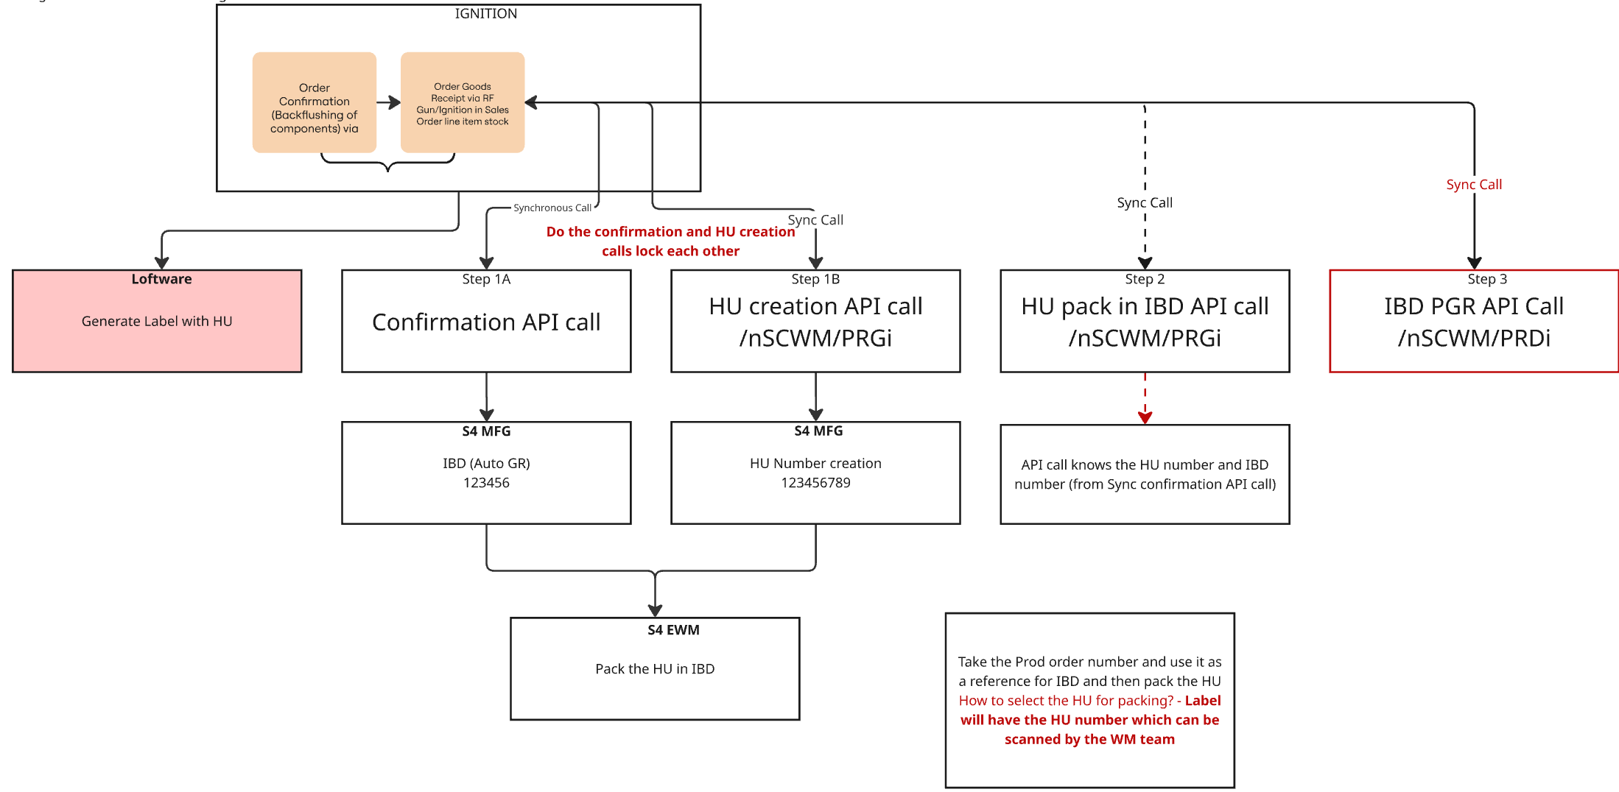

Steps to Perform with API references:

Production Order Confirmation will generate GR and create IBD if sloc is EWM

<https://api.sap.com/api/OP_API_PROD_ORDER_CONFIRMATIO_2_SRV_0001/overview>

HU Create

<https://api.sap.com/api/OP_HANDLINGUNIT_0001/overview>

Pack HU onto Inbound Delivery

<https://api.sap.com/api/OP_HANDLINGUNIT_0001/overview>

PGR Inbound Delivery

<https://api.sap.com/api/OP_API_INBOUND_DELIVERY_SRV_0002/path/post_PostGoodsReceipt>

### Error Handling Requirement

Given the API-based architecture of S4 and the overarching principle of “Clean Core”, OC has decided not to implement custom error handling in S4 but instead push that requirement to the API consumers/users. Therefore it is the responsibility of the Ignition application to handle all failure scenarios and ramifications. This is particularly of note for this four-step confirmation process:

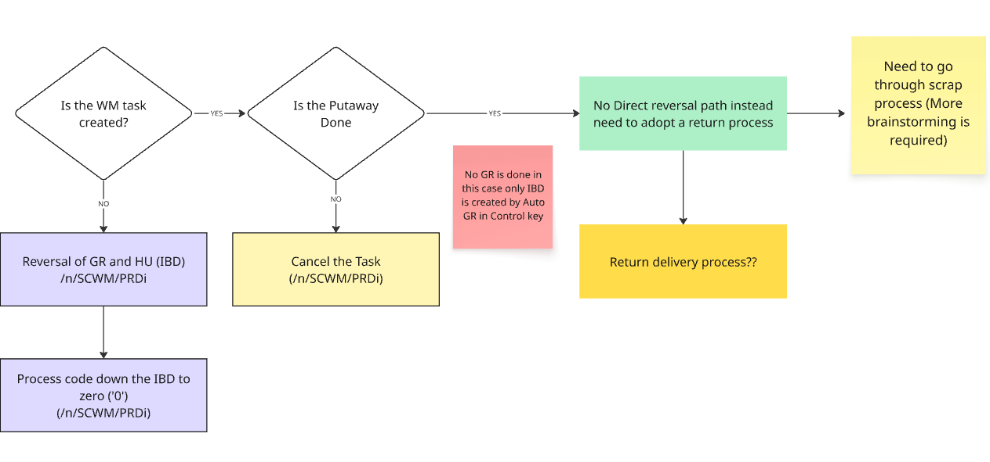

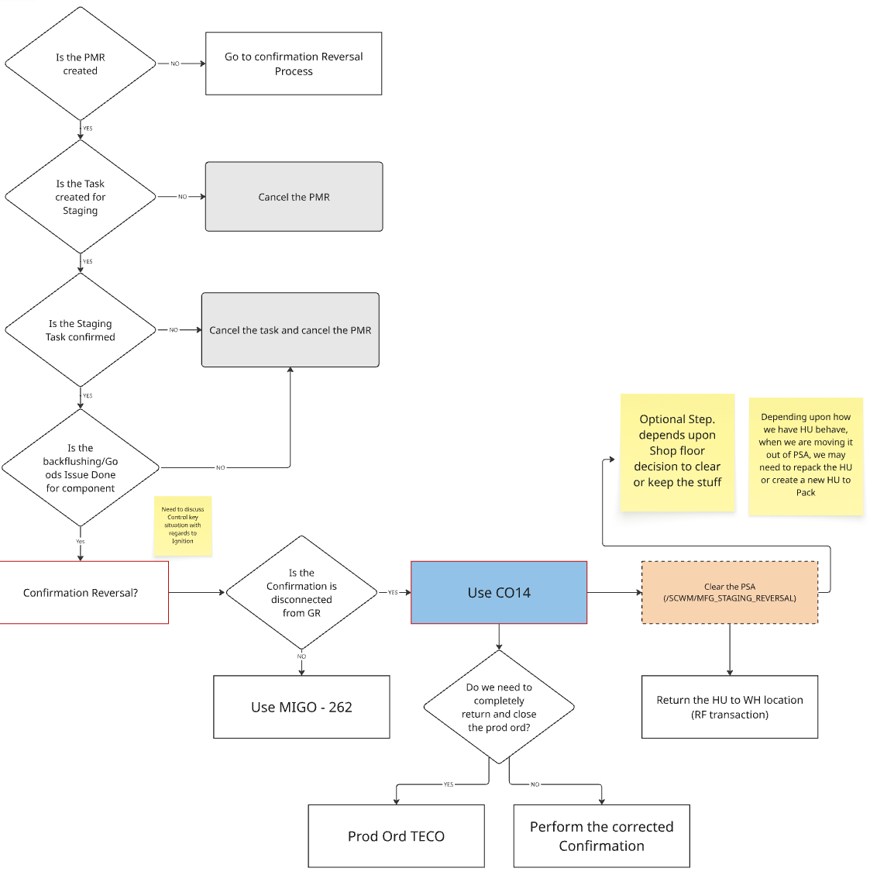

# Automation Integration

## OSI Pi Integration

Pi system will be integrated with Ignition.

## Response File

### Overview

Today we have a “Response” file that is created at the finalization of a production schedule.  A file is created for every production ticket and downloaded to the local plant server.  The file name is the 6-digit ticket number.  When the ticket is scanned at the trim saw that file is retrieved and a program at the saw picks the data it needs from that file.  The folder where those files reside is on a 60-day purge cycle to clear out tickets that have passed through production.

Ignition will need to recreate this file based on received S4 information.

Entry and Interior Plants want the ability to print coding directly on the physical materials inline during the manufacturing process. This is also done through the response file currently.

### As-is Labeling Process

Notes on the response file usage and potential items that may change from MasterPack -> S4 data sourcing:

* The inkjet printer (or its controlling PLC/computer) reads the response file from a local shared drive after a production ticket is scanned at the plant.
* The file is named after the ticket number, and scanning the ticket triggers the system to retrieve the corresponding file.
* Local scripts or VB programs in front of the trim saw and Jetta Mark (the printing machine) know to look in the response folder for the file and extract the required data.
* The printer or PLC parses the file, ignoring legacy Matcom language if not needed, and uses the quoted data fields to format and print the required information on the door.
* The process is automated, with the only manual step being the scanning of the production ticket to initiate file retrieval.
* The response file is created by a routine that runs at the finalize the schedule step in master pack.
* Some customers, such as Metree Canada, require door size information to be printed in inches (e.g., "30 inch 80 inch") instead of traditional millwork terminology (e.g., "2/6X6/8"). This is set up at the warehouse customer level in Masterpack, but Jim noted it would be better at the customer level since requirements don't change by plant.
* Certain customers want their own SKU number printed on the end of the door. This is an optional field that can be enabled per customer. If not enabled, nothing is printed in that field.
* Some customers require their purchase order (PO) number to be printed on the door. This is also a customer-level option
* For products shipped to Canada, compliance statements (e.g., Tosca Title 6) must be printed in both English and French, regardless of the destination within North America.
* Printing is done on Interior doors and Entry Fiberglass doors, not on Steel or Glass doors.
* We only print on doors that are trimmed on a DET (double end tenoner), which we just call "trimsaws". There are inkjet printers within the machine that print on the doors after the length cut is performed. It is possible for Interior doors intended for Menards to be made without a customer order, and put into inventory to be picked and shipped. This happens in Walkerton.
* We will also have FERT inventory of Fiberglass and Interior doors in the DorFabs that will be picked to be pre-hung or picked to be shipped as slabs, neither of which will be made for an external customer order, but will be a replenishment STO for the DorFabs.
* stock doors are built today under “customer” 999999, stock doors in house. Since the first 5 characters of the customer print. They get “STOCK” instead of the customer name
* As per Steve Moore's comment "We don’t inkjet print order or product info directly onto products in DorFab. We do print various labels and apply them, though."
* **Mitri (Metree)** requires the conversion from millwork dimensions (feet/inches format, e.g., 2/6) to inches for their orders.
* This conversion is specifically needed for Mitri as a Canadian customer, and the system should have the ability to turn this conversion on by customer as not all the Canadian customers require this conversion.
* VMI (Vendor Managed Inventory) is used for Mitri, where the program is vendor managed and production orders are generated based on Mitri's inventory and demand data
* **Menards**
* **Make-to-Stock Program**: Menards uses a make-to-stock approach for interior doors, particularly bifolds, which are produced and packaged without a specific customer order
* **Dummy Customer Usage**: In the current system (Master Pack), orders for Menards stock are entered under a dummy customer (customer number 999999), allowing production without a real customer order.
* **Label Printing**: Information for labels is pulled from the customer master, but for stock orders, PO information is not printed, and the customer name is set to "stock."
* **Internal Use of Labels**: The Jetta Mark and other label details are mainly for internal tracking, as the retail packaging covers these labels before reaching the customer.

## Automatic Confirmations

### Overview

Components Plants want the ability to manage the control of automated operations by utilizing integrated data from the PLCs such as CIM, Laser eyes, etc. to perform automation of confirmation data such as (yields, scraps)

There are dropout sensors counting how many items irrespective of material or order information. This data will be used by Ignition to confirm back the production to S4 against the production order.

Operator will interact with S4 system to record confirmations in most situations but a deviation is necessary in this because there are 4 points within the manufacturing process where skins are being stacked and counted on a conveyor system. There is not a person monitoring specifically this step.

### Laurel

1. After brownborad get out the press
2. After cut coat operation.
3. SMC Bin production (PLC- CIM)
4. Fiber glass press dropout count

### Sacopan

1. After forming operation (Brownboards)

# Labeling & Confirmations

## Functional Overview

### Make to Stock

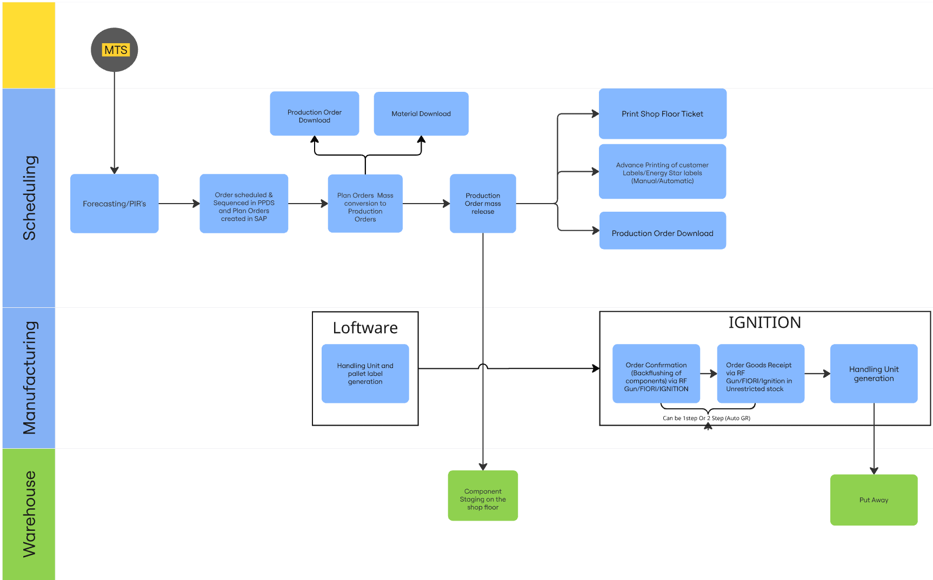

### Make to Order

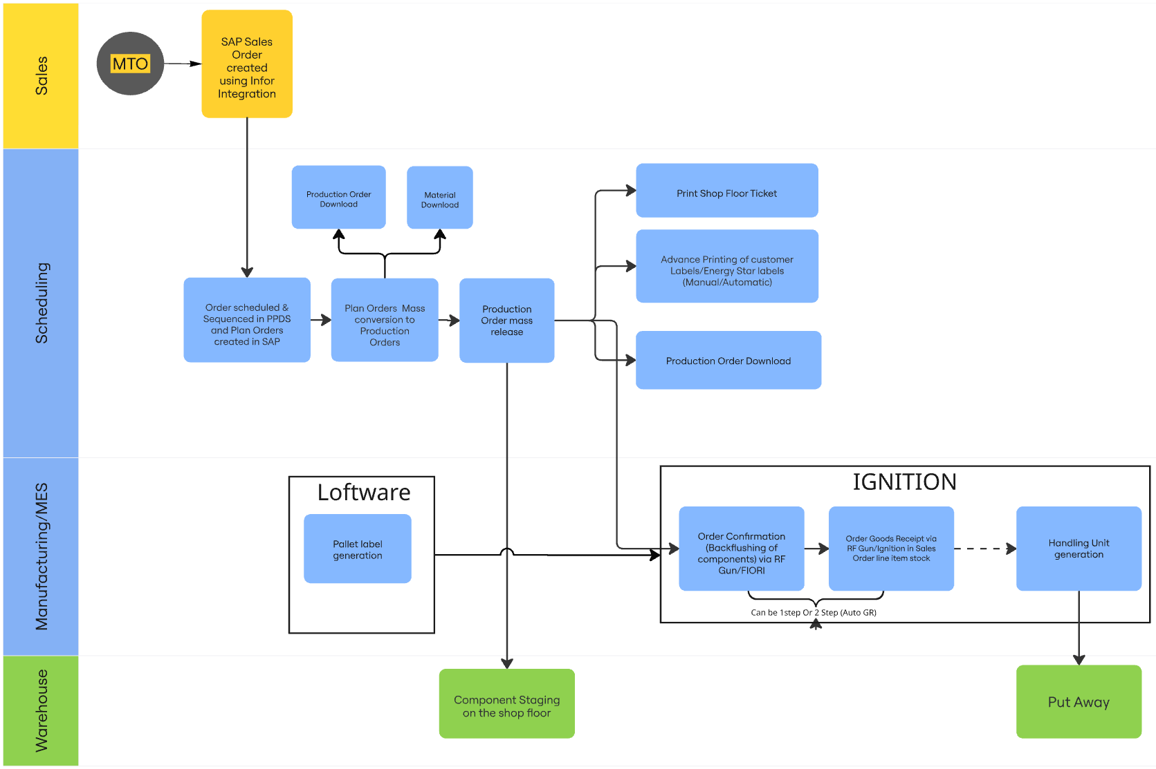

## Labeling Application

Develop a Labelling application on Ignition Platform to connect to the Loftware and S4 for

* Pallet/Customer label printing based on Production Order
* Confirmation posting and HU creation [reference above Ignition->SAP notes]
* User Interface creation which can be accessed via Android RF gun and Shop floor UI screen
  + Operators will utilize the barcodes on shop floor paperwork by scanning them via RF.
  + With a RF based confirmation screen, operators will be able to use mobile devices on the shop floor to record production when it is produced. This would provide more accurate and up to date inventory accuracy for produced finished good and consumed raw materials where putting a terminal or computer screen is a challenge.

## Blocked Stock Posting

Pittsburg plant wants the ability to assign multiple reason for variance codes to production order confirmation. Currently Interior & Entry receive these as good product and then do the inventory adjustment to mark 4 as bad out of 25 GR. This requirement is to have an indicator in Ignition to mark the goods receipt with Blocked status

Mitigating risk of shipping bad product by enabling production good receipts to be posted into blocked stock through the Ignition production good receipt screen.

**Customer Ontime Delivery to Promise Adherence:**

Accurate inventory supports accurate material availability checking for orders.

Specifically with the ability to receive possible scrap / quality issue production into blocked stock, ATP checking (via back order promising simulation) can be used to identify orders that are at risk of not meeting their Confirmed Material Availability date due to production variances.

Based on data from Dec to June 2025:

* For Entry and Interior plants: the rough estimate is about 2.5% of product would be received into blocked stock at therefore taken out of material availability and in-turn create visibility to at-risk orders.
* DorFab plants the rough estimate is about .6% of product would be received into blocked stock.

For Interior Entry and DorFab - We will receive the bad inventory into Block stock and then Warehouse will assign the reason code to if the blocked inventory is moved to scrap with scrap code.

As we are using IGNITION for all the confirmations and Goods receipt calls, so this would be an indicator in the existing confirmation interface.

We need an indicator on the Ignition screen to post the inventory in either scrap/blocked stock or unrestricted stock.

## Preprint Customer Labels

Need the ability to preprint labels as per schedule only for certain orders not for all the scheduled orders. This is for Customer Specific Label that can be preprinted. It does not require a HU, but in the case of Energy Star, it requires a unique code that needs to be system generated and printed on the label.

There are Customer Specific Labels that can be preprinted that do not require serialization or HUs.

### Energy Star

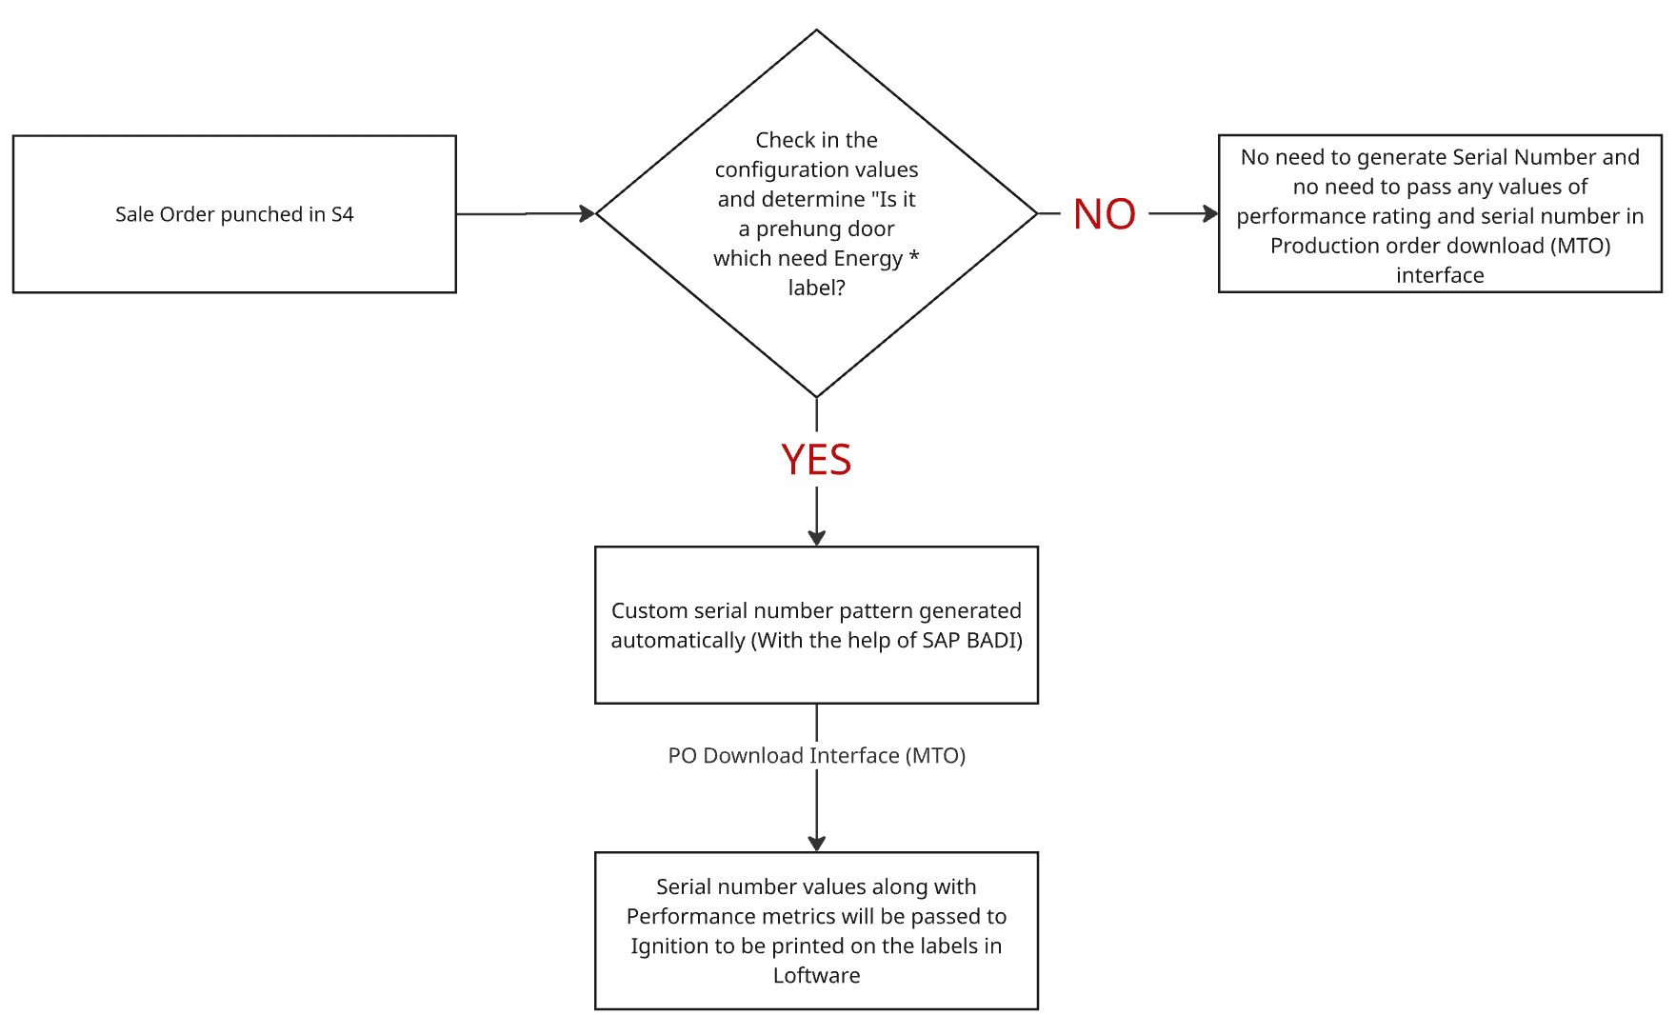

### Pella Labels

As part of the labeling process, there is a complex requirement from Pella, a specific customer of OC Doors. They provide ZPL files via EDI that are tied to sales orders. Ignition will need to lookup these ZPL files based on the master data and print them on-demand from the application.

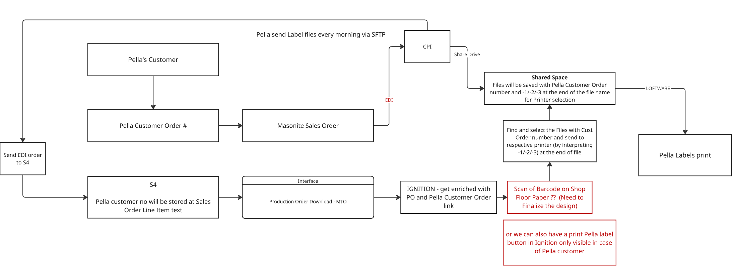

## Production Dashboards

### Overview & Current State

Various plants have developed solutions to allow the operator to view the manufacturing drawing for the current order. These solutions all leverage the existing response file.

#### Existing Excel solution:

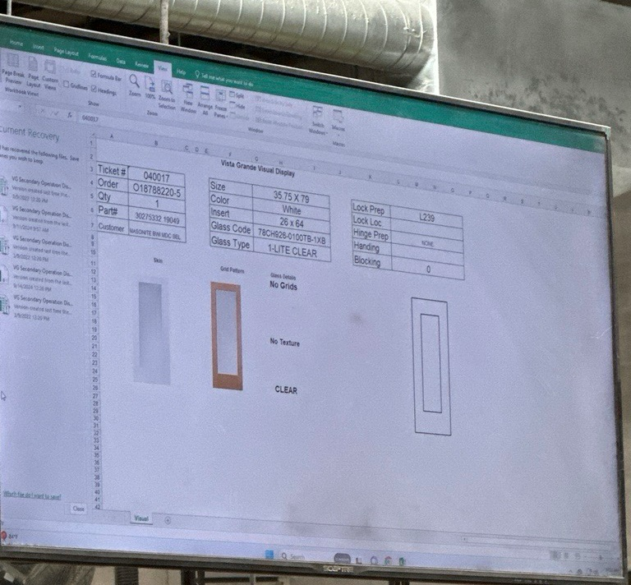

Key features:

* Based off a ticket number (cell B3), Excel looks up the response file and retrieves all of the information.
* All drawings are stored inside the excel sheet and are looked up via information.

#### Existing Java solution:

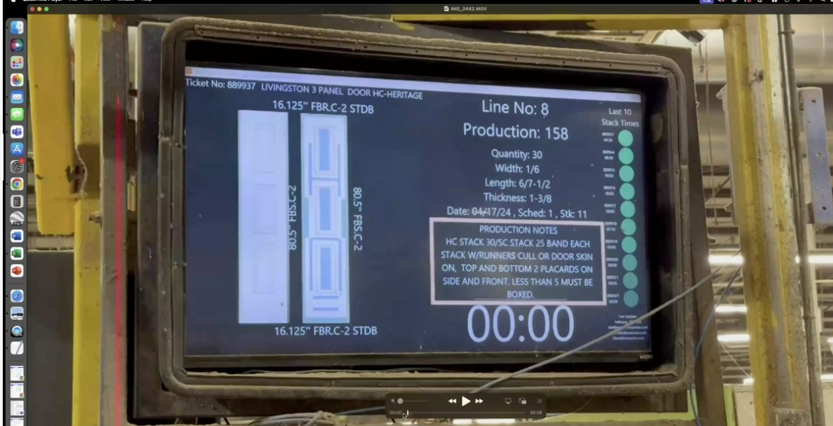

Key Features:

* Ticket No is scanned, and the solution retrieves the information from the response file
* This application provides a scan-to-scan timer (potentially with physical button integration)
* Note the last 10 cycle times recorded on the right. These are based off of a 15-minute target cycle time.

### To-be Solution

Ignition will replace these individual solutions with a standardized capability for the division. Instead of Ticket Number, Ignition will scan the Production Order. All other functionality above should be replicated.

#### Drawing Retrieval

* AutoDesk Vault will contain specific drawings, following a standard naming convention.
* S4 will maintain a linkage between material number & engineering drawing number.
* Ignition will receive this field as part of the material downloads specified earlier.
  + We can use this field to store drawing number if we have material variant for all the variations. If KMAT material is there then we need the drawing number to be coming down from Infor.
* When Ignition retrieves a Production Order, Ignition should query the AutoDesk API to cache the drawing (based on file version).

# Driver Check-In / Check-Out

## Overview

Ability for a driver to check in at facility and weigh their vehicle. Plant operational cost increase avoidance via automation: implement same automation in place today at Laurel plant via scale integration to determine wood quantity to receive.

Ignition will:

* Integrate to the with existing scales
* Receive Sales Orders from SAP
* Record inbound/outbound weights, material type, and driver info

## Background

* Accurate recording of receipts based on scale weights is a requirement.
* There is high volume at the Components sites for inbound materials. Plant operations do not want to slow down this process to create steps manually as given in SAP standard.  Today, they have this process automated for Laurel and would like to continue this.
  + There are $50,000 in GRs per day (total of $15MM/yr) in chips/longwood from 50-70 inbound trucks per day at Laurel.
* To perform the manual check-out to record the weight on departure would:
  + Require 1 FTE for each of the 2 scales (2 total FTEs) and 3 hours per day in the office for someone to retrieve the manual tickets from the scale and process them in the office.
  + Incorrect wood quantity received would be expected to increase as a result if manual entry. The estimated weight error increase rate would be ~5%, (affecting $500K of spend) which is ~15 trucks/week with an incorrect wood quantity received.
* Scenarios:
* Weighing for empty truck weight for shipments to be loaded (outbound)
* Weight to verify on the way out to validate they will be able to carry the total shipment
* Loaded weight to be printed on BOL at the checkout point
* The driver, when they cross the unmanned scale, they are responsible for validating that he's not overweight.
* They also have to validate that the weight on the axles is within "spec". This is not expected to be integrated into the system.
* Overweight happens once or twice a week due to axle issues. Driver will pull back into dock and either take weight off or re-distribute weight over axles
* Inbound and Outbound truck weight are captured and retained as part of historical record to ensure accuracy and to provide proof if required.

# Appendix A – Project Locations

|  |  |  |
| --- | --- | --- |
| City | Region/State | Country |
| Sacopan | Quebec | Canada |
| Laurel | Mississippi | USA |
| Wahpeton | North Dakota | USA |
| Verdi | Nevada | USA |
| Aldergrove | British Columbia | Canada |
| Charlotte | North Carolina | USA |
| Dickson | Tennesse | USA |
| Pittsburg | Kansas | USA |
| Yarrow | British Columbia | Canada |
| Monterrey | NL | Mexico |
| Tijuana | Baja California | Mexico |
| Fort Mill | South Carolina | USA |
| Greenville | Texas | USA |
| Haleyville | Alabama | USA |
| North Platte | Nebraska | USA |
| Stanley | Virginia | USA |
| Walkerton | Indiana | USA |
| Toronto | Ontario | Canada |
| Janesville | Wisconsin | USA |
| Kirkwood | New York | USA |
| Lawrenceville | Georgia | USA |
| Mesquite -  COE | Texas | USA |
| Mesquite -  Dallas Fulfillment Center (DFC) | Texas | USA |
| Moreno Valley | California | USA |
| Vandalia | Ohio | USA |
| Winchester | Virgina | USA |
| Yulee | Florida | USA |