Grant Proposal Application

Ministry of Health - Chief Scientist Office

1. Title Page

Research Title: Deciphering the mechanisms behind Chromothripsis: the "Shortcut to Cancer"

Principal Investigator (PI): Oded Rechavi
Institute: Tel Aviv University

Research Authority:

Date of Application:

Is the project associated with a commercial company? YES ☐ NO ☒
Is the project associated external parties? YES ☐ NO ☒
If yes, please elaborate:

Signature of the PI: ___________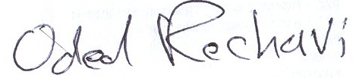____

Signature of the Research Authority:________________________________________

2. Abstract (English): Chromothripsis (Greek for “chromosome shattering into pieces”) is a phenomenon in which large segment of the genome is broken to hundreds of DNA segments that are rearranged in a singular, one-time cellular crisis, providing what can be defined as "a shortcut to cancer". It challenges the dogma that cancer progresses through a slow, stepwise process. Initially described in 2011 and thought to be rare, research indicates that chromothripsis is in fact pervasive across cancers, with a frequency of more than 50% in several aggressive cancer types, such as glioblastoma and lung cancer, and is associated with bad prognosis. Among the suggested mechanisms are the formation of micronuclei around lagging chromosomes, which are prone to DNA damage from faulty base excision repair or cytoplasmic nucleases. Another key mechanism involves the creation of dicentric chromosomes, which form bridges that can be broken by actomyosin forces or nucleases, ultimately causing extensive DNA fragmentation. However, the full etiology of this massive genomic catastrophe remains a mystery. Moreover, the logic of the repair mechanisms dictating the rearrangement of the DNA fragments into newly formed chromosomes and ecDNAs is still unknown.

C. elegans is a small, free-living roundworm that has become one of the most studied and important model organisms in scientific research, with 8 Nobel prizes were awarded to C. elegans researchers since the year 2000). When DNA is injected into the worm’s gonads, the worm concatemerizes the injected DNA and forms gigantic, repetitive, extrachromosomal “arrays” (ECAs). The emergence of third-generation sequencing technologies now allows for the direct sequencing of these long DNA molecules, offering new insights into the precise sequences and, with the help of advanced computational tools, enables us to decipher the rules governing ECA formation. We propose that this massive ECA formation, which is a normal event in C. elegans life cycle, is analogous to the second part of the chromothripsis, and thus can be used to model it. Our lab, which specializes in C. elegans research, and which has recently pioneered sequencing and characterization of ECA (unpublished) is uniquely positioned to advance the understanding of ECA formation in C. elegans and establishing it as a model to study chromothripsis and ecDNA formation. To achieve this novel goal, we will: (1) Use Nanopore long-read sequencing to systematically compare the DNA recombination patterns between chromothripsic chromosomes and human ecDNA and C. elegans ECAs. (2) Identify C. elegans mutants in which ECA formation is abrogated. (3) Examine whether the genes we identified in the worm affect chromothripsis in human cancer.

Chromothripsis is typically described as an early event in tumor development, which can occur long before cancer diagnosis. In some cancers, chromothripsis frequently happens in childhood to adolescence, several decades before cancer diagnosis. Understanding the biology of early cancer development driven by chromosomal instability could lead to the identification of new cancer risk factors and biomarkers, as well as the development of highly sensitive technologies for early cancer diagnosis. Ultimately, such advances are expected to provide a basis for improvements in cancer cure rates.

Abstract (Hebrew): כרומותריפסיס (מיוונית: "כרומוזום מתרסק לחתיכות") זו תופעה שבה חלק ניכר מהגנום נשבר למקטעי דנ"א נפרדים ומתארגן מחדש במשבר תאי יחיד, שמהווה מה שיכול להיות מוגדר בתור "קיצור דרך לסרטן". תופעת הכרומותריפסיס תוארה לראשונה בשנת 2011, ולמרות שבתחילה נתפסה כנדירה, המחקר העדכני מצביע על כך שכרומותריפסיס נפוצה בסוגים שונים של סרטן, עם שכיחות של יותר מ50% בסוגים מסוימים של סרטן אגרסיבי במיוחד, כמו גליובלסטומה וסרטן ריאה, וגם נקשרו לסיכויי החלמה נמוכים במיוחד. מנגנונים שונים נקשרו להופעה של כרומותריפסיס, בהם היווצרות של מיקרו-גרעיני תא סביב כרומוזומים מתעכבים בשלב האנפאזה, שהופכים לפגיעים לנזקי דנ"א כתוצאה מתיקון דנ"א פגום או פעולה של נוקלאזות ציטופלזמטיות. מנגנון בולט נוסף הוא ההיווצרות של כרומוזומים עם צנטרומטרים כפולים, היוצרים חיבורים שעלולים להישבר כתוצאה מפעולה של אקטומיצין או נוקלאזות ולגרום להתפרקות של חלקי דנ"א רבים. למרות הבנה גוברת זאת, האטיולוגיה המלאה של קטסטרופה גנטית זו נותרת לא מובנת. יתרה מזאת, ההיגיון המניע את מנגנוני תיקון הדנ"א המעצבים את החיבור מחדש של חלקי הדנ"א לכרומוזום שלם ולדנ"א אקטרה-כרומוזומלי נלווה נותר בעיקרו עלום.

סי אלגנס היא תולעת עגולה שהפכה לאחד מאורגניזמי המודל הנחקרים והמשמעותיים ביותר במחקר מדעי. כאשר דנ"א מוזר לגונדות של התולעת, מנגנונים בתאי הסי אלגנס גורמים לדנ"א המוזרק להתחבר ל"מערכי" דנ"א אקסטרה-כרומוזומלי (מא"כ) ענקיים וחזרתיים. הפיתוח של שיטות הדור השלישי לריצוף דנ"א מאפשרות כיום לרצף באופן ישיר את מולקולות הדנ"א הארוכות הללו, ומציעות תובנות חדשות לגבי הרצפים המדויקים שלהן. בסיוע כלים חישוביים מתקדמים, התקדמות זו מאפשרת לנו לפענח את החוקים שמכתיבים את היווצרות המא"כים הללו. ההיפותזה שלנו היא שהיווצרות המא"כים, שהיא תופעה שגרתית במחזור החיים של סי אלגנס, היא אנלוגית לחלק השני של תופעת הכרומותריפסיס, ולכן התולעת יכולה לשמש כמודל של תהליכים אלה. המעבדה שלנו, שמתמחה במחקר הביולוגיה של סי אלגנס, יזמה באחרונה מחקר חדשני בריצוף ואפיון של מא"כים בסי אלגנס (טרם פורסם). ניסיון זה מציב אותנו בעמדה אידיאלית לקדם את הבנת היצירה של מאכ"ים בסי אלגנס והשימוש בתולעת כמודל למחקר של כרומותריפסיס והיווצרות של דנ"א אקסטרה-כרומוזומלי. לצורך כך, אנו מציעים: (1) להשתמש בנאנופור לריצוף דנ"א כדי להשוות באופן שיטתי בין כרומוזומים לאחר כרומותריפסיס ודנ"א אקסטרה-כרומוזומלי אנושי עם מא"כים בסי אלגנס. (2) לזהות מוטציות בסי אלגנס שמשבשות את ההיווצרות של מא"כים. (3) לבחון אם הגנים אותם זיהינו בתולעת ממלאים תפקיד גם בהתפתחות של כרומותריפסיס בסרטן בבני אדם.

כרומותריפסיס מתואר לרוב כתופעה שמתרחשת בשלב מוקדם בהתפתחות הגידול, ועלולה לקרות זמן רב לפני האבחון בסרטן. בסוגים מסוימים של סרטן, כרומותריפסיס מופיעה בילדות או בגיל ההתבגרות, עשרות שנים לפני האבחון במחלה. הבנת הביולוגיה של התפתחות מוקדמת של מחלת הסרטן שנובעת מחוסר יציבות כרומוזומלית יכולה לאפשר זיהוי גורמי סיכון וסמנים ביולוגיים חדשים, ולקדם פיתוח של טכנולוגיות חדשות ורגישות במיוחד לאבחון מוקדם של סרטן. בסופו של דבר, פיתוחים שכאלו יכולים לבסס התקדמות משמעותית באפשרות הריפוי של מחלת הסרטן במטופלים רבים.

Abstract (Hebrew - Layman's term): סרטן נתפס לרוב כתוצאה של תהליך ארוך שנים של נזק מצטבר לדנ"א, עד שנוצרת "מסה קריטית" שהופכת תא לסרטני. אולם לפני מעט יותר מעשור גילו חוקרים "קיצור דרך" לסרטן: במקרים מסוימים, כרומוזום אחד או יותר עשויים להתרסק לעשרות ומאות חתיכות ולהתחבר מחדש בצורה שונה. תהליך זה, שנקרא כרומותריפסיס, יוצר מספר רב של מוטציות בגנום בו זמנית, ויכול להפוך את התא לסרטני באירוע יחיד. בשנים האחרונות, מתגלה בהדרגה כי כרומותריפסיס אינה תופעה נדירה בסרטן נדירה כלל וכלל, ובסוגים שונים של סרטן אגרסיבי וקטלני במיוחד, כמו סרטן מוח מסוג גליובלסטומה וסרטן ריאות, היא זוהתה במחצית מהדגימות, כמו גם כמעט בכל דגימות סרטן העצמות שנבדקו. מאז גילוי התופעה, ההבנה המדעית של הגורמים לכרומותריפסיס הולכת וגוברת. אולם שאלות משמעותיות נותרו לא מענה, בהן כיצד נקבע אילו חלקים יתחברו מחדש אחד לשני ובאיזו צורה.

סי אלגנס היא תולעת זעירה שהפכה בעשורים האחרונים לאחת מכלי המחקר המובילים בחקר הביולוגיה המולקולרית, עם שבעה פרסי נובל שונים שהוענקו למחקרים שנעשו בעזרתה. אחד מהמאפיינים יוצאי הדופן של סי אלגנס הוא שכאשר מזריקים לתאי המין שלה מקטעי דנ"א נפרדים, המנגנונים של תא התולעת, באופן ספונטני, מחברים אותם יחדיו לרצף דנ"א שלם וחדש לחלוטין. תכונה זו מאפשרת לרתום את התולעת כדי לחקור את המנגנונים שמשמשים את התא באיחוי מחדש של הכרומוזום לאחר התפרקותו בכרומותריפסיס. המעבדה שלנו היא אחת המעבדות המובילות בעולם למחקר ביו-מולוקולרי בתולעי סי אלגנס. המעבדה מצטיינת גם בפיתוח שיטות פורצות דרך וחשיבה "מחוץ לקופסה" במחקר מדעי, כמו למשל בשימוש בטפילים שעברו הנדסה גנטית ככלי להובלת תרופות למוח או רתימת כלי מחקר מולקולרי לפענוח חידות ארכיאולוגיות.

מטרת הפרויקט המוצע היא להיעזר בסי אלגנס כדי להשיג הבנה עמוקה יותר של תופעת הכרומותריפסיס בסרטן, שיכולה במקרים רבים להתרחש שנים רבות לפני שהסרטן מזוהה. הבנה זו תוכל לסייע בפיתוח כלים לזיהוי מוקדם וגישות טיפוליות חדשניות לסרטן – בייחוד לסוגי הסרטן האגרסיביים והקשים לטיפול שנגרמים כתוצאה מכרומותריפסיס. במסגרת הפרויקט, אנחנו מציעים לרתום את הכלים והמיומנות של המעבדה שלנו כדי: 1. להשתמש בכלי ריצוף גנטי מתקדמים לחקור לעומק את רצפי הדנ"א שנוצרים באופן ספונטני בתולעת, ולהשוות את הדפוסים למאפיינים של כרומוזומים שנפגעו מכרומותריפסיס מדגימות שנלקחו מחולי סרטן; 2. לבחון כיצד הגברה או שיבוש של מנגנונים שונים של תיקון דנ"א משפיעים על אופן היצירה של רצפי הדנ"א בתאי סי אלגנס; 3. להשתמש בהבנה החדשה על חשיבות מנגנוני תיקון דנ"א שונים בניתוח רצפי דנ"א של חולי סרטן כדי להבין איזה תפקיד ממלאים מנגנונים אלה בהיווצרות מחדש של הכרומוזום הסרטני כתוצאה מכרומותריפסיס. הבנת הביולוגיה של התפתחות מוקדמת של מחלת הסרטן שנובעת מחוסר יציבות כרומוזומלית יכולה לאפשר זיהוי גורמי סיכון וסמנים ביולוגיים חדשים, ולקדם פיתוח של טכנולוגיות חדשות ורגישות במיוחד לאבחון מוקדם של סרטן. בסופו של דבר, פיתוחים אלו יוכלו לבסס התקדמות משמעותית באפשרות הריפוי של מחלת הסרטן במטופלים רבים.

- Scientific Background, Research Question
We often think of cancer as a result of a progressive process, in which mutations are accumulated in a stepwise manner, over the course of many years, until the cell becomes cancerous. Chromothripsis (Greek for “chromosome shattering into pieces”) is a phenomenon in which large segment of the genome is broken to hundreds of DNA segments that are rearranged in a singular, one-time cellular crisis, providing what can be defined as "a shortcut to cancer". Chromosomal fragments that are not reincorporated into the derivative chromosome can self-ligate to generate circular extrachromosomal DNA (ecDNA) structures. Initially described in 2011 (1) and thought to be rare, recent research utilizing advances in sequencing technologies indicates that chromothripsis events are pervasive across cancers, with a frequency of more than 50% in several aggressive cancer types, such as glioblastoma and lung cancer, and is associated with especially bad prognosis (2). Recent studies have revealed the presence of ecDNAs in various cancer types and highlighted it as an adverse prognostic factor that is associated with tumor aggressiveness (3).
Different mechanisms have been implicated in the development of chromothripsis. One mechanism is that lagging chromosomes during mitosis become encapsulated in micronuclei, which have defective nuclear envelopes. These micronuclei can rupture, exposing their DNA to the cytoplasm, leading to extensive DNA fragmentation (4). Cytoplasmic exonucleases (e.g. TREX1), have also been suggested to promote DNA fragmentation in micronuclei (5-7). Another important mechanism of chromothripsis initiation is the formation of dicentric chromosomes. During mitosis, dicentric chromosomes can simultaneously attach to both spindle poles, leading to the formation of chromosome bridges during anaphase (5-6). Dicentric chromosomes can also arise through end-to-end fusions of non-homologous chromosomes or sister chromatids, which can occur as a result of telomere crisis (8) or ligation between broken sister chromatids following DNA replication. The eventual breakage of stretched chromosome bridges generates free chromosome ends in the two daughter cells, which can initiate a new round of formation of dicentric chromosomes, known as the breakage–fusion–bridge (BFB) cycle. The link between telomere attrition, BFB cycles and chromothripsis has been demonstrated in different studies (8-9). Several additional mechanisms of chromothriptic initiation have been suggested such as abortive apoptosis; escape of chromatin digestion by the autophagy–lysosome system that removes micronuclei; infection of cells with viruses such as human papillomaviruses and Epstein–Barr virus; and exposure to agents inducing DNA damage (2).
Understanding how the fractured DNA is rearranged focuses predominantly on non-homologous end joining (NHEJ), leading to random fragment reassembly. Another hallmark of chromothripsis is the presence of alternating copy-number states, which results from selective retention or loss of DNA segments. Chromosomes may lose unrepaired fragments, resulting in large deletions, and tethered fragments can cluster and be inherited together in daughter cells (2, 7). In addition, the formation of ecDNA amplifies oncogenes and drives tumor heterogeneity (3).
Several experimental models have been developed to study the mechanisms of chromothripsis. In vitro cell-based models have been instrumental in inducing chromothripsis by simulating conditions that lead to chromosome missegregation and micronuclei formation. For example, using mitotic inhibitors to generate micronuclei and investigate their subsequent rupture and DNA fragmentation (4) or disabling centromeres on certain chromosomes using centromere inactivation models triggers chromosomal shattering and non-homologous end-joining (10). Another approach involves telomere crisis models, where telomeric attrition leads to end-to-end chromosome fusions and breakage–fusion–bridge cycles (5). Moreover, live-cell imaging has been used to directly observe chromosome bridge stretching and breakage under actomyosin forces, providing insights into progressive chromothriptic events (6). These experimental systems, complemented by genomic studies such as whole-genome sequencing, have significantly advanced our understanding of chromothripsis and its role in cancer progression. However, the full etiology of this massive genomic catastrophe remains a mystery. Moreover, the logic of the repair mechanisms dictating the rearrangement of the DNA fragments into newly formed chromosomes and ecDNAs, shaping the level of randomness in the repair and influencing which DNA segments will be retained or lost is similarly still unknown.
C. elegans is a small, free-living roundworm that has become one of the most studied and important model organisms in scientific research. For over three decades, it has been well-established that when DNA is injected into the worm’s gonads (plasmids, for example), the worm concatemerizes the injected DNA and forms gigantic, repetitive, extrachromosomal “arrays” (ECAs), which are typically 1-3 million base pairs long (11). Studies have explored ECAs' formation and composition using traditional techniques such as gel electrophoresis, southern blots, and “DNA paint”, but the precise mechanisms and sequences of ECAs remain unclear, largely due to their length and repetitive nature which hinder standard sequencing methods. The emergence of third-generation sequencing technologies now allows for the direct sequencing of these long DNA molecules, offering new insights into the precise sequences and, with the help of advanced computational tools, enables us to decipher the rules governing ECA formation. We propose that this massive ECA formation, which is a normal event in C. elegans life cycle, is analogous to the rearrangement part of the chromothripsis, and thus can be used to model it. Our lab, which specializes in C. elegans research (12-14), and which have recently pioneered sequencing and characterization of ECA (unpublished) is uniquely positioned to advance the understanding of ECA formation in C. elegans and establishing it as a model to study chromothripsis and ecDNA formation. To achieve this novel goal, we will: (1) Use Nanopore long-read sequencing to systematically compare the DNA recombination patterns between chromothripsic chromosomes and human ecDNA and C. elegans ECAs. (2) Identify C. elegans mutants in which ECA formation is abrogated. (3) Examine whether the genes we identified in the worm affect chromothripsis in human cancer. Chromothripsis is typically described as an early event in tumor development, which can occur long before cancer diagnosis. In some cancers, chromothripsis frequently happens in childhood to adolescence, several decades before cancer diagnosis. Understanding the biology of early cancer development driven by chromosomal instability could lead to the identification of new cancer risk factors and biomarkers, as well as the development of highly sensitive technologies for early cancer diagnosis. Ultimately, such advances are expected to provide a basis for improvements in cancer cure rates.
- Study Design
Aim 1: Comparing ECA formation in C. elegans and chromothripsis recombination patterns (Time estimate: 10 months).
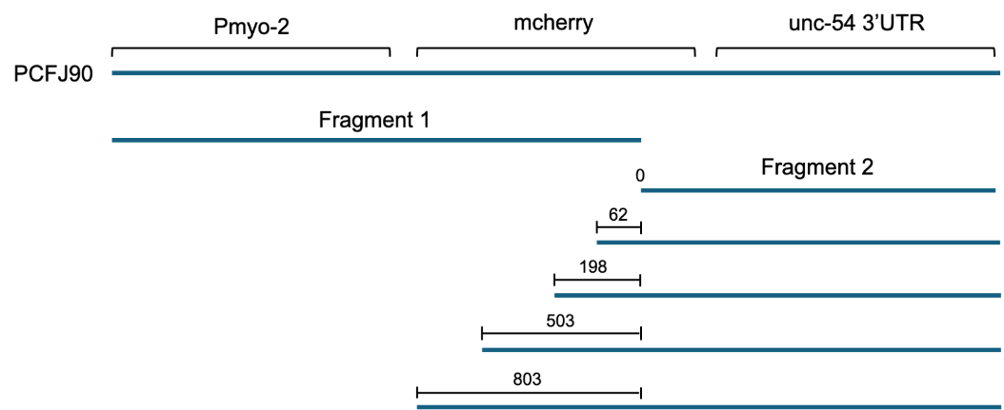
Aim 1.1: Decipher the rules of ECA formation in C. elegans: We will use the PCFJ90 plasmid [Pmyo-2::mcherry::Punc-54 3’UTR] to create 5 sets of split mCherry reporters with varying degrees of overlap (Figure 1). The overlaps will range from 0 bp (no overlap) to 803 bp. The two halves of the split reporter will be injected into the worms so that only successful, error-free recombination (homology-directed repair) will lead to fluorescence from the intact mCherry gene. We will count the number of fluorescent progenies in each overlap condition to determine whether we have successful recombination, and thus to decipher the rules that govern array formation, and hopefully also the formation of the aberrant chromosomes formed in chromothripsis. These experiments will allow us to determine a cutoff point of necessary homology length under which we see no meaningful successful recombination. Our preliminary results using 503 bp overlap yielded fluorescence, attesting to the validity of the method and the role of homologous recombination in array formation as the injected split reporter was correctly repaired.
Figure 1. Split mCherry reporters. The PCFJ90 plasmid split into five sets of two fragments. The sets range from 0-803 bp of overlap between the fragments. Only error-free recombination of the two fragments will lead to mCherry expression.
If the 0 and 62 bp overlap conditions result in fluorescence, we will use qPCR to quantify the number of successful recombination events in each condition and compare. Since the recombined product in all conditions is the same, we will use CRISPR with the same five guide sequences for all overlap conditions that yielded fluorescent progeny to fragment the recombined product in the resulting arrays into four segments of 200-250 bp each (Figure 2). On these fragments we will perform Illumina sequencing with unique molecular identifiers to determine the sequences of recombined fragments and their relative occurrence in each overlap condition.
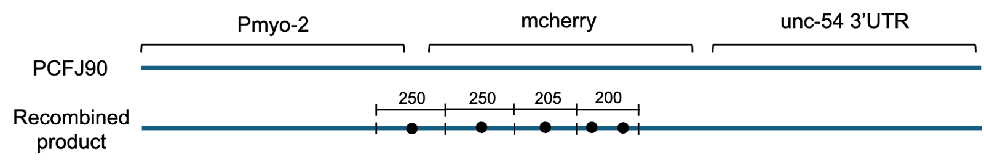
Having discovered the lengths of homology between two injected sequences which lead to their recombination, the previously described sequencing analysis will be performed on an ECA formed from three injected sequences sharing homologous regions. The resulting ECA will also be sequenced using third generation Long-read Oxford Nanopore Technologies and its sequence will be determined using genome assemblers. The connections that formed between the injected segments will be analyzed and further optimized to characterize the conditions leading to recombination in real life scenarios (such as chromothripsis).
Figure 2. CRISPR splicing of recombination region in each of the ECAs. Lines on the recombined product represent CRISPR cut sites and dots represent the ends of each of the segments in the five overlap conditions. Four segments of 200-250 bp will be sequenced with unique molecular identifiers using Illumina.
Aim 1.2: Compare ECA formation patterns to chromothripsis recombination patterns. We will analyze whole-genome sequencing data from human cancer datasets, including those provided by the ICGC/TCGA Pan-Cancer Analysis of Whole Genomes (14). Our focus will be on identifying chromothripsis-associated structural variants. Specifically, we will map the breakpoints and examine the microhomology or lack thereof at junction sites to determine the mechanisms of repair—whether predominantly non-homologous end joining (NHEJ), microhomology-mediated end joining (MMEJ), or other pathways. We will assess the presence of ecDNA formation in these samples, paying particular attention to oncogene amplification patterns. We will compare these findings to recombination patterns characterized in C. elegans in Aim 1.1. Our analysis will evaluate whether human chromothripsis exhibits similar fragment reassembly processes or differs due to additional selective pressures. We will also assess the distribution of structural variations across different cancer types to understand how tumor-specific contexts influence recombination patterns.
Aim 2. Identify C. elegans mutations abrogating ECA formation (Time estimate: 10 months).
Aim 2.1: Study the effects of mutations in DNA repair mechanisms. Optimized three-segment injection mixtures with the optimal lengths of homology identified in Objective 1 will be injected into DNA repair mutants defective in the non-homologous end-joining DNA repair pathway or overexpressing genes in the homology-directed repair pathway (see Table 1). The resulting ECAs in mutants will be compared to those in wild type nematodes and the effect of the mutation on array formation will be examined. The resulting arrays in repair mutants will be sequenced using Oxford Nanopore.

Table 1. Candidate DNA repair genes for mutant creation.
Human gene | Worm ortholog | Pathway
Lig4 | lig-4 | canonical NHEJ (non-homologous end-joining)
Ku70 / Xrcc6 | cku-70 | NHEJ
Ku80 / Xrcc5 | cku-80 | NHEJ
Nbs1 | nbs-1 | DNA end resection in alternative NHEJ and HR (Homology-directed Repair)
Fan1 | fan-1 | 5’-3’ nuclease  implicated in interstrand cross-link repair and replication fork stability
Polq | polq-1 | MMEJ (Microhomology-Mediated End Joining)
Parp1 | parp-1 | Promotes MMEJ
Msh2 | msh-2 | MMR (Microhomology-Mediated Repair)
Mlh1 | mlh-1 | MMR

Aim 2.2: Development of C. elegans multi-gene mutants reliably replicating Chomothripsis recombination patterns. The mutants that result in ECA connections resembling patterns identified in Aim 1.2 will be crossed to create multi-gene mutants that lead to high occurrence chromothripsis-like array formation. Once the most effective mutants are established and crossed, we will use advanced statistical techniques to determine a minimal set of experiments required to maximize the accuracy and yield of ECA formation. These experiments will test different combinations of experimental parameters, such as number of fragments, fragment size, overlap length, GC content, total DNA quantity, and expression/activity levels of different DNA repair genes, to optimize the repair between the injected fragments, while maximizing the success rate of ECA formation.
Aim 3. Examine whether the genes we identified in the worm affect chromothripsis in human cancer (Time estimate: 4 months).
We will examine whether the mutations in genes identified in our C. elegans mutants, which replicate chromothripsis-like recombination patterns in ecDNA formation, are also present in human cancer samples exhibiting chromothripsis. Using whole-genome sequencing data from human datasets as in Aim 1, we will perform targeted variant analysis to identify mutations or structural alterations in homologs of the C. elegans genes of interest. We will compare the frequency and types of mutations across different tumor types to evaluate their association with chromothripsis events. Additionally, we will assess whether these mutations correlate with the prevalence of ecDNA or copy-number alterations. Functional enrichment analysis will determine if these genes are part of conserved genomic instability pathways.
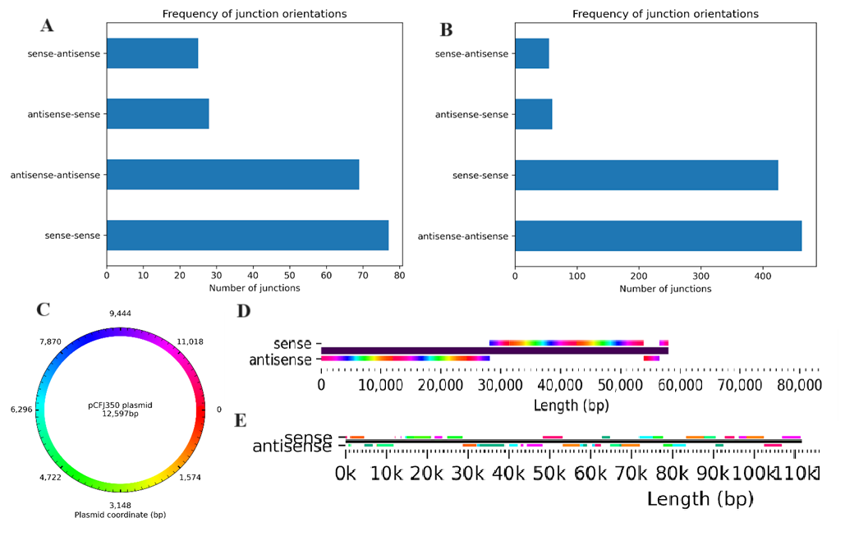
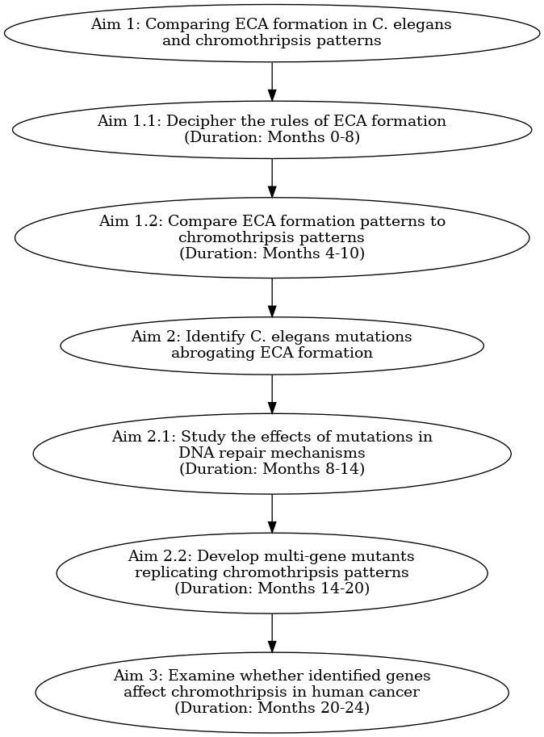
Preliminary Results: In our preliminary study, we have already demonstrated the applicability of using our methods to begin deciphering the mechanisms shaping the formation of ECAs. We successfully used long read sequencing technologies to sequence arrays of different compositions. We created arrays of increasing complexity, starting with arrays that are made of a repetitive single short DNA sequence, moved on towards arrays that are made of two different DNA sequences, and finally successfully sequenced and assembled an array which is made of 43 different DNA plasmids. We injected C. elegans worms with a plasmid either with “blunt ends” or “sticky ends” and characterized the way in which the plasmids connected to form an extrachromosomal array. We found that there is a bias toward same-orientation connections, which can be seen more strongly in the blunt ends scenario (Figure. 3A and 3B). Also, junctions in both the same and opposite orientations (sense-sense vs. sense-antisense) tend to occur at the same coordinate in the two plasmids (Figure. 3C and 3D). We mapped the alignments of 43 different plasmids with varying degrees of homology to the ECA that they formed and visualized their connections (Figure. 3E). In preliminary studies of array formation in worms that are mutants in NHEJ, we found that it was much harder to obtain a stable ECA, suggesting the importance of NHEJ repair in forming arrays and pointing toward expression of homology-directed repair pathways as a means to encourage homology-based connections.
Figure 3. Plasmid connections in ECAs. A) There is a strong bias (~75% of connections) toward same-orientation connections (sense-sense, antisense-antisense) between a plasmid with sticky ends and B) a stronger bias (~90% of connections) in a plasmid with blunt ends. C) The sticky-end plasmid represented as a colormap to easily distinguish plasmid coordinates. D) Sense and antisense alignments to a ~60 kb sequence of the ECA (sequenced by Oxford Nanopore sequencing). Same orientation connections tend to form between the end coordinate of one plasmid to the start coordinate of another, “reclosing” the plasmid. Opposite orientation connections tend to form at the same coordinate on both plasmids. E) Alignments of plasmids to a 110 kb section of an ECA that formed from 43 different plasmids. Each unique color represents a different plasmid.
Figure 4: Schematic representation of the project

References:
1. Stephens, P. J. Massive genomic rearrangement acquired in a single catastrophic event during cancer development. Cell 144, 27–40 (2011).
2. Simovic-Lorenz, M., Ernst, A. Chromothripsis in cancer. Nat Rev Cancer 25, 79–92 (2025).
3. Shoshani, O. Chromothripsis drives the evolution of gene amplification in cancer. Nature. 591, 137–141 (2021).
4. Crasta, K. DNA breaks and chromosome pulverization from errors in mitosis. Nature 482, 53–58 (2012).
5. Maciejowski, J. et al. APOBEC3-dependent kataegis and TREX1-driven chromothripsis during telomere crisis. Nat. Genet. 52, 884–890 (2020).
6. Umbreit, N. T. Mechanisms generating cancer genome complexity from a single cell division error. Science 368, eaba0712 (2020).
7. Lin, Y.-F. et al. Mitotic clustering of pulverized chromosomes from micronuclei. Nature 618, 1041–1048 (2023).
8. van Steensel, B., Smogorzewska, A. & de Lange, T. TRF2 protects human telomeres from end-to-end fusions. Cell 92, 401–413 (1998).
9. Mardin, B. R. A cell-based model system links chromothripsis with hyperploidy. Mol. Syst. Biol. 11, 828 (2015).
10. Ly, P. Selective Y centromere inactivation triggers chromosome shattering in micronuclei and repair by non-homologous end joining. Obstet. Gynecol. Surv. 72, 282–283 (2017).
11. Stinchcomb, D. T., et al. Extrachromosomal DNA transformation of Caenorhabditis elegans. Molecular and Cellular Biology, 5(12), 3484–3496 (1985).
12. Houri-Zeevi, L., Korem Kohanim, Y., Antonova, O. & Rechavi, O. Three Rules Explain Transgenerational Small RNA Inheritance in C. elegans. Cell 182, 1186-1197.e12 (2020).
13. Posner, R. et al. Neuronal Small RNAs Control Behavior Transgenerationally. Cell 177, 1814-1826.e15 (2019).
14. Anava, S. et al. Illuminating Genetic Mysteries of the Dead Sea Scrolls. Cell 181, 1218-1231.e27 (2020).
15. The ICGC/TCGA Pan-Cancer Analysis of Whole Genomes Consortium. Pan-cancer analysis of whole genomes. Nature 578, 82–93 (2020).

4a. Budget should be described for the WHOLE research duration, in accordance to the budget items in the electronic form
Budget (in NIS) | Other sources of funding | Requested sum  Year 2 | Requested sum  Year 1
 |  |  |  | Person Power (indicate position, e.g. Technician, Assistant)
127,000 | - | 63,500 | 63,500 | 1 PhD student – 50%
123,000 | - | 61,500 | 61,500 | 1 Lab Technician – 30%
250,000 |  | 125,000 | 125,000 | Total Person Power
 |  |  |  | Other expenditures (Please itemize)
180,000 | - | 90,000 | 90,000 | Consumables and Reagents
20,000 | - | 10,000 | 10,000 | Services
200,000 |  | 100,000 | 100,000 | Total Other expenditures
50,000 |  | 25,000 | 25,000 | Overhead (10% of the final sum)
500,000 |  | 250,000 | 250,000 | Total
Salaries to PI and CoI, permanent equipment (including computers and software), clinics charges, and travels abroad are not eligible costs.

4b: Funding from other resources for similar programs
____There are no other fundings for this program._________________________________

4c: Budget justification
(If this project is presently supported by another grant or if a similar application was made to fund this project, the PI must justify the request).
The budget requested for personnel (125,000NIS per year) will be dedicated to: 50% Scholarship for a PhD student and salary for Lab technician who will help with the ECA synthesis and injections and will dedicate 30% of her/his time on this project.
90,000NIS per year will be dedicated to consumables and reagents. This includes: petri dishes and agar powders for C. elegans maintenance, plastics for molecular biology such as: Eppendorf tubes, PCR tubes and tips. Reagents for molecular biology: different enzymes for cloning, reagents for DNA extraction and library preparation. Consumables for injections: glass slides, special tips and Quartz Tubing capillary.
The budget for Services (10,000NIS per year) will be dedicated for the Faculty Core Facility services, for example: Sanger sequencing in order to validate the cloning products, Qbit and tapestation to check the quality of DNA and libraries before injections and sequencing.

5. Curriculum Vitae
Fill out a form for EACH applicant
First name: Oded Surname: Rechavi Title: Full Professor

Main Research Area: Molecular Biology, C. elegans Research, Epigenetics, Genetics, Neuroscience,

Education (Academic or equivalent)
From – To | Academic Institute | Area of Specialty | Degree
2010-2012 | Howard Hughes Medical Institute Columbia University Medical Center | Biochemistry and Molecular Biophysics | Post-doctoral Research Fellow
2006-2010 | Tel-Aviv University | Neurobiology | Ph.D. -Direct PhD program
2003-2006 | Tel-Aviv University | Interdisciplinary neuroscience program for excellent students | B.Sc.

Employment (Begin with current employment) ³
From – To | Academic Institute | Area of Specialty | Degree
2020 - current | Tel Aviv University | Neurobiology | Full Professor
2018 - 2020 | Tel Aviv University | Neurobiology | Associate professor
2012 - 2018 | Tel Aviv University | Neurobiology | Senior Lecturer
2010 – 2012 | Howard Hughes Medical Institute, Columbia University Medical Center | Molecular Biophysics | Post-Doctoral Research Fellow

Active Research Grants and Contracts ³
From - To | Funding Source | Research Subject | Percent Effort | Grant Amount
2022-2026 | The Kahn Foundation | Rethinking inheritance: Transgenerational small RNA- based memory | 25% | 2,687,655
2021-2025 | Schmidt Fund for strategic innovation | Polymath Program | 25% | 2,240,000
2020-2025 | The Colton Foundation | Revealing a Hidden PD-L1 Variant – Implications for Autoimmunity and Cancer | 15% | 315,000
2019-2025 | Horizon 2020 – ERC Consolidators | RNA Flashbacks | 25% | 2,000,000
2015-2026 | Minerva -STIFTUNG Centres | Live emulation of genome evolution in the lab | 10% | 90,000

6. Collaboration letters:
Please include letters from collaborators, consenting to contribute to the research and their part in it. In addition, these letters should be scanned (B&W, low resolution PDF files) and attached to the electronic form

7. Bio-Ethics approvals
If applicable, please find attached:

☐ Bio-Ethics approval is not required
☐ Research requires "Helsinki" approval for research on Human Subjects.

☐ | "Helsinki" approval (Signed by the Hospital Director), Valid until___________
☐ | Temporary approval by the hospital "Helsinki" committee.
☐ | Copy of the application to the hospital "Helsinki" committee (2 first pages ONLY)

☐ Research requires approval from Institutional Committee for Animal Research approval

☐ | Approval of the Institutional Committee for Animal Experimentation, Valid until___________
☐ | Copy of the application to the Institutional Committee for Animal Experimentation  (2 first pages ONLY)
☐ Approval of the Institutional Safety Committee

☐ Approval of from the Ministry of Education (or other required approvals)

- Suggested reviewers:
Names at-least 5 experts in the field (avoid using reviewers who may be affected by a conflict of interest with the proposal and / or the researchers)
Name: Oliver Hobert Email: or38@columbia.edu
Name: Ehud Cohen Email: ehudc@ekmd.huji.ac.il
Name: Einav Gross Email: einavg@ekmd.huji.ac.il
Name: Beni Podbilewicz Email: podbi62@gmail.com
Name: Yitzhak Pilpel Email: pilpel@weizmann.ac.il

רשימת בדיקה:
יש לאגד את ההצעה על פי הסדר ברשימה ולצרף אותה בסוף ההצעה

- עותק מודפס של הטופס האלקטרוני המלא של "בקשה למימון מחקר" הכולל:
- חתימת כל השותפים למחקר (כולל יועצים) על טופס בקשה למימון מחקר.
- חתימה וחותמת רשות המחקר.
- תקציר הצעת המחקר בעברית באנגלית ובלשון לא מדעית
- תכנית המחקר
- תקציב המחקר
- קורות חיים של כל אחד מהחוקרים (בדפים שיוחדו לכך).
- מכתבי שיתוף פעולה
- אישורי ביו-אתיקה:
- אישור לניסוי באנוש או העתק הבקשה שהוגשה לועדת הלסינקי.
- אישור הועדה המוסדית לניסויים בבעלי חיים או העתק הבקשה שהוגשה
- אין צורך באישור ביו-אתיקה
- אישור משרד החינוך או אחר
- שמות סוקרים פוטנציאלים
- רשימת בדיקה זו.
- הבקשה נשלחה online בתאריך:__________

If this application is being re-submitted, a letter explaining the changes made to the original one should be attached.
Add more lines, as required
Ethical documents attached should strictly follow the instructions on "BioEthics" on the Chief Scientist website. Only hard-copies should be attached to this application. Scanned dcouments (low resolution, B&W PDF files) should be attached only to the electronic form.

