NAME-GRANTH CHAUHAN
SECTION-B
SUBJECT-SOFTWARE ENGINEERING

Class Identification for Budget Management System
In a Budget Management System, classes represent the main entities of the system, their attributes, methods, and relationships.
1. Identify the classes
The following classes can be identified:
- User — stores user details and login information.
- Budget — stores the user's budget limit and period.
- Income — stores income source, amount, and date.
- Expense — stores expense category, amount, and date.
- Category — classifies income and expenses.
- Report — generates summaries of income, expenses, and savings.
2. Classification into Strong and Weak classes
A strong class can exist independently, whereas a weak class depends on another class for its existence or identification in the system design.
Strong classes | Weak classes | Reason
User | Budget | A budget belongs to a user.
Category | Income | Income records are associated with a user.
 | Expense | Expense records are associated with a user.
 | Report | A report is generated from financial records.
Note: This classification depends on the design assumptions. Income, Expense, and Budget can also be modeled as independent strong classes if they have their own identifiers and lifecycle.
3. Class Diagram
The following PlantUML code shows the classes, attributes, methods, and their relationships.
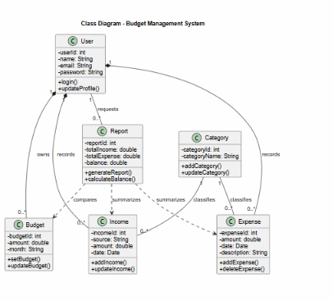
4. Relationship explanation
- User–Budget: One user can create multiple budgets.
- User–Income: One user can record multiple income entries.
- User–Expense: One user can record multiple expenses.
- Category–Income/Expense: Each record belongs to a category.
- User–Report: A user can generate multiple reports.
- Report–Financial records: Reports summarize income and expenses and compare spending against the budget.
Conclusion: The class diagram represents the static structure of the Budget Management System. It identifies six classes and shows their attributes, operations, and relationships.

